INDEX PAGES
S/N | PROJECT TITLE | LOCATION | PROJECT DESCRIPTION | PAGE NO
1 | Construction of PHC building | Mubi North | Duda PHC_Re-construction of PHC building | 1
2 | Fencing of PHC Centre | Mubi North | Fencing of Duda PHC_Fence | 1
3 | Construction of Hostel | Maiha | Construction of GSS Maiha Girls Hostel | 2
4 | Rehabilitation of classroom and furniture Supply | Maiha | Rehabilitation of classroom block and furniture Supply at GSS Maiha | 2
5 | Construction of classroom block | Mubi North | Kwa Primary School construction of classroom block | 3
6 | Rehabilitation of classroom blocks | Mubi North | Kwa Primary School | 3
7 | Rehabilitation of classroom blocks | Maiha | Rehabilitation of classroom blocks at Maksha Primary School | 4
8 | Community storage facility and VIT toilet | Maiha | Dafura community storage facility and VIT toilet | 4
9 | Construction of classroom block | Maiha | Domayo Primary School | 5
10 | Construction of VIP Toilet | Maiha | Domayo Primary School VIP Toilet | 5
11 | Construction of classroom block | Mubi North | Duda Primary School, classroom block front view | 6
12 | Construction of VIP Toilets | Mubi North | Duda Primary School VIT Toilets | 6
13 | Rehabilitation of General Hospital Maternity Ward | Gombi | Garkida General Hospital Maternity Ward | 7
14 | Provision of Hospital equipment | Gombi | Provision of Hospital equipment at Garkida General Hospital | 7
15 | Construction of sport field spectator stand | Gombi | EYN Garkida sportfield spectator stand | 8
16 | sport field spectator stand | Gombi | EYN Garkida sportfield spectator stand | 8
17 | Construction of classroom block | Mubi South | Gaya Primary School classroom block | 9
18 | Construction of VIP Toilet | Mubi South | Gaya Primary School VIP Toilet | 9
19 | Construction of classroom block | Maiha | GDSS Bawo Hosere classroom block | 10
20 | Construction of VIP toilet | Maiha | GDSS Bawo Hosere VIP Toilet blocks | 10
21 | Construction of Boys Hostel | Maiha | GSS Maiha Boys Hostel block | 11
22 | Construction of Kitching block | Maiha | GSS Maiha Kitching block | 11
23 | Rehabilitation of two classroom block | Mubi South | Gella 1 Primary School rehabilitation of two classroom block | 12
24 | Construction of School, VIP Toilet block | Mubi South | Gella 1 Primary School, VIP Toilet block | 12
25 | Sport field spectator stand | Girei | Gerei ASD Sporfield | 13
26 | Sport field spectator stand | Girei | Gerei ASD Sporfield | 13
27 | Construction of market shed | Maiha | Construction of market shed at Hubare market | 14
28 | Hubare market shed and VIP Toilet | Maiha | Construction of VIP Toilet at Hubare Market shed | 14
29 | Rehabilitation of PHC building | Maiha | Rehabilitation of PHC building at Luga | 15
30 | Construction of VIP Toilets | Maiha | Construction od VIP Toilets at Luga PHC | 15
31 | Magara PHC block | Maiha | Magara PHC block | 16
32 | Maiha Gari PHC construction and VIP Toilet construction | Maiha | Maiha Gari PHC construction and VIP Toilet construction | 16
33 | Maiha Gari VIP Toilet construction | Maiha | Maiha Gari VIP Toilet construction | 17
34 | Masagala Primary classroom block construction | Maiha | Masagala Primary classroom block construction | 17
35 | Masagala Primary VIP Toilet block construction | Maiha | Masagala Primary VIP Toilet block construction | 18
36 | Mubi II Primary School new construction of 3 classroom block, store and office | Mubi South | Mubi II Primary School new construction of 3 classroom block, store and office | 18
37 | Mubi II Primary Rehabilitation of classroom block and office | Mubi South | Mubi II Primary Rehabilitation of classroom block and office | 19
38 | Mubi II Primary Construction of VIP Toilet | Mubi South | Mubi II Primary Construction of VIP Toilet | 19
39 | Nduku PHC rehabilitation of PHC building block | Mubi South | Nduku PHC rehabilitation of PHC building block | 20
40 | Nduku PHC building construction | Mubi South | Nduku PHC building construction | 20
41 | Ombel Primary School Construction of 3 classroom blocks and offices | Maiha | Ombel Primary School Construction of 3 classroom blocks and offices | 21
42 | Ombel Primary School – Construction of VIP Toilet block | Maiha | Ombel Primary School – Construction of VIP Toilet block | 21
43 | Ribawa Central Market_Construction of 2 storage facility_Front view | Mubi North | Ribawa Central Market_Construction of 2 storage facility_Front view | 22
44 | Ribawa Central Market _Construction of VIP Toilets | Mubi North | Ribawa Central Market _Construction of VIP Toilets | 22
45 | Sabon Pegi Primary School, re-construction of 2-classroom block | Mubi South | Sabon Pegi Primary School, re-construction of 2-classroom block | 23
46 | Sabon Pegi Primary School _Construction of VIP Toilets | Mubi South | Sabon Pegi Primary School _Construction of VIP Toilets | 23
47 | Vokna PHC_Rehabilitation of PHC Building | Maiha | Vokna PHC_Rehabilitation of PHC Building | 24
48 | Vokna PHC_Construction of VIP Toilet block | Maiha | Vokna PHC_Construction of VIP Toilet block | 24
49 | Barama VTTC_Construction of spectator stand | Mubi North | Barama VTTC_Construction of spectator stand | 25
50 | Barama VTTC_Construction of multi_sport field complex | Mubi North | Barama VTTC_Construction of multi_sport field complex | 2526
51 | Wuro Ladde Primary School Re-construction of 2-classrooms and office_Front view | Maiha | Wuro Ladde Primary School Re-construction of 2-classrooms and office_Front view | 26
52 | Yadafa Nomadic Primary School_Construction of Two Classroom block and office Front View | Mubi South | Yadafa Nomadic Primary School_Construction of Two Classroom block and office Front View | 27
53 | Yadafa Nomadic Primary School_Construction of VIP Toilets | Mubi South | Yadafa Nomadic Primary School_Construction of VIP Toilets | 27
54 | Duda PHC_Solar powered borehole | Mubi North | Duda PHC_Solar powered borehole | 28
55 | Duda PHC_Solar powered borehole_Fetching point | Mubi North | Duda PHC_Solar powered borehole_Fetching point | 28
56 | ADSU Kolere Water Point | Mubi North | ADSU Kolere Water Point | 29
57 | ADSU Kolere Water fetching point | Mubi North | ADSU Kolere Water fetching point | 29
58 | Kagii Community Solar powered borehole | Mubi South | Kagii Community Solar powered borehole | 30
59 | Nasarawo PHC rehabilitation of Solar powered borehole | Mubi South | Nasarawo PHC rehabilitation of Solar powered borehole | 30
60 | Nduku PHC solar powered borehole | Mubi South | Nduku PHC solar powered borehole | 31
61 | Sabon Pegi Primary School solar powered borehole | Mubi South | Sabon Pegi Primary School solar powered borehole | 31
62 | Mubi II Primary School Solar powered borehole | Mubi South | Mubi II Primary School Solar powered borehole | 32
63 | Maiha Holmare upgrading to Solar powered borehole | Maiha | Maiha Holmare upgrading to Solar powered borehole | 32
64 | Maiha Central Solar powered borehole | Maiha | Maiha Central Solar powered borehole | 33
65 | Maiha Nguli Solar powered borehole | Maiha | Maiha Nguli Solar powered borehole | 33
66 | Vokna PHC Solar powered borehole | Maiha | Vokna PHC Solar powered borehole | 34
67 | Hubare PHC Solar powered borehole | Maiaha | Hubare PHC Solar powered borehole | 34
68 | Mbalagi community solar powered borehole | Maiha | Mbalagi community solar powered borehole | 35
69 | Muva market upgrade to solar powered borehole | Mubi North | Muva market upgrade to solar powered borehole | 35
70 | ADSU 02 Solar powered borehole | Mubi North | ADSU 02 Solar powered borehole | 36
71 | Mubi Central Solar Powered borehole | Mubi North | Mubi Central Solar Powered borehole | 36
72 | Lokuwa 1 Primary School solar powered borehole | Mubi North | Lokuwa 1 Primary School solar powered borehole | 37
73 | Lokuwa 1 Primary School WP_Fetching point | Mubi North | Lokuwa 1 Primary School WP_Fetching point | 37
74 | Lokuwa 2 Primary School solar powered borehole | Mubi North | Lokuwa 2 Primary School solar powered borehole | 38
75 | Garkida General Hospital solar powered borehole | Gombi | Garkida General Hospital solar powered borehole | 38
76 | Gahiga Paryel solar powered borehole | Maiha | Gahiga Prayel solar powered borehole | 39
77 | Anguwan Hijira community solar powered boreholes | Maiha | Anguwan Hijira community solar powered boreholes | 39
78 | Yelwa-Belel community solar powered borehole | Maiha | Yelwa-Belel community solar powered borehole | 40
79 | Ribawa Central market solar powered borehole | Mubi North | Ribawa Central market solar powered borehole | 40
80 | Bamila-Koma community solar powered borehole | Mubi North | Bamila-Koma community solar powered borehole | 41
81 | Duga community solar powered borehole | Mubi North | Duga community solar powered borehole | 41
82 | Girinburum community solar powered borehole | Mubi South | Girinburum community solar powered borehole | 42
83 | Wafa community solar powered borehole | Mubi South | Wafa community solar powered borehole | 42
84 | Gripa community solar powered borehole | Mubi North | Gripa community solar powered borehole | 43
85 | Rinda Community WP | Mubi South | Rinda Community WP | 43
86 | Aiwa Pela water point (WP) | Maiha | Aiwa Pela water point (WP) | 44
87 | Aiwa Pela water point (WP)_Fetching point | Maiha | Aiwa Pela water point (WP)_Fetching point | 44
88 | Anguwan Forest WP | Mubi North | Anguwan Forest WP | 45
89 | Anguwan Forest WP_Fetching point | Mubi North | Anguwan Forest WP_Fetching point | 45
90 | Basulum community Water Point | Maiha | Basulum community Water Point | 46
91 | Dafura storage facility WP | Maiha | Dafura storage facility WP | 46
92 | Dafura storage facility WP_Fetching point | Maiha | Dafura storage facility WP_Fetching point | 47
93 | Dede storage facility WP_Fetching point | Maiha | Dede storage facility WP_Fetching point | 47
94 | Domayo Primary School_WP | Maiha | Domayo Primary School_WP | 48
95 | Domayo Primary School_WP_Fetching point | Maiha | Domayo Primary School_WP_Fetching point | 48
96 | Duda Primary School_Water Point | Mubi North | Duda Primary School_Water Point | 49
97 | Duda Primary School WP_Fetching point | Mubi North | Duda Primary School WP_Fetching point | 49
98 | GDSS Bawo Hosere WP | Maiha | GDSS Bawo Hosere WP | 50
99 | Giragira community water point | Mubi South | Giragira community water point | 50
100 | Kalari Community WP | Mubi South | Kalari Community WP | 51
101 | Kwashikini PHC WP | Mubi South | Kwashikini PHC WP | 51
102 | Madanya Primary School Water Point | Mubi South | Madanya Primary School Water Point | 52
103 | Maiha Gari PHC WP | Maiha | Maiha Gari PHC WP | 52
104 | Masagala Primary School Water Point | Maiha | Masagala Primary School Water Point | 53
105 | Ombel Primary School Water Point | Maiha | Ombel Primary School Water Point | 53
106 | Pegin Community Water Point | Maiha | Pegin Community Water Point | 54
107 | Pette community_Water point | Maiha | Pette community_Water point | 54
108 | Wuro Alhaji community WP | Maiha | Wuro Alhaji community WP | 55
109 | Wuro Jabbe community WP | Maiha | Wuro Jabbe community WP | 55
110 | Kwa Primary School Handpum | Mubi North | Kwa Primary School Handpum | 56
111 | Gaya Primary School Handpump | Mubi South | Gaya Primary School Handpump | 56
112 | Nasarawo Primary School Handpump | Mubi South | Nasarawo Primary School Handpump | 57
113 | Wuro Patuji Primary School Handpump borehole | Mubi South | Wuro Patuji Primary School Handpump borehole | 57
114 | Yadafa Nomadic Primary School Handpump | Mubi South | Yadafa Nomadic Primary School Handpump | 58
115 | Magara PHC Handpump | Maiha | Magara PHC Handpump | 58
116 | Wuro Ladde Primary School Handpump | Maiha | Wuro Ladde Primary School Handpump | 59
117 | Kuna Vinde Primary School Handpump | Maiha | Kuna Vinde Primary School Handpump | 59
118 | Bahuli Primary Handpump | Mubi North | Bahuli Primary Handpump | 60
119 | Miza Primary Handpump | Mubi North | Miza Primary Handpump | 60
120 | Ligudira Kwalavaya Handpump | Maiha | Ligudira Kwalavaya Handpump | 61
121 | Shafa community Handpump | Mubi North | Shafa community Handpump | 61
122 | Jauro Musa_Belel Handpump | Maiha | Jauro Musa_Belel Handpump | 62

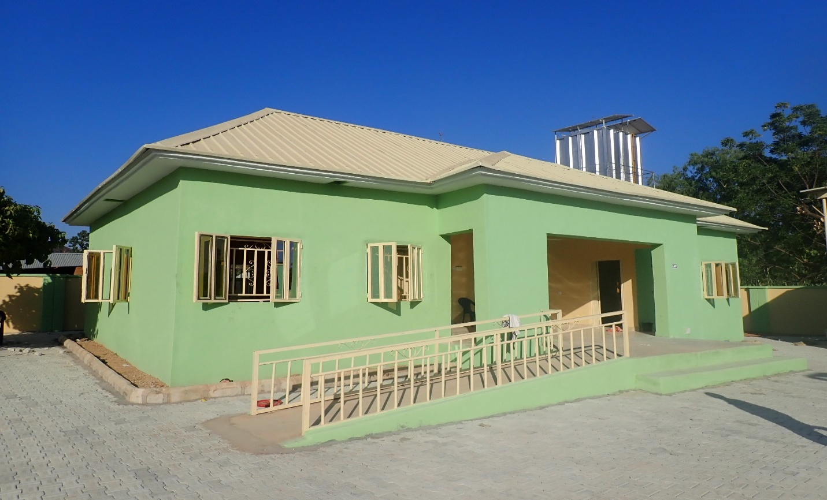Duda PHC_Re-construction of PHC building

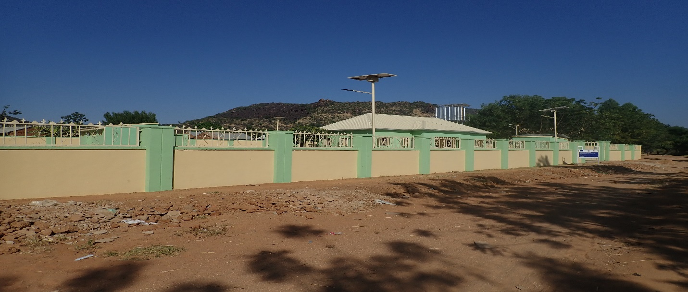Duda PHC_Fence

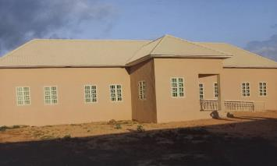GSS Maiha Girls Hostel

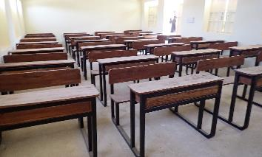GSS Maiha Rehabilitation of classroom block and furniture Supply

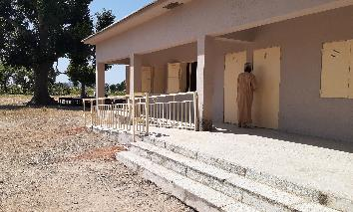Kwa Primary School construction of classroom block

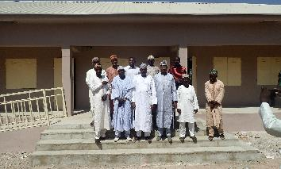
Kwa Primary School
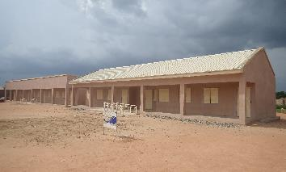
Rehabilitation of classroom blocks at Maksha Primary School

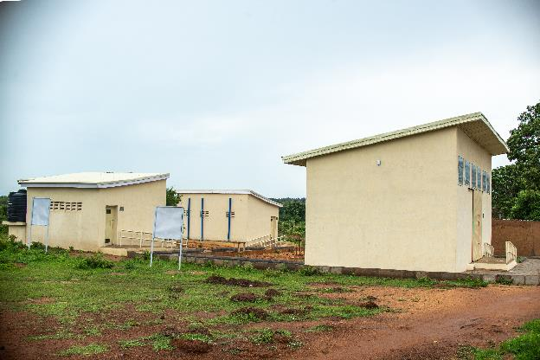
Dafura community storage facility and VIT toilet

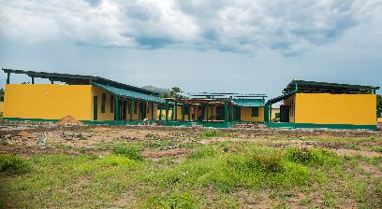
Domayo Primary School front view

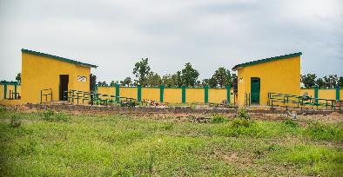
Domayo Primary School VIP Toilet

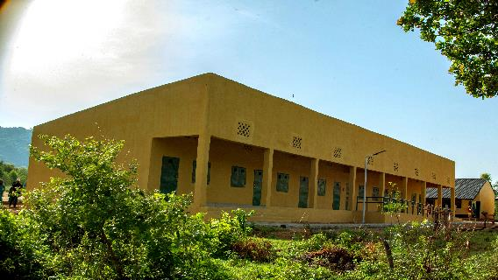
Duda Primary School, classroom block front view

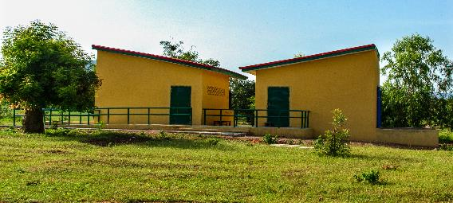
Duda Primary School VIT Toilets
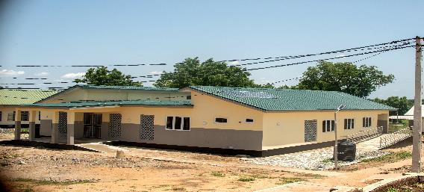 Garkida General Hospital Maternity Ward

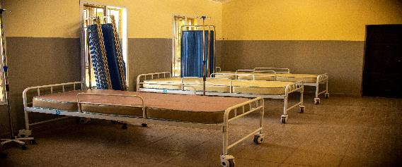 Garkida General Hospital Maternity Ward Internal View
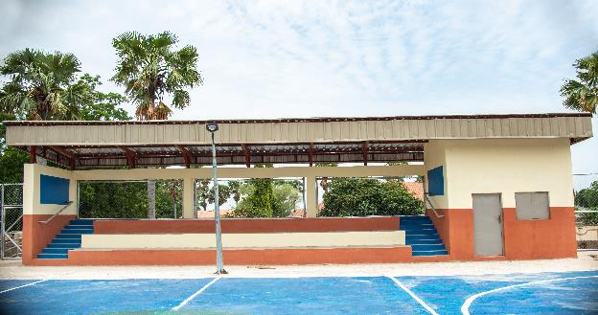EYN Garkida sportfield spectator stand

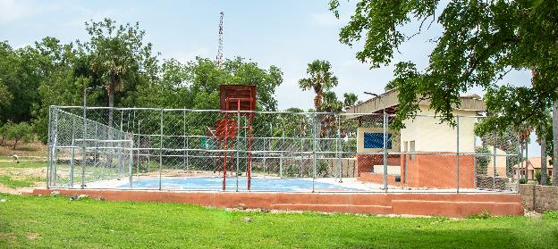EYN Garkida sportfield spectator stand
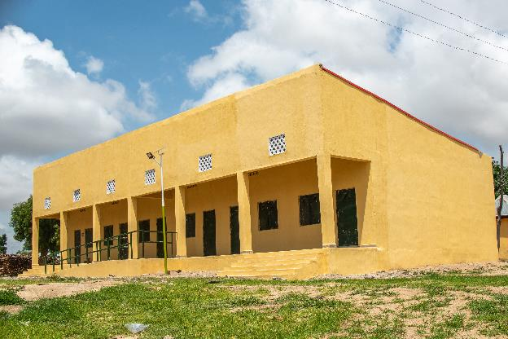Gaya Primary School classroom block

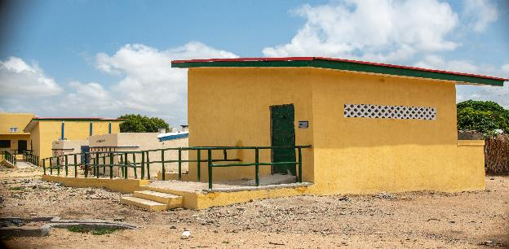Gaya Primary School VIP Toilet
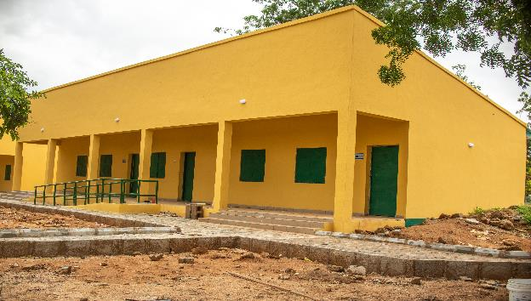GDSS Bawo Hosere classroom block

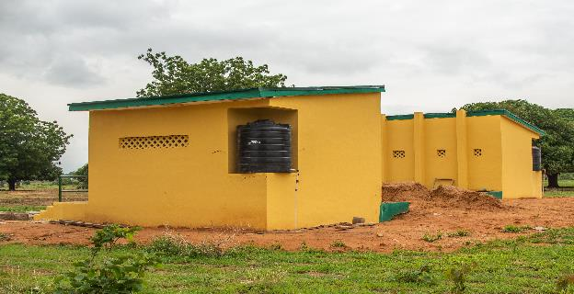GDSS Bawo Hosere VIP Toilet blocks

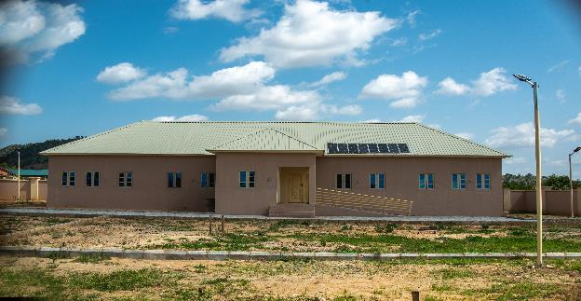GSS Maiha Boys Hostel block

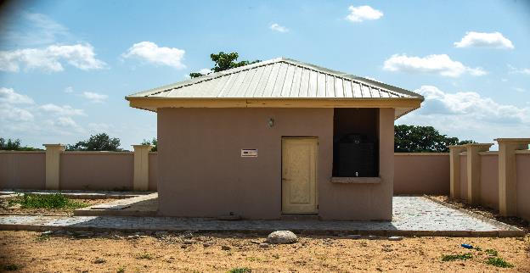GSS Maiha Kitching block

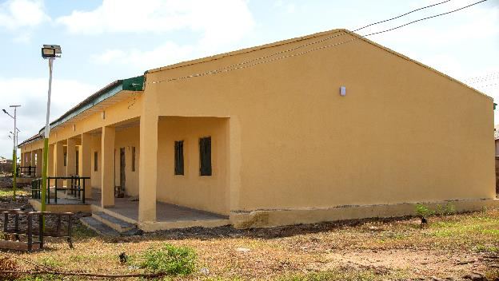Gella 1 Primary School rehabilitation of two classroom block

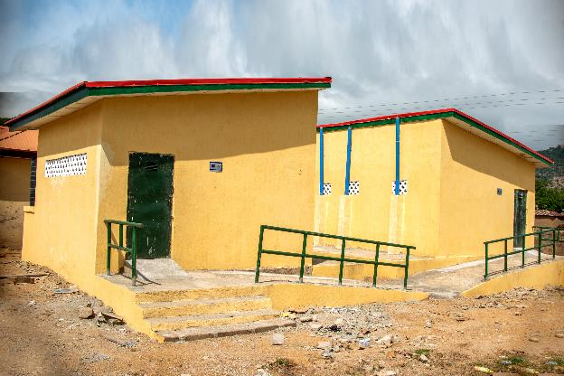Gella 1 Primary School, VIP Toilet block
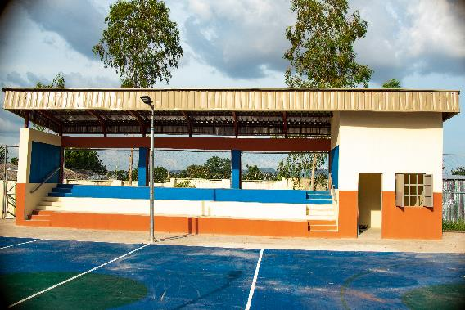Gerei ASD Sporfield

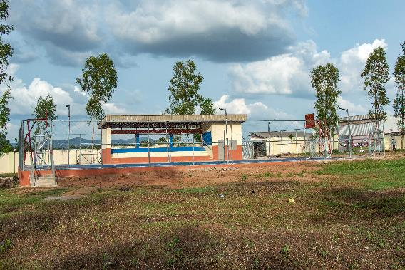 Gerei ASD Sporfield
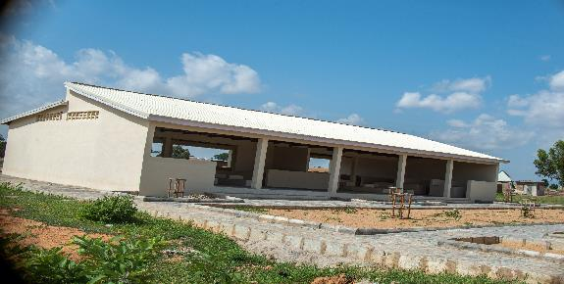 Hubare market shed

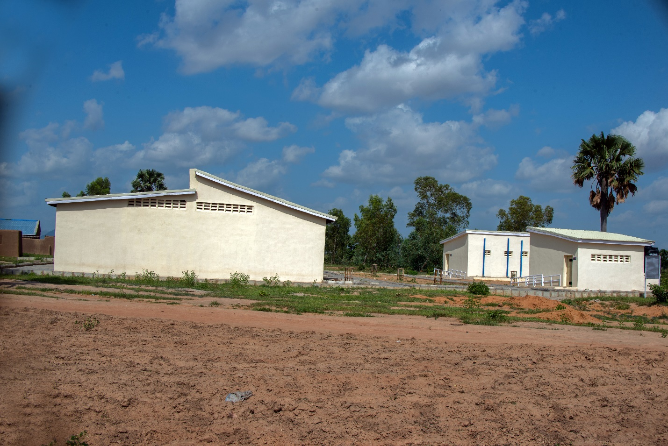Hubare market shed and VIP Toilet
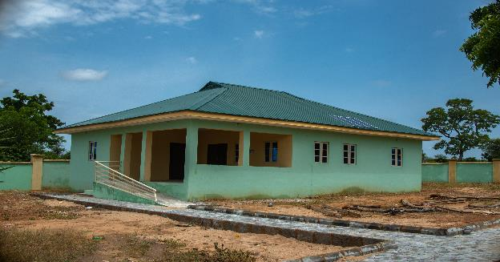Lugga PHC

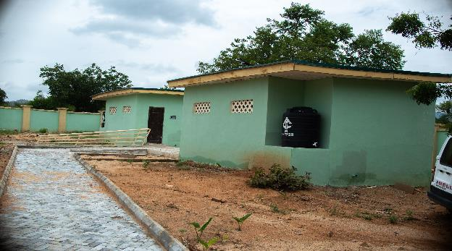Lugga PHC VIP Toilets
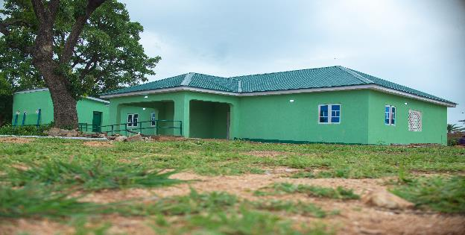Magara PHC block

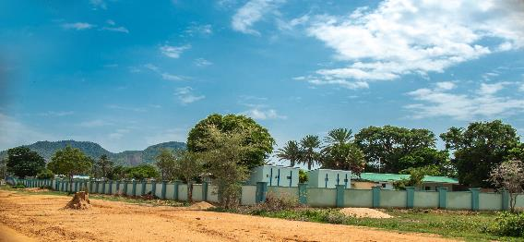 Maiha Gari PHC construction and VIP Toilet construction

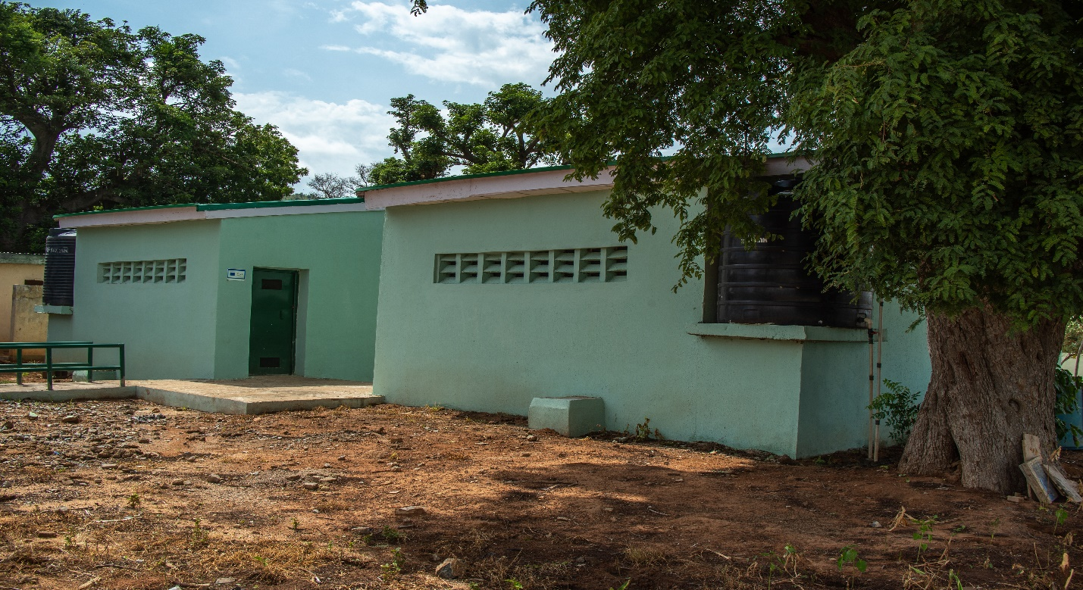Maiha Gari VIP Toilet construction

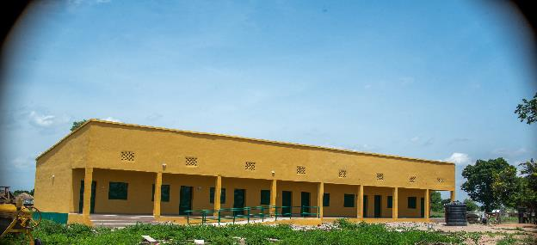Masagala Primary classroom block construction

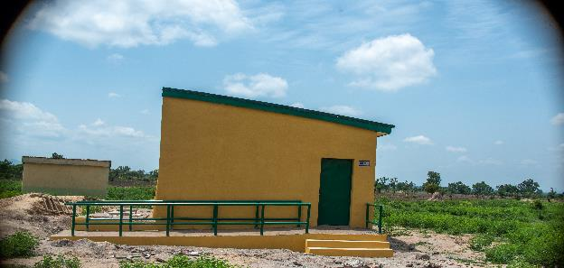Masagala Primary VIP Toilet block construction
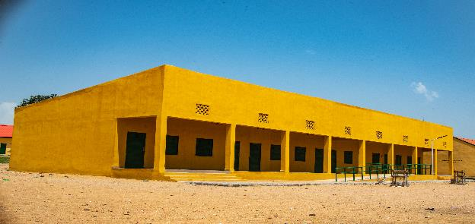Mubi II Primary School new construction of 3 classroom block, store and office
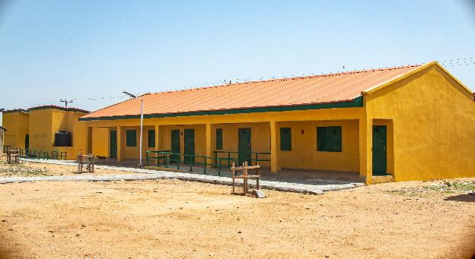Mubi II Primary Rehabilitation of classroom block and office
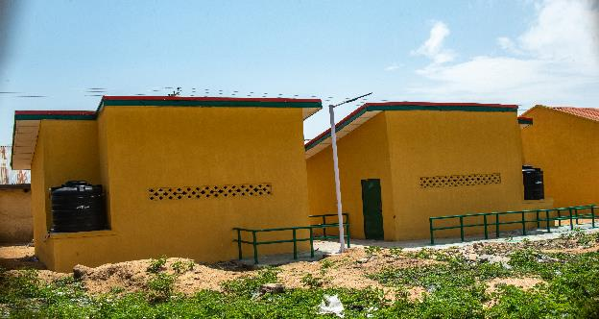Mubi II Primary Construction of VIP Toilet

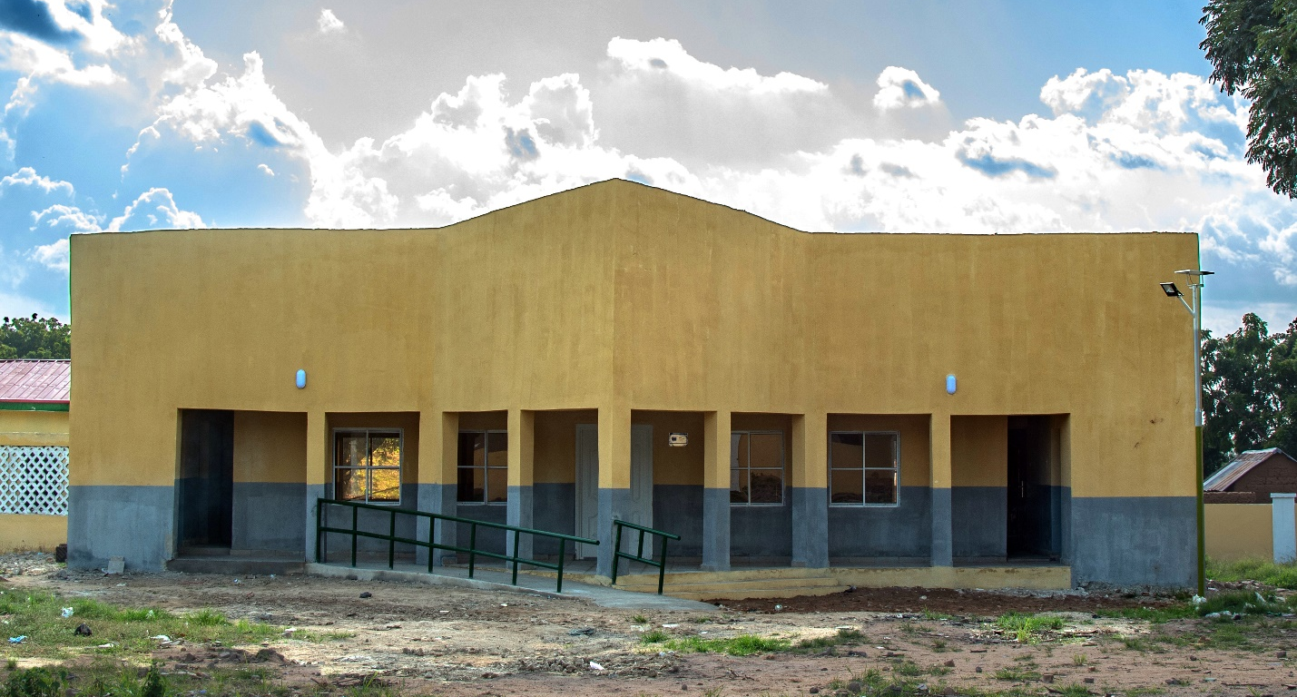Nduku PHC rehabilitation of PHC building block
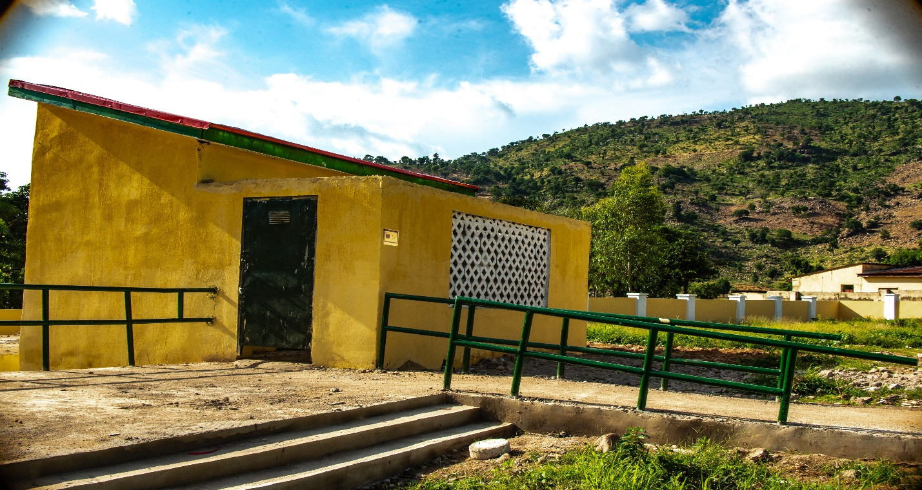Nduku PHC building construction

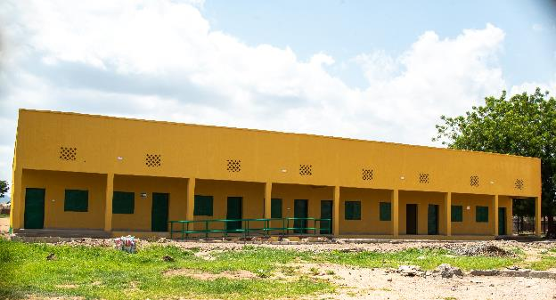Ombel Primary School Construction of 3 classroom blocks and offices
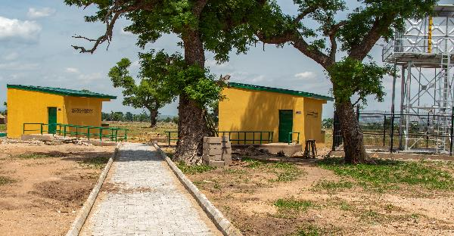Ombel Primary School – Construction of VIP Toilet block

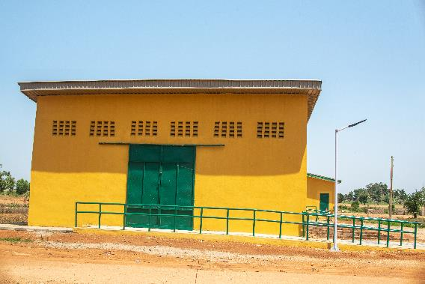 Ribawa Central Market_Construction of 2 storage facility_Front view

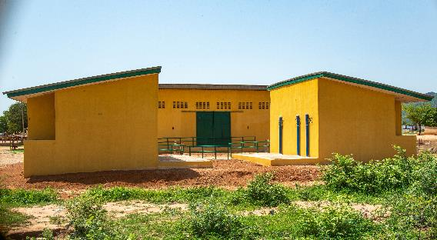 Ribawa Central Market _Construction of VIP Toilets
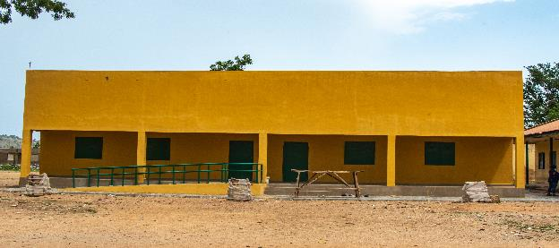
Sabon Pegi Primary School, re-construction of 2-classroom block
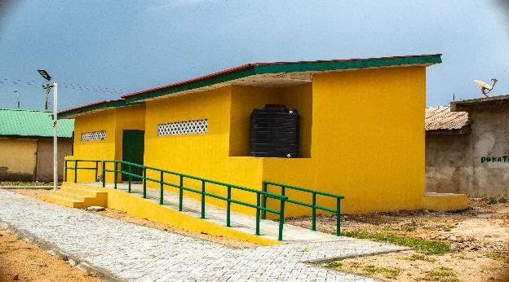Sabon Pegi Primary School _Construction of VIP Toilets

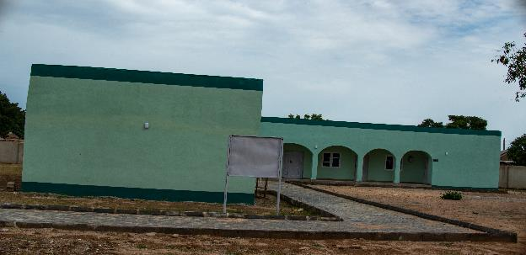 Vokna PHC_Rehabilitation of PHC Building

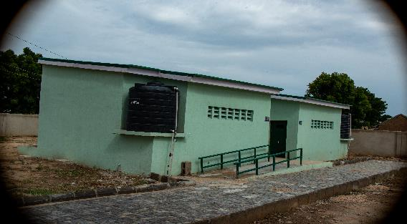 Vokna PHC_Construction of VIP Toilet block

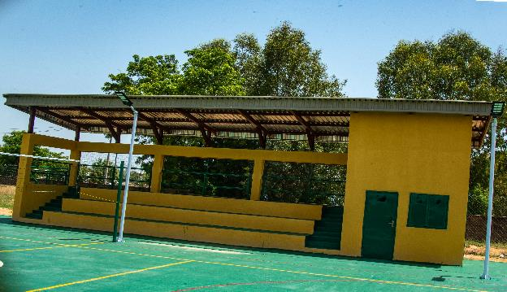Barama VTTC_Construction of spectator stand
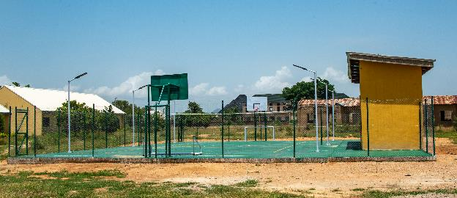Barama VTTC_Construction of multi_sport field complex

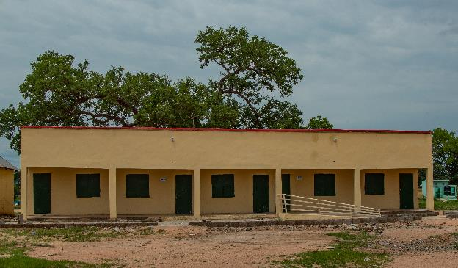Wuro Ladde Primary School Re-construction of 2-classrooms and office_Front view

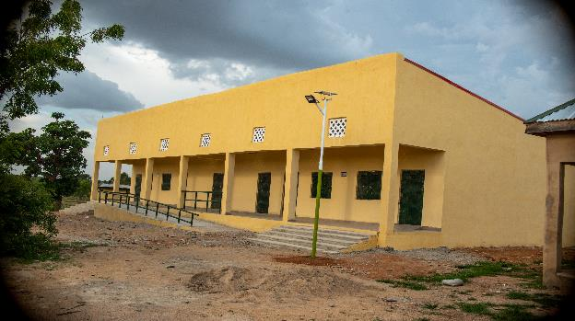Yadafa Nomadic Primary School_Construction of Two Classroom block and office Front View

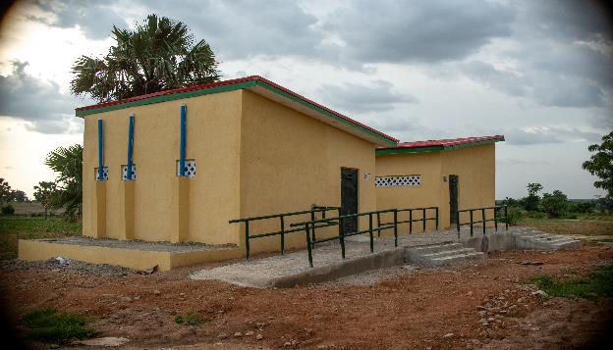
Yadafa Nomadic Primary School_Construction of VIP Toilets

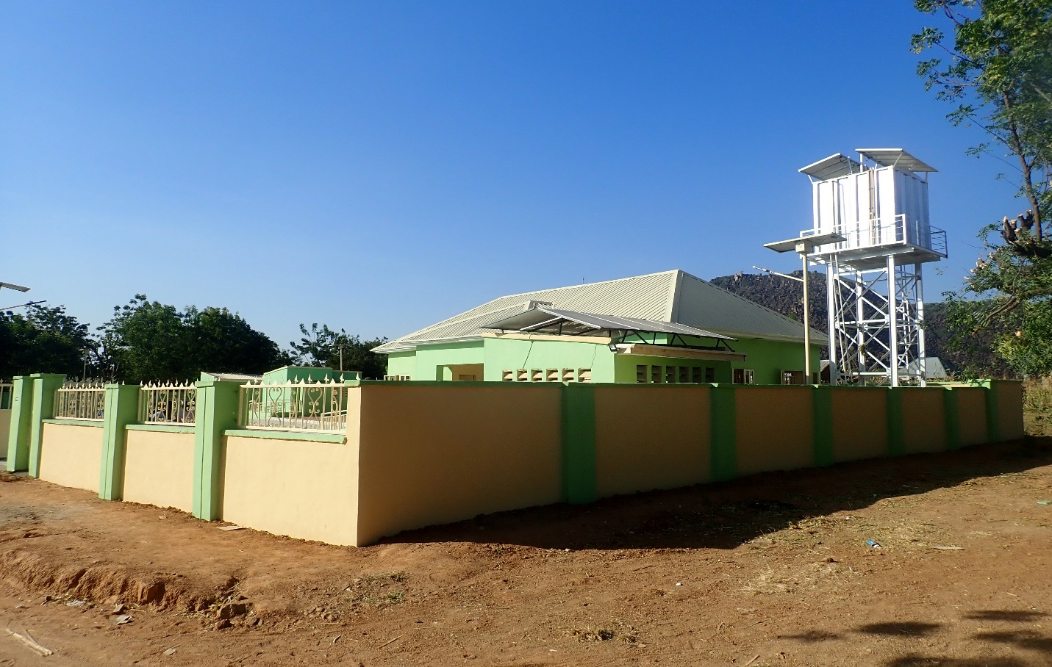Duda PHC_Solar powered borehole

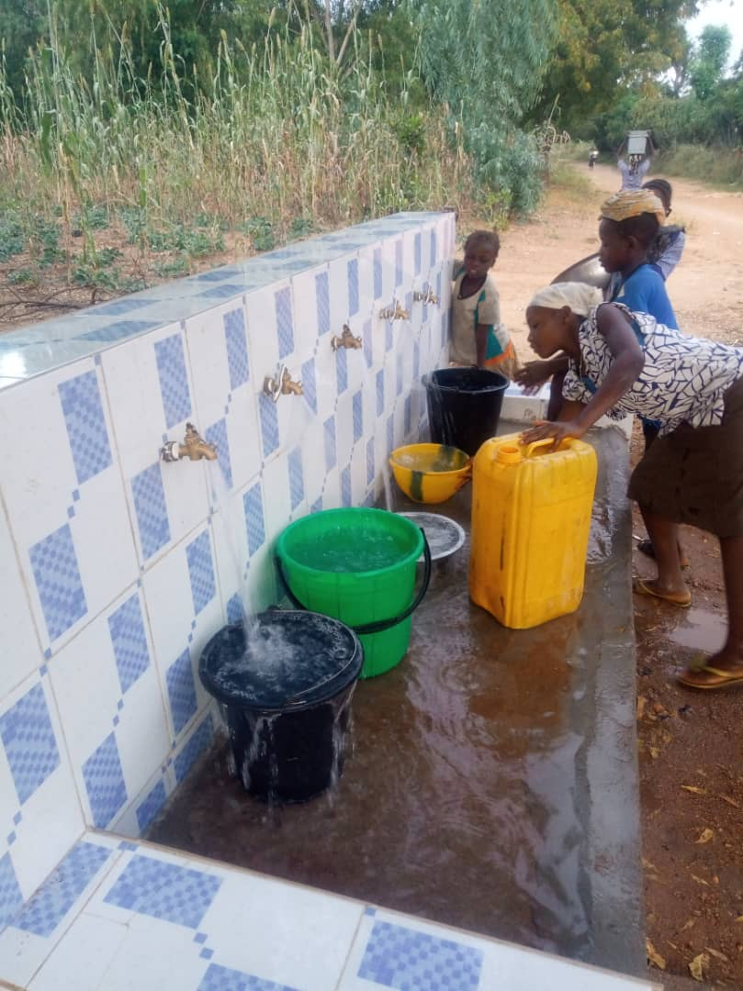Duda PHC_Solar powered borehole_Fetching point
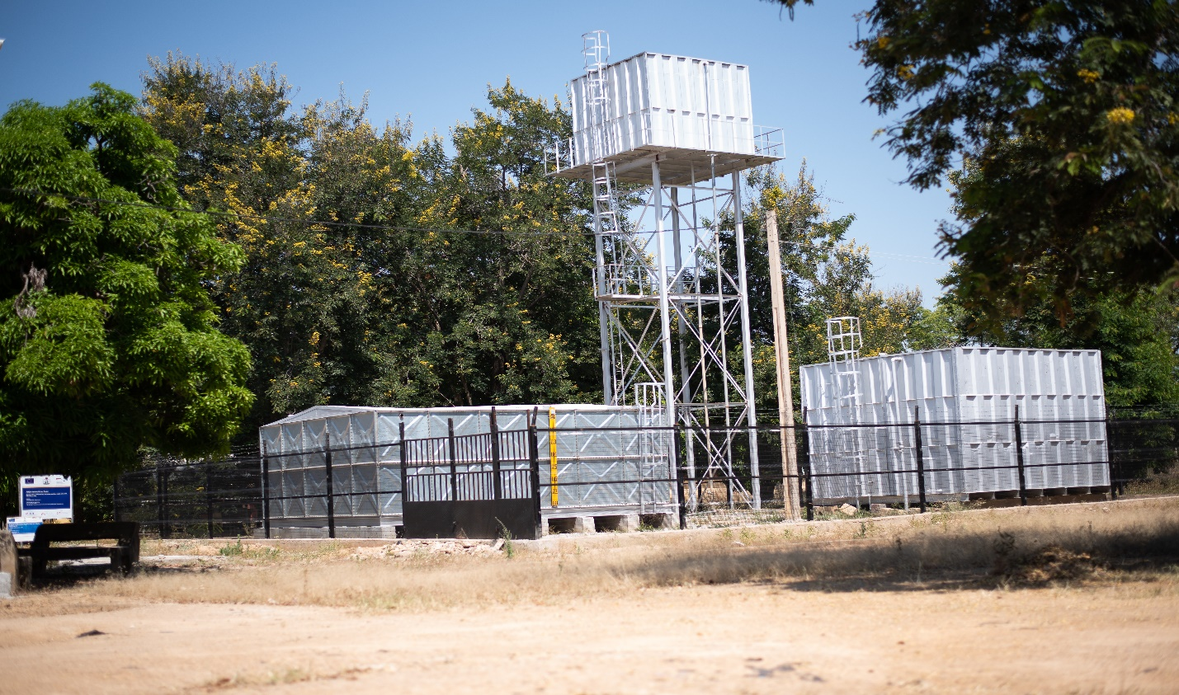
ADSU Kolere Water Point

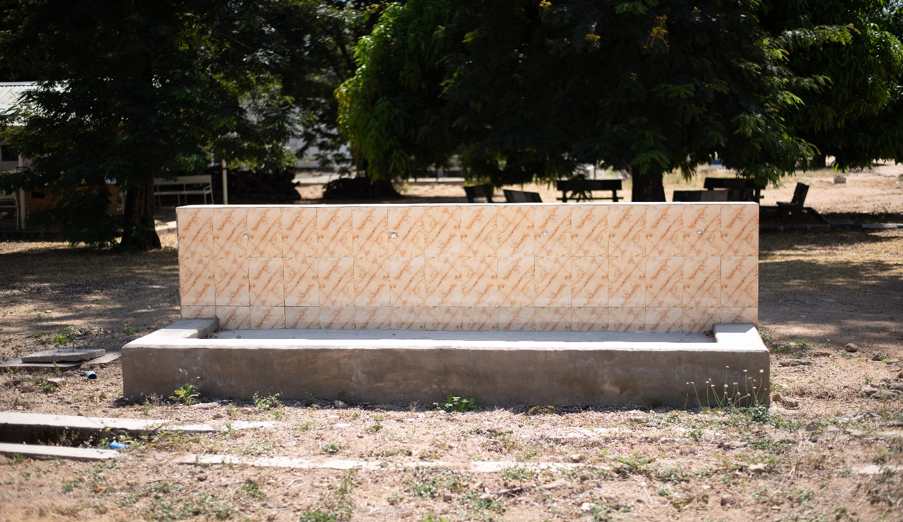
ADSU Kolere Water fetching point

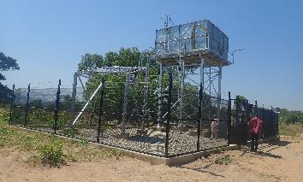
Kagii Community Solar powered borehole

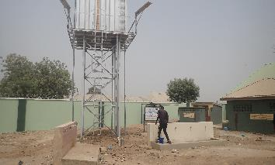
Nasarawo PHC rehabilitation of Solar powered borehole

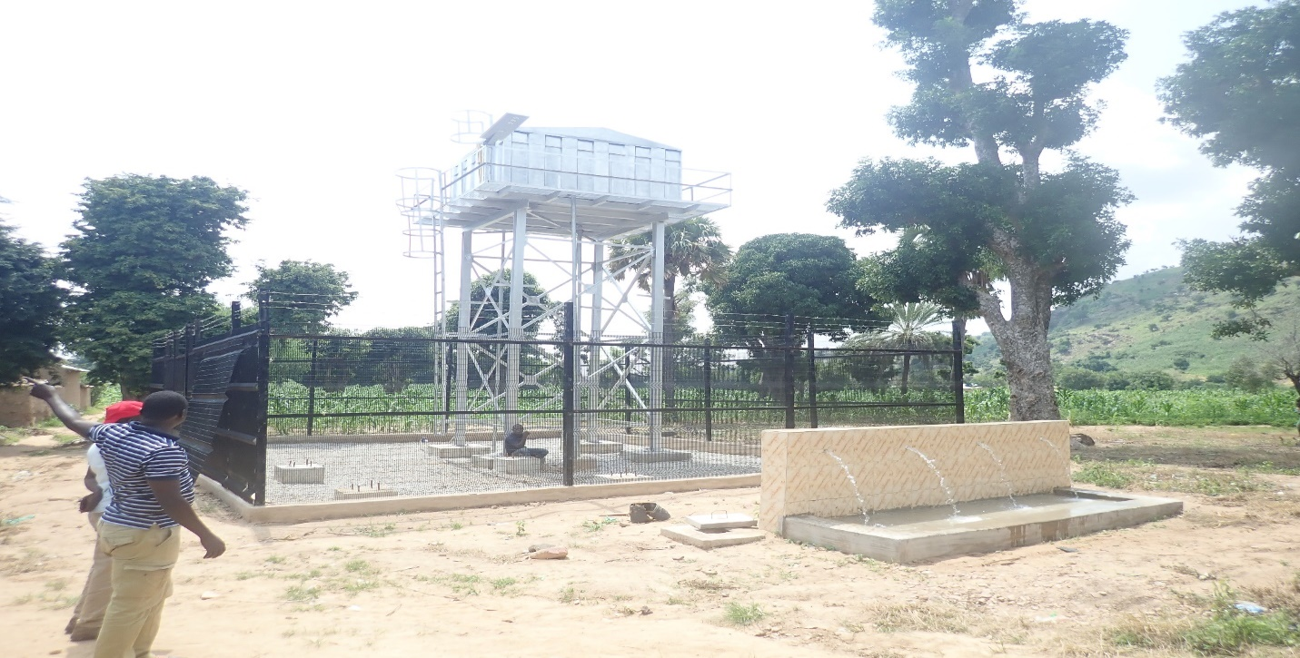
Nduku PHC solar powered borehole
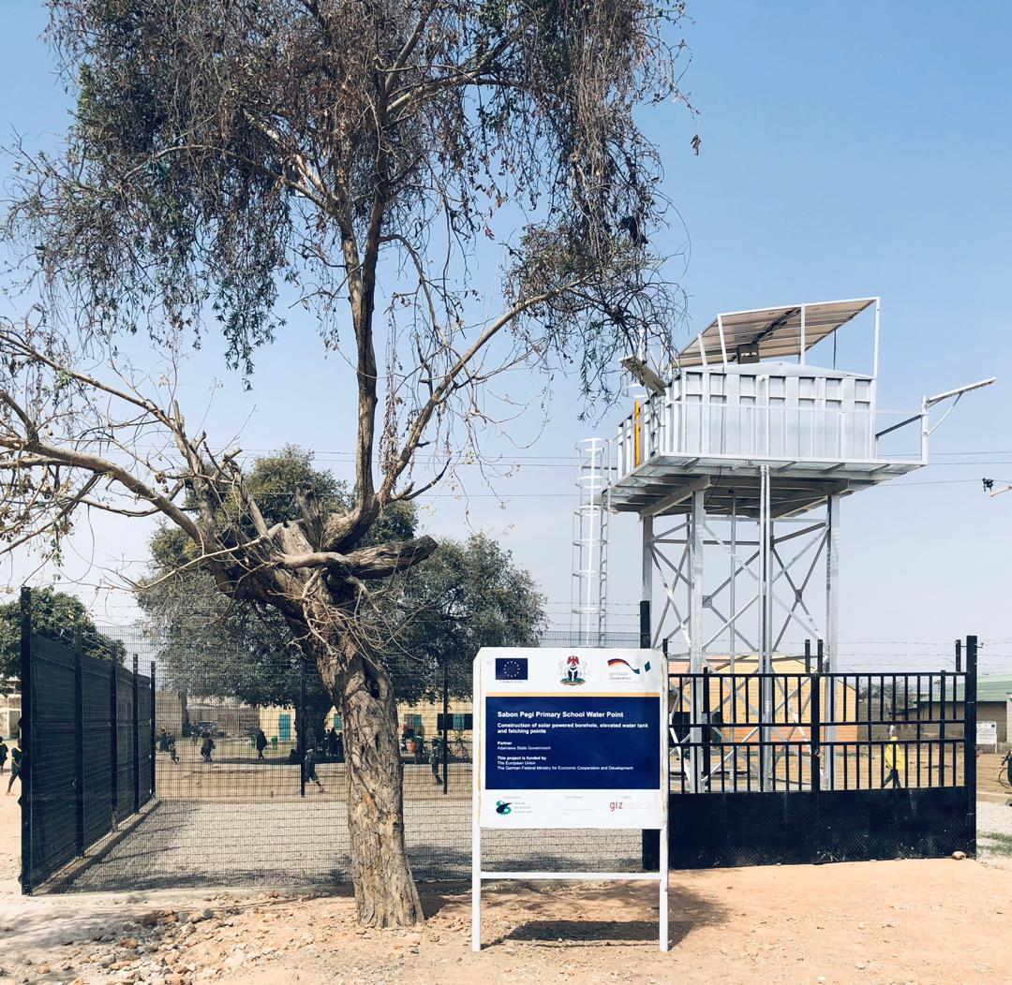
Sabon Pegi Primary School solar powered borehole
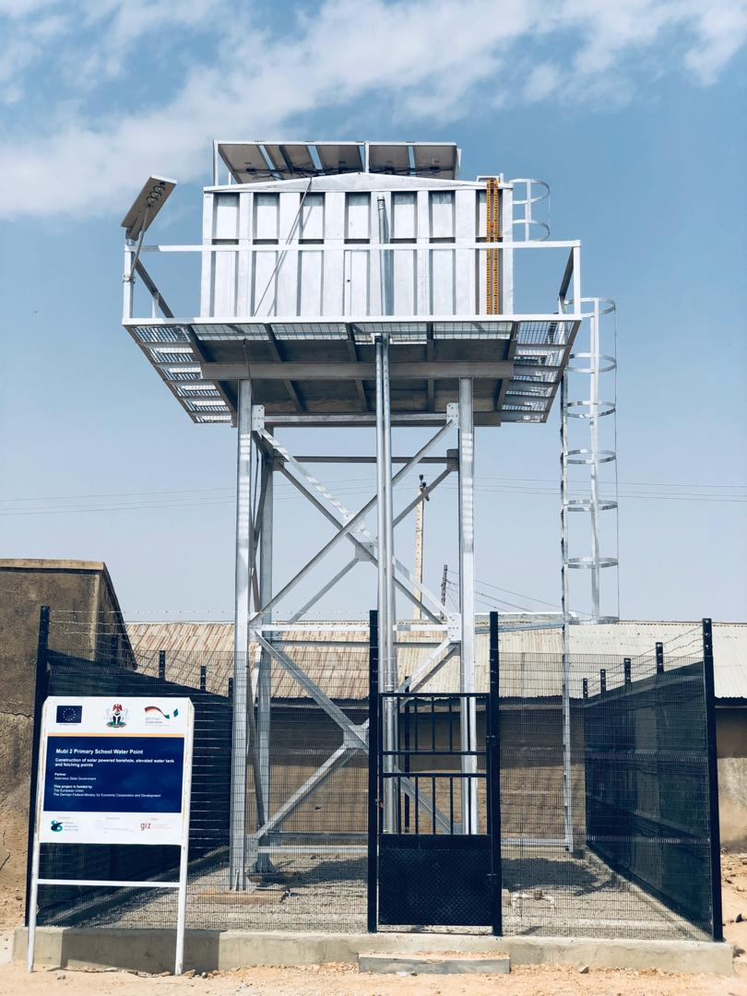 Mubi II Primary School Solar powered borehole

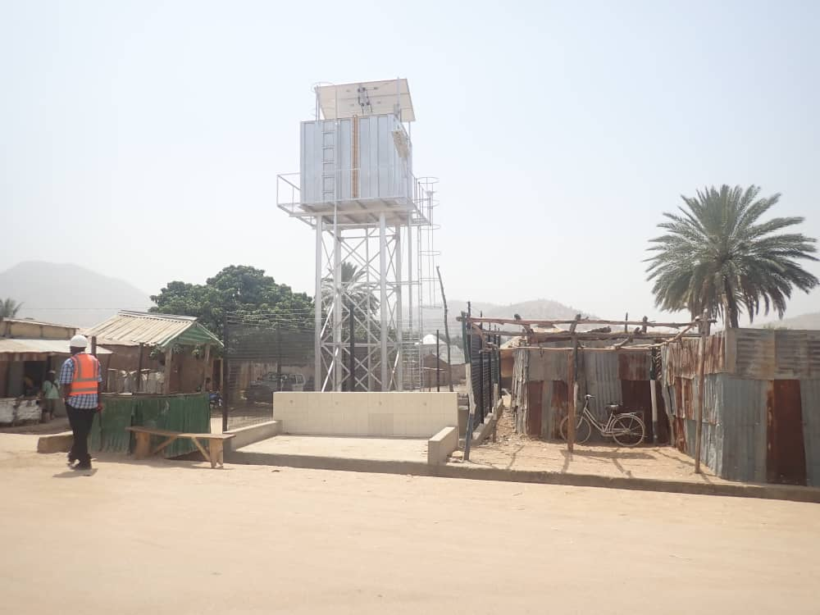
Maiha Holmare upgrading to Solar powered borehole
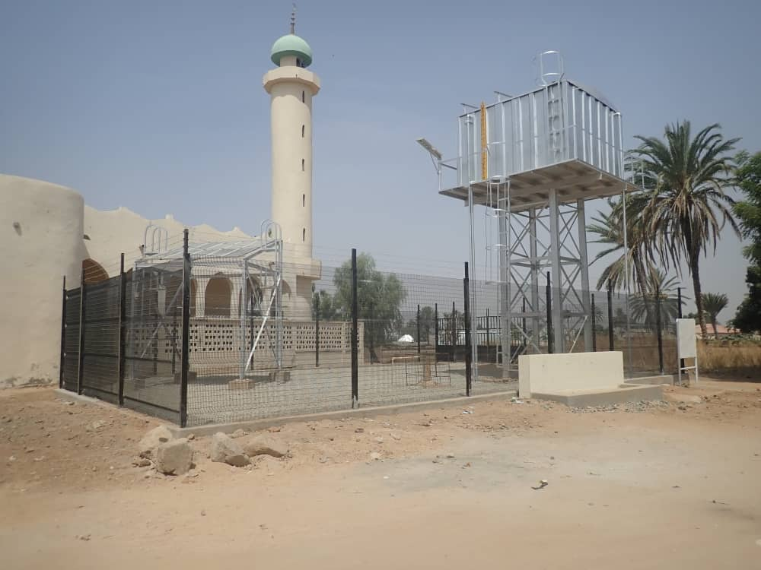
Maiha Central Solar powered borehole

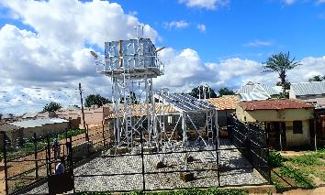
Maiha Nguli Solar powered borehole

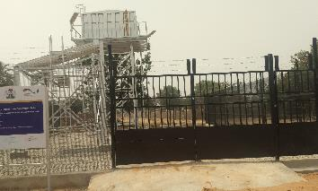
Vokna PHC Solar powered borehole
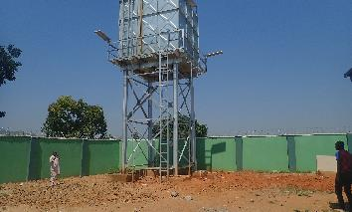
Hubare PHC Solar powered borehole

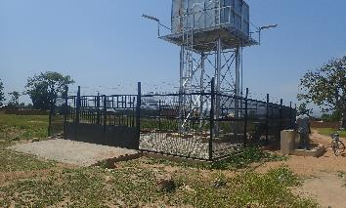
Mbalagi community solar powered borehole

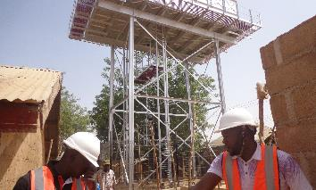
Muva market upgrade to solar powered borehole

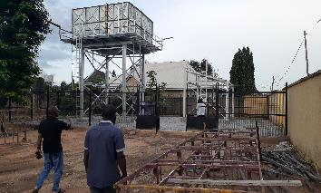
ADSU 02 Solar powered borehole

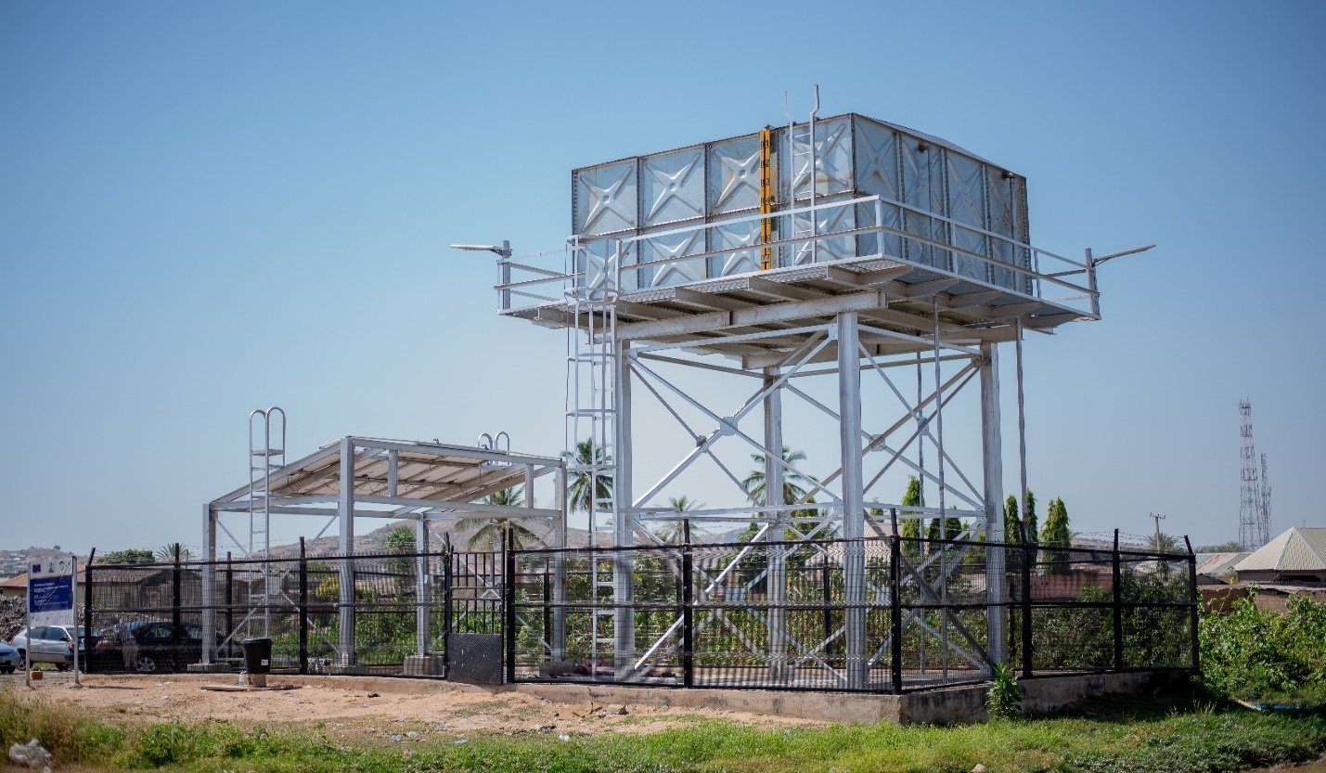
Mubi Central Solar Powered borehole
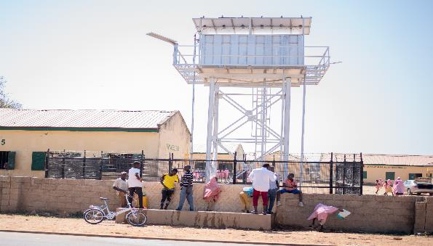 Lokuwa 1 Primary School solar powered borehole

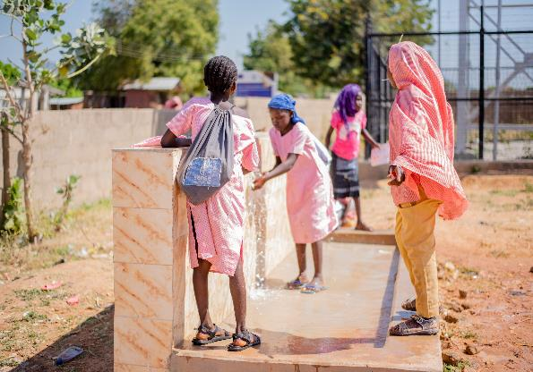
Lokuwa 1 Primary School WP_Fetching point
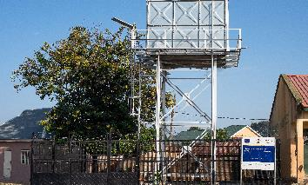
Lokuwa 2 Primary School solar powered borehole

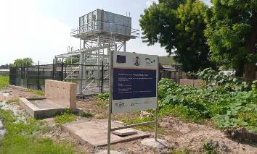
Garkida General Hospital solar powered borehole
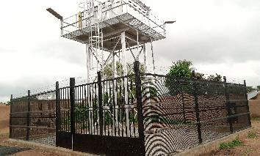
Gahiga Prayel solar powered borehole

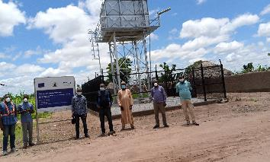
Anguwan Hijira community solar powered boreholes

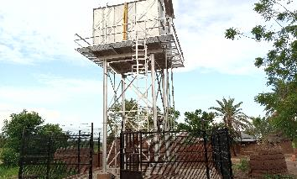
Yelwa-Belel community solar powered borehole

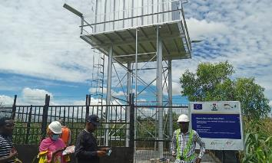
Ribawa Central market solar powered borehole

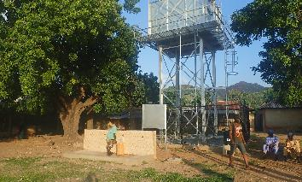
Bamila-Koma community solar powered borehole

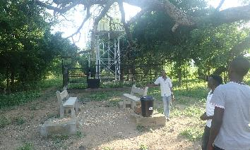
Duga community solar powered borehole

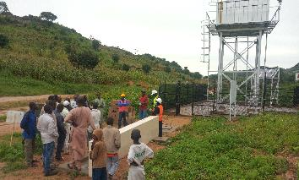
Girinburum community solar powered borehole

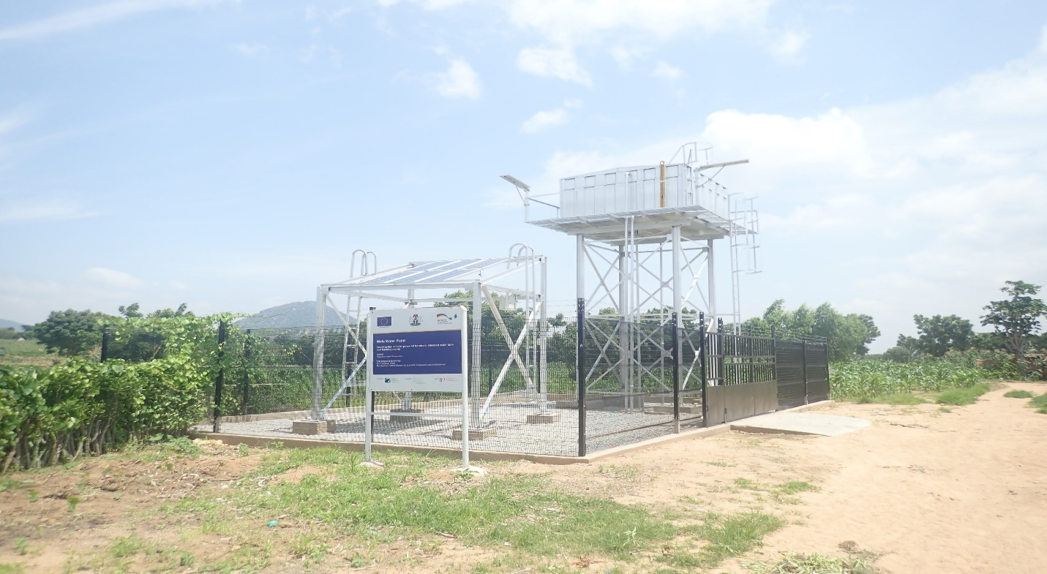
Wafa community solar powered borehole
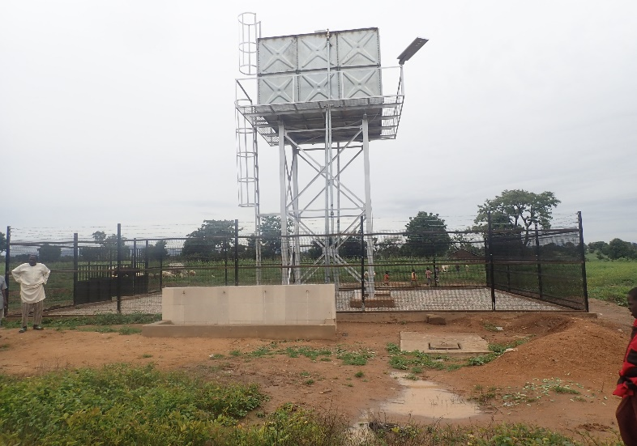
Gripa community solar powered borehole

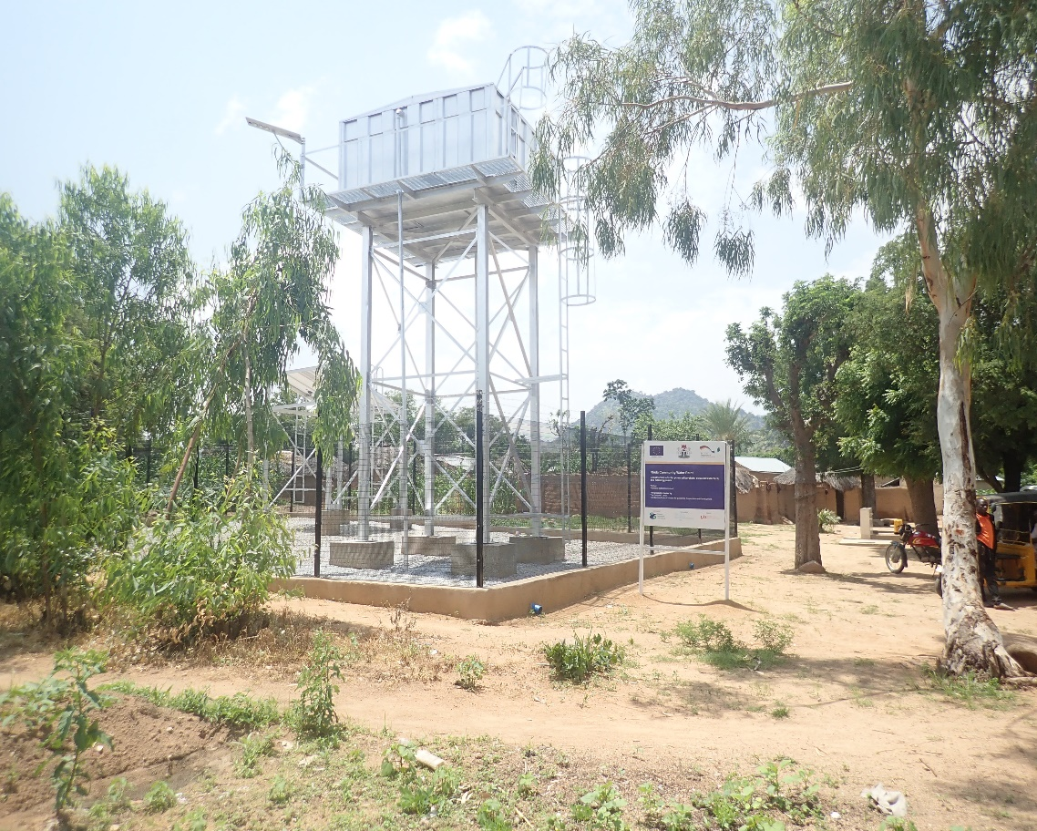
Rinda Community WP

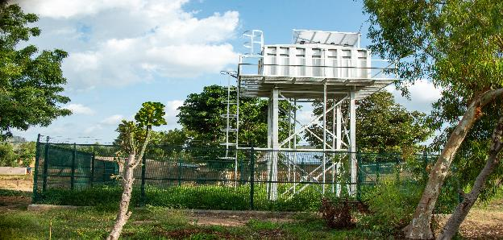Aiwa Pela water point (WP)
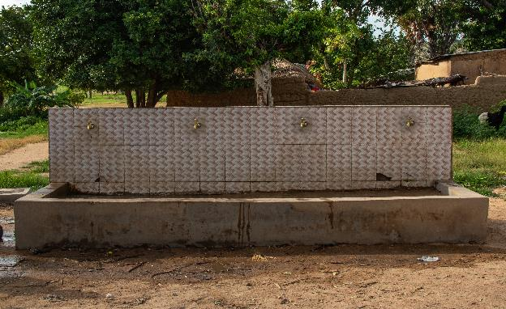Aiwa Pela water point (WP)_Fetching point
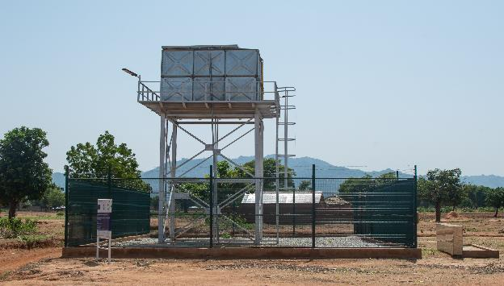Anguwan Forest WP
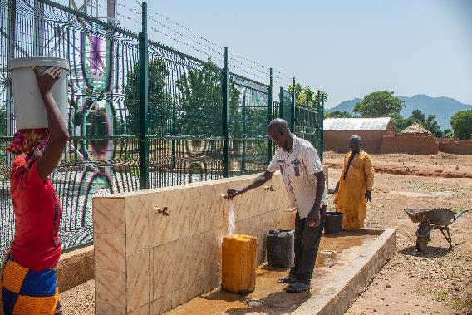Anguwan Forest WP_Fetching point
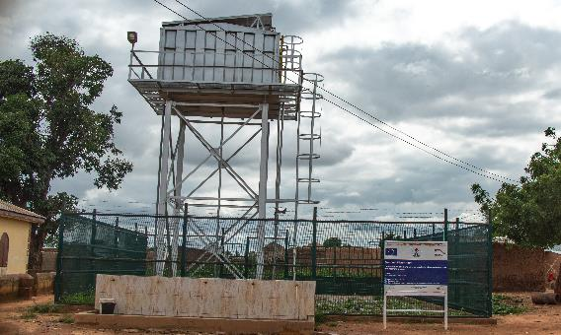
Basulum community Water Point

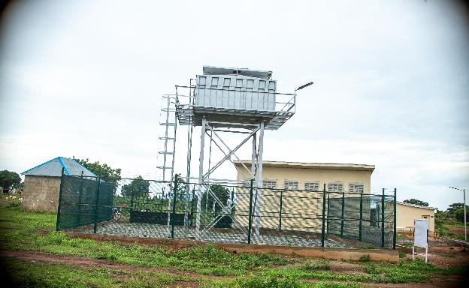Dafura storage facility WP
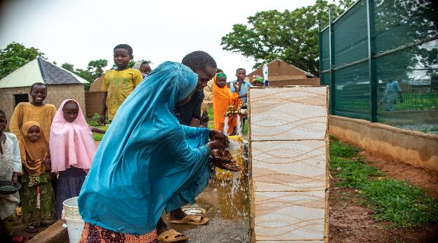Dafura storage facility WP_Fetching point

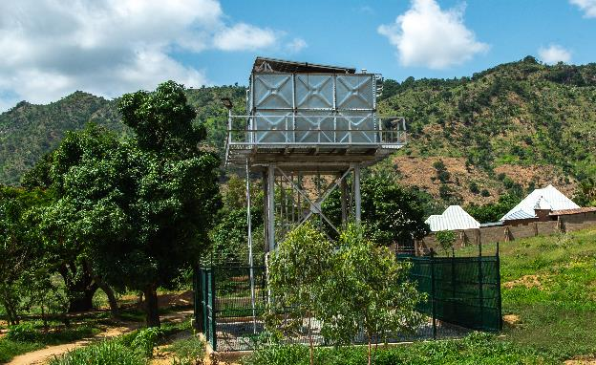Dede storage facility WP_Fetching point
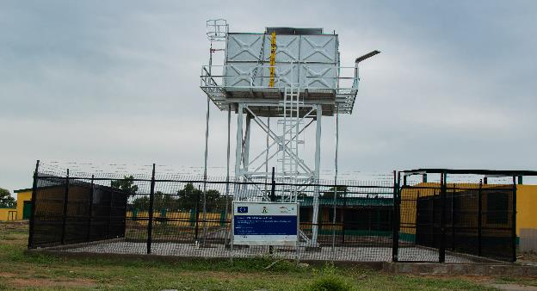
Domayo Primary School_WP

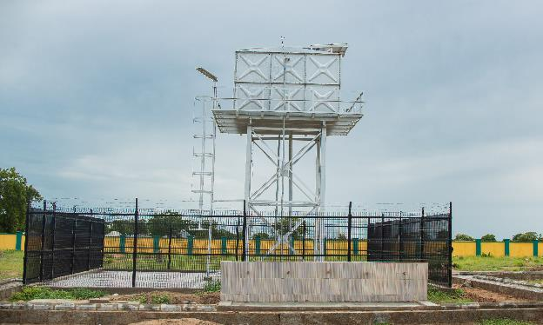Domayo Primary School_WP_Fetching point
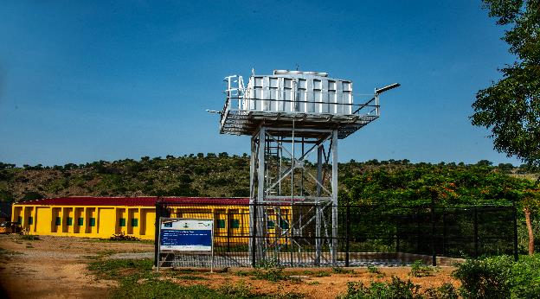Duda Primary School_Water Point

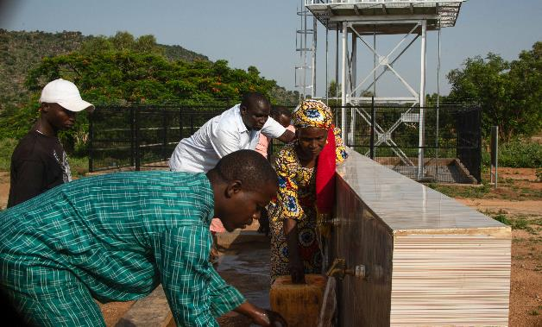Duda Primary School WP_Fetching point
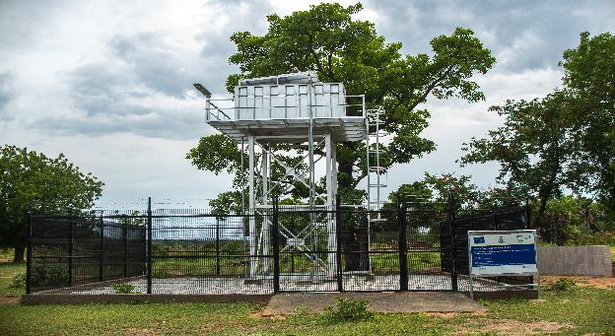GDSS Bawo Hosere WP

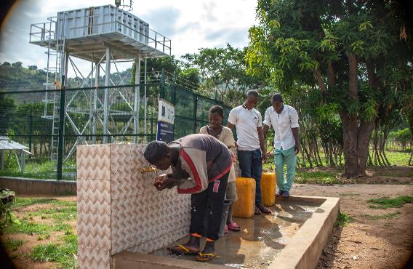 Giragira community water point
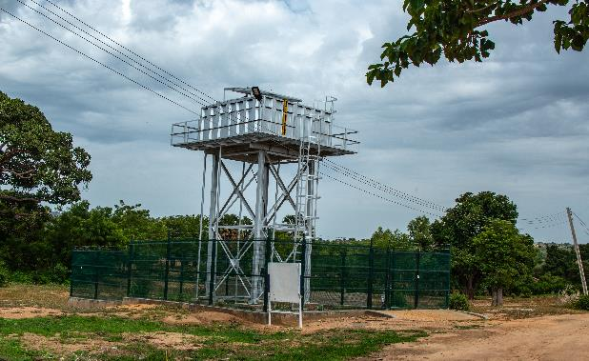Kalari Community WP

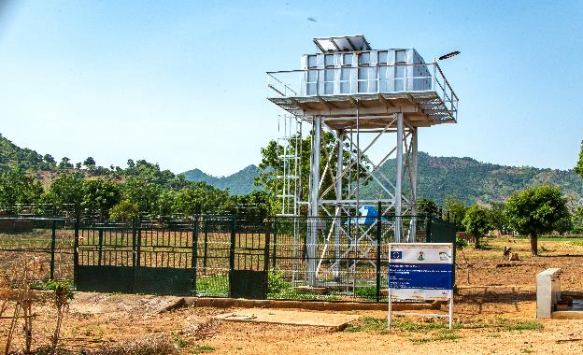Kwashikini PHC WP

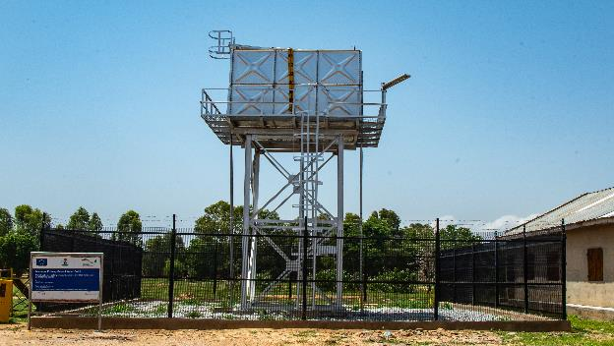Madanya Primary School Water Point

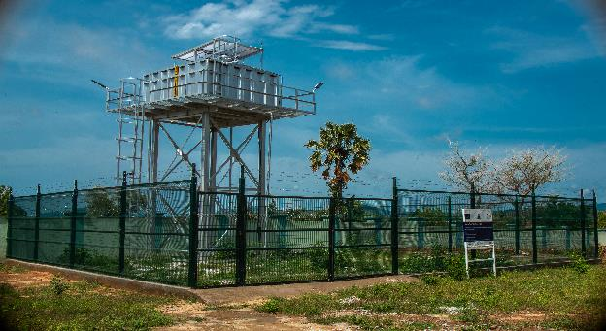Maiha Gari PHC WP
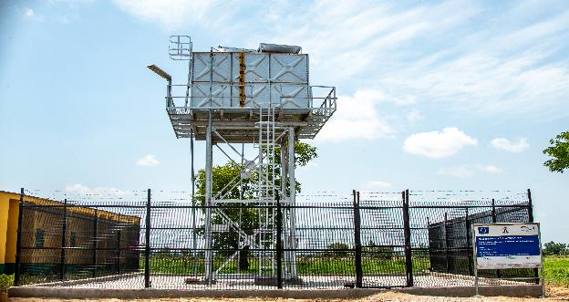Masagala Primary School Water Point

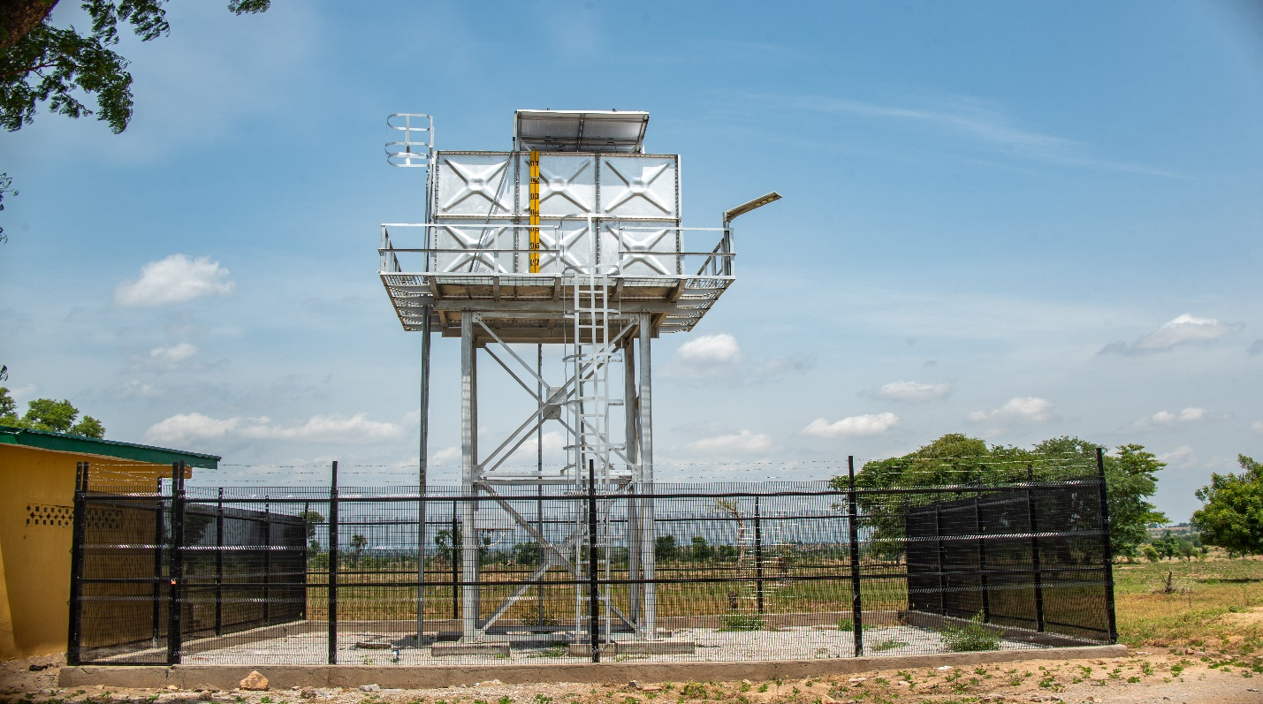Ombel Primary School Water Point
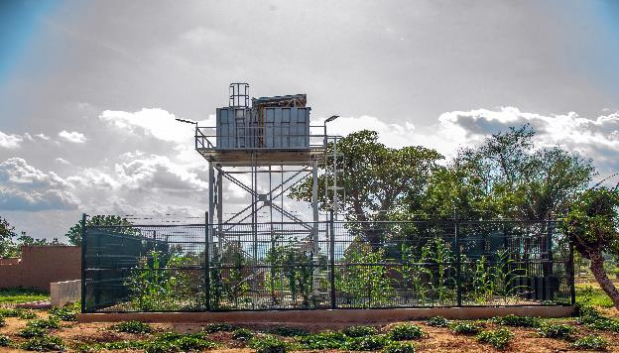Pegin Community Water Point

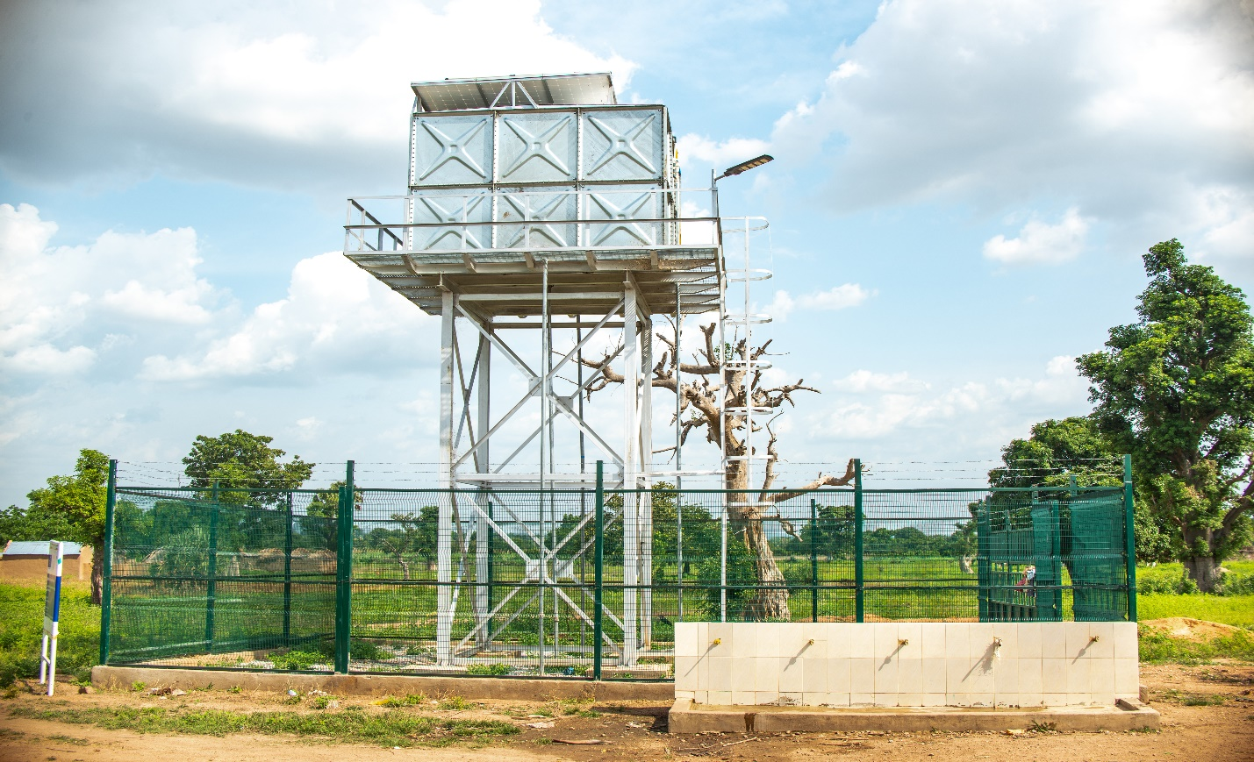Pette community_Water point
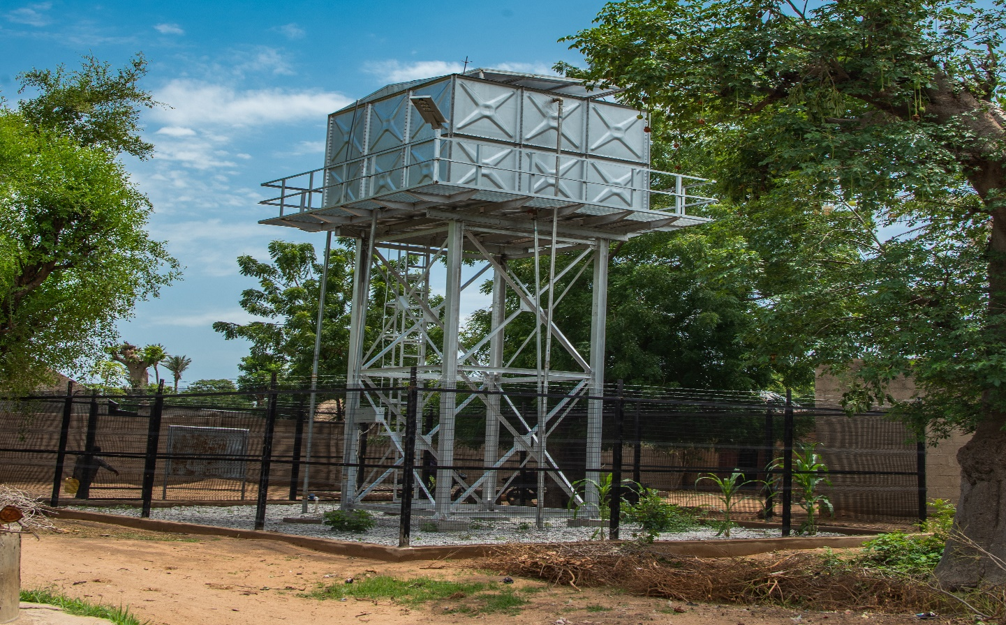Wuro Alhaji community WP

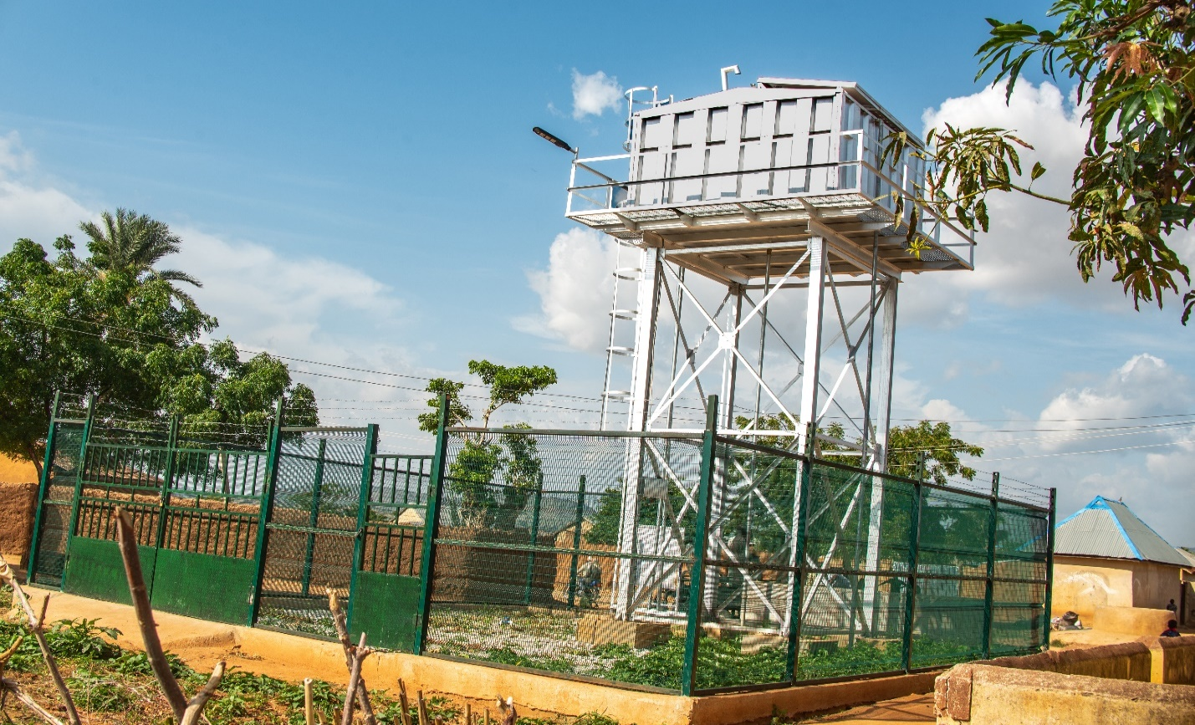Wuro Jabbe community WP
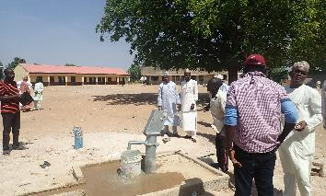
Kwa Primary School Handpump

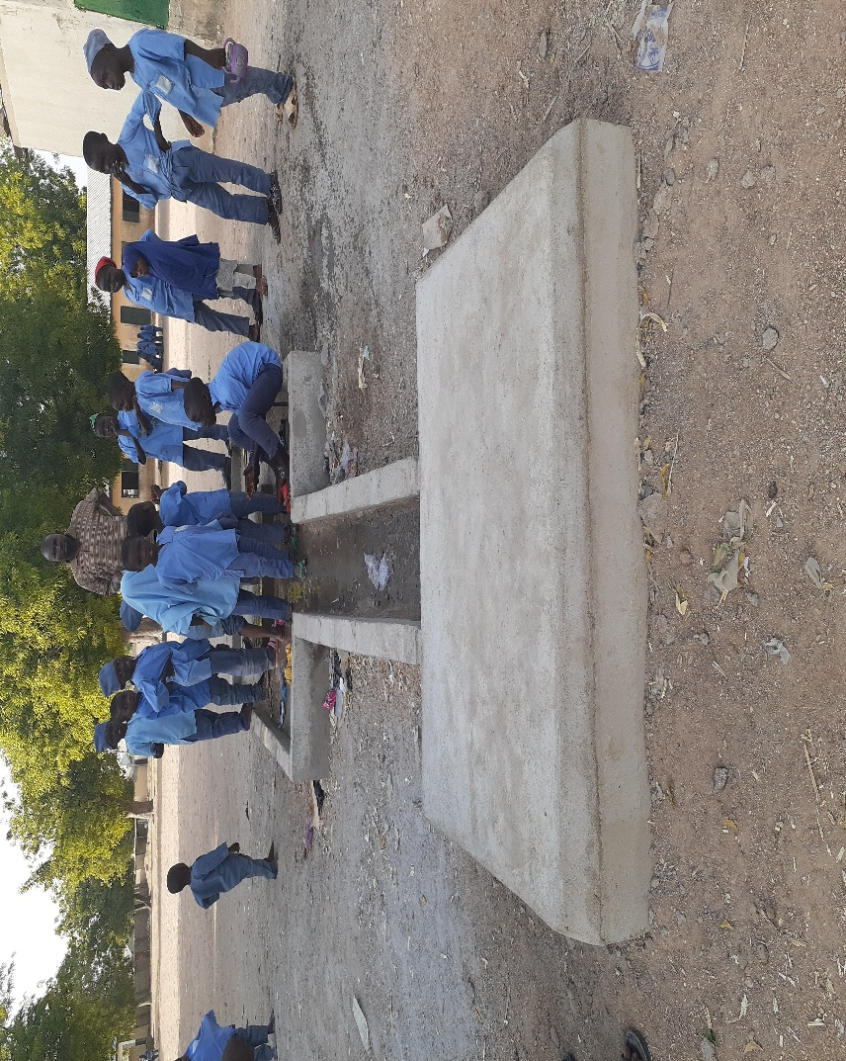 Gaya Primary School Handpump
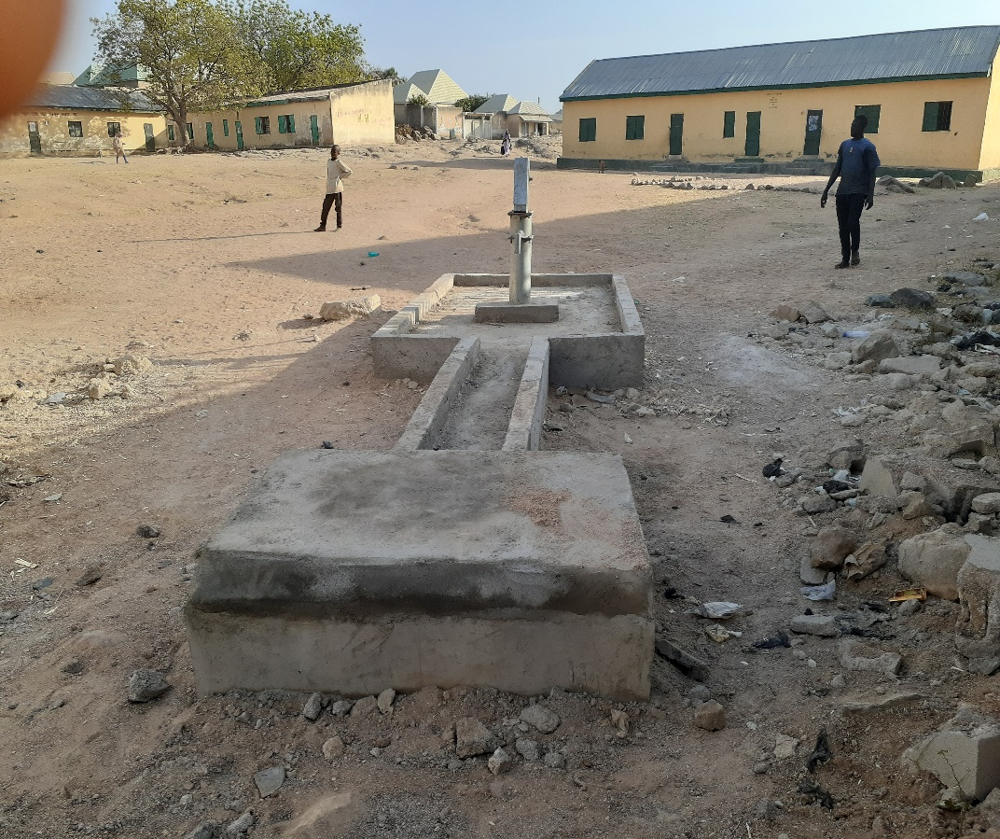 Nasarawo Primary School Handpump

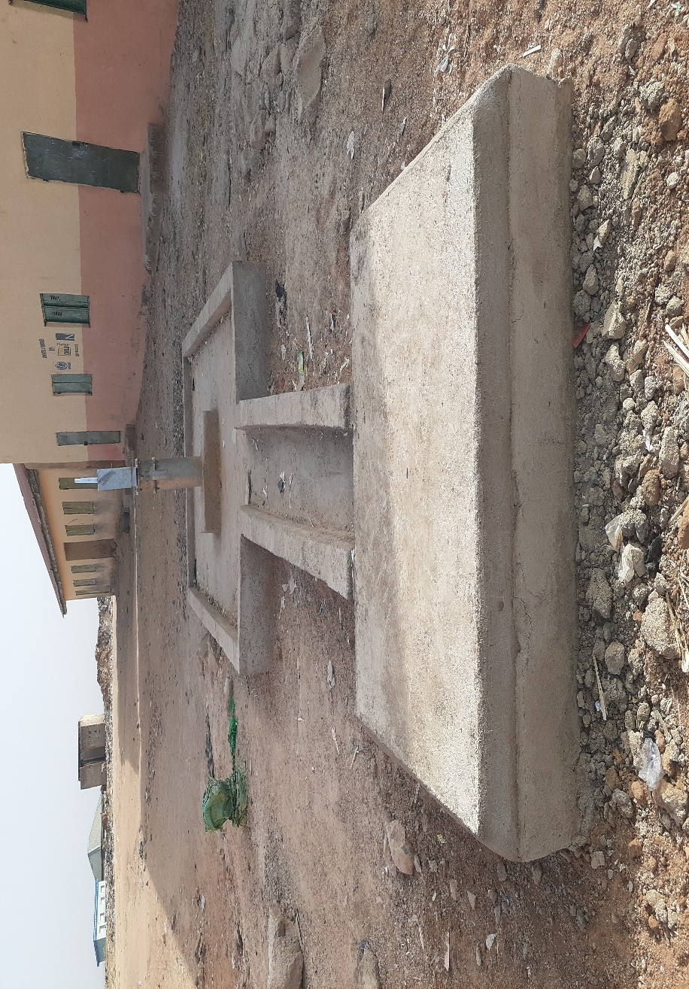
Wuro Patuji Primary School Handpump borehole
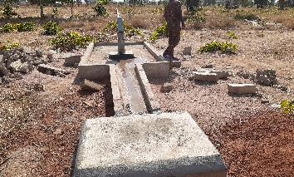
Yadafa Nomadic Primary School Handpump

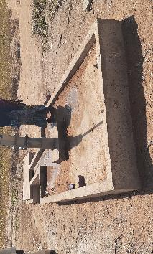
Magara PHC Handpump

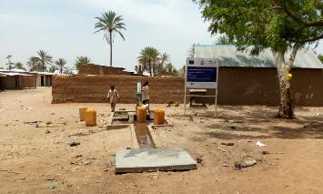
Wuro Ladde Primary School Handpump

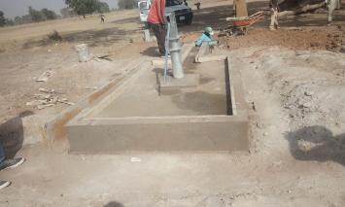
Kuna Vinde Primary School Handpump
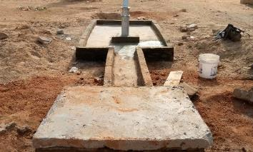
Bahuli Primary Handpump

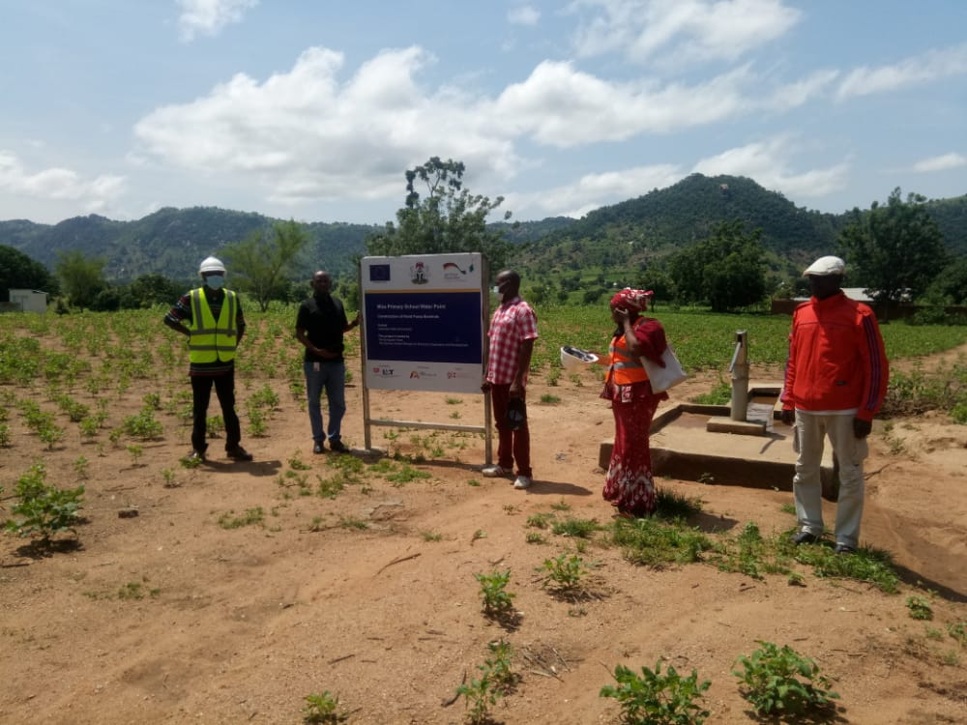
Miza Primary Handpump

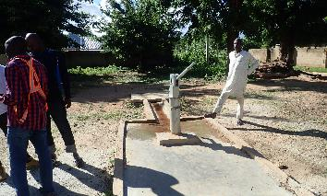
Ligudira Kwalavaya Handpump

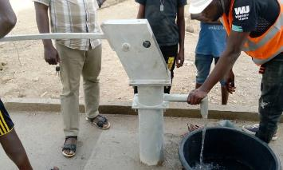Shafa community Handpump

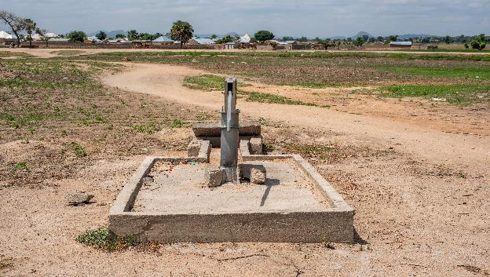Jauro Musa_Belel Handpump

