

UPDATE ON THE PROJECT ACTIVITIES IMPLEMENTED IN ADAMAWA STATE

REPORTING PERIOD: APRIL - JUNE 2025

TARGETED ACTIVITIES FOR THIS PERIOD:
NTDs:
Give Well Schistosomiasis and Soil-Transmitted Helminths (STH) Mass Drug Administration
- Planning meeting for Pre TAS in 9 LGA April-2025
- Training of (Electronic Data Managers
Card Readers, and laboratory scientist) for Pre TAS May-2025
- Treatment Assessment Survey in 9 LGAs April-2025
- Data Validation for Pre-TAS April-2025
- Stakeholders briefing for Pre TAS April-2025
- School Verification for TAS 1 in 7 LGAs May 2025
- Planning Meeting for TAS 1 in 7 LGAs May-2025
- Training of (Electronic Data Managers
Card Readers, and laboratory scientist) for TAS 1 May-2025
- Data Validation for 7 LGAs TAS Data May-2025
- Treatment Assessment Survey 1 in 7 LGAs May-June 2025
- Stakeholders Debriefing for TAS 1 outcome June-2025
Foreign Commonwealth Development Office (Eliminating Lymphatic Filariasis in Africa)
- Comcare Data facility Assessment data cleaning April-2025
- Facility Assessment report donor submission April-2025
Bill and Melinda Gates Foundation (Onchocerciasis Entomological Survey)
- Monitoring of human landing catchers April -June 2025
- Training of human landing catchers April- June 2025
- Collection of Blackflies April & June 2025
- Sorting of Blackflies and Data validation April & June 2025

Improving the food security and nutrition of IDPs and non-IDPs in Fufore LGA

- House-to-house mid-upper arm circumference (MUAC) screening - Apr– Jun 2025
- Supervision of demonstration and home gardens - Apr – Jun 2025
- Monthly support group meetings - Apr – Jun 2025
- Supervision of village savings and loan association (VSLA) savings group meeting - Apr – Jun 2025
- Supervision and monitoring of income-generating activities (IGA) - Apr – Jun 2025
- Monthly data validation with community health workers and agricultural extension workers. - Apr – Jun 2025
- Training of Agricultural extension workers from the State Ministry of Agriculture on home gardening techniques - June 2025
- Training for project participants on Tom brown porridge preparation - April 2025
- Cooking demonstration to project participants - June 2025
- Distribution of income-generating activities items to project participants - June 2025
- Distribution of improved seed to project participants - June 2025

Transforming Lives through Nutrition (TLTN)

- Monthly support group meeting across 15 LGAs - April- June 2025
- Multiple micronutrient supplementation (MMS) - April- June 2025
- Stakeholders' advocacy visit - May 2025
- Integrated supervision of home gardens and multiple micronutrient supplementation - April-June 2025
- Cooking demonstration across 15 LGAs - April- May 2025
- LGA data validation - April- May 2025
VITAMIN A SUPPLEMENTATION:
- Maternal Newborn and child Health Week micro planning Meeting - April 2025
- MNCHW first planning Meeting - June 2025
- Advocacy Visit to 15 Emirate councils and chiefdoms - June 2025
- Community Dialogue - June 2025
- Commodity distribution from state to LGA and to facility - June 2025
- Facility data Officers training - June 2025
- MNCHW Implementation - June 2025
- Data Validation - June 2025

ACHIEVEMENT MADE TOWARDS THESE TARGETS:

The Bill and Melinda Gates Foundation
- Planning meeting for LF Pre TAS in 9: Between the 25th and 26th of April 2025, a planning meeting was coordinated by Helen Keller Intl and facilitated by staff of the Federal Ministry of Health and Social Welfare Neglected Tropical Diseases and elimination Program. The meeting involved the Executive Secretary of the Local Government Primary Health Care Development Agencies of Fufore, Ganye, Numan, Guyuk, Demsa, Sheleg, Mayo Belwa, Michika, and Gombi LGAs, along with their respective Neglected Tropical Diseases (NTDs) coordinators. During the session, the selected communities were shared with the team to facilitate targeted mobilization efforts. Presentations were delivered on Nigeria’s LF journey, highlighting the progress made, the current phase, and the roadmap ahead. The expected outcomes, roles and responsibilities, as well as the methodology and approach for the pre-TAS, were clearly outlined to ensure alignment and effective execution.
The meeting emphasized the importance of community engagement and detailed strategies to ensure mobilization of both children and adults, regardless of age and gender, to achieve comprehensive coverage. Discussions focused on fostering collaboration, clarifying roles, and setting actionable steps for a successful Pre-TAS. This strategic planning session is a vital step toward accelerating Nigeria’s progress in the fight against LF and attaining elimination targets in the affected LGAs. The participants in the meeting were 33, 18 males and 15 females.
- Training of Electronic Data Manager, Laboratory scientist, Card readers and Team lead on LF Pre TAS: Following the strategic planning session coordinated by Helen Keller Intl and facilitated by staff of the Federal Ministry of Health, a comprehensive training session on pre-TAS activities was conducted. The training targeted key personnel including Electronic Data Managers, Laboratory Scientists, Card Reader Operators, and Team Leads, with 15 participants in each category, totaling 75 participants. The participants comprised 44 males and 33 females. The four-day training program included both theoretical presentations and practical assessments aimed at enhancing capacity in field data collection, laboratory testing, and data management.

During the training, emphasis was placed on demonstrating the use of the Filariasis Test Strips (FTS) for laboratory testing, assessing the level of understanding among laboratory scientists, and providing hands-on practice in using the FTS. Participants also engaged in practical tests on capturing data efficiently using the CommCare application, including timing and data accuracy. The overall outcome was successful, as the capacity-building activities significantly enhanced the knowledge and skills of all personnel involved, thereby strengthening the team’s ability to effectively carry out pre-TAS activities in targeted LGAs.

- Pre TAS Survey: During the 10-day Pre-TAS field work implementation, a total of 18 communities across 9 Local Government Areas (LGAs) were successfully visited, covering both Sentinel Sites (SS) and Spot Check (SC) locations. The survey achieved remarkable coverage with 5,741 individuals selected from the target sample size of 5,400, resulting in 5,716 valid samples collected. This represents an impressive 99.6% validity rate with only 25 invalid samples recorded across all surveyed communities. The comprehensive approach ensured balanced representation across diverse geographic locations including Demsa, Fufore, Ganye, Gombi, Guyuk, Mayo Belwa, Michika, Numan, and Shelleng LGAs, with each area contributing both sentinel and spot check data points for robust epidemiological assessment.
The field work's success resulted from coordinated efforts led by the Adamawa State Neglected Tropical Diseases program and the Federal Ministry of Health and Social Welfare Division's Lymphatic Filariasis program offices, with Helen Keller Intl providing essential consumables and logistics coordination support. This multi-level coordination enabled comprehensive mobilization across participating Local Government Areas through systematic community engagement with village heads and religious leaders, who support recruitment of town announcers and local guides. The inclusive survey collected samples from all participants regardless of gender or age, distributed soap to promote hygiene practices, and assessed Long-Lasting Insecticidal Net availability and usage patterns to evaluate existing vector control measures that complement lymphatic filariasis elimination efforts. See the details data below

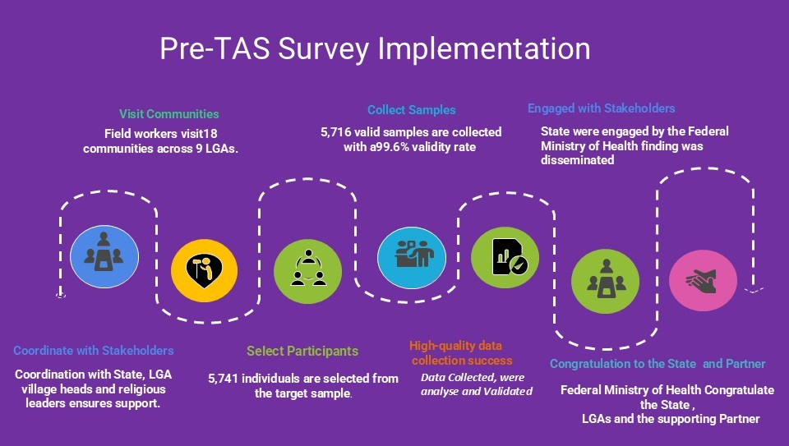
- Pre TAS Stakeholders Debriefing Meeting: Following the conclusion of field activities, the State NTDs, supporting partner Helen Keller Intl, and the Federal Ministry of Health and Social Welfare conducted a one-day stakeholder debriefing meeting to share the Pre-TAS survey outcomes and discuss next steps. The comprehensive presentation of the lymphatic filariasis elimination journey in Adamawa State revealed highly encouraging results from the Pre-TAS implementation. Out of 5,716 valid samples collected across all participating communities, zero positive cases were detected, representing a 100% negative rate that demonstrates significant progress in LF transmission interruption. The survey also identified 2 morbidity cases: 1 lymphoedema case in Kpasham village (Demsa LGA) and 1 hydrocele case in Ribadu village (Mayo Belwa LGA). Notably, all 9 participating LGAs successfully passed the Pre-TAS threshold criteria based on the absence of positive antigen cases, indicating that these areas have achieved the critical milestone required for progression to the Transmission Assessment Survey 1 (TAS 1). The exceptional results, with zero refusals recorded and only 25 invalid samples out of 5,741 total samples collected, underscore the effectiveness of community mobilization strategies and the high level of community acceptance achieved during the implementation process, providing a solid foundation for the stakeholder discussions on advancing to the next phase of the elimination program.
- School Assessment and Verification Exercise for TAS 1: Supporting partner Helen Keller Intl, with guidance from SightSaver (the NTD coordinating partner in the country), conducted an extensive school assessment and verification exercise across seven LGAs designated for TAS 1, utilizing local data collectors equipped with mobile devices and the CommCare app developed by SightSaver for efficient data collection and real-time reporting. The exercise aimed to verify school existence, record accurate enrollment data, assess facility functionality, and identify accessibility and security challenges, with critical support from LGA NTDs Coordinators and Executive Secretaries of Education who provided detailed school contact information including locations and head teacher details. Out of 300 schools assessed, most were verified as existing and operational, while schools found to be nonexistent or inaccessible due to security concerns were documented and cross-verified against the Federal Ministry of Health and Social Welfare's list to ensure the TAS plan accounts only for accessible and realistic sites, thereby optimizing resource allocation, streamlining logistical planning, and preventing wastage of efforts on unviable locations in preparation for the upcoming TAS 1 implementation.
- Planning Meeting for TAS 1: On Helen Keller International, in partnership with the Adamawa State Ministry of Health and Women Affairs, organized a comprehensive stakeholder planning meeting on May 19-20, 2025, to prepare for the upcoming lymphatic filariasis (LF) Transmission Assessment Survey 1 (TAS 1) in Adamawa State.
- Key Participants: The meeting brought together 24 participants representing multiple sectors, including NTD Coordinators from 7 Local Government Areas (Maiha, Song, Girei, Lamurde, Yola South, Toungo, and Jada), education officials from the Executive Secretary's office, Divisional Inspectors, State Universal Basic Education Board representatives, Ministry of Education staff, Federal Ministry of Health personnel, and Social Welfare Division members.
- Meeting Objectives: The primary goal was to orient all stakeholders on the TAS 1 methodology and approach, which will target school children in Classes 1 and 2. Participants received detailed presentations on the school-based assessment process for evaluating LF prevalence, with clear explanations of sampling approaches and individual roles and responsibilities.
- Key Outcomes: The meeting identified critical planning focus areas including school enrollment data, local guide requirements, hard-to-reach locations, and security-compromised zones. A systematic visitation schedule was developed to ensure comprehensive and timely coverage across all participating LGAs.
This collaborative planning effort represents a significant step toward effective TAS 1 implementation and supports Nigeria's broader goal of lymphatic filariasis elimination through coordinated, multi-stakeholder engagement.
- Training of Electronic Data Manager, Laboratory Scientics, Card Readers and team Leader for TAS 1: Helen Keller International, in collaboration with the Federal Ministry of Health and Social Welfare (LF Program Unit) and the Adamawa State Ministry of Health and Women Affairs NTDs Division, conducted comprehensive training sessions for the lymphatic filariasis Transmission Assessment Survey 1 (TAS 1) from May 21-23, 2025. The training specifically targeted electronic data managers, laboratory scientists, card readers, and team leaders who will conduct the survey in 7 Local Government Areas of Adamawa State. The primary objective was to orient these key personnel on various aspects of LF TAS 1, including methodology, approach, target sample size, and the roles of stakeholders and community members in ensuring survey success.
The training emphasized practical skills through hands-on sessions covering data collection and collation using the CommCare app, blood sample collection techniques, data documentation, strip reading, community entry and exit protocols, and ethical considerations in research and surveys. Participatory methods including presentations, role-plays, and field visits to selected schools for pre-testing and piloting activities were incorporated to identify potential challenges and develop corrective measures before official data collection commenced. The training successfully established an effective team structure with clarified roles and logistical arrangements, while material resources such as attendance sheets, field test kits, consumables, and social mobilization items were distributed to ensure readiness. A total of 75 participants, comprising 47 males and 28 females, actively engaged in the training, equipping the team with the necessary knowledge and skills to carry out the TAS efficiently.
- TAS1 Field Visit: The TAS field activities commenced on the 26th of May and concluded on the 23rd of June, 2025. During this period, teams visited a total of 240 schools across the LGAs of Lamurde, Song, Maiha, Girei, Yola South, Toungo, and Jada. This exceeded the initial target of 210 schools, demonstrating the commitment and dedication of the field teams. A total of 11,206 children were tested during these visits. The data collected resulted in 11,191 valid tests, with no rejections recorded, and 15 tests classified as invalid due to technical or procedural issues. The exercise faced some operational challenges, including crossing rivers and mountains which posed logistical difficulties, as well as delays caused by farming activities in rural communities, especially during peak farming seasons. Additionally, public holidays, notably Eid el Kabir, and mid-term school breaks contributed to delays and rescheduling of some activities, leading to an extension beyond the initially planned timeline. Despite these challenges, the teams successfully collected data for schools in Song, Lamurde, Girei, and Yola during weekends and public holidays, ensuring comprehensive coverage.
This extensive field effort highlights the resilience and adaptability of the teams involved in the TAS, despite logistical and socio-cultural hurdles. The data collected will significantly inform the program’s next steps towards LF elimination, and the operational lessons learned during this activity will aid in planning future surveys more efficiently and effectively.
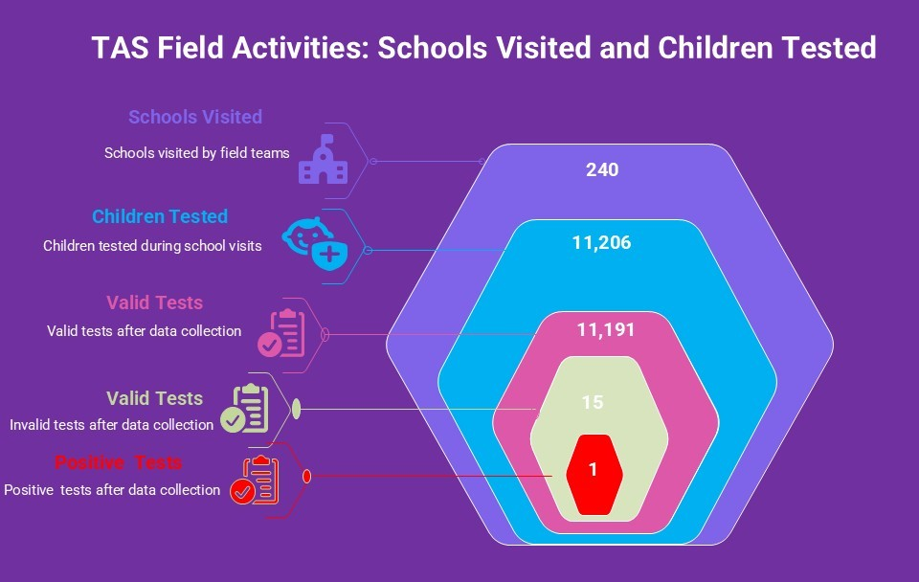
- Data Validation and Harmonization: Helen Keller Intl, in collaboration with the Federal Ministry of Health and Social Welfare (LF Program Unit) and the Adamawa State Ministry of Health and Women Affairs NTDs Division, conducted a comprehensive data validation and harmonization meeting on June 24, 2025, at the Specialist Hospital in Yola. The session brought together team leads from 15 teams involved in the TAS 1 activity. The FMoH program officers, team lead, State NTDs Coordinator, and the State Data Manager, come together to review, reconcile, and harmonize all collected data. Each team presented their findings, which were meticulously checked for accuracy, completeness, and consistency, with discrepancies collaboratively resolved to ensure data reliability. This critical harmonization process consolidated findings from various LGAs, ensured adherence to standardized formats and quality standards, and fostered shared understanding among stakeholders while strengthening data integrity and collective accountability. The validated data now serves as the foundation for final analysis, informing decision-making processes for subsequent LF elimination strategies and reporting to relevant national and international agencies.
- Stakeholder Debriefing Meeting and Result Sharing:
The Federal Ministry of Health, Helen Keller International, and the State NTDs Division collaborated to conduct a one-day stakeholders meeting to share feedback and outcomes of the TAS 1 field activity following its successful completion across seven LGAs in Adamawa State. The survey results demonstrated exceptional performance, with all seven LGAs (Song, Toungo, Maiha, Lamurde, Jada, Yola South, and Girei) successfully passing TAS 1, indicating interrupted lymphatic filariasis transmission and progression to the post-MDA phase. Out of 11,206 children tested across 240 schools (exceeding the initial target of 210 schools), 11,191 results were valid with only 15 invalid tests due to technical issues, demonstrating high data quality and community participation. Notably, zero refusals were recorded, confirming strong community engagement and effective mobilization efforts, while only one positive case was identified in Wailare community of Jada LGA.
The exercise highlighted successful mobilization strategies and high awareness levels among schools and communities, supported by effective involvement of technical teams and security agencies. However, operational challenges including difficult terrain, logistical delays, barcode duplication issues, and limited access to some schools impacted field activities and require attention for future interventions. Moving forward, immediate next steps include requesting medicines for focused treatment in Wailare community given the positive case, initiating enrollment and screening of schools in LGAs that have passed Pre-TAS, and implementing operational improvements such as increasing barcode supplies and enhancing community mobilization. These strategic actions will ensure continued momentum toward achieving and sustaining lymphatic filariasis-free status across all targeted areas, with the successful TAS 1 passage providing a strong foundation for subsequent elimination efforts.
Bill and Melinda Gates Foundation (Onchocerciasis Entomological Survey)
- Monitoring of Human Landing Catchers: Between April and June 2025, fly-catching activities were monitored across 16 LGAs using both physical visits and WhatsApp communication. The State Ministry of Health, LGA NTD teams, health workers, and Helen Keller collaborated to ensure that human landing catchers followed standard procedures. This monitoring helped identify issues, provide guidance, and improve data quality and reliability.
- Training of Human Landing Catchers: Between April, May June 2025, new HLCs were recruited and trained in Maiha, Song, Gombi, and other LGAs due to inactivity and lack of proactiveness among previous HLCs. The training aimed to enhance participation, improve surveillance, and ensure local support and ownership in the communities.
- Data Collection and Sorting of Blackflies in April and May: During this period, fly-catching monitoring was carried out by FMOH, SMOH, and Helen Keller across all 16 LGAs with catching sites in the state. The results of the activity are highlighted below by month.
- In April 2025, blackfly data collected across 16 LGAs and 33 communities in Adamawa revealed a total of 112 flies caught, with 78 captured through the HLC (human landing catch) method and 34 via trap catches. This widespread monitoring highlights the persistent presence of blackflies across the region, indicating ongoing activity that could pose health risks to residents. The high number of blackflies caught through human landing underscores the need for targeted control measures to mitigate biting and potential disease transmission. These comprehensive findings provide valuable insights for local authorities, guiding future efforts to reduce blackfly populations and protect the health and well-being of communities in Adamawa.
The chart below shows the breakdown of suspected blackflies caught.
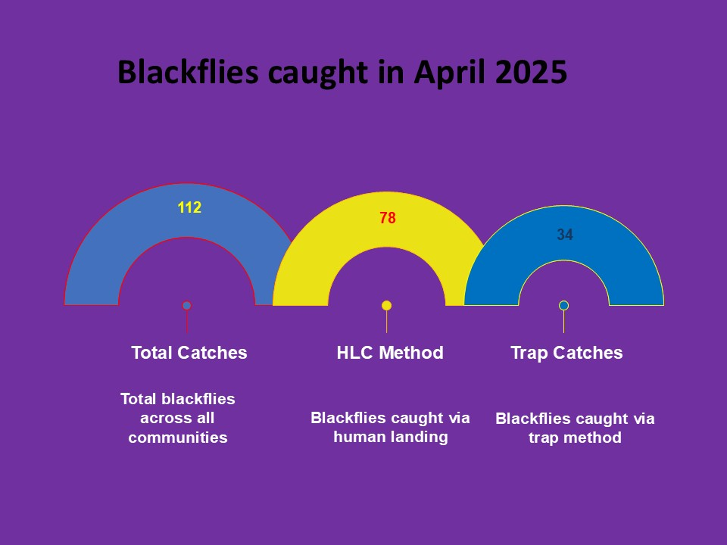
- Based on the data in the chart below, in April 2025 in Adamawa, the highest number of blackflies was caught using the human landing catch (HLC) method, with 45 flies, highlighting its effectiveness for monitoring activity in the communities. The HLC method also captured 32 blackflies via traps, underscoring its dual role in surveillance. Other trap methods, such as Doumeli (4 catches) and Wuro Baba (3 catches), contributed less but provided valuable additional data. Community participation through human landing catches played a significant role in total blackfly collection, demonstrating the importance of involving residents in control and monitoring efforts. Overall, the data indicate that a combined approach using HLC and trap methods, supported by community engagement, is essential for effective blackfly management in Adamawa.
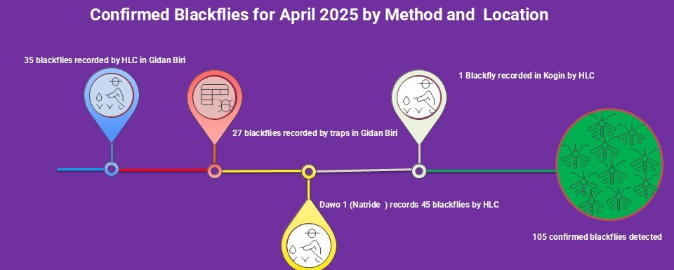
- The contribution of 368 flies from other species, collected across 33 communities including Zhedinyi, Pubba (Munga), Wuro Hammagu, Madagali, Damai (Mildeu), Kogin Baba 2 (Kiri), and Mayo Biriji (Mayo Butali) highlights their widespread distribution in the State. Most of these flies were captured through human landing catch (HLC), which proved highly effective, complemented by trap-based methods that contributed significantly. This data underscores the crucial role of community involvement and the combined use of HLC and trapping techniques in comprehensive surveillance, enabling better understanding and management of fly populations across multiple localities.
- Results from May 2025 Blackfly Surveillance: A total of 157 blackflies were caught across two locations using trap methods and human landing catchers. Gidan Biri recorded 112 blackflies (85 through human landing catchers and 27 through traps), while Dawo 1 (Matride) documented 45 blackflies through trap methods. The surveillance results demonstrate active blackfly populations in both locations, with Gidan Biri showing particularly high blackfly activity through human landing catcher monitoring, indicating potential areas of concern for vector control programs and ongoing transmission risk assessment. See the chart below.
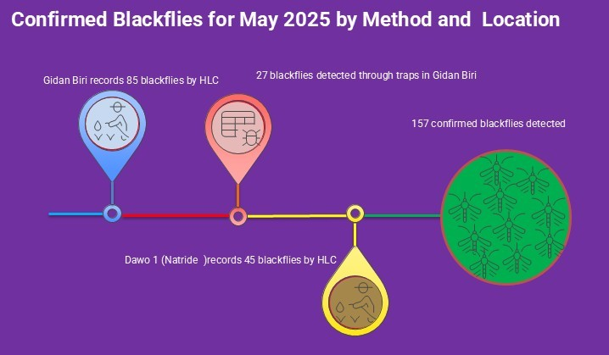
- During the surveillance period, a total of 595 other fly species were collated through combined catching methods. Human Landing Catch (HLC) methods accounted for many captures, with 368 flies, while trap-based methods yielded 227 flies. These results demonstrate the presence of diverse fly populations in the surveillance areas, with human landing catchers proving to be the predominant method for capturing other fly species. The substantial number of non-target flies collected alongside blackfly surveillance efforts provides valuable ecological data on the broader dipteran community and helps inform comprehensive vector control strategies in the monitoring.

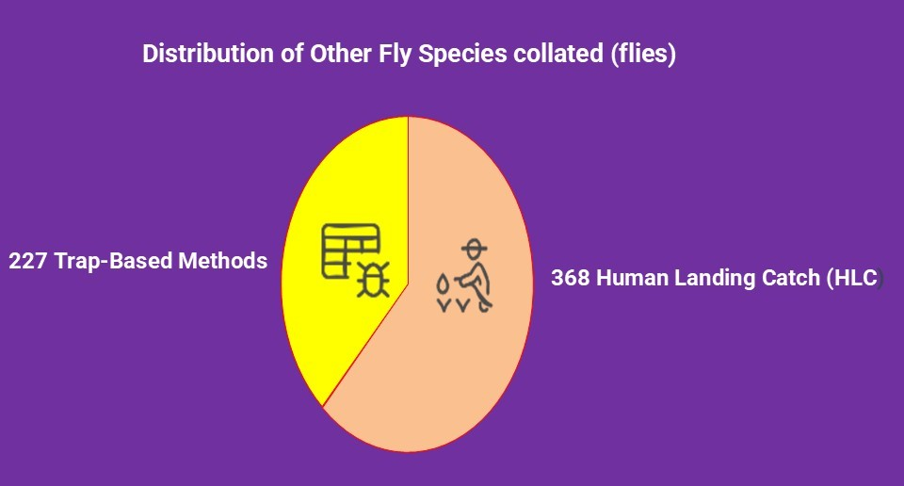

Improving the food security and nutrition of IDPs and non-IDPs in Fufore LGA

- House-to-house mid-upper arm circumference (MUAC) screening: From April 1 to June 30, 2025, trained community health extension workers conducted MUAC screenings of children aged 6-59 months across 11 wards of Fufore LGA (Daware, Pariya, Mayo-Inne, Fufore, Gurin, Ribadu, Karlahi, Uki-Tuki, Yadim, Farang, Wuro-Bokki, and Mararaban Cigari). During this period, 7985 children (3859 males and 4097 females) were screened. Following the screening, 287 children (127 males and 160 females) were identified with moderate acute malnutrition (MAM), and 215 children (94 males and 131 females) were identified with severe acute malnutrition (SAM). The cases of moderate and severe acute malnutrition have been referred to the nearest outpatient therapeutic program (OTP) centers and health facilities for treatment. Additionally, caregivers received counseling on managing acute malnutrition (SAM and MAM) cases using locally available community resources to improve household dietary diversity.

- Supervision of demonstration and home gardens: From April 1 to June 30, 2024, the project oversaw the monitoring of 29 communal and 446 individual gardens in collaboration with agricultural extension workers across 11 wards (Daware, Fufore, Mararaba Cigari, Mayo-Inne, Pariya, Uki-Tuki, Farang, Yadim, Wuro-Bokki, Karlahi, Ribadu, Gurin communities) in Fufore LGA. This activity focused on providing technical advice on best practices for home gardening to beneficiaries involved in home and micro gardening. The extension workers also offered technical assistance concerning climate-smart approaches that help participants use local resources to address challenges such as limited space, water shortages, and pest and disease infestations. This comprehensive visit ensured most gardens were in good condition and was used to educate project participants and the community about the significance of home gardening as a tool to combat food insecurity.
Additionally, project participants harvested vegetables such as amaranthus, sorrel, and jute (ayoyo), which were utilized primarily for consumption. The surplus was sold to other individuals or at the local market. Most harvested gardens are re-established to ensure that households have sustainable access to safe and nutritious food.
- Support group meetings: Between 1st April to 30th June 2025, 77 support groups (55 moms and 22 adolescent girls) conducted monthly meetings across 11 wards of Fufore LGA, which include Pariya, Mayo-Inne, Fufore, Karlahi, Gurin, Ribadu, Uki-Tuki, Farang, Wuro-Bokki, Yadim, and Mararaban Cigari. The meeting, which is aimed at creating a safe space where women can connect, share their experiences, and learn more about maternal, infant, and young child nutrition, was facilitated by 77 trained model moms and supervised by health workers across the locations. On average, 1134 women attended the monthly meetings during this period. To ensure the widespread dissemination of the knowledge gained from the meetings, project participants and health workers engaged in cascading this knowledge to other community members (Indirect beneficiaries), reaching 6124 persons with sensitization messages on Maternal, Infant, and Young Child Nutrition.

- Supportive supervision of Village Savings and Loans Association (VSLA) meetings: Between April and June 2025, the project facilitated the monitoring and supervision of weekly meetings of 34 village savings and loan associations comprising 11 old groups currently in their second saving cycle and 23 groups currently in their first cycle across 11 wards of Fufore LGA. This activity was conducted by 12 supervisors from the Ministry of Entrepreneurship and Development with the aim of offering technical guidance to the groups while ensuring that standard meeting procedures are not compromised.
As of this reporting period, the 11 old groups have accumulated savings of 16.8 million naira and have disbursed loans of 4.3 million naira to members to support their income-generating activities. Meanwhile, the 23 new groups have accumulated savings of over 11 million naira and have disbursed loans of 8.4 million naira to members.

- Supportive supervision and monitoring of income-generating activities (IGAs): Between 1st April 2025 and 30th June 2025, monitoring and supervision of 310 income-generating activities were conducted by the staff of the Adamawa State Ministry of Entrepreneurship across five IDPs host communities (Daware, Pariya, Mararaban Cigari, Fufore, and Mayo Inne) in Fufore LGA. This activity enabled the project to monitor their sales and income and provide professional counsel on improving their enterprises.

- Training of Project Participants on Tom Brown Preparation: From 23rd to 25th April 2025, the project team in collaboration with the Adamawa State Ministry of Health and Human Development and the Adamawa State Primary Healthcare Development Agency (ASPHCDA) conducted the training of 425 project participants (women and adolescent girls) on Tom Brown preparation across 11 wards of Fufore LGA. The training was aimed at equipping the participants with the knowledge and skills for the preparation of Tom brown (a nutrient-dense meal made from locally available raw materials (sorghum, soya beans, and groundnut) used for feeding young children). The training spanned one day across each location and was facilitated by 4 Nutrition officers drawn from the state ministry of health and ASPHCDA comprehensively teaching the women and adolescent girls the step-by-step procedures to preparing the meal which includes, appropriate measurement and ratio for the grains, cleaning, drying, roasting of the grains, grinding and finally cooking it to desired consistency. Additionally, the training had 19 community health workers in attendance whose knowledge was also refreshed and improved on the subject matter. The project team supervised the training to ensure quality and technical assistance.

- Flag-Off Ceremony for the distribution of Income Generating Activities (IGA) Items: On June 3rd, 2024, the project held a flag-off ceremony to distribute Income Generating Activities (IGA) items to participants across 11 Wards of Fufore LGA. The event took place at PHCC Fufore in the Fufore ward and was attended by several key stakeholders, including the Executive Secretary of the Primary Healthcare Authority (PHCA), Fufore LGA, the District head of Ribadu, and Directors from the Adamawa State Ministry of Entrepreneurship and Development, the Ministry of Information, and the Ministry of Agriculture. Health workers and project participants were also present. The event featured sensitization, remarks, and goodwill messages from the stakeholders. Notably, the District head of Ribadu, who was represented at the flag-off, expressed gratitude to the organization for this valuable intervention and encouraged the participants to diligently utilize the support they received.
This remarkable event aimed to promote Helen Keller International’s commitment to alleviating poverty among vulnerable households through an accountable and transparent approach and to strengthen partnerships with the stakeholders, who expressed their satisfaction with the initiative's and project's effectiveness.

- Distribution of Income Generating Activities (IGA) Items: Between 3rd – 5th June 2025, the project team conducted the distribution of Income Generating Activities (IGA) items to 440 project participants across 11 wards of Fufore. The distribution aimed to support the project participants with basic items necessary to start up or improve the IGAs. The distributed items will be used to support 16 identified IGAs across the 11 wards.
- Distribution of Improved Seeds: From 16th – 20th June 2025, the project team distributed improved seeds to 440 project participants across 11 wards of Fufore LGA. The seeds included tomato, sorrel, Amaranthus, okra, jute, Pro-Vitamin A-fortified maize, and sesame leaves. This distribution aims to increase year-round access to nutritious vegetables, improve food security, and support livelihoods in the communities of vulnerable households, particularly Internally Displaced Persons (IDPs).
- Training of Agric Extension Workers on Home gardening Techniques: From 18th – 19th June 2025, A two-day interactive training session was held with Agricultural Extension Workers supporting the project in Fufore LGA. The training was facilitated by 2 master trainers (1male and 1 female) from the Adamawa State Ministry of Agriculture and Adamawa State Agricultural Development Program (ASADP), with support from the project team. 13 participants (6 males and 7 females) were in attendance, including 3 staff of Helen Keller Int’l from Katsina state who came on a learning visit. Key topics discussed included crop selection, site selection, garden layout, compost making, when to plant, when to harvest, and the benefits of the garden. An important action point noted was to identify and plant certain crops, such as maize and okra, in the season they thrive best to avoid wasting seeds. The training objectives were fully achieved, equipping participants with practical knowledge to improve extension services and food security in Fufore LGA.
- Cooking Demonstration: For project participants (mothers and adolescent girls), a cooking demonstration was conducted across the 11 wards of Fufore LGA. The training aimed to equip participants with techniques for preparing nutritious meals for children (6 – 23 months) using locally available resources. Nutrition officers from the Adamawa State Primary Health Care Development Agency, with support from Helen Keller Intl staff, led the training sessions.

The following recipes were selected for different age groups:
Age Group | Recipes | Ingredients Required
6–8 months | Millet and Groundnut Pap | Groundnut, Millet
9–11 months | Mashed Sweet Potato and Vegetable | Sweet Potato, Deboned Fish, Spinach, Tomatoes, Onions, Iodized Salt, Red Palm Oil
12–23 months | Fresh Okra Soup with Tuwon Masara | Fresh Okra, Onions, Red Bell Pepper, Daddawa, Dried Fish, Iodized Salt, Maize Flour, Red Oil

Overall, the demonstration focused on showing mothers practical cooking methods and healthy feeding practices for young children, while also emphasizing the importance of hygiene in food preparation.

Transforming Lives Through Nutrition (TLTN) Project

- Monthly Support Group Meetings: Between 1st April and 30th June 2025, a total of 472 support group meetings were conducted across 15 LGAs in Adamawa State, 158 in April, 158 in May, and 156 in June. These LGAs included Gombi, Song, Yola North, Toungo, Numan, Demsa, Lamurde, Girei, Guyuk, Jada, Hong, Yola South, Mayo-Belwa, Shelleng, and Ganye. In April, 2,068 support group members attended the meetings, while in May, attendance increased to 2,224 women. Meetings were facilitated by trained support group leaders with technical guidance from health workers, LGA Nutrition Focal Persons (NFPs), and Nutrition Directors. The sessions aimed to connect mothers for peer learning, emotional and social support, and knowledge exchange on maternal and child health and nutrition. Participants were also encouraged to disseminate the knowledge gained within their communities, contributing to broader nutrition awareness and behavioural change at the grassroots level.

- Multiple Micronutrient Supplementation (MMS) for Pregnant Women:
Between April and June 2025, Multiple Micronutrient Supplementation (MMS) activities were carried out across 300 health facilities in 21 LGAs of Adamawa State. The intervention focused on improving maternal nutrition by ensuring pregnant women received essential micronutrients during antenatal visits. A total of 69,361 pregnant women were supplemented with MMS during this period. Out of this number, 29,103 were first-time recipients, while 40,258 received the supplementation as revisits. This demonstrates consistent progress in coverage and follow-up for maternal health and nutrition services across the state

- Advocacy visit to the LGA Executive Secretaries and Nutrition Directors: Between May 27th and 29th, 2025, as part of efforts to strengthen coordination and enhance the effective implementation of the Transforming Lives through Nutrition Project. The project team conducted advocacy visits in eight Local Government Areas (LGAs) of Adamawa State, which include Guyuk, Shelleng, Toungo, Ganye, Hong, Gombi, Lamurde, and Numan. These visits specifically targeted LGAs where new Executive Secretaries and Nutrition Focal Persons (NFPs) have recently been appointed and may not yet be fully conversant with the project’s objectives, components, and implementation strategies. The purpose of the visits was to introduce the project framework, emphasize its critical role in improving nutritional outcomes, and advocate for stronger leadership support at the LGA level. The engagements were well received, with officials expressing appreciation for the effort and a willingness to support ongoing and future project activities. Continued follow-up and collaboration are planned to ensure sustained commitment and successful project delivery across the LGAs.

- Integrated Supervision of Gardens and MMS Services Across 15 LGAs – April to June 2025: Between April and June 2025, Helen Keller Intl conducted a series of supportive supervision exercises across the 15 implementing LGAs in Adamawa State to strengthen home and communal gardening and enhance Multiple Micronutrient Supplementation (MMS) service delivery. From 1st to 30th April, garden supervision was carried out in all 15 LGAs by Model Moms, resulting in the successful harvest of nutritious crops such as Amaranthus, Jute, Sorrel, cucumber, okra, and tomatoes for household consumption. Between 7th and 30th May, the supervision extended to include wards such as Kiri and Talum in Shelleng and seven wards in Toungo, Mayo-Belwa, Numan, and Demsa. This round focused on both gardening and MMS implementation, covering 12 health facilities and leading to improvements in counselling, stock management, and data reporting at PHCCs. Most recently, supervision was conducted across Yola South, Numan, Girei, and Song LGAs, covering 13 health facilities (including Murke, Sigire, Damare, and others), 12 communal and individual gardens, and 13 mother-led support groups. These efforts provided technical guidance, reinforced best practices, ensured data quality, and contributed significantly to food security, maternal nutrition, and improved program outcomes across the state.

- Cooking Demonstration: From April to May 2025, Helen Keller Intl conducted two rounds of cooking demonstrations for 158 Model Moms across 15 LGAs in Adamawa State to promote improved nutrition practices for children. The first session, held from 4th to 7th April, targeted children aged 6–59 months and featured the preparation of Guinea corn and groundnut pap for children 6–9 months, Moi-Moi for 9–11 months, and Tuwon masara with Miyan Kuka for 12–24 months. The second session, conducted from 27th to 30th May, focused on children 6–24 months and showcased meals such as mashed sweet potatoes with vegetables (6–8 months), rice with fish and daddawa (9–11 months), and Tuwon dawa with Miyan Alaihu (12–24 months). Both rounds emphasized the use of affordable, locally sourced ingredients and covered topics such as balanced diets, complementary feeding, household feeding practices, and overcoming common child feeding challenges. The initiative successfully empowered Model Moms with practical cooking skills, enhanced nutrition awareness, and encouraged knowledge sharing within their communities, thereby reinforcing good nutrition practices at the household level.

- Data Validation: Between 2nd and 7th May 2025, and earlier from 2nd to 4th April 2025, Helen Keller Intl conducted two rounds of comprehensive data validation exercises across twenty-one Local Government Areas (LGAs): Numan, Demsa, Yola North, Yola South, Fufore, Girei, Song, Gombi, Hong, Michika, Madagali, Mubi North, Mubi South, Maiha, Guyuk, Shelleng, Lamurde, Mayo-Belwa, Jada, Ganye, and Toungo. The validation focused on programmatic data related to Multiple Micronutrient Supplementation (MMS), Mid-Upper Arm Circumference (MUAC) screening (in April), and support group meetings. The exercises were carried out by Helen Keller staff members in collaboration with the Nutrition Focal Persons (NFPs) from the respective LGAs. This joint effort ensured data completeness, consistency, and quality, ultimately strengthening the integrity of program monitoring and reporting.

Vitamin A Supplementation

- Micro-Planning Meeting (15th April 2025): The Adamawa State Primary Health Care Development Agency, with support from Helen, conducted its microplanning with participants from the state and LGA to effectively prepare, coordinate, and successfully implement the campaign at the local level. It involves identifying target populations, mapping service delivery points, assigning roles to health workers, planning logistics and supplies, organizing community mobilization strategies, setting up data collection and reporting systems, and addressing potential challenges. The meeting ensures that all stakeholders are aligned and that resources are efficiently utilized to maximize coverage and impact during MNCHW.

- First Planning Meeting (3rd June 2025): The Adamawa state primary Health care agency held its first planning meeting to discuss the possibilities of the integration of NIPDs and Maternal Newborn and Child Health Week, and to source resources from supporting partners of the MNCHW campaign. At the end of the meeting, the integration of NIPDs and the MNCHW was agreed, but due to the limited time to the agreed date of Implementation, Helen Keller Intl will be supporting the state with the training of facility data Officers and community dialogue.

- Advocacy visits to 15 emirate councils and Chiefdoms (9th –11th June 2025): The Community engagement department of the Adamawa State primary Health Care Development Agency paid an advocacy visit to 15 emirate councils and Chiefdoms of the State to secure the support of traditional leaders to enhance community mobilization, participation, and acceptance of maternal, newborn, and child health interventions.

- Community Dialogue (9th—12th June 2025): A community dialogue was held across 226 wards of the state with key community players, such as community leaders, religious leaders, women leaders, and youth leaders, to foster mutual understanding, address misconceptions, and promote collective action for an improved maternal, newborn, and child health campaign.

- Delivery of MNCHW Commodities: The ASPHCDA took delivery of Vitamin commodities from Vitamin Angels in Preparation for the May/June 2025 Maternal Newborn and Child Health Week. A total of 110,000 Blue capsules and 690,000 Red capsules were delivered to the Adamawa State Primary Health Care Agency medical store.

- Facility Data Officers training: The ADSPHCDA M&E team, with the Helen Keller Intl team, built the capacity of one data officer from each MNCHW implementing facility in the state. Their knowledge was improved on proper MNCHW data recording, summation, and collation before entry into the state's daily call-in data.

- Receipt of Vitamin A Commodities (9th June 2025): The Adamawa State Primary Health Care Development Agency (ASPHCDA) received a total of 216,000 doses of Vitamin A (red capsules) from the Taraba State Primary Health Care Development Agency (TSPHCDA). These commodities were borrowed to bridge the existing commodity gap in the state’s Vitamin A supplementation efforts.

- MNCHW Flag-off Ceremony (13th June 2025): The State Ministry of Health and ADSPHCDA, in collaboration with Helen Keller Intl, UNICEF, WHO, and other partners, conducted the official flag-off ceremony for the MNCHW and NIPD campaign. The event aimed to raise public awareness, mobilize community participation, and reinforce government and stakeholder commitment to delivering impactful maternal, newborn, and child health interventions and NIPDs to targeted-aged children.

- MNCHW Implementation: The Adamawa State Primary Health Care Development Agency, with support from Helen Keller International, successfully conducted an integrated May/June 2025 round of the Maternal, Newborn, and Child Health Week (MNCHW) alongside National Immunization Plus Days (NIPDs) and Inactivated Polio Vaccine (IPV) programs within the state from June 14th to 18th, 2025. The aim of the campaign was to improve the health and survival of mothers, newborns, and children by providing high-impact, cost-effective interventions at both community and facility levels. Key interventions during the five-day campaign included immunization services, vitamin A supplementation, deworming for children, antenatal and postnatal care, nutritional assessments, and health education and promotion activities. Supervisory personnel from national, state, and local government levels were deployed to monitor and oversee implementation across the LGAs to ensure coverage of all target populations. Additionally, Helen Keller Intl engaged consultants, independent monitors, and ad-hoc supervisors in various LGAs to ensure all eligible children aged 6–59 months received vitamin A supplements and deworming tablets. These monitors also ensured accurate data collection, reporting, and documentation.

- Data Validation (19th – 20th June 2025): The MNCHW data validation exercise was conducted across all LGAs in the state to verify the accuracy, completeness, and reliability of reported data, particularly on Vitamin A supplementation, deworming, and MUAC screening. This process aims to support evidence-based decision-making, strengthen accountability, and enhance the quality and impact of future campaign implementations.

REASONS FOR SUCCESS OR DEVIATION FROM TARGETS:
Reasons for success
- Good working relationship between Helen Keller, the State, the LGA team, and the communities.
- Commitment of Adamawa State Primary Health Care Development Agency (ASPHCA), State Ministry of Health (SMoH), State Ministry of Agriculture (SMoA), Other supporting partners, and Helen Keller project staff to the projects.

Reasons for deviation from the target

