CRS INFRASTRUCTURE INTERVENTIONS PHASE II

- School infrastructure Construction: A total of 3 blocks of classroom and 3 sanitation facilities are under construction in Ngurore, Gereng and Dumne wards.
- Health Centre Rehabilitation: Construction of a ward with 2 rooms for Song Waje health post.
- Hand Pump construction: Construction of borehole facilities equipped with handpump in Ngurore and Gereng Wards.
- Borehole Rehabilitation and upgrade: 4 rural water supply facilities were rehabilitated and upgraded to solar powered system in Jumbul, Tallum, Ngurore and Dumne wards.
- Culvert Construction: Construction of a three-cell culvert in Hona, Girei 1 ward including earth filling.
CfW construction:
- Road upgrade: Upgrade and rehabilitation of 6 earthen roads including installation of culverts through CfW in Jumbul, Tallum, Ngurore, Malkohi, Gereng and Song Waje wards.
- Drainage Construction: Construction of 1 drainage and evacuation of 1 drainage through CfW in Ngurore and Dumne wards.

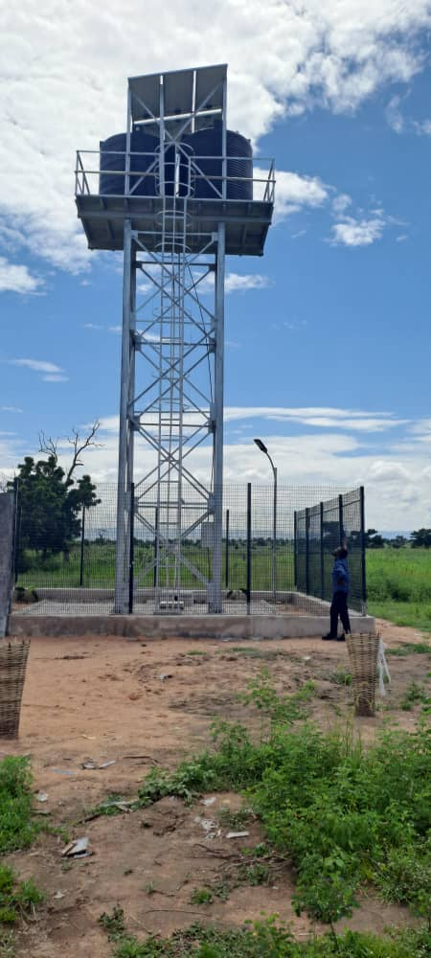
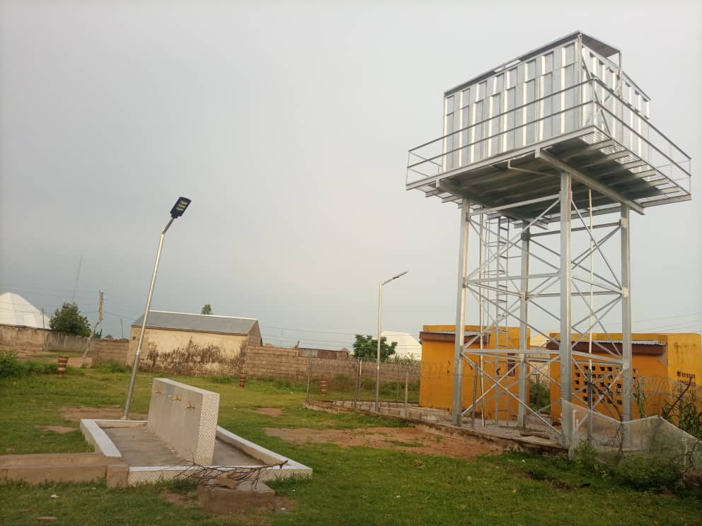

BOREHOLE D
BOREHOLE D

