

NARRATIVE REPORT ON STEP DOWN TRAINING ON CLMS

Submitted to

UNFPA, YOLA COMPILED

BY

SFP COORDINATOR
Aishatu Garba Abubakar

21st to 22nd June, 2024

The Adamawa state primary health care development agency yola In collaboration with FMOH/UNFPA organized two days training on CLMS.

Date 21st to 22nd June, 2024.
Venue: Mubi North, Gombi, Yola North, Jada, and Guyuk LGA
BACKGROUND INFORMATION:
In 2022, the FMOH in collaboration with SMOH and implementing partners reviwed the CLMS tools. The CLMS tools were reviwed to capture current realities in the logistic management of contraceptives both at the national and sub national. The scope of the revised CLMS tools captures new additions such as product batch number and other element which would enhance visibility of data from the central contraceptive warehouse down to the service delivery point.
To familiarize key stakeholders {national and state} with the revised CLMS tool there is need to build the capacity of service provider at the LGA for efficient implementation of revise tools.

HIGHLIGHT OF THE MEETING
- Day one activities commence with registration, open prayers {2nd stanza of the national anthem}
- Goodwill massages by various ES/MCH of the LGA
- Ground rules was set
- Expectation by the participants during the training
- Pre test was administered to assess the participant
- All topics were covered during the training such as {overview of CLMS, purpose of CLMS}
- The training lasted for two days
- Post test was administered on the last day to assess and understand the current level of knowledge of participant after the training
- Closing remarks by the ES/MCH of the various clusters

OBJECTIVES OF THE TRAINING

- To build the capacity of service provider at the LGA level

ACTION POINTS
- Participants agreed to supervise after the training

NEXT STEP
- Step down training for the remaining providers
CHALLENGES
- Days of the training of the is inadequate
- No enough materials for the training
RECOMMENDATION
- FMOH/UNFPA to increase more days for the CLMS training
- FMOH to supply more training materials for the CLMS training.

ACTON PICTURES

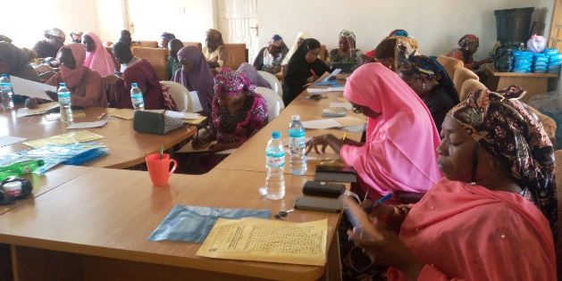
CLMS at Mubi North cluster
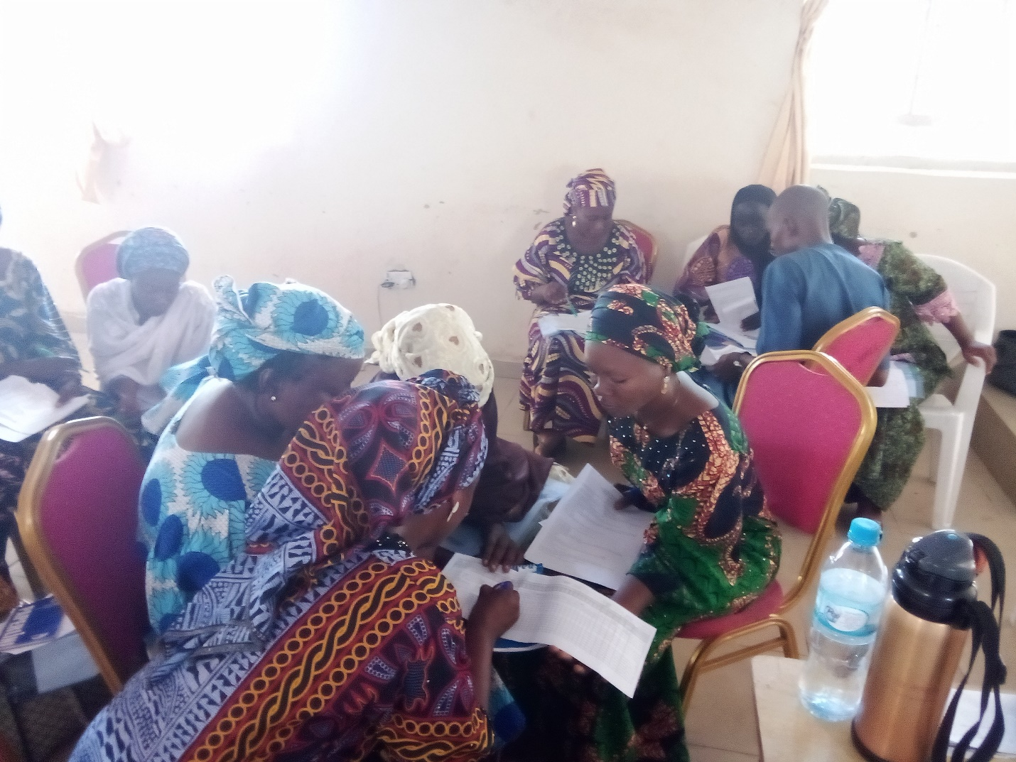
CLMS at Jada cluster
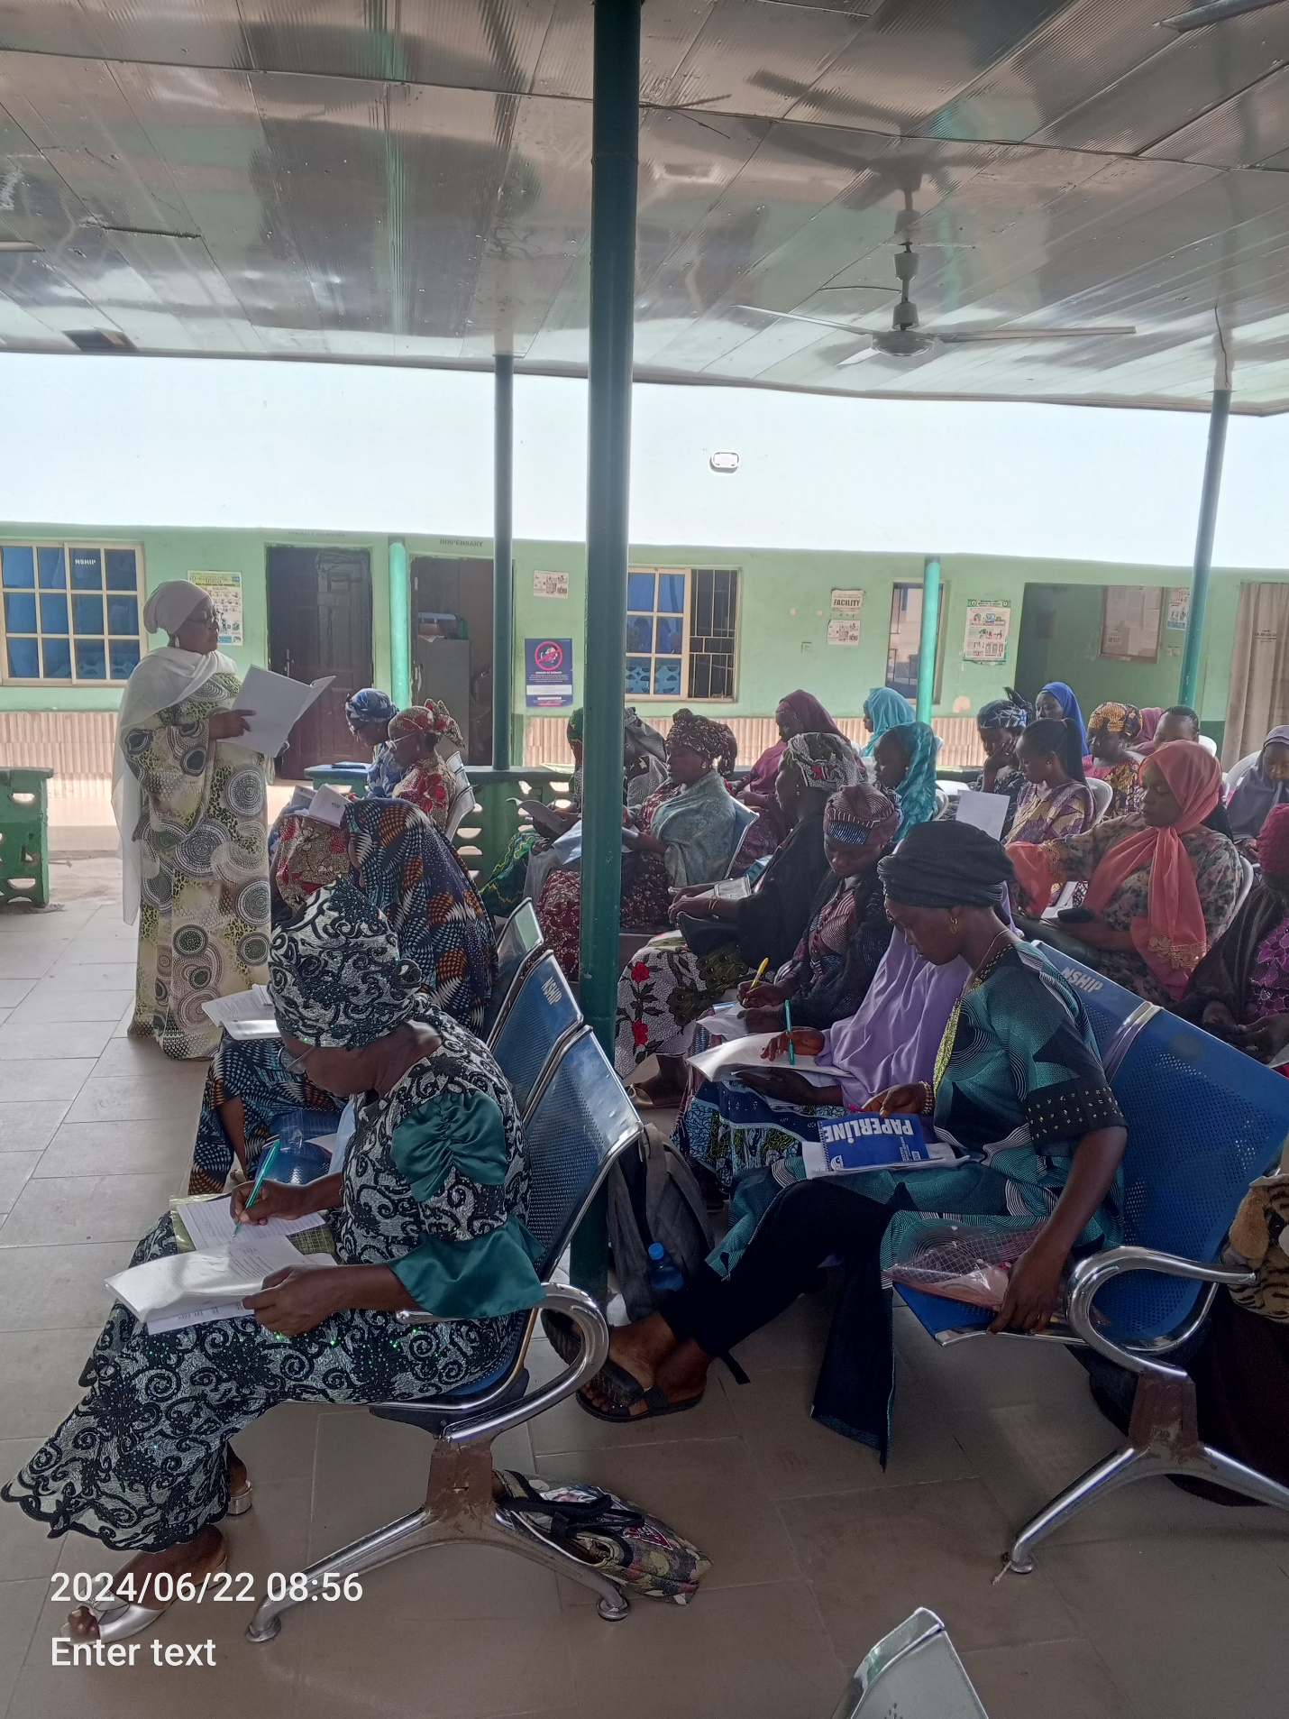
CLMS at Yola North

