ADAMAWA STATE PLANNING COMMISSION
In Partnership with UNICEF Nigeria

UNICEF ACTIVITY REPORT 2025
Consolidated Report of UNICEF-Supported Programme Activities
Adamawa State | January – November 2025

Submitted by:
Adamawa State Planning Commission (ASPC)
Secretariat – State Committee on Food and Nutrition (SCFN)
Jimeta-Yola, Adamawa State, Nigeria

SECTION 1

STATE COMMITTEE ON FOOD AND NUTRITION (SCFN) MEETING — 2ND QUARTER, MAY 2025

1.1 Background and Context
The State Committee on Food and Nutrition (SCFN) convened its 2nd Quarter meeting on 29th May, 2025, at the State Planning Commission Conference Hall, Jimeta-Yola. The meeting was chaired by the Permanent Secretary, Adamawa State Planning Commission, Mal. Tanimu Habu, who welcomed members and acknowledged their sustained commitment to combating malnutrition in the state.
The Chairman noted that the 1st Quarter meeting had been deferred due to circumstances beyond the Commission's control, and that the 2nd Quarter session would serve a dual purpose of reviewing planned activities and setting the stage for critical upcoming interventions.

1.2 Key Agenda and Deliberations
The central agenda of the meeting was the planned establishment of the Local Government Committee on Food and Nutrition (LGCFN) across all 21 LGAs in Adamawa State, scheduled to commence in June 2025. After thorough deliberation, the following resolutions were reached:
- The Secretariat was directed to write formal letters to all 21 LGA Chairmen requesting the constitution of Local Government Committees on Food and Nutrition, with a directive to notify the ASPC in writing upon establishment.
- Inaugural ceremonies for the LGCFN would be conducted across the three senatorial zones, with LGAs converging at their respective zonal headquarters as follows:
- Northern Senatorial Zone: Mubi North, Mubi South, Maiha, Michika, and Madagali LGAs
- Southern Senatorial Zone: Numan, Guyuk, Shelleng, Lamurde, Demsa, Mayo Belwa, Jada, Ganye, and Toungo LGAs
- Central Senatorial Zone: Hong, Gombi, Song, Girei, Yola North, Yola South, and Fufore LGAs

1.3 Expected Outputs and Achievements
- Participants achieved a common understanding of the need to establish the LGCFN across all 21 LGAs.
- Participants gained better knowledge of the importance and operational mandate of the LGCFN.
- Participants acknowledged and appreciated the contributions of UNICEF to nutrition activities in the state.

1.4 Recommendations and Way Forward
- Formation and establishment of the LGCFN across all 21 LGAs to be coordinated by the SCFN Secretariat in collaboration with UNICEF.
- Dispatch of formal letters to all 21 LGA Chairmen to constitute their respective committees and formally notify ASPC upon establishment.
- Convening of inaugural ceremonies at the three senatorial zone headquarters.

1.5 Photo Gallery
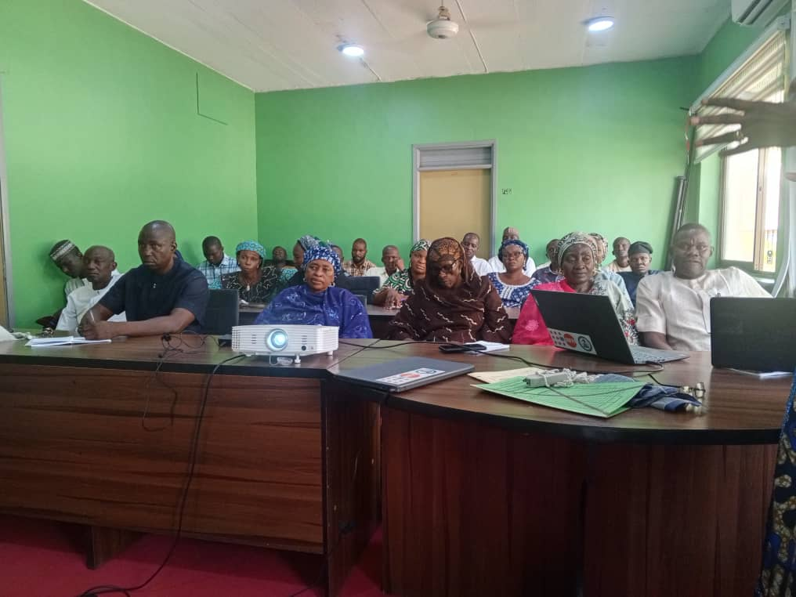

SECTION 2:

FOUR-DAY WORKSHOP FOR ADAMAWA STATE HOUSE OF ASSEMBLY MEMBERS AND 21 LGA CHAIRMEN ON NUTRITION FINANCING — MAY 2025

2.1 Background
Adamawa State, like many regions in Nigeria, faces significant nutrition challenges, particularly among children under five years of age. Malnutrition remains a critical public health concern contributing to high rates of stunting, wasting, and micronutrient deficiencies. Poor dietary practices, inadequate healthcare access, food insecurity, and low awareness of optimal infant and young child feeding have exacerbated the situation. Despite various interventions, funding for nutrition has remained inadequate and inconsistent.
The Adamawa State Planning Commission, as the Secretariat for both the SCFN and LGCFN as stipulated in the State Food and Nutrition Policy document, engaged Members of the State House of Assembly and Chairmen/Vice Chairpersons of all 21 LGAs to advocate for the unlocking of resources in support of nutrition activities at the local government level.

2.2 Objectives
- Increase awareness: Educate Members of the House of Assembly and LGA Chairmen on the current nutrition situation, including malnutrition trends and funding gaps.
- Advocate for Resource Mobilization: Encourage LGAs to prioritize nutrition financing through the state budget and innovative mechanisms.
- Promote investment in the Child Nutrition Matching Grant (CNMG): Highlight the benefits of co-funding nutrition interventions through state and local government partnership.
- Strengthen Legislative Action: Develop a legislative framework that supports sustainable financing for nutrition programmes.
- Develop a Commitment Plan: Secure LGA legislative commitment to increase and release budgetary allocations for nutrition.

2.3 Key Resolutions — Legislative Commitments
- Ensure the establishment of dedicated budget lines for nutrition activities across all relevant Ministries, Departments, and Agencies (MDAs).
- Ensure increased budgetary provisions to scale up nutrition interventions across the state.
- Collaborate with UNICEF to facilitate legislation that extends paid maternity leave from 3 to 6 months, allowing nursing mothers adequate time for exclusive breastfeeding.
- Ensure the creation of dedicated nutrition budget lines in all 21 LGAs.
- All Honourable Members of the House of Assembly agreed to commit N10 million each from their Constituency Projects Funds to support nutrition interventions across the state.

2.4 Key Resolutions — LGA Chairmen's Commitments
- All LGA Chairmen to allocate budgets, ensure timely release, and efficient utilization of nutrition funds in the 2026 budget.
- Establishment of the Local Government Committee on Food and Nutrition (LGCFN) in all 21 LGAs.
- All LGA Chairmen to incorporate nutrition interventions through the 2025 supplementary budget to address immediate malnutrition challenges.
- ALGON to partner with the State Planning Commission on donor interventions at the local government level.
- Domestication of 6-month paid maternity leave at the local government level.
- Establishment of crèches in all 21 LGAs.
- The Vice Chairpersons to coordinate nutrition activities within the LGCFN, with Chairmen providing oversight functions.

2.5 Methodology
- Participants received an overview of nutrition activities in Adamawa State.
- Facilitated discussions, plenary sessions, and working group consultations.

2.6 Meeting Outputs
- Common understanding among participants on nutrition challenges and opportunities in the state.
- Better knowledge on legislative support for nutrition financing, including commitment to the Child Nutrition Matching Grant.
- Concrete resolution on increasing and timely release of nutrition budgets.
- Common knowledge on the development of an Action Plan for LGA legislative oversight and accountability on nutrition financing.
- Proactive measures proposed to strengthen the partnership between the State Assembly, executive arm, local governments, and development partners to sustain funding for nutrition programmes.

2.7 Recommendations and Way Forward
- Implement key resolutions reached on food and nutrition intervention.
- Facilitate the implementation of a budget line item for food and nutrition at the local government level.
- Facilitate legislation extending paid maternity leave from 3 to 6 months at the local government level.

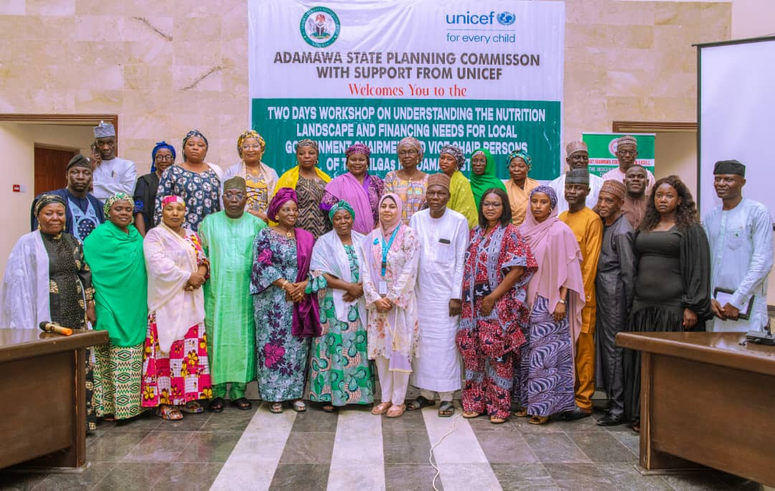
Photo Gallery
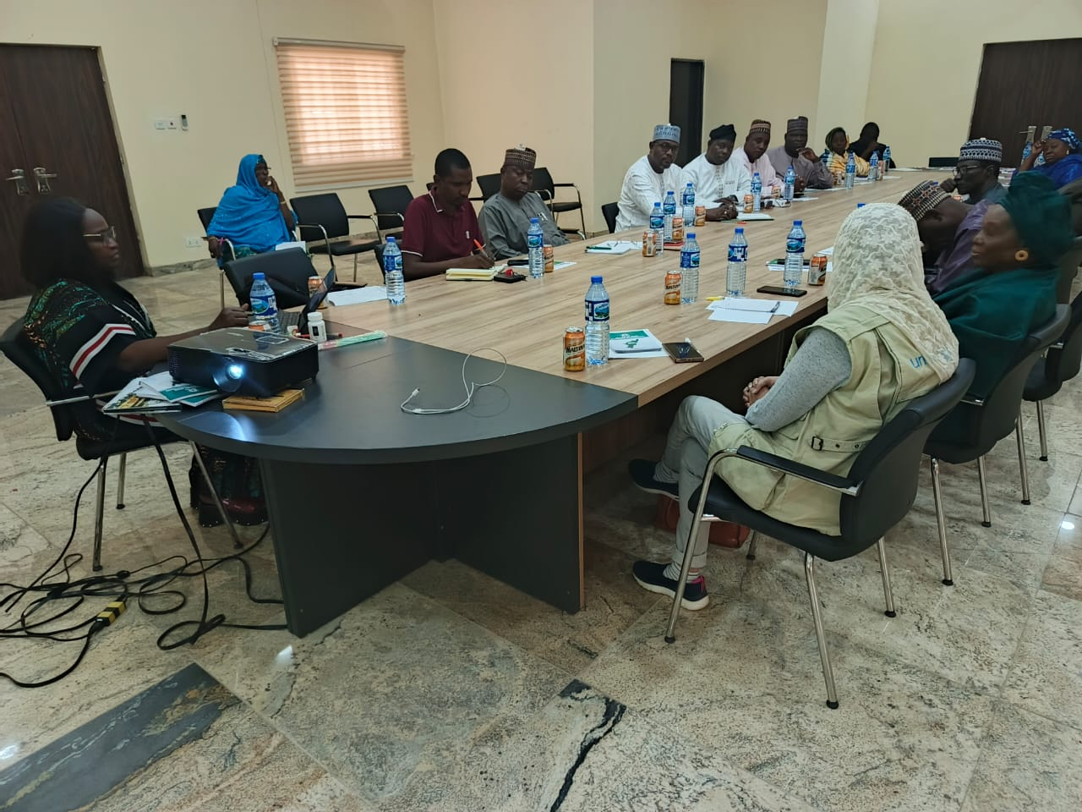

SECTION 3:

ONE-DAY RESCHEDULED WORKSHOP FOR 21 LGA CHAIRMEN ON UNLOCKING RESOURCES FOR FOOD AND NUTRITION — JULY 2025

3.1 Background
Following the initial four-day workshop in May 2025, a rescheduled one-day session was convened on 29th July, 2025, at the Deputy Governor's Conference Hall, Jimeta-Yola, to reinforce commitments and address outstanding action points from the LGA Chairmen regarding nutrition resource mobilization. The workshop brought together Chairmen and Vice Chairpersons from all 21 LGAs, along with representatives of the State House of Assembly and development partners.

3.2 Objectives
- Increase awareness on malnutrition trends and funding gaps at the LGA level.
- Advocate for resource mobilization through the state budget and innovative financing mechanisms.
- Promote investment in the Child Nutrition Matching Grant (CNMG).
- Strengthen legislative action to support sustainable financing for nutrition programmes.
- Secure LGA legislative commitment to increase and release budgetary allocations for nutrition.

3.3 Key Resolutions
- All LGA Chairmen to allocate budgets, ensure timely release, and efficient utilization of nutrition funds in the 2026 budget.
- Establishment of the LGCFN in all 21 LGAs.
- All LGA Chairmen to incorporate nutrition interventions through the 2025 supplementary budget to address immediate malnutrition challenges.
- ALGON to partner with the State Planning Commission on donor interventions at the local government level.
- Domestication of 6-month paid maternity leave at the local government level.
- Establishment of crèches in all 21 LGAs.
- Vice Chairpersons to coordinate nutrition activities within the LGCFN, with Chairmen providing oversight functions.

3.4 Meeting Outputs
- Common understanding among participants on nutrition challenges and opportunities in Adamawa State.
- Better knowledge on nutrition financing, including commitment to the Child Nutrition Matching Grant.
- Concrete resolution on increasing and timely release of nutrition budgets.
- Common knowledge on the development of an Action Plan for LGA legislative oversight and accountability.
- Proactive measures proposed for a strengthened partnership between the State Assembly, executive arm, LGAs, and development partners.

3.5 Recommendations and Way Forward
- Implement key resolutions reached on food and nutrition intervention at the LGA level.
- Facilitate the implementation of a budget line item for food and nutrition at the local government level.
- Facilitate legislation extending paid maternity leave from 3 to 6 months at the local government level.

Photo Gallery

SECTION 4:

TWO-DAY ADVOCACY VISIT, TOWN HALL MEETING AND TRAINING ON THE NUTRITION 774 INITIATIVE — OCTOBER 2025

4.1 Introduction
Malnutrition remains a significant public health and development challenge in Adamawa State, with adverse effects on health outcomes, educational attainment, and economic productivity. The state continues to face high rates of undernutrition, micronutrient deficiencies, and other nutrition-related challenges. To accelerate progress towards improved nutrition outcomes, it is imperative to strengthen interventions at the Local Government level and with stakeholders to plan, implement, and monitor both nutrition-sensitive and nutrition-specific interventions across the state.

4.2 Nutrition 774 Objectives
- Improved food security and diet quality
- Boost nutrition outcomes at all levels
- Reduce malnutrition rates across the 774 LGAs
- Strengthen multi-sectoral governance
- Improve nutrition-sensitive practices

4.3 Expected Outcomes
- Enhanced governance and prioritization of nutrition programmes at the local level
- Increased access to affordable, nutritious food for vulnerable populations
- Improved community awareness and education on nutrition
- Increased agency and flexibility for women in household nutrition decision-making
- Strengthened integration of nutrition and health services, leading to improved health outcomes

4.4 Town Hall Meeting, Inauguration and Technical Sessions
The Stakeholders' Town Hall Meeting on the Nutrition 774 Initiative was convened on 7th October, 2025, at 10:00 a.m., in the Banquet Hall of the Government House, Yola. The session marked a significant milestone with the formal inauguration of the Adamawa State Committee on Nutrition (SCN) by Her Excellency, the Deputy Governor, Professor Kaletapwa George Farauta. The meeting brought together key stakeholders and participants drawn from all 21 Local Government Areas, State Ministries, Departments and Agencies, development partners, and community-based organizations actively engaged in nutrition and social protection efforts across the state.
The representative of the Nutrition 774 Initiative from the Office of the Vice President, Ms. Uju Rochas Okorocha, articulated the overarching goals, structure, and operational framework of the initiative. She underscored that the initiative seeks to deliver sustainable nutrition solutions and promote equitable dietary interventions targeted at vulnerable populations, with the overarching objective of eliminating malnutrition across all 21 LGAs of Adamawa State. She further commended the Adamawa State Government for its commitment, as evidenced by its endorsement and participation in the Compact Signing during the official national launch held on 20th February 2025 at the National Economic Council (NEC).

4.5 Objectives of the Meeting and Workshop
- Officially launch and domesticate the Nutrition 774 Initiative in Adamawa State
- Strengthen multisectoral coordination and planning for nutrition at both State and Local Government levels
- Build the capacity of key officers on budgeting, monitoring, and evaluation of nutrition programmes
- Develop an actionable State Nutrition Plan with clear indicators and defined budgetary commitments
- Identify vulnerable groups and establish intervention priorities to guide implementation

Photo Gallery
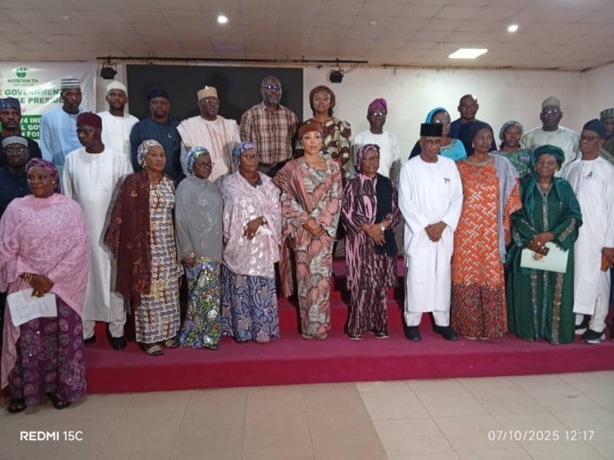 | 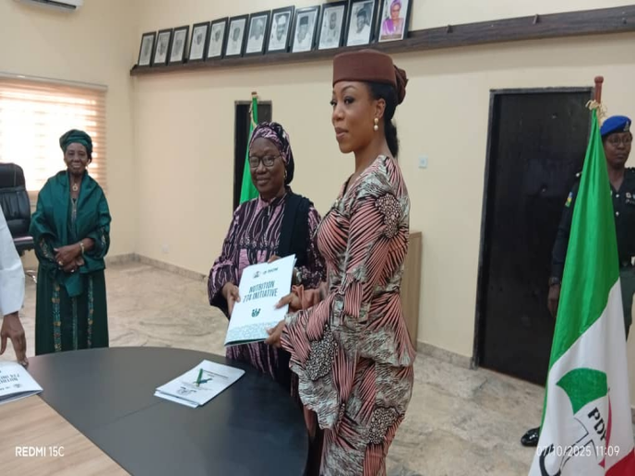

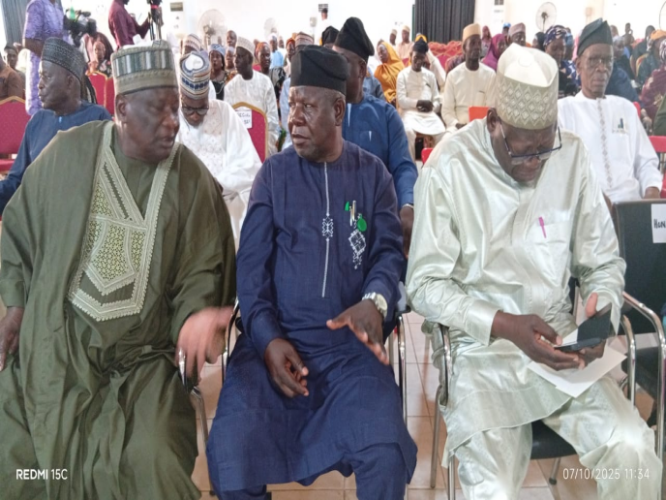 | 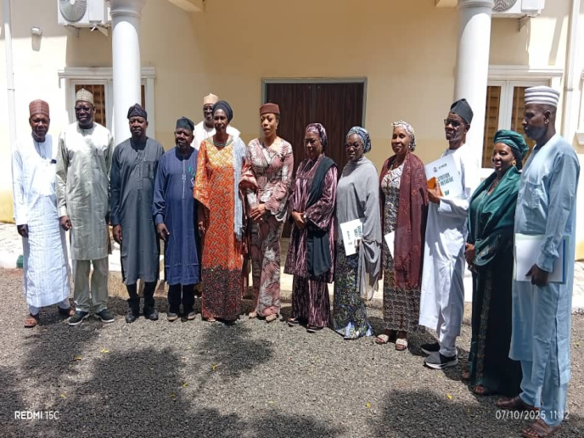

SECTION 5:

2025 END-OF-YEAR PROGRAMME REVIEW AND 2025–2027 WORKPLAN CONSULTATIONS FOR ADAMAWA AND TARABA STATES — NOVEMBER 2025

5.1 Introduction
The End-of-Year (EYR) Review Meeting was held on 4th November, 2025, at Homtel Hotel and Derivatives, Barracks Road, Jimeta-Yola, Adamawa State. The meeting served as an annual interactive forum between UNICEF and implementing partners from Adamawa and Taraba States, to review activities carried out in 2025, assess progress, identify challenges, and propose solutions. It also provided a platform for collaboration, idea sharing, collective problem-solving, improved coordination, and enhanced implementation mechanisms for better programme outcomes in both states.

5.2 Welcome Remarks and Keynote Addresses
The keynote address was delivered by the Executive Chairman of the Adamawa State Planning Commission (ASPC), ably represented by the Permanent Secretary, Alhaji Tanibu Buba. The Permanent Secretaries of the Ministry of Local Government Affairs and Entrepreneurship, the Executive Chairman of ADSPHCDA, and the Executive Secretary of the Taraba State Primary Health Care Development Agency (TSPHCDA), Dr. Tukura N. Nyigwa, jointly acknowledged the invaluable support UNICEF has provided to both states across critical sectors including Health, Education, Nutrition, Child Protection, WASH, and Social Protection.
The Chief of the UNICEF Nigeria Bauchi Field Office, Dr. Nuzhat Rafique, reiterated UNICEF's commitment to improving coordination and implementation mechanisms for better programme outcomes and effective service delivery in both states. The Honourable Commissioner of Education, Dr. Umar Garba Pella, who formally declared the workshop open, underscored UNICEF's laudable contributions across multiple sectors and looked forward to deepened collaboration in the years ahead.

5.3 Objectives
- Enhance the efficiency and effectiveness of programme implementation mechanisms in Adamawa and Taraba States.
- Improve service delivery outcomes in both states.
- Improve coordination and implementation mechanisms for better programme outcomes.
- Improve evidence-based decision-making in addressing identified gaps and challenges.

5.4 Methodology
- Participants reviewed programme implementations in Adamawa and Taraba States, sector by sector.
- Facilitated discussions, plenary sessions, and structured question-and-answer exchanges.

5.5 Outputs of the Meeting
- Participants achieved a common understanding of coordination mechanisms, improving the efficiency and effectiveness of programme implementation by implementing partners in both states.
- Participants gained better knowledge on sector-by-sector performance, challenges, and innovations as presented by sector specialists.
- Common understanding was reached on key adjustments to 2025 work plans.
- Participants gained better knowledge of key work priorities for 2026.
- Funding needs for identified work priorities were reviewed and documented.

5.6 Recommendations and Way Forward
- Training and retraining of programme officers for improved efficiency and effectiveness in programme implementation by implementing partners in both states.
- Review of the meeting timeframe to two days instead of one day to allow for more comprehensive deliberations.
- Harmonization of key work priorities for the 2026 programme plans by UNICEF.
- UNICEF to increase its presence and engagement across all sectors in Taraba State.

Photo Gallery
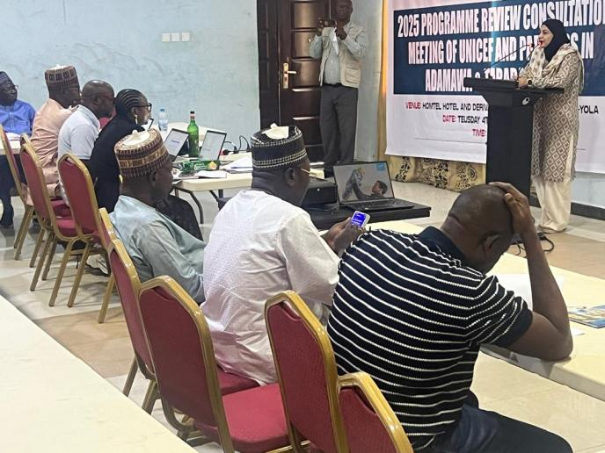 | 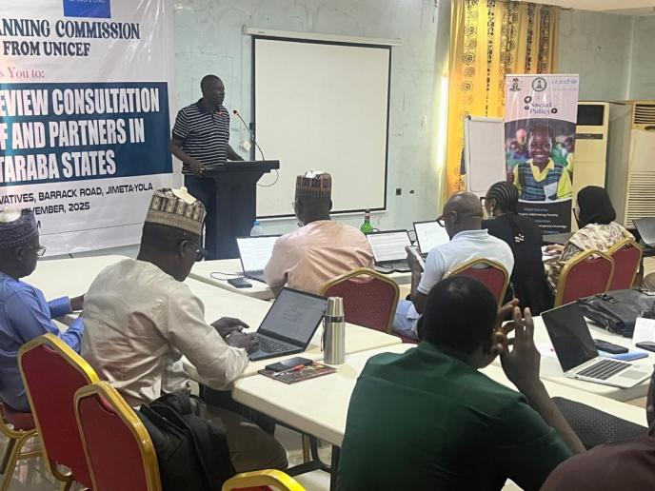

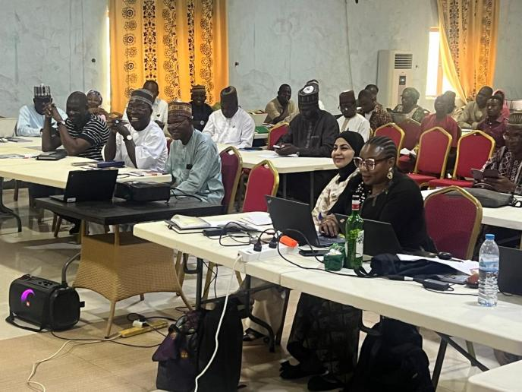 | 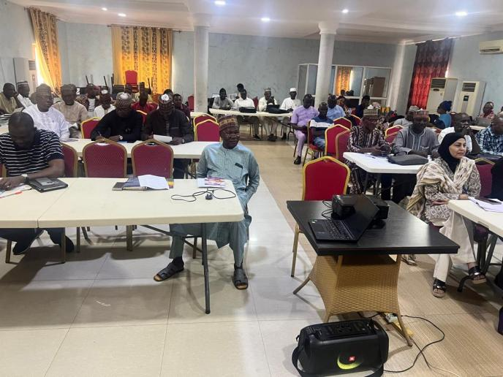
SECTION 6: CONSOLIDATED SUMMARY OF 2025 PROGRAMME ACTIVITIES
The table below provides a consolidated overview of all UNICEF-supported activities implemented by the Adamawa State Planning Commission in 2025:

S/N | Activity | Date | Venue | Participants | Key Outcome
1 | SCFN 2nd Quarter Meeting | 29 May 2025 | ASPC Conf. Hall, Yola | SCFN Members | Resolved to establish LGCFN in all 21 LGAs
2 | 4-Day Workshop: House of Assembly & LGA Chairmen on Nutrition Financing | 12–15 May 2025 | Conf. Hall, Govt. House, Yola | Hon. Members, 21 LGA Chairmen/VPs | Legislative & LGA commitments secured; N10m/member pledged
3 | Rescheduled 1-Day Workshop: 21 LGA Chairmen on Unlocking Resources | 29 Jul. 2025 | Dep. Gov. Conf. Hall, Yola | 21 LGA Chairmen/VPs | Renewed commitments; supplementary budget action agreed
4 | Town Hall Meeting & Training: Nutrition 774 Initiative | 7–8 Oct. 2025 | Govt. House & Nyako Centre, Yola | All 21 LGAs, MDAs, Dev. Partners | SCN inaugurated; State Nutrition Plan development initiated
5 | End-of-Year Review & 2025–2027 Workplan Consultations | 4 Nov. 2025 | Homtel Hotel, Yola | Adamawa & Taraba IP reps, UNICEF | 2025 progress reviewed; 2026 priorities harmonized

6.1 Overall Achievements
- Five major UNICEF-supported activities successfully implemented across Adamawa State in 2025.
- Formal establishment and inauguration of the Local Government Committee on Food and Nutrition (LGCFN) across all 21 LGAs in Adamawa State.
- Inaugural inauguration of the Adamawa State Committee on Nutrition (SCN) under the Nutrition 774 Initiative.
- Legislative commitments secured from all Members of the Adamawa State House of Assembly, including N10 million per member from Constituency Projects Funds for nutrition.
- LGA Chairmen commitments to allocate dedicated nutrition budget lines in 2026 and incorporate nutrition in the 2025 supplementary budget.
- Strengthened partnerships among ASPC, UNICEF, LGAs, state legislature, and community stakeholders.
- Enhanced capacity of programme officers and implementing partners across Adamawa and Taraba States.

6.2 Challenges and Lessons Learned
- Scheduling constraints led to the deferral of the SCFN 1st Quarter meeting; mechanisms to ensure timely convening should be strengthened.
- The End-of-Year Review highlighted the need to expand the meeting duration to two days for more comprehensive sector-by-sector deliberations.
- Increased UNICEF presence and technical support in Taraba State remains a priority for the 2026 programme cycle.

6.3 Way Forward
- Implementation of the Adamawa State Nutrition Plan developed under the Nutrition 774 framework.
- Operationalization of dedicated nutrition budget lines in all 21 LGAs.
- Monitoring of legislative commitments made by the Adamawa State House of Assembly.
- Continuation of UNICEF-supported capacity building and technical assistance in 2026.
- Regular SCFN and LGCFN quarterly meetings to track progress and address emerging challenges.
- Harmonization and roll-out of the 2025–2027 Work Plan priorities across Adamawa and Taraba States

