LICENCES RECORDS FROM AUGUST, 2021 TO DECEMBER, 2025

S/N | NAME OF COMPANY | LOCATION | CLEARANCE FOR CONSENT LETTER | LICENCE/LEASE
1 | Fombina Grassroot Development Association | Fufore | Ministry of Mineral Resources Development | Mining Cadastre Office
2 | Fombina Artisanal Miners | Fufore | Ministry of Mineral Resources Development | Mining Cadastre Office
3 | Kautal Hoore Engineering Service | Fufore | Ministry of Mineral Resources Development | Mining Cadastre Office
4 | Jawal Project Ltd | Mayo-Belwa | Ministry of Mineral Resources Development | Mining Cadastre Office
5 | Jawal Project Ltd | Toungo | Ministry of Mineral Resources Development | Mining Cadastre Office
6 | Jawal Project Ltd | Ganye | Ministry of Mineral Resources Development | Mining Cadastre Office
7 | Drangon Abundant International Ltd | Jada L | Ministry of Mineral Resources Development | Mining Cadastre Office
8 | Chubado Murtar Chosen Globan Concept Ltd |  | Ministry of Mineral Resources Development | Mining Cadastre Office
9 | Haskala Investment | Jada | Ministry of Mineral Resources Development | Mining Cadastre Office
10 | Haskala Investment | Mayo –Belwa | Ministry of Mineral Resources Development | Mining Cadastre Office
11 | Haskala Investment | Ganye | Ministry of Mineral Resources Development | Mining Cadastre Office
12 | Nakazuba Nig. Ltd | Ganye | Ministry of Mineral Resources Development | Mining Cadastre Office
13 | Albarku Metals Ltd | Jada | Ministry of Mineral Resources Development | Mining Cadastre Office
14 | Albarku Metals Ltd |  | Ministry of Mineral Resources Development | Mining Cadastre Office
15 | Haskala Investment | Jada | Ministry of Mineral Resources Development | Mining Cadastre Office
16 | Haskala Investment | Mayo –Belwa | Ministry of Mineral Resources Development | Mining Cadastre Office
17 | Haskala Investment | Ganye | Ministry of Mineral Resources Development | Mining Cadastre Office
18 | Haskala Investment |  | Ministry of Mineral Resources Development | Mining Cadastre Office
19 | Dragon Abundant International Trading Ltd | Ganye | Ministry of Mineral Resources Development | Mining Cadastre Office
20 | Zebra Energy Nig. Ltd | Toungo | Ministry of Mineral Resources Development | Mining Cadastre Office
21 | Zebra Energy Nig. Ltd | Ganye | Ministry of Mineral Resources Development | Mining Cadastre Office
22 | Zebra Energy Nig. Ltd | Mubi South | Ministry of Mineral Resources Development | Mining Cadastre Office
23 | Zebra Energy Nig. Ltd | Lamurde | Ministry of Mineral Resources Development | Mining Cadastre Office
24 | Mamudi Role Gems International | Mayo – Belwa | Ministry of Mineral Resources Development | Mining Cadastre Office
25 | Wiz China Worldwide Engineering Ltd | Fufore | Ministry of Mineral Resources Development | Mining Cadastre Office
26 | Thermo Dynamo | Mayo-Belwa | Ministry of Mineral Resources Development | Mining Cadastre Office
27 | Energy Ltd | Mayo-Belwa | Ministry of Mineral Resources Development | Mining Cadastre Office
28 | SRVI Nig. Ltd | Mayo –Belwa | Ministry of Mineral Resources Development | Mining Cadastre Office
29 | Timothy John | Fufore | Ministry of Mineral Resources Development | Mining Cadastre Office
30 | Mtalip Industry Nig. Ltd | Mayo-Belwa | Ministry of Mineral Resources Development | Mining Cadastre Office
31 | Gorgeous Metals Maters Ltd | Toungo | Ministry of Mineral Resources Development | Mining Cadastre Office
32 | Gorgeous Metals Makers Ltd | Mayo-Belwa | Ministry of Mineral Resources Development | Mining Cadastre Office
33 | Gorgeous Metals Makers Ltd | Mayo – Belwa | Ministry of Mineral Resources Development | Mining Cadastre Office
34 | Gorgeous Metals Makers Ltd | Ganye | Ministry of Mineral Resources Development | Mining Cadastre Office
35 | Kasugula Mines Ltd | Jada | Ministry of Mineral Resources Development | Mining Cadastre Office
36 | Ikechukwu Ogwu | Mayo-Belwa | Ministry of Mineral Resources Development | Mining Cadastre Office
37 | Curkart Mining Ltd (Kasugula) | Jada | Ministry of Mineral Resources Development | Mining Cadastre Office
38 | Curkart Mining Ltd | Jada | Ministry of Mineral Resources Development | Mining Cadastre Office
39 | Jengle Integrated Service Nig. Ltd | Jada | Ministry of Mineral Resources Development | Mining Cadastre Office
40 | Ragorde Investment Nig. Ltd | Fufore | Ministry of Mineral Resources Development | Mining Cadastre Office
41 | Kasugula Mining Co. Ltd | Mayo-Belwa | Ministry of Mineral Resources Development | Mining Cadastre Office
42 | Curkart Mining Lt | Mayo-Belwa | Ministry of Mineral Resources Development | Mining Cadastre Office
43 | Kenlin Multitude Ventures | Hong | Ministry of Mineral Resources Development | Mining Cadastre Office
44 | Ragorde Investment Nig. Ltd | Jada | Ministry of Mineral Resources Development | Mining Cadastre Office
45 | Albarku Metals Ltd | Jada | Ministry of Mineral Resources Development | Mining Cadastre Office
46 | Sanur Global Enterprise | Hong | Ministry of Mineral Resources Development | Mining Cadastre Office
47 | Equatorial Metals & Stones Ltd | Mayo Belwa | Ministry of Mineral Resources Development | Mining Cadastre Office
48 | Rokobat Enterprise | Ganye | Ministry of Mineral Resources Development | Mining Cadastre Office
49 | Jamilu Mohammed | Toungo | Ministry of Mineral Resources Development | Mining Cadastre Office
50 | Blue Sapphire Security Ltd | Jada | Ministry of Mineral Resources Development | Mining Cadastre Office
51 | Ragorde Investment Nig. Ltd | Toungo | Ministry of Mineral Resources Development | Mining Cadastre Office
52 | Ragorde Investment Nig. Ltd | Toungo | Ministry of Mineral Resources Development | Mining Cadastre Office
53 | Ahmed Aliyu Abubakar | Girei | Ministry of Mineral Resources Development | Mining Cadastre Office
54 | Ugo Capital Multi-Trade | Mayo-Belwa | Ministry of Mineral Resources Development | Mining Cadastre Office
55 | Blue Sapphire Security Ltd | Mubi North | Ministry of Mineral Resources Development | Mining Cadastre Office
56 | Blue Sapphire Security Ltd | Hong | Ministry of Mineral Resources Development | Mining Cadastre Office
57 | Curkart Mining Co. Ltd | Ganye | Ministry of Mineral Resources Development | Mining Cadastre Office
58 | Global Projecting System Ltd | Mayo-Belwa | Ministry of Mineral Resources Development | Mining Cadastre Office
59 | Zebra Energy Nig. Ltd | Mubi South | Ministry of Mineral Resources Development | Mining Cadastre Office
60 | Zebra Energy Nig. Ltd | Mubi North | Ministry of Mineral Resources Development | Mining Cadastre Office
61 | Haskala Investment | Jada | Ministry of Mineral Resources Development | Mining Cadastre Office
62 | Donadon Global Enterprise | Ganye | Ministry of Mineral Resources Development | Mining Cadastre Office
63 | Gorgeous Metals Makers Ltd | Jada | Ministry of Mineral Resources Development | Mining Cadastre Office
64 | El-Caster Miners and Realtors Ltd | Jada | Ministry of Mineral Resources Development | Mining Cadastre Office
65 | Rokobat Enterprises | Toungo | Ministry of Mineral Resources Development | Mining Cadastre Office
66 | Wanru Mining Nig. Ltd | Jada | Ministry of Mineral Resources Development | Mining Cadastre Office
67 | Wanru Mining Nig. Ltd | Jada | Ministry of Mineral Resources Development | Mining Cadastre Office
68 | Rhodium Ltd | Fufore | Ministry of Mineral Resources Development | Mining Cadastre Office
69 | D.I.D Al’amana Nig. Ltd | Fufore | Ministry of Mineral Resources Development | Mining Cadastre Office
70 | Al-Malik Integrated Service Ltd | Jada | Ministry of Mineral Resources Development | Mining Cadastre Office
71 | Wanrun Mining Company Ltd | Fufore | Ministry of Mineral Resources Development | Mining Cadastre Office
72 | Masyn Multitude Nig. Ltd | Hong | Ministry of Mineral Resources Development | Mining Cadastre Office
73 | Gasarle Enterprises | Hong | Ministry of Mineral Resources Development | Mining Cadastre Office
74 | Greenfield Master Aggregator | Mayo-Belwa | Ministry of Mineral Resources Development | Mining Cadastre Office
75 | Penam Borthers International Service | Jada | Ministry of Mineral Resources Development | Mining Cadastre Office
76 | Gasarle Enterprises | Song | Ministry of Mineral Resources Development | Mining Cadastre Office
77 | Jimfache Mobile Belt Mining Ltd | Gombi | Ministry of Mineral Resources Development | Mining Cadastre Office
78 | Zebra Energy Nig. Ltd | Toungo | Ministry of Mineral Resources Development | Mining Cadastre Office
79 | Muzadabi Mining Ltd | Gombi | Ministry of Mineral Resources Development | Mining Cadastre Office
80 | Adamawa Mining Company Ltd  (Ministry of Mineral Resources Development) | Mayo-Belwa | Ministry of Mineral Resources Development | Mining Cadastre Office
81 | Adamawa Mining Company Ltd  (Ministry of Mineral Resources Development) | Mayo-Belwa | Ministry of Mineral Resources Development | Mining Cadastre Office
82 | Adamawa Mining Company Ltd  (Ministry of Mineral Resources Development) | Song | Ministry of Mineral Resources Development | Mining Cadastre Office
83 | Adamawa Mining Company Ltd  (Ministry of Mineral Resources Development) | Ganye | Ministry of Mineral Resources Development | Mining Cadastre Office
84 | Adamawa Mining Company Ltd  (Ministry of Mineral Resources Development) | Toungo | Ministry of Mineral Resources Development | Mining Cadastre Office
85 | Adamawa Mining Company Ltd  (Ministry of Mineral Resources Development) | Mubi South | Ministry of Mineral Resources Development | Mining Cadastre Office
86 | Adamawa Mining Company Ltd  (Ministry of Mineral Resources Development) | Mubi South | Ministry of Mineral Resources Development | Mining Cadastre Office
87 | Adamawa Mining Company Ltd  (Ministry of Mineral Resources Development) | Mubi South | Ministry of Mineral Resources Development | Mining Cadastre Office
88 | Maidankali Minerals and Mines Enterprises | Shelleng | Ministry of Mineral Resources Development | Mining Cadastre Office
90 | Maidankali Minerals and Mines Enterprises | Mubi North | Ministry of Mineral Resources Development | Mining Cadastre Office
91 | Trac International Ltd | Hong | Ministry of Mineral Resources Development | Mining Cadastre Office
92 | Trac International Ltd | Hong | Ministry of Mineral Resources Development | Mining Cadastre Office
93 | Mamudi Mining Nig. Co. Ltd | Hong | Ministry of Mineral Resources Development | Mining Cadastre Office
94 | Mamudi Mining Nig. Co. Ltd | Hong | Ministry of Mineral Resources Development | Mining Cadastre Office
95 | Zebra Energy Nig Ltd |  | Ministry of Mineral Resources Development | Mining Cadastre Office
96 | Penam Brother Int’l Service | Hong | Ministry of Mineral Resources Development | Mining Cadastre Office
97 | Jamilu Mohammed & Mines | Toungo | Ministry of Mineral Resources Development | Mining Cadastre Office
98 | Albarku Metals Ltd | Hong | Ministry of Mineral Resources Development | Mining Cadastre Office
99 | Trac International Ltd | Hong | Ministry of Mineral Resources Development | Mining Cadastre Office
100 | Trac International Ltd | Hong | Ministry of Mineral Resources Development | Mining Cadastre Office
101 | Trac International Ltd | Hong | Ministry of Mineral Resources Development | Mining Cadastre Office
102 | Mubi Mining Cooperative Society Ltd | Madagali | Ministry of Mineral Resources Development | Mining Cadastre Office
103 | Onazi Ltd | Madagali | Ministry of Mineral Resources Development | Mining Cadastre Office
104 | Trac International Ltd | Hong | Ministry of Mineral Resources Development | Mining Cadastre Office
105 | Trac International Ltd | Hong | Ministry of Mineral Resources Development | Mining Cadastre Office
106 | Drigimi Nig Ltd | Michika | Ministry of Mineral Resources Development | Mining Cadastre Office
107 | Drigimi Nig. Ltd | Michika | Ministry of Mineral Resources Development | Mining Cadastre Office
108 | Ragorde Investment Nig. Ltd | Hong | Ministry of Mineral Resources Development | Mining Cadastre Office
109 | Mamudi Mining Co. Ltd | Hong | Ministry of Mineral Resources Development | Mining Cadastre Office
120 | Mamudi Mining Co. Ltd | Hong | Ministry of Mineral Resources Development | Mining Cadastre Office
121 | Samparoco Nig. Ltd | Mubi North | Ministry of Mineral Resources Development | Mining Cadastre Office
122 | Elkayase Enterprise | Mayo-Belwa | Ministry of Mineral Resources Development | Mining Cadastre Office
123 | A.M. Mining & Export Nig. Ltd | Hong | Ministry of Mineral Resources Development | Mining Cadastre Office
124 | A.M. Mining & Export Nig. Ltd | Hong | Ministry of Mineral Resources Development | Mining Cadastre Office
125 | Sichros Nig. Ltd | Hong | Ministry of Mineral Resources Development | Mining Cadastre Office
126 | Trac International Ltd | Mayo Belwa | Ministry of Mineral Resources Development | Mining Cadastre Office
127 | Trac International Ltd | Mayo Belwa | Ministry of Mineral Resources Development | Mining Cadastre Office
128 | Adamawa Mining Co. Ltd | Michika | Ministry of Mineral Resources Development | Mining Cadastre Office
129 | Adamawa Mining Co. Ltd | Michika | Ministry of Mineral Resources Development | Mining Cadastre Office
130 | Dabija Global Ventures Nig. Ltd | Mubi North | Ministry of Mineral Resources Development | Mining Cadastre Office
131 | Dabija Global Ventures Nig. Ltd | Mubi North | Ministry of Mineral Resources Development | Mining Cadastre Office
132 | Trac International Ltd | Hong | Ministry of Mineral Resources Development | Mining Cadastre Office
133 | Adamawa Mining Co. Ltd | Fufore | Ministry of Mineral Resources Development | Mining Cadastre Office
134 | Lichpin Synergy Concept Ltd | Jada | Ministry of Mineral Resources Development | Mining Cadastre Office
135 | Oval Global Engeering Services | Mubi North | Ministry of Mineral Resources Development | Mining Cadastre Office
136 | Apidarya Nig. Ltd | Madagali | Ministry of Mineral Resources Development | Mining Cadastre Office
137 | Decent Mines Ltd | Madagali | Ministry of Mineral Resources Development | Mining Cadastre Office
138 | Wudco Mining Ltd | Madagali | Ministry of Mineral Resources Development | Mining Cadastre Office
139 | Task Team Integrated Consult Ltd | Fufore | Ministry of Mineral Resources Development | Mining Cadastre Office
140 | Mines craft Synergy Resources Ltd | Toungo | Ministry of Mineral Resources Development | Mining Cadastre Office
141 | Rain Kana Geological Services Nig. Ltd | Madagali | Ministry of Mineral Resources Development | Mining Cadastre Office
142 | Immoja Enterprise Nig. Ltd | Ganye | Ministry of Mineral Resources Development | Mining Cadastre Office
143 | Datong Industries Co. Ltd | Hong | Ministry of Mineral Resources Development | Mining Cadastre Office
144 | Immoja Enterprise Nig. Ltd | Hong | Ministry of Mineral Resources Development | Mining Cadastre Office
145 | Immoja Industries Nig. Ltd | Maiha | Ministry of Mineral Resources Development | Mining Cadastre Office
146 | H Mining Ltd | Hong | Ministry of Mineral Resources Development | Mining Cadastre Office
147 | Excell Allicence | Madagali | Ministry of Mineral Resources Development | Mining Cadastre Office
148 | Zebra Energy Nig. Ltd | Mubi North | Ministry of Mineral Resources Development | Mining Cadastre Office
149 | Datong Industries Co. Ltd | Mubi South | Ministry of Mineral Resources Development | Mining Cadastre Office
150 | Zurfi Mining Ltd | Madagali | Ministry of Mineral Resources Development | Mining Cadastre Office
151 | At Gongola Group of Companies | Madagali | Ministry of Mineral Resources Development | Mining Cadastre Office
152 | West burg Mining Ltd | Maiha | Ministry of Mineral Resources Development | Mining Cadastre Office
153 | West burg Mining Ltd | Mubi South | Ministry of Mineral Resources Development | Mining Cadastre Office
154 | Jonsyn Global Intergrated Resources Nig. Ltd | Hong | Ministry of Mineral Resources Development | Mining Cadastre Office
155 | Bungel Nig. Ltd | Maiha | Ministry of Mineral Resources Development | Mining Cadastre Office
156 | Malik Mining Enterpries Nig. Ltd |  | Ministry of Mineral Resources Development | Mining Cadastre Office
157 | Elipse Nig. Ltd | Ganye | Ministry of Mineral Resources Development | Mining Cadastre Office
158 | Tytron Exploration Ltd | Ganye | Ministry of Mineral Resources Development | Mining Cadastre Office
159 | Divitex Comercio | Hong | Ministry of Mineral Resources Development | Mining Cadastre Office
160 | Zurfi Mining Ltd | Song | Ministry of Mineral Resources Development | Mining Cadastre Office
161 | Vickeny E-Commerce | Yola North | Ministry of Mineral Resources Development | Mining Cadastre Office
162 | West burge Mining Ltd | Song | Ministry of Mineral Resources Development | Mining Cadastre Office
163 | Trac International Ltd | Ganye | Ministry of Mineral Resources Development | Mining Cadastre Office
164 | Mezzo Forte Prospect | Mubi South | Ministry of Mineral Resources Development | Mining Cadastre Office
165 | SA Fiducia Mines Ltd | Hong | Ministry of Mineral Resources Development | Mining Cadastre Office
166 | Vickeny E-Commerce Ltd | Yola North | Ministry of Mineral Resources Development | Mining Cadastre Office
167 | El-Caster Mines & Realtors Ltd | Hong | Ministry of Mineral Resources Development | Mining Cadastre Office
168 | El-Caster Mines & Realtors Ltd | Song | Ministry of Mineral Resources Development | Mining Cadastre Office
169 | Penan Brother Int’l Service | Mayo Belwa | Ministry of Mineral Resources Development | Mining Cadastre Office
170 | Global Resources Nig. Ltd | Song | Ministry of Mineral Resources Development | Mining Cadastre Office
171 | Abu-Khairat Agroket Enterprise Nig. Ltd | Ganye | Ministry of Mineral Resources Development | Mining Cadastre Office
172 | Penan Brother Int’l Service | Ganye | Ministry of Mineral Resources Development | Mining Cadastre Office
173 | Mamudi Mining co. Ltd | Mayo- Belwa | Ministry of Mineral Resources Development | Mining Cadastre Office
174 | Mamudi Mining co. Ltd | Song | Ministry of Mineral Resources Development | Mining Cadastre Office
175 | Kaluba Covers Ltd | Hong | Ministry of Mineral Resources Development | Mining Cadastre Office
176 | Ragorde Investment | Fufore | Ministry of Mineral Resources Development | Mining Cadastre Office
177 | Mblatava Nig. Ltd | Hong | Ministry of Mineral Resources Development | Mining Cadastre Office
178 | Plam Global Resources | Jada | Ministry of Mineral Resources Development | Mining Cadastre Office
179 | Plam Global Resources | Jada | Ministry of Mineral Resources Development | Mining Cadastre Office
180 | Plam Global Resources | Jada | Ministry of Mineral Resources Development | Mining Cadastre Office
181 | Memphis Mines Ltd | Ganye | Ministry of Mineral Resources Development | Mining Cadastre Office
182 | Kasugula Mines Ltd | Toungo | Ministry of Mineral Resources Development | Mining Cadastre Office
183 | Curkant Mining co. Ltd | Ganye | Ministry of Mineral Resources Development | Mining Cadastre Office
184 | Abudeen Mining Co. Ltd | Toungo | Ministry of Mineral Resources Development | Mining Cadastre Office
185 | Kasugila Mines Ltd | Jada | Ministry of Mineral Resources Development | Mining Cadastre Office
186 | Memphis mines Ltd | Jada | Ministry of Mineral Resources Development | Mining Cadastre Office
187 | Rimsa Commodity Trading Ltd | Maiha | Ministry of Mineral Resources Development | Mining Cadastre Office
188 | MDI Mines Ltd | Jada | Ministry of Mineral Resources Development | Mining Cadastre Office
189 | Hamshatere & Son General Enterprise | Michika | Ministry of Mineral Resources Development | Mining Cadastre Office
190 | RK Wandiya International Ltd | Ganye | Ministry of Mineral Resources Development | Mining Cadastre Office
191 | Haskala Investment | Jada | Ministry of Mineral Resources Development | Mining Cadastre Office
192 | Trac International Ltd | Fufore | Ministry of Mineral Resources Development | Mining Cadastre Office
193 | Stable Amaco Nig. Ltd | Mayo-Belwa | Ministry of Mineral Resources Development | Mining Cadastre Office
194 | Desolid A.T.C Mining & Suppliers Ltd | Song | Ministry of Mineral Resources Development | Mining Cadastre Office
195 | Ant Mines & General Services Ltd | Song | Ministry of Mineral Resources Development | Mining Cadastre Office
196 | Habam Agro & Mines Ltd | Song | Ministry of Mineral Resources Development | Mining Cadastre Office
197 | Earth wish Nigeria Ltd | Song | Ministry of Mineral Resources Development | Mining Cadastre Office
198 | Yelwa properties Ltd | Fufore | Ministry of Mineral Resources Development | Mining Cadastre Office
199 | Prime Crest Mining Ltd | Song | Ministry of Mineral Resources Development | Mining Cadastre Office
200 | Prime Crest Mining Ltd | Fufore | Ministry of Mineral Resources Development | Mining Cadastre Office
201 | Prime Crest Mining Ltd | Song | Ministry of Mineral Resources Development | Mining Cadastre Office
202 | Prime Crest Mining Ltd | Song | Ministry of Mineral Resources Development | Mining Cadastre Office
203 | Nordatech Energy Ltd | Song | Ministry of Mineral Resources Development | Mining Cadastre Office
204 | Hamshatere & Sons General Enterprise | Michika | Ministry of Mineral Resources Development | Mining Cadastre Office
205 | BaseWatch Concept Nigeria Ltd | Toungo | Ministry of Mineral Resources Development | Mining Cadastre Office
206 | Mountain & Rivers Co. Nig. Ltd | Ganye | Ministry of Mineral Resources Development | Mining Cadastre Office
207 | Alamtika Voyage Oil & Gas Ltd | Ganye | Ministry of Mineral Resources Development | Mining Cadastre Office
208 | Luteng Investment Ltd | Yola South | Ministry of Mineral Resources Development | Mining Cadastre Office
209 | Samparaco Nig. Ltd | Song | Ministry of Mineral Resources Development | Mining Cadastre Office
210 | Alhaji Maiwada | Fufore | Ministry of Mineral Resources Development | Mining Cadastre Office
211 | Hassan Hussain Merchant Enterprise Ltd | Jada | Ministry of Mineral Resources Development | Mining Cadastre Office
212 | Prime crest Mining | Mayo Belwa | Ministry of Mineral Resources Development | Mining Cadastre Office
213 | Gudumawa Int’l Bizness Ltd | Toungo | Ministry of Mineral Resources Development | Mining Cadastre Office
214 | EXXO Mining Ltd | Fufore | Ministry of Mineral Resources Development | Mining Cadastre Office
215 | Plam Global Resources | Jada | Ministry of Mineral Resources Development | Mining Cadastre Office
216 | Plam Global Resources | Jada | Ministry of Mineral Resources Development | Mining Cadastre Office
217 | Plam Global Resources | Jada | Ministry of Mineral Resources Development | Mining Cadastre Office
218 | Hadeem Energy Concept Ltd | Maiha | Ministry of Mineral Resources Development | Mining Cadastre Office
219 | Btg Energy & Natural Resources Ltd | Jada | Ministry of Mineral Resources Development | Mining Cadastre Office
220 | Trac International Ltd | Ganye | Ministry of Mineral Resources Development | Mining Cadastre Office
221 | MSG Mining Co. Ltd | Maiha | Ministry of Mineral Resources Development | Mining Cadastre Office
222 | Xterra Metals & Minerals | Song | Ministry of Mineral Resources Development | Mining Cadastre Office
223 | Xterra Metals & Minerals | Song | Ministry of Mineral Resources Development | Mining Cadastre Office
224 | Xterra Metals & Minerals | Gombi | Ministry of Mineral Resources Development | Mining Cadastre Office
225 | Xterra Metals & Minerals | Song | Ministry of Mineral Resources Development | Mining Cadastre Office
226 | Xterra Metals & Minerals | Maiha | Ministry of Mineral Resources Development | Mining Cadastre Office
227 | Xterra Metals & Minerals | Hong | Ministry of Mineral Resources Development | Mining Cadastre Office
228 | Xterra Metals & Minerals | Hong | Ministry of Mineral Resources Development | Mining Cadastre Office
229 | Xterra Metals & Minerals | Hong | Ministry of Mineral Resources Development | Mining Cadastre Office
230 | Primcrest Mining Ltd | Toungo | Ministry of Mineral Resources Development | Mining Cadastre Office
231 | Gudumawa Int’l Bizness | Fufore | Ministry of Mineral Resources Development | Mining Cadastre Office
232 | Richland Integrated PTE Nig. Ltd | Ganye | Ministry of Mineral Resources Development | Mining Cadastre Office
233 | Rain – Kana Geological Services Nig. Ltd | Yola South | Ministry of Mineral Resources Development | Mining Cadastre Office
234 | Kakada Mines Nigeria Ltd | Mayo Belwa | Ministry of Mineral Resources Development | Mining Cadastre Office
235 | Trimatalic Ltd | Lamurde | Ministry of Mineral Resources Development | Mining Cadastre Office
236 | Trimatalic Ltd | Lamurde | Ministry of Mineral Resources Development | Mining Cadastre Office
237 | Hydro Sources & Resources | Fufore | Ministry of Mineral Resources Development | Mining Cadastre Office
238 | Mufkad Mines & Investment Ltd | Fufore | Ministry of Mineral Resources Development | Mining Cadastre Office
239 | Mufkad Mines & Investment Ltd | Fufore | Ministry of Mineral Resources Development | Mining Cadastre Office
240 | Dauda Dankano Commercial Ltd | Jada | Ministry of Mineral Resources Development | Mining Cadastre Office
241 | Exxo Mining Limited | Fufore | Ministry of Mineral Resources Development | Mining Cadastre Office
242 | Goldfort Mining & Exploration Ltd | Fufore | Ministry of Mineral Resources Development | Mining Cadastre Office
243 | Goldfirst Mining & Exploration Ltd | Fufore | Ministry of Mineral Resources Development | Mining Cadastre Office
244 | Abudeen Mining Co. Ltd | Ganye | Ministry of Mineral Resources Development | Mining Cadastre Office
245 | Abudeen Mining Co. Ltd | Ganye | Ministry of Mineral Resources Development | Mining Cadastre Office
246 | Mufkad Mines & Investment Ltd | Maiha | Ministry of Mineral Resources Development | Mining Cadastre Office
247 | JDZ Multi Enterprise Nig. Ltd | Yola South | Ministry of Mineral Resources Development | Mining Cadastre Office
248 | Jangle Integrated Services Ltd | Fufore | Ministry of Mineral Resources Development | Mining Cadastre Office
249 | Jangle Integrated Services Ltd | Fufore | Ministry of Mineral Resources Development | Mining Cadastre Office
250 | Dan Zarewa Gemstone International | Jada | Ministry of Mineral Resources Development | Mining Cadastre Office
251 | Trimetalic Ltd | Toungo | Ministry of Mineral Resources Development | Mining Cadastre Office
252 | Wizechino Engineering Ltd | Ganye | Ministry of Mineral Resources Development | Mining Cadastre Office
253 | Habam Agro & Mines Limited | Fufore | Ministry of Mineral Resources Development | Mining Cadastre Office
254 | Jinrun Resources Ltd | Mayo-Belwa | Ministry of Mineral Resources Development | Mining Cadastre Office
255 | Xterra Metals & Minerals | Gombi | Ministry of Mineral Resources Development | Mining Cadastre Office
256 | Xterra Metals & Minerals | Gombi | Ministry of Mineral Resources Development | Mining Cadastre Office
257 | Mufkad Mines & Investment Ltd | Fufore | Ministry of Mineral Resources Development | Mining Cadastre Office
258 | A.G Vision Construction Nig. Ltd | Song | Ministry of Mineral Resources Development | Mining Cadastre Office
259 | Decent Mines Ltd | Madagali | Ministry of Mineral Resources Development | Mining Cadastre Office
260 | Nanakango Mines Ltd | Madagali | Ministry of Mineral Resources Development | Mining Cadastre Office
261 | Nanakango Mines Ltd | Madagali | Ministry of Mineral Resources Development | Mining Cadastre Office
262 | Nanakango Mines Ltd | Madagali | Ministry of Mineral Resources Development | Mining Cadastre Office
263 | Winners Bliss Nig. Ltd | Mayo-Belwa | Ministry of Mineral Resources Development | Mining Cadastre Office
264 | Plam Global Resources | Ganye | Ministry of Mineral Resources Development | Mining Cadastre Office
265 | Plam Global Resources | Ganye | Ministry of Mineral Resources Development | Mining Cadastre Office
266 | Plam Global Resources | Ganye | Ministry of Mineral Resources Development | Mining Cadastre Office
267 | Immoja Enterprise Nig. Ltd | Fufore | Ministry of Mineral Resources Development | Mining Cadastre Office
268 | Exxo Mining Ltd | Fufore | Ministry of Mineral Resources Development | Mining Cadastre Office
269 | Mufkad Mines & Investment Ltd | Fufore | Ministry of Mineral Resources Development | Mining Cadastre Office
270 | Hinapwa Codes Global Nig. Ltd | Lamurde | Ministry of Mineral Resources Development | Mining Cadastre Office
271 | Al-Jiteng Gana Investment Nig. Ltd | Demsa | Ministry of Mineral Resources Development | Mining Cadastre Office
272 | Reino Stone Mining Nig. Ltd | Lamurde | Ministry of Mineral Resources Development | Mining Cadastre Office
273 | Hinapwa Codes Global Nig. Ltd | Lamurde | Ministry of Mineral Resources Development | Mining Cadastre Office
274 | Full Energy Intergrated Ltd | Mayo –Belwa | Ministry of Mineral Resources Development | Mining Cadastre Office
275 | Pentahere Mining Service Ltd | Lamurde | Ministry of Mineral Resources Development | Mining Cadastre Office
276 | Zebra Energy Nig. Ltd | Michika | Ministry of Mineral Resources Development | Mining Cadastre Office
277 | Zebra Energy Nig. Ltd | Michika | Ministry of Mineral Resources Development | Mining Cadastre Office
278 | Zebra Energy Nig. Ltd | Michika | Ministry of Mineral Resources Development | Mining Cadastre Office
279 | Legend Mining Co. Ltd | Jada | Ministry of Mineral Resources Development | Mining Cadastre Office
280 | Core Drilling Ltd | Mayo-Belwa | Ministry of Mineral Resources Development | Mining Cadastre Office
281 | Core Drilling Ltd | Mayo-Belwa | Ministry of Mineral Resources Development | Mining Cadastre Office
282 | Ure Mines Ltd | Yola South | Ministry of Mineral Resources Development | Mining Cadastre Office
283 | Trac International | Ganye | Ministry of Mineral Resources Development | Mining Cadastre Office
284 | Hydro – Sources & Resources Ltd | Fufore | Ministry of Mineral Resources Development | Mining Cadastre Office
285 | Azmaf –Akmaa Mining & Multi purpose Nig. Ltd | Fufore | Ministry of Mineral Resources Development | Mining Cadastre Office
286 | Ray Trading & Mining Co. Ltd | Hong | Ministry of Mineral Resources Development | Mining Cadastre Office
287 | Shadgla Mollsa Ltd | Song | Ministry of Mineral Resources Development | Mining Cadastre Office
288 | Al- Yaman Global Concept Nig Ltd | Hong | Ministry of Mineral Resources Development | Mining Cadastre Office
289 | Zebra Energy Nig Ltd | Michika | Ministry of Mineral Resources Development | Mining Cadastre Office
290 | M.S.G Mining Co. Ltd | Fufore | Ministry of Mineral Resources Development | Mining Cadastre Office
291 | M.K Mohammed Yelwa Solid Mineral Investment Ltd | Song | Ministry of Mineral Resources Development | Mining Cadastre Office
292 | Jicen Farms Nig Ltd | Song | Ministry of Mineral Resources Development | Mining Cadastre Office
293 | Alfa Distillers & Food Processing Industry Ltd | Song | Ministry of Mineral Resources Development | Mining Cadastre Office
294 | Futodou Global Ltd | Michika | Ministry of Mineral Resources Development | Mining Cadastre Office
295 | Abba 17 Mining Co. Resources Ltd | Yola North | Ministry of Mineral Resources Development | Mining Cadastre Office
296 | Vickeny E Commerce Ltd | Hong | Ministry of Mineral Resources Development | Mining Cadastre Office
297 | Vickeny E Commerce Ltd | Song | Ministry of Mineral Resources Development | Mining Cadastre Office
298 | Core & Ore Synergy | Lamurde | Ministry of Mineral Resources Development | Mining Cadastre Office
299 | Godiya Kwada Co. Ltd | Michika | Ministry of Mineral Resources Development | Mining Cadastre Office
300 | Kayme Nig. Ltd | Fufore | Ministry of Mineral Resources Development | Mining Cadastre Office
301 | Maldeeni Mining Concept Ltd | Fufore | Ministry of Mineral Resources Development | Mining Cadastre Office
302 | Azmaf Akmaaa Mining & Multipurpose Nig Enterprise | Mayo Belwa | Ministry of Mineral Resources Development | Mining Cadastre Office
303 | Sikda Global Resources Nig Ltd | Mayo Belwa | Ministry of Mineral Resources Development | Mining Cadastre Office
304 | Miracle Processing Service Ltd | Yola North | Ministry of Mineral Resources Development | Mining Cadastre Office
305 | Umolin Ventures Ltd | Shelleng | Ministry of Mineral Resources Development | Mining Cadastre Office
306 | Hafrinu Exploration & Mining Ltd | Lamurde | Ministry of Mineral Resources Development | Mining Cadastre Office
307 | Eminent Mega Enterprise | Jada | Ministry of Mineral Resources Development | Mining Cadastre Office
308 | Abudeen Mining Co. Ltd | Ganye | Ministry of Mineral Resources Development | Mining Cadastre Office
309 | Al- Jilani Mining Co. Ltd | Hong | Ministry of Mineral Resources Development | Mining Cadastre Office
310 | Pakarika Investment Ltd | Hong | Ministry of Mineral Resources Development | Mining Cadastre Office
311 | Jas Mineral Nig. Ltd | Maiha | Ministry of Mineral Resources Development | Mining Cadastre Office

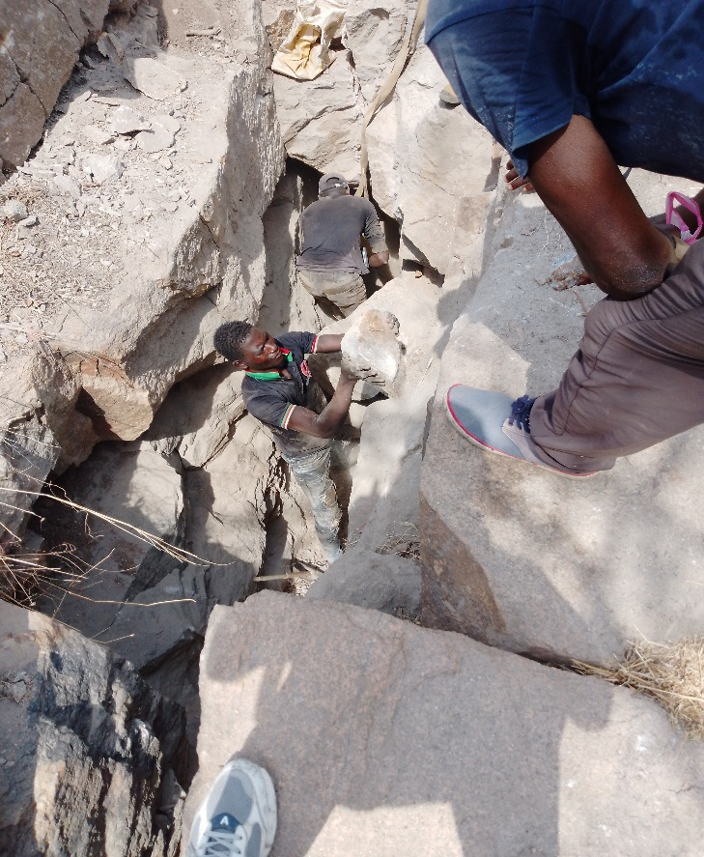
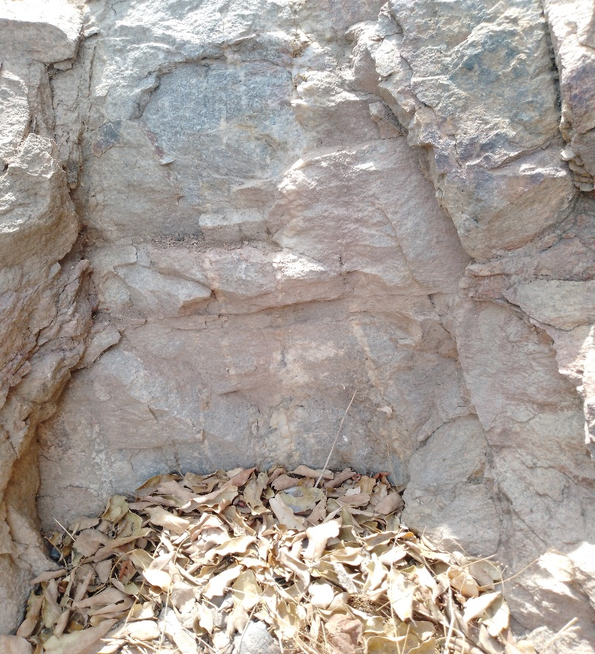
MINING SITE INSPECTION PHOTOS

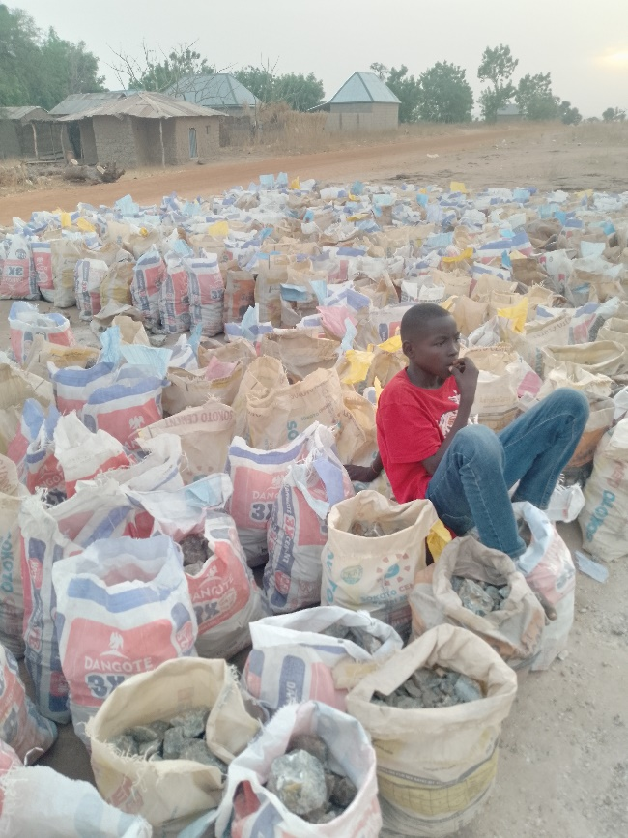
WOLFRAMITE SITE IN SERAP; FUFORE LOCAL GOVERNMENT
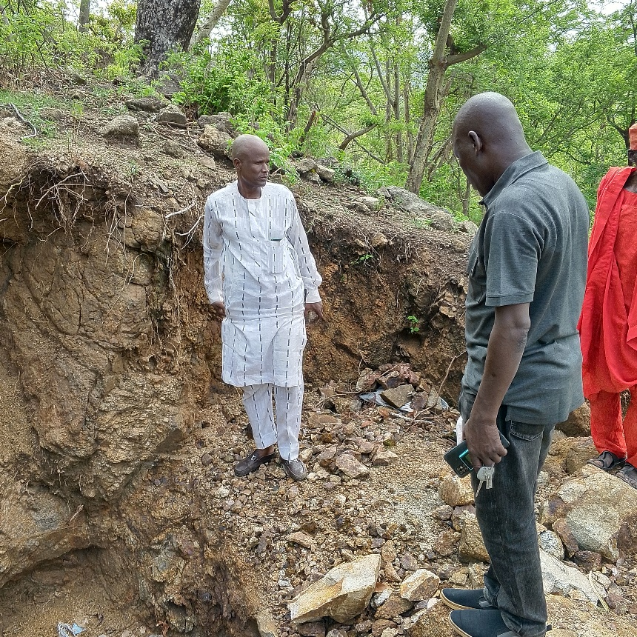
FLOURITE LOADING POINT IN WURO YANKA, SHELLENG LOCAL GOVERNMENT CHALCOPYRITE SITE IN KAIGA, YEBBI DISTRICT
GANYE LOCAL GOVERNMENT
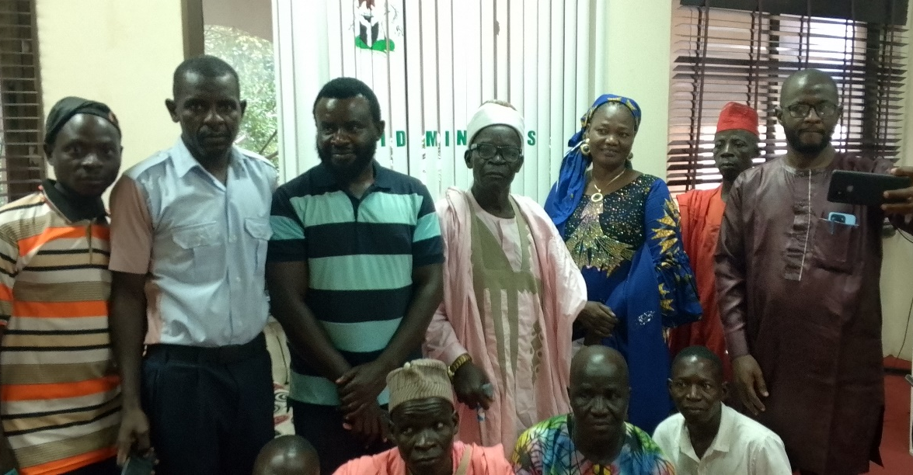
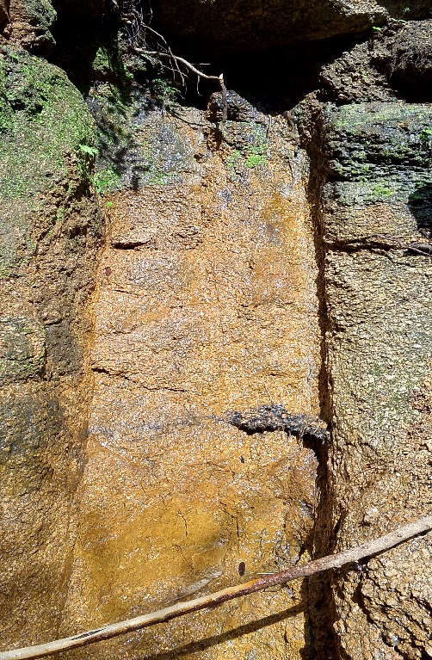
CONFLICT RESOLUTION BETWEEN KOMA ONE AND TWO WITH ELIPSE NIGERIA LIMITED AT OFFICE OF HON. COMMISIONER MINISTRY OF MINERAL RESOURCES DEVELOPMENT.

FLOURITE SITE IN JAGGU DISTRICT
GANYE LOCAL GOVERNMENT

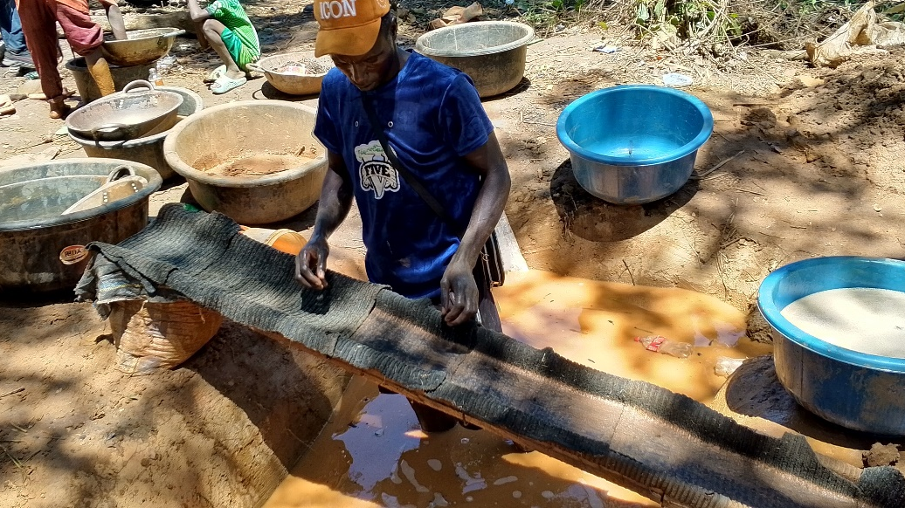
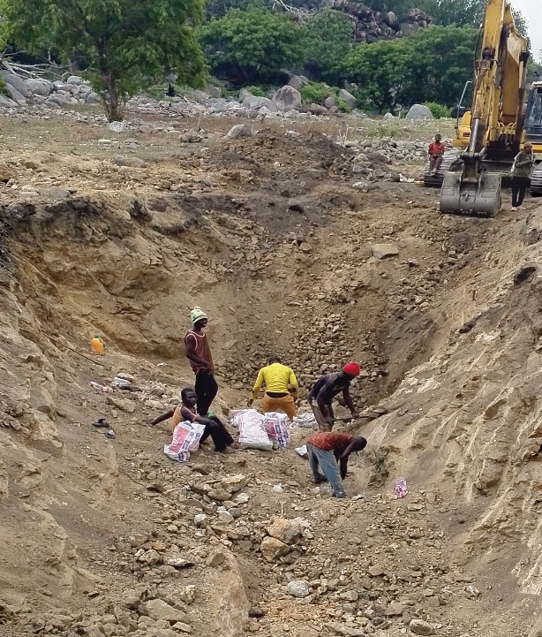
GOLD MINING AND LOCAL PROCESSING IN KOGIN BABA DISTRICT, TOUNGO LOCAL GOVERNMENT

FLOURITE MINING SITE IN WALTANDI
DISTRICT, SONG LOCAL GOVERNMENT

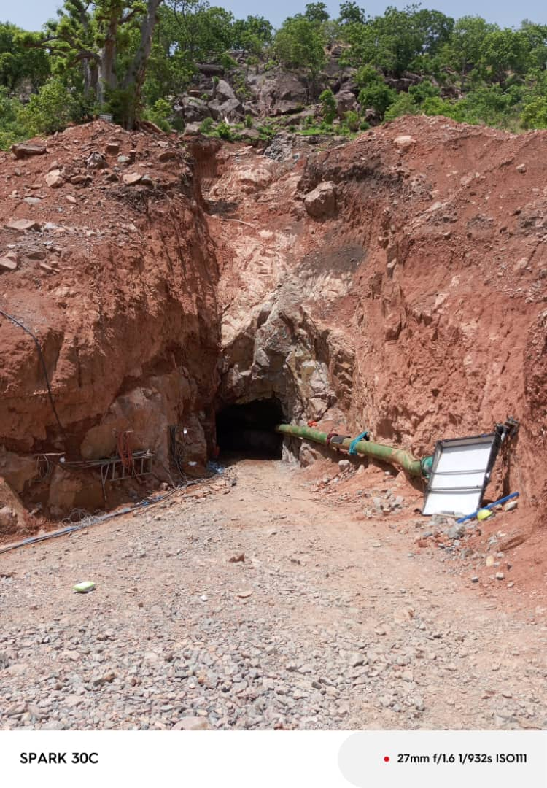
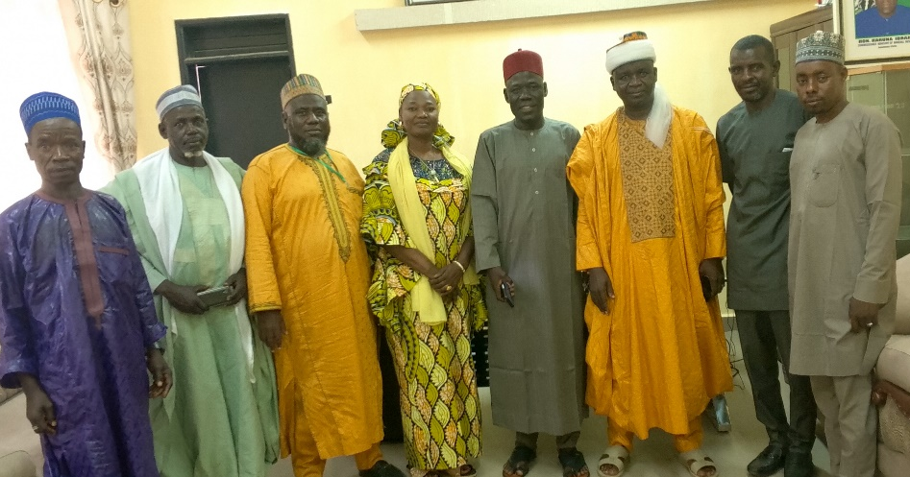
CONFLICT RESOLUSION OF GOLD MINING SITE,
IN KOGIN BABA DISTRICT, AT THE HON. COMMISSIONER MINISTRY OF MINERAL RESOURCES DEVELOPMENT.

WOLFRAMITE UNDERGROUND TUNNEL MINING
SITE IN SERAP, KUSAUFA DISTRICT, FUFORE
LOCAL GOVERNMENT

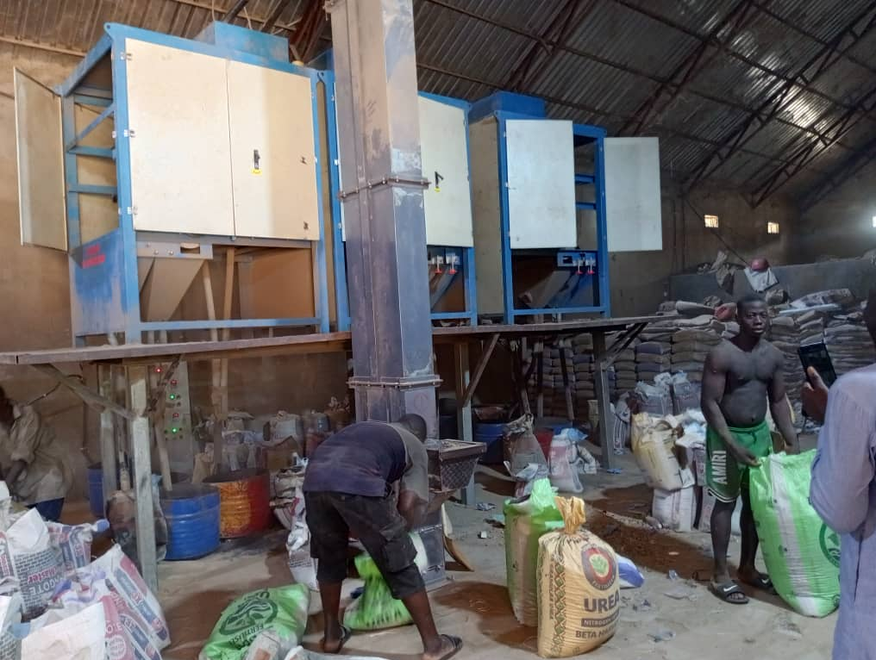
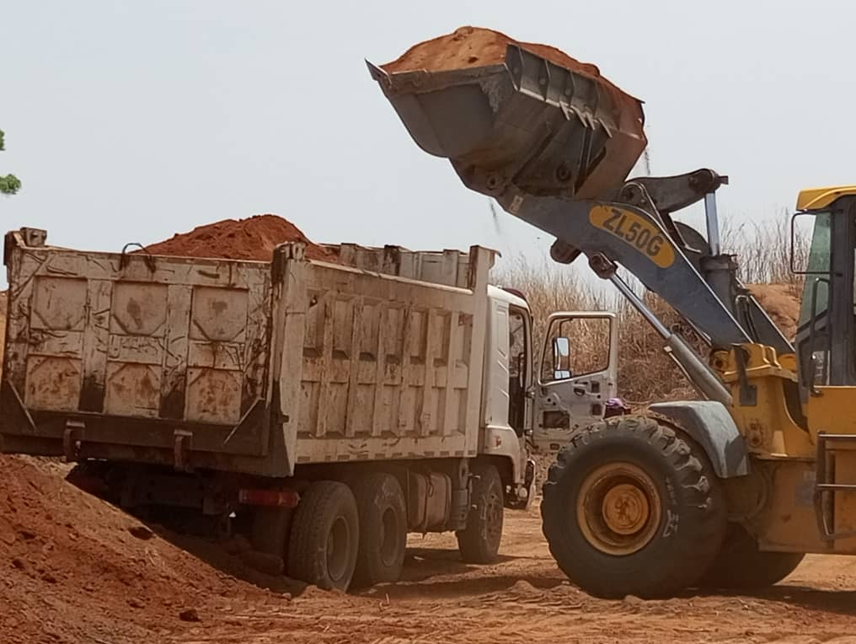

LATARITE BORROW PIT, AT MARARBA CHIGARI, MONAZITE MINERAL PROCESSING FUFORE LOCAL GOVERNMENT MILL IN JIMETA.

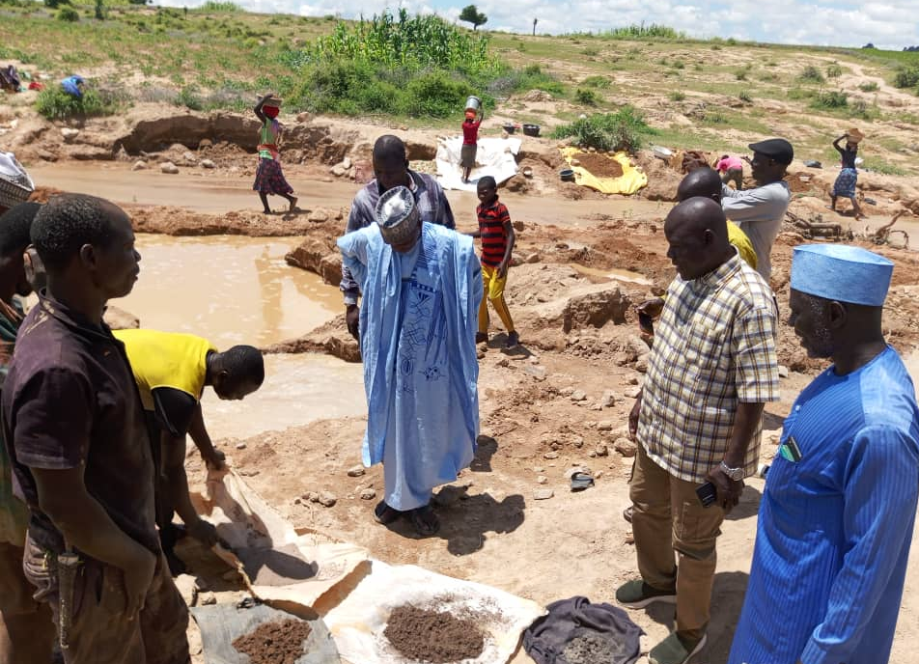
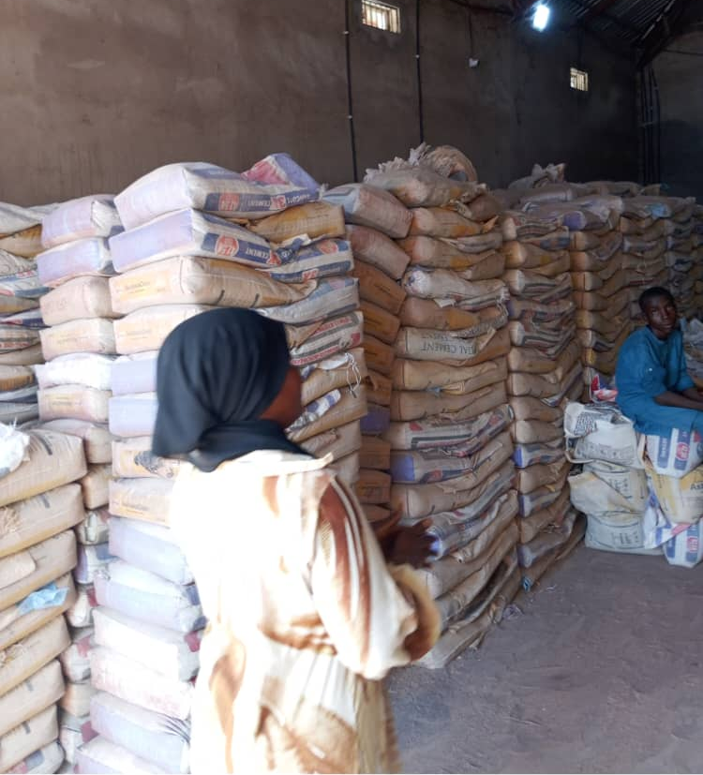
RELIEF MATERIAL TO HONG LGA
AFTER FLASH FLOOD BY INVESTTOR MONAZITE MINING SITE IN DIRMA, SONG LGA

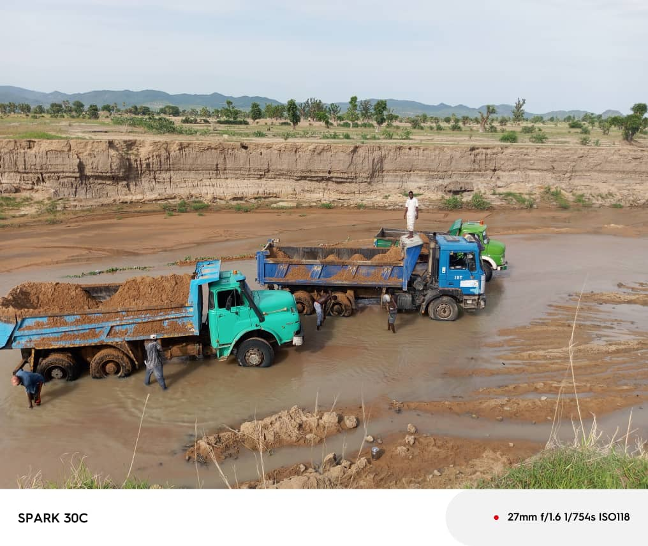
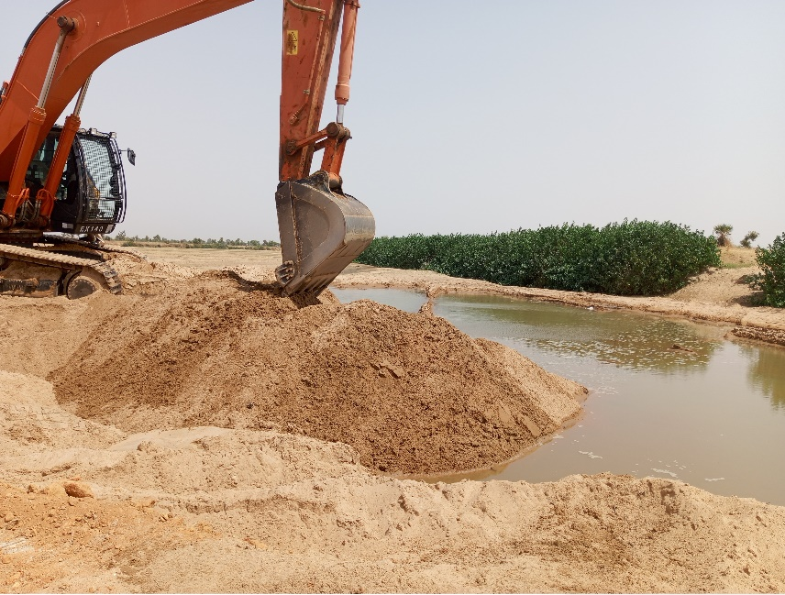

SHARP SAND LOADING POINT AT BOLE RIVER SHARP SAND LOADING POINT AT
SIDE, YOLA-SOUTH LGA NGURORE, YOLA-SOUTH LGA.

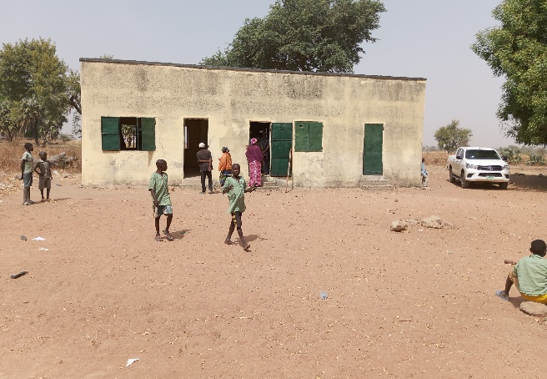
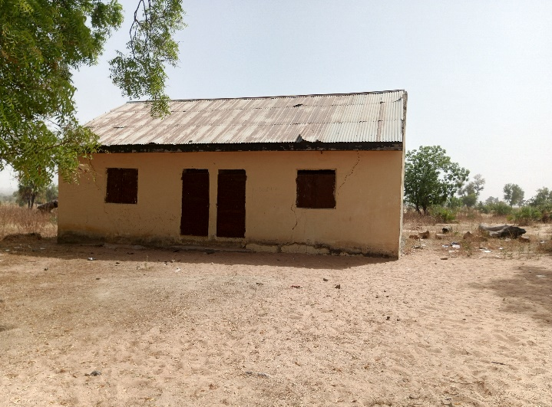
COMMUNITY DEVELOPMENT AGREEMENT PROJECT EXECUTED BY TRIACTA NIGERIA LIMITED IN SERAGU; MAYO-BELWA LGA
CLASSROOM BLOCKS

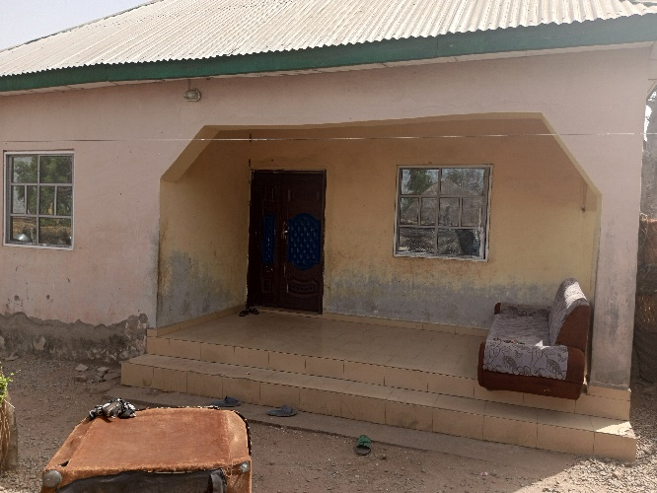

VILLAGE HEAD APARTMENT

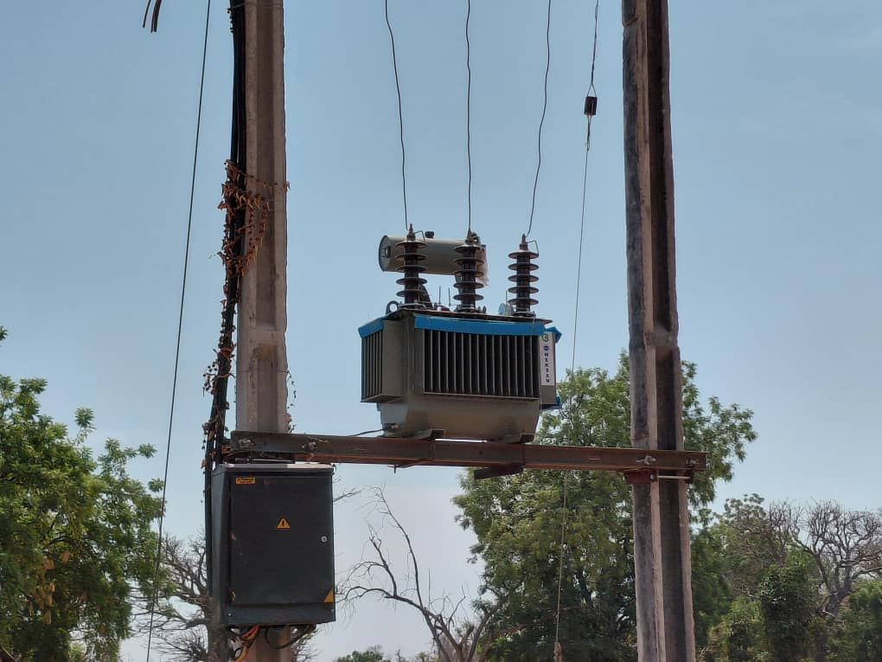
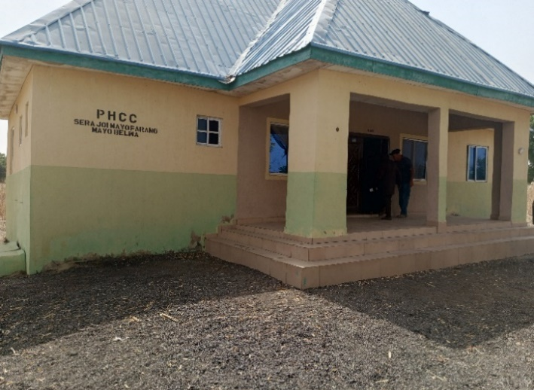

ELECTRIFICATION HOSPITAL CLINIC

