ADAMAWA STATE PLANNING COMMISSION, YOLA

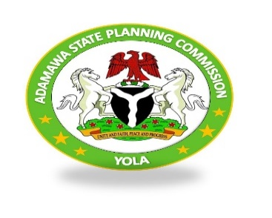
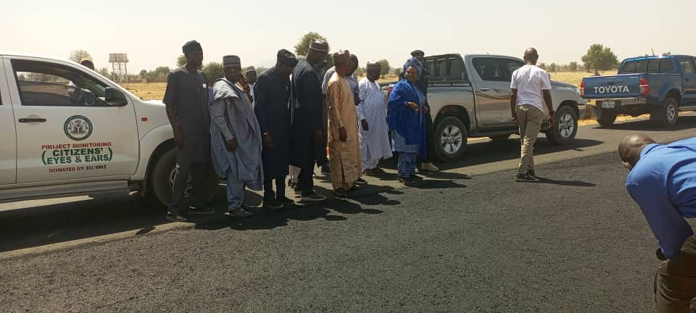
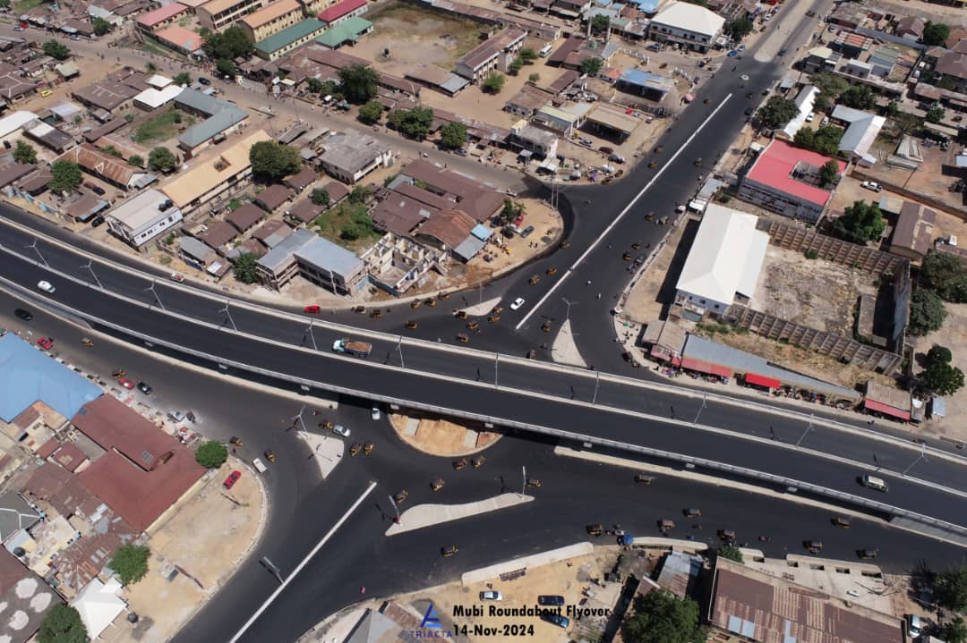

FIRST QUARTER 2025 STATE PROJECT MONITORING REPORT
JANUARY, 2025

TABLE OF CONTENT
PROJECT PAGE
- COVER PAGE ………………………………………………………………….……1
- TABLE OF CONTENT……………………………………………………………….2
- TEAM COMPOSITION ……………………………………………………………..3
- EXECUTIVE SUMMARY……………………………………………………...........4
- REMODELLING OF STATE HIGH COURT ……………………………….............5
- CONSTRUCTION OF MODERN SHOPPING COMPLEX ………………………..6
- CONSTRUCTION OF YOLA MAIN MARKET ……………………………...........7
- CONSTRUCTION OF A.A LAWAN FLYOVER …………………………………. 8
- CONSTRUCTION OF 18KM SUPER HIGHWAY ………………………………...9
- CONSTRUCTION 1000 HOUSING UNIT ……………………………...……….10
- CONSTRUCTION OF HALF GLOVER LEAF …………………..….………… 11
- CONSTRUCTION OF STORMWATER DRAINAGE …………….……………12
- CONSTRUCTION OF UNDERPASS AT BEKAJI ROUNDABOUT ………….13
- CONSTRUCTION OF STATE OF ART STADIUM …………………….……..14
- CONSTRUCTION OF FEDERAL HOUSING ROAD NETWORK…….………15
- CONSTRUCTION OF MUBI ROUNDABOUT FLYOVER …… ………..……16
- CONSTRUCTION OF YOLA NORTH MODEL SCHOOL ………………..…....17
- CONCLUSION ……………………………………………………………….…18

TEAM COMPOSITION
1). Mrs. Mary Paninga (Ph.D) ………………………………… Executive Chairman ASPC
2). Mal. Hassan M. Modibbo .....………………………………. Permanent Secretary ASPC
3). Mr. Augustine James Pella …………………… S.A to Governor on Project Monitoring
4). Mr. Abraham Murbuge ….…………………. S. A to Governor on Planning & Statistics
5). Mr. Hassan Dedan…………………………. Director of Service Delivery Improvement
6). Mrs. Farida Bukar ………...…..………………. Director of Donor Support Coordination
7). Mr. Solomon Z. Kyagya ………………………………Director of Planning & Research
8). Mrs. Joyce N. Ezikiel ………..…………………Director of Admin & Human Resources
- . Mrs. Drambi Cromwell ……………………….………. Director of Finance & Budget
- Mrs. Hassana Yakubu Papka……………………………..Principal Planning Officer
11). Mr. Patrick Yunana ………………………………………. Principal Planning Officer
14). Mrs. Hyelana’ati H. Bernard ……………………………….……. Program Analyst I
15). Patu Mohammed Tugga ……………………………………..…….Planning Officer I
16). Kpeshi Takoba …………………………………..…………Principal Planning Officer
17). Koungu Thomson ………………………..……………….. Principal Planning Officer
18) Solome Bawa ………………………………………………. Principal Planning Officer
19) Lydia Bitrus ……………………………………………. Asst. Chief Statistician Officer
20) Joy Diamond Leka ……………………............................................Information Officer
21) Saadatu Ahmed ……………………………………………. Principal Planning Officer
22) Adamu Mohammed Sadiq …………………………………. Principal Planning Officer

EXECUTIVE SUMMARY

The Monitoring and Evaluation (M&E) team from the Adamawa State Planning Commission In collaboration with the Special Adviser to the Governor of Adamawa State on Monitoring conducted a comprehensive assessment of key infrastructural projects across the state. The monitoring exercise aimed to evaluate these projects' progress, quality, and impact, ensuring they align with the state’s development goals and meet completion timelines. The team visited ongoing projects State High Court, Mubi roundabout flyover, Supper Highway, Malkohi 1000 Unit Housing Estate, Half Leaf Clover at Welcome to Yola, Stormwater Drainage at FGGC Yola, Bekaji Roundabout Underpass, State of the Art Stadium and AA Lawal flyover respectively. The Adamawa State government is making significant strides in infrastructure development, with multiple projects to improve transportation, commerce, judiciary infrastructure, and public welfare. While some projects are progressing steadily, others require urgent intervention to ensure timely completion. Continuous monitoring and collaboration among stakeholders will be essential in achieving the state's development objectives.

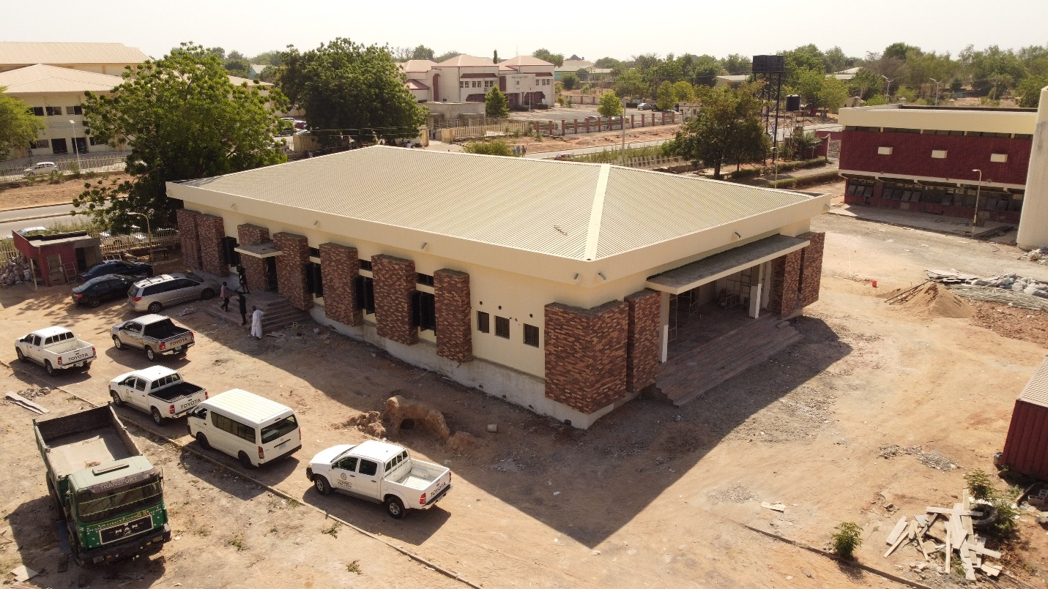

- RENOVATION OF ADAMAWA STATE HIGH COURT COMPLEX
Scope: The comprehensive remodeling of the Adamawa State High Court, which includes the construction of a new court hall, renovation of the court complex, a protocol office, worship centers, and VIP toilets. The project is designed to modernize judicial infrastructure, enhance efficiency, and provide a conducive environment for legal proceedings.
Progress: 80% completion level.
Expected Completion Date: March 2025.
Observations: The Comprehensive Remodeling of the Adamawa State High Court is progressing well, with an overall completion rate of 80%. The project remains on track for its March 2025 completion date.

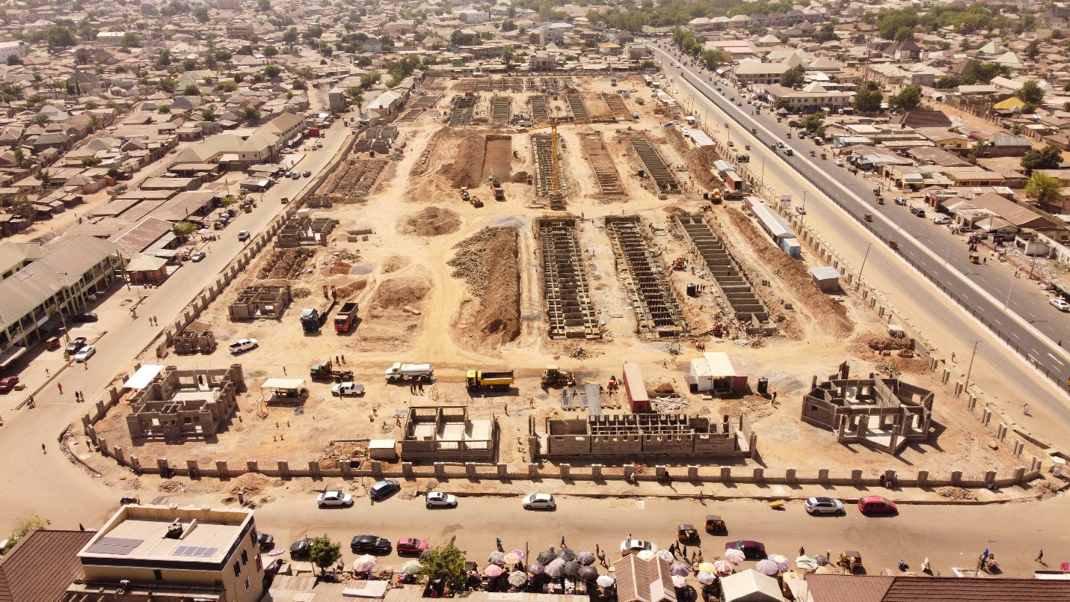
2. CONSTRUCTION OF JIMETA MODERN SHOPPING COMPLEX
Scope: The project aims to develop a commercial hub featuring modern infrastructure to support business activities, enhance economic growth, and provide essential public services. The complex includes 2 shopping mall blocks, over 2,000 small shops for petty traders, banking facilities, a police station, worship centers, a fire service station, a clinic, and a waste management system.
Progress: Ongoing (about 20% level of completion), with significant structural developments in place.
Observations: The construction work is progressing steadily, with significant advancements in structural developments. The major sections of the complex, including the shopping mall blocks and small shops, are in different stages of construction.

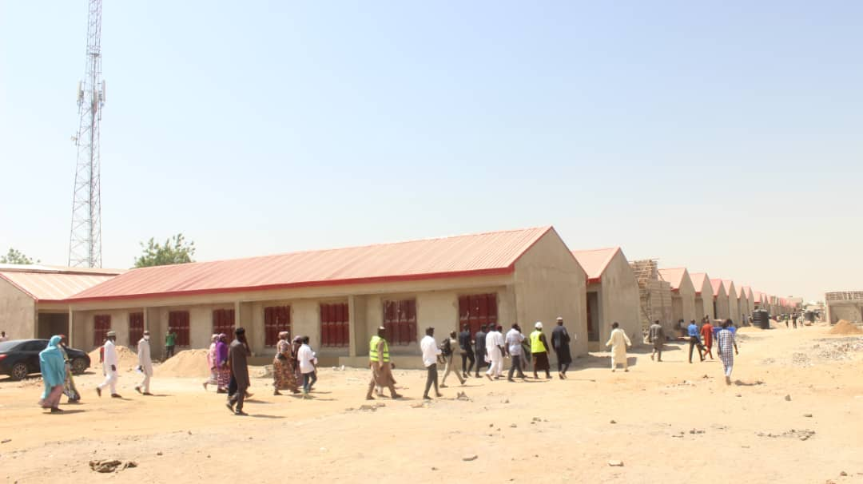
3. CONSTRUCTION OF YOLA MAIN MARKET
Scope: The Yola Main Market project is designed to create a modern and well-structured marketplace that caters to traders and the general public by incorporating essential facilities such as shops, a microfinance bank, a police station, worship centers, a fire service station, and a clinic.
Progress: As of the site visit date, the overall project completion rate is estimated at 75%. Most structural works are nearing completion while finishing works and installations are ongoing.
Observations: The Yola Main Market construction is progressing well, with an overall completion rate of 75%. While most structural works are completed, attention is needed for finishing works, installations, and landscaping. Addressing the identified challenges promptly will ensure the project meets its expected completion timeline, providing traders and the public with a modern and well-equipped marketplace.

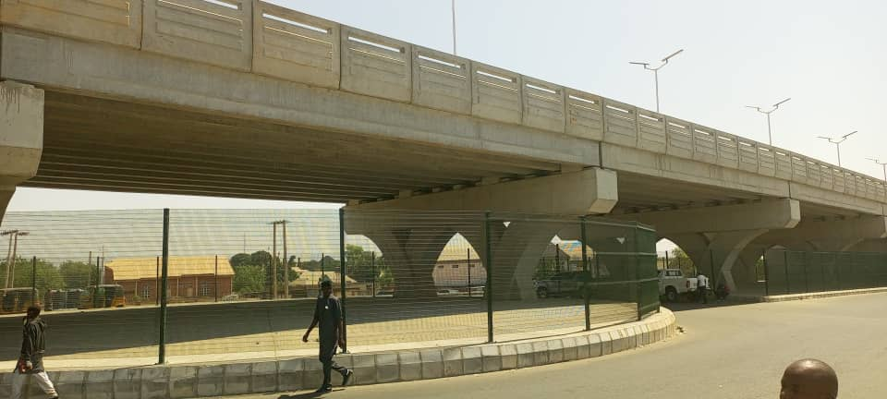
4. CONSTRUCTION OF A.A LAWAL FLYOVER
Progress: 95% completion level.
Observations: The flyover is nearing completion, with only minor finishing touches and road markings remaining. Once completed, it will significantly ease traffic congestion and improve urban mobility.

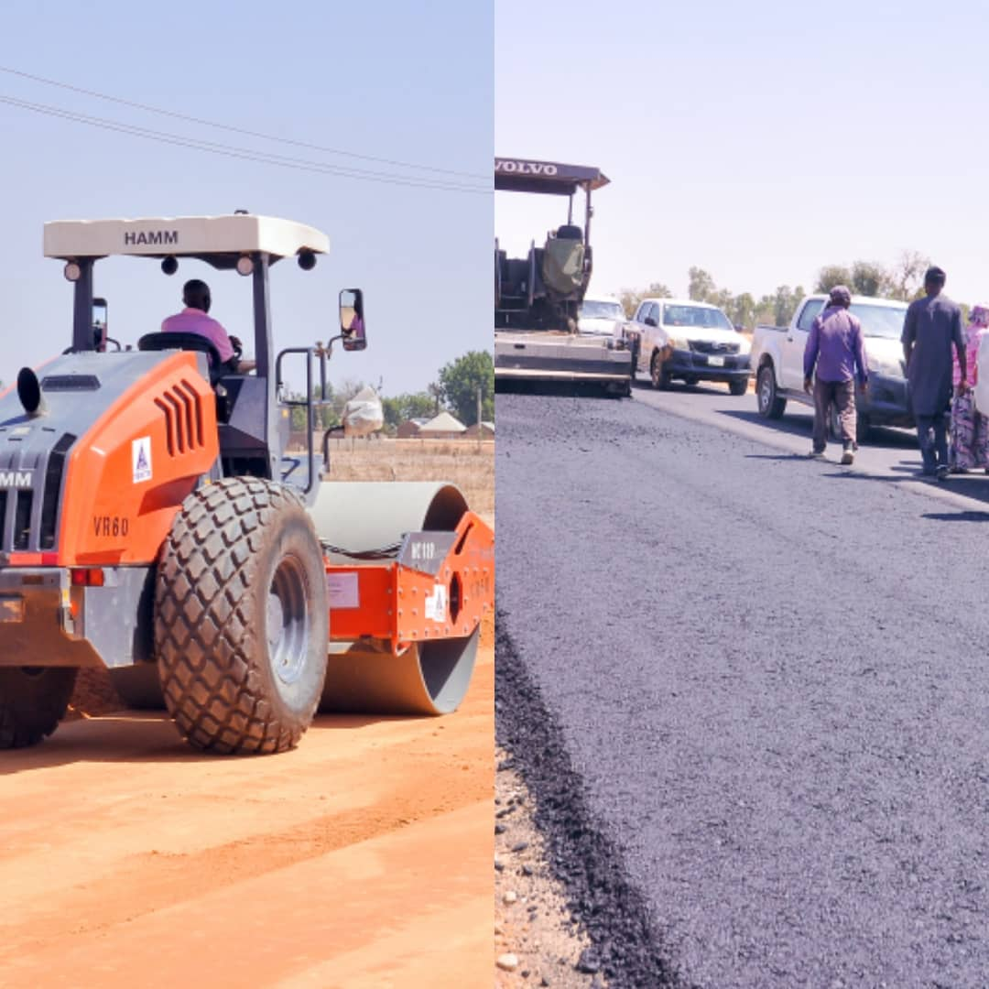

5. CONSTRUCTION OF SUPERHIGHWAY FROM A.A LAWAN TO NUMAN ROAD
Scope: The construction of the AA Lawal to Welcome to Yola Superhighway is progressing well, with asphalt paving in progress. While a few challenges exist, timely interventions can ensure smooth completion. The project remains on track to significantly enhance road infrastructure and connectivity in the region.
Progress: Asphalt level.
Observations: The project is currently at the asphalt laying stage, indicating significant progress in the construction. Asphalt paving is ongoing, with workers ensuring proper leveling and compaction to enhance road durability. The road has reached a critical phase in construction. Proper quality control measures are being enforced to ensure durability.

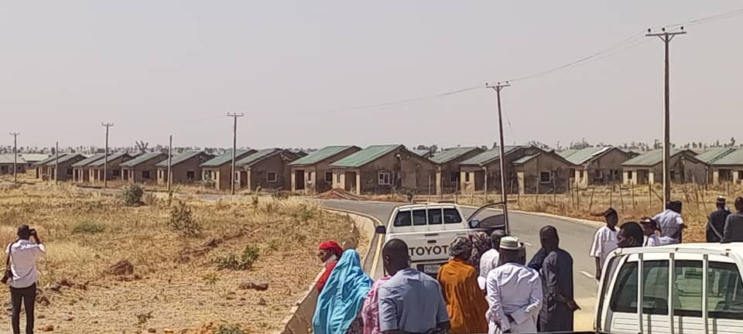
6. CONSTRUCTION OF 1000 HOUSING UNITS AT MALKOHI
Progress: Building construction has stopped, but infrastructure such as water supply, roads, and electricity is complete.
Observations: The halted construction of the housing units raises concerns. To address the state's housing deficits. recommendations include re-engaging contractors to resume work and complete the project.

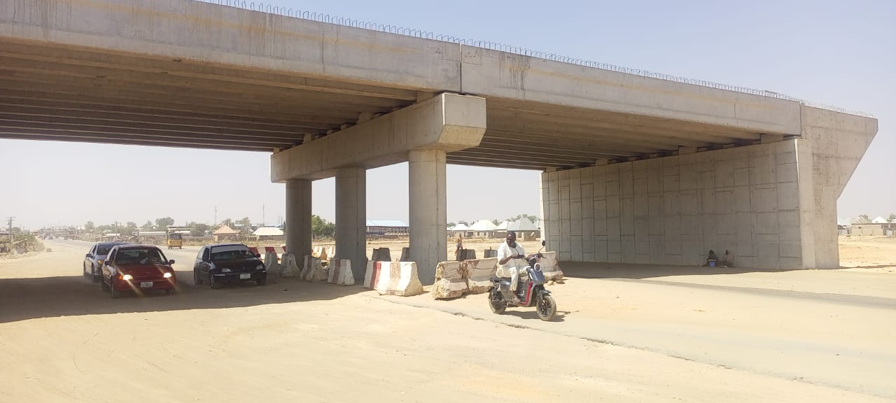
7. CONSTRUCTION OF HALF-LEAF CLOVER INTERCHANGE AT WELCOME TO YOLA
Scope: The Half-Leaf Clover Interchange at the "Welcome to Yola" junction is being constructed to improve traffic flow, reduce congestion, and enhance road safety at this critical entry point to Yola. The project includes road realignment, bridge construction, and traffic management features.
Currently, the project is at 50% completion, with major structural works and road paving in progress, while finishing and auxiliary works remain.
Progress: 50% completion level.
Observations: The project is progressing, with major structural elements in place. Once completed, it will enhance traffic flow and reduce congestion at key intersections.

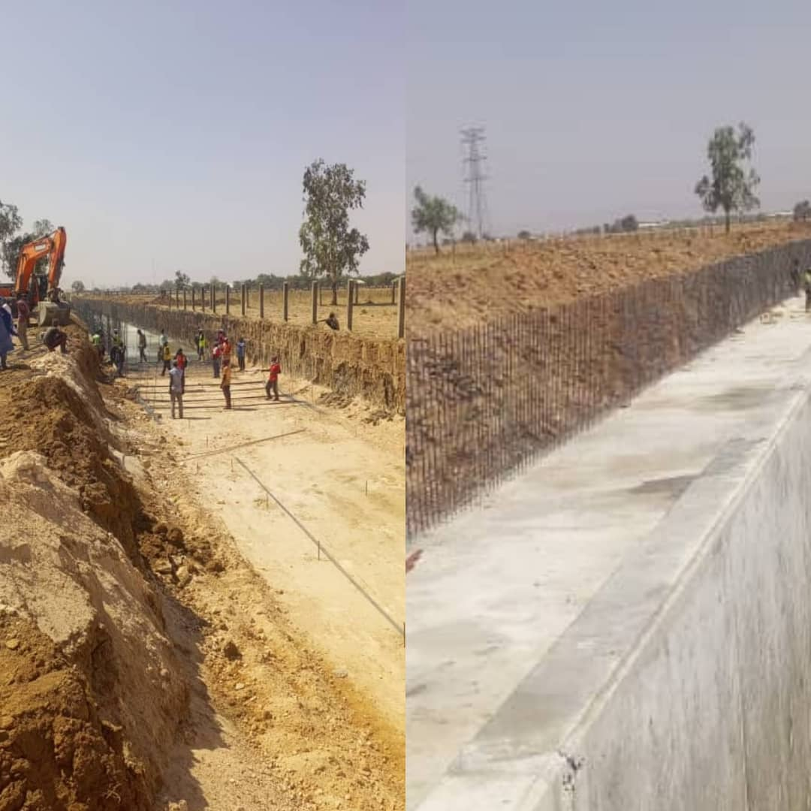

8. CONSTRUCTION OF STORMWATER DRAINAGE AT FGCC YOLA
Scope: The construction of the stormwater drainage system at FGCC Yola is aimed at managing rainwater runoff, preventing flooding, and protecting infrastructure within the community. The project involves the installation of a structured drainage network to improve water flow and ensure sustainability.
Currently, the project is 80% complete, with major excavation and drainage channel construction finalized, while minor finishing and landscaping works remain.
Progress: 80% completion level.
Observations: The drainage project is a crucial intervention to mitigate flooding in the area. The final phase includes completing culverts and minor structural adjustments.

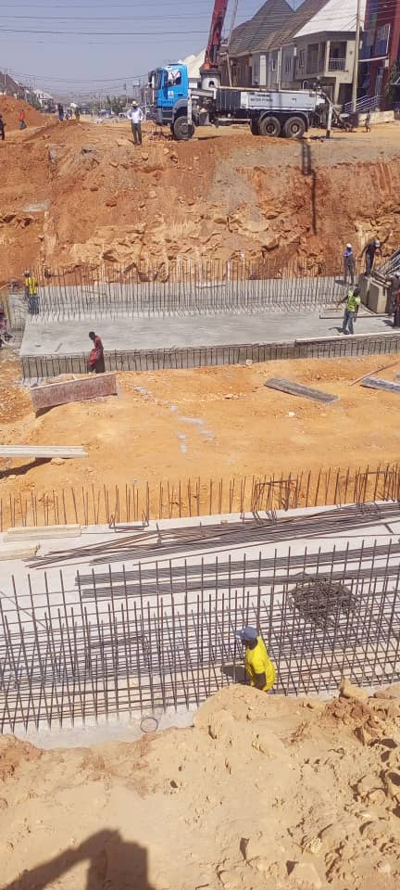
9. CONSTRUCTION OF BEKAJI UNDERPASS AND EXPANSION OF GALADIMA AMINU WAY
Scope: Expansion of the road into an eight-lane highway and the development of an underpass at Bekaji Roundabout.
Progress: 40% completion level.
Observations: The project is at an early stage but is expected to ease traffic congestion and improve road infrastructure in Yola significantly.

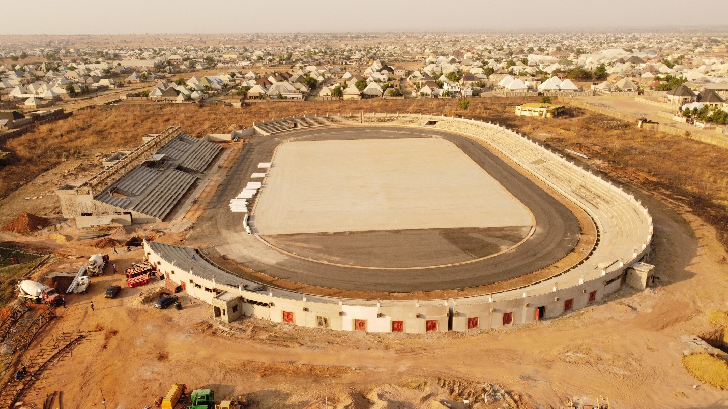

10. CONSTRUCTION OF STATE OF ART FOOTBALL STADIUM IN JIMETA
Scope: The Jimeta Modern Stadium is being developed to provide a world-class sports facility that will support local and national sporting activities. The stadium is designed to accommodate multiple sports, spectators, and auxiliary services to ensure functionality and sustainability. Currently, the project is at 65% completion, with major structural works ongoing, while finishing, installations, and external works are still in progress.
Progress: 65% level of completion.
Observations: The stadium is expected to provide a world-class sporting facility, promoting youth engagement in sports and recreational activities. The project is currently focused on structural development.

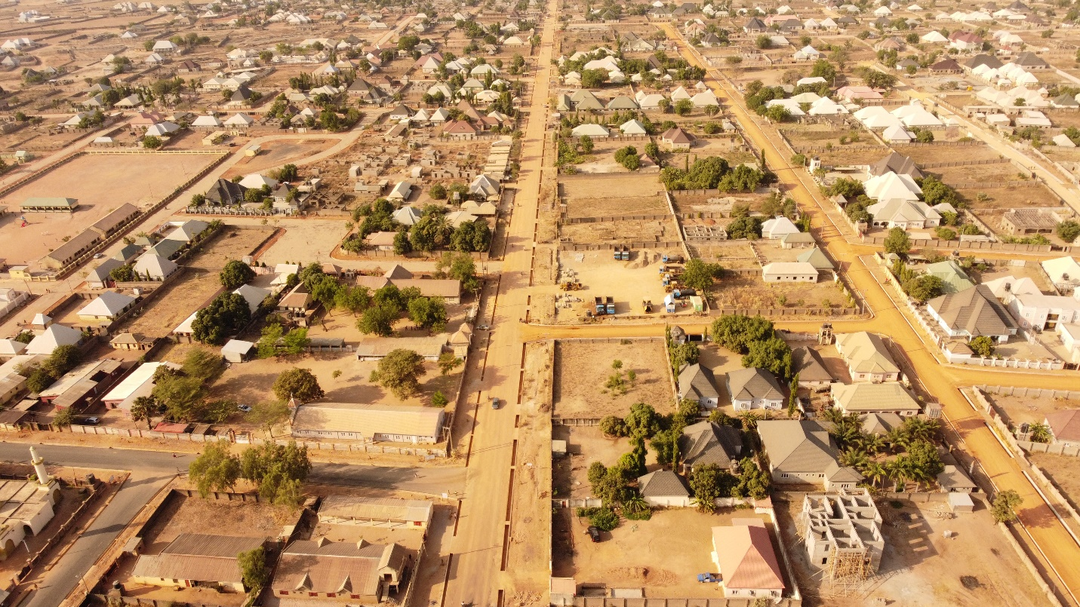
11. CONSTRUCTION OF FEDERAL HOUSING ROAD NETWORK
Scope: The construction of the 18.3 KM Federal Housing Estate Road is a crucial infrastructure project aimed at improving accessibility, enhancing transportation, and boosting economic activities within the estate. The project commenced with a well-structured plan, including earthworks, drainage construction, base preparation, and asphalt laying.
Progress: 90% level of completion
Observations: The 18.3 KM Federal Housing Estate Road construction has progressed significantly, with the project now at the asphalt level. Efforts are being made to ensure timely completion while maintaining high construction standards. With the current pace of work, the project is on track for completion.

12. CONSTRUCTION OF MUBI ROUNDABOUT FLYOVER
Scope: The construction of the Mubi Roundabout Flyover is a strategic infrastructure project aimed at decongesting traffic, improving road safety, and enhancing connectivity in the area. The project includes the main flyover structure, approach roads, drainage systems, and safety installations.
Progress: Flyover Structure (100% Completed)
Observations: The project is near completion, with most major construction activities finalized. The remaining work primarily involves installing barricades along the expressway to prevent pedestrian crossings and ensure safety.

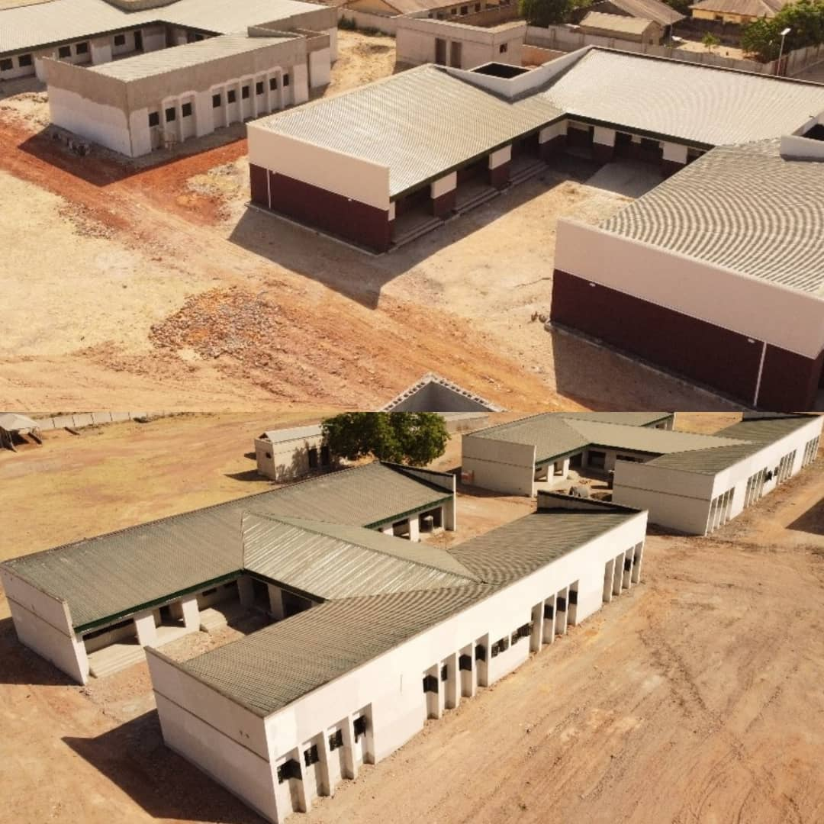
CONSTRUCTION OF YOLA NORTH MODEL SCHOOL
Scope: The construction of the Jimeta Model School aims to provide a modern, well-equipped learning environment. The project involves the development of classrooms, administrative offices, laboratories, and other essential school facilities to ensure quality education delivery.
Progress: 90% completion
Observation: The construction of the Jimeta Model School is at 90% completion, with most structural works finalized. Roofing, flooring, and window installations are fully completed. Remaining work includes painting, electrical fittings, plumbing, landscaping, and furnishing

CONCLUSION
The Adamawa State government is making significant strides in infrastructure development, with multiple projects aimed at improving transportation, commerce, judiciary infrastructure, and public welfare. While some projects are progressing steadily, others require urgent intervention to ensure timely completion. Continuous monitoring and collaboration among stakeholders will be essential in achieving the state's development objectives

