ADAMAWA STATE PLANNING COMMISSION

FOURTH QUARTER 2024 (4TH QTR)

STATE PROJECT MONITORING REPORT

OCTOBER, 2024

APPRECIATION
Your Excellency may wish to be informed that the edict establishing the Adamawa State Planning Commission has among its mandates to prepare and monitor the implementation of capital budgets and projects of the state to assess the progress of project executions and provide policy advice on developmental plans to the Governor
The Adamawa State Planning Commission acknowledges and appreciates the exemplary support provided by His Excellency, Rt. Hon. Ahmadu Umaru Fintri. His commitment to fulfilling the mandate of the ASPC has significantly contributed to the success of the commission in monitoring and evaluating state projects. This collaborative effort has set a positive precedent for sustainable development and effective governance in Adamawa State. As enshrined in the Law establishing Adamawa State Planning Commission Mandates Section 6(1) to monitor, and evaluate state projects. The commission serves as a critical entity in the overall development planning process, contributing to the realization of the state's socioeconomic objectives; the collaboration between the ASPC and other relevant stakeholders, creating a conducive environment for information sharing and joint efforts in achieving developmental milestones in the state.

TEAM COMPOSITION

1). Mrs. Mary Paninga (Ph.D) ……………… Executive Chairman ASPC
2). Mal. Hassan M. Modibbo ...……………. Permanent Secretary ASPC
3). Mr. Augustine James Pella ……………… S.A to Governor on Project
Monitoring
4). Mr. Abraham Murbuge ………………….S.A to Governor on Planning
& Statistics
5). Mr. Hassan Dedan ……………….Director of Service Delivery Improvement
6). Mrs. Farida Bukar ……………….Director of Donor Support Coordination
7). Mr. Solomon Z. Kyagya ……………….. Director of Planning & Research
8). Mrs. Joyce N. Ezikiel …………………Director of Admin & Human Resources
- . Mrs. Drambi Cromwell ……………….Director of Finance & Budget
- Hassana Yakubu …………………….Principal Planning Officer
11). Mr. Patrick Yunana …………………. Principal Planning Officer
14). Mrs. Hyelana’ati H. Bernard ………….Program Analyst I
15). Patu Mohammed Tugga ……………….Planning Officer I
16). Kpeshi Takoba …………………………Principal Planning Officer
17). Koungu Thomson …………………….. Principal Planning Officer
18) Ahmad Hamanyero ……………………. Planning Officer I
19) Umar Aliyu Abubakar …………………. Procurement Officer
20) Joy Diamond Leka ……………………... Information Officer

INTRODUCTION
The Monitoring and Evaluation (M&E) team from the Adamawa State Planning Commission conducted an on-site visit to assess the progress of several ongoing infrastructural projects within the state. The projects span various sectors, including education, urban development, and housing. The exercise which is part of the commission's mandate aims to ensure standard execution of the projects. The team visited ongoing projects comprising Girei Model School, Federal Housing Estate 18.3KM Federal Housing Estate Road Network, Mubi roundabout flyover, Supper High way, Yola North Model School, Malkohi 1000 Unit Housing Estate and AA Lawal flyover respectively. This report provides a summary of findings from the visits to the project sites, assessing the level of completion and challenges encountered in project execution.

OBJECTIVES OF THE MONITORING VISIT
1. To evaluate the current progress of the ongoing projects.
2. To assess compliance with project timelines and specifications.
3. To identify any challenges or risks that may hinder the timely completion of the projects.
4. To provide recommendations for improvement where necessary.

PROJECTS MONITORING SITES VISITED
The following projects were visited:
- Girei Model School
- Yola North Model School
- Mubi Roundabout Flyover
- Jimeta Modern Shopping Mall
- Malkohi 1000-Unit Housing Estate
- A.A Lawan Flyover
- Federal Government Girls' College (FGGC) Flyover
SUMMARY OF FINDINGS

- Construction of Model Schools in Girei and Yola North LGAs
- Progress: Approximately 80% completion and to be completed by the end of October 2023
- Details: The construction of the model schools is progressing steadily. Both structural and finishing works have been carried out on the buildings, with roofing and wall finishes nearing completion. Internal works, such as electrical and plumbing installations, are also underway.
- Challenges: Minor delays due to the supply of construction materials, especially during the rainy season, inflation, and flooding experienced in some parts of the state are the major challenges.

- Federal Housing Estate 18.3 Road network

- Progress Assessment
The site engineer from the Adamawa State Ministry of Works and Energy Development reported that the road network project is currently at 40% completion. This assessment aligns with the physical inspection conducted by the M&E team, which observed substantial progress in road grading and drainage construction.
- Quality of Work
The road construction observed met the quality standards expected at this stage. The materials used and the construction practices on-site were consistent with specifications.

- Mubi Roundabout Flyover
- Details: The Mubi Roundabout Flyover is a key project aimed at easing traffic congestion in the area. Structural work, including the bridge deck and supporting piers, has been completed. The focus is now on 8finishing works. The project managers confirmed the progress of work and assured of completion within the stipulated time frame.
- Progress: Approximately 95% completion.

- Jimeta Modern Shopping Mall
- Details: The modern shopping mall in Jimeta is designed to boost commercial activities in the area. The new modern shopping complex is said to have six (6) lanes. Two (2) on the left-hand side will accommodate vehicles going from Girei to Yola with a free parking space., then two (2) free lanes internally which will accommodate vehicles from Yola to Girei and beyond, and another two (2) reserved lanes for the market which a crash barrier will be assembled to enable customers that are intending to go to the market. A person from the left-hand lane cannot cross to the right-hand lane because a barrier fence of 2cm will be put in place to prevent passersby from crossing due to the high speed of moving vehicles approaching from the Mubi roundabout flyover.
- Progress: The foundation and structural work have begun and the internal spaces are being partitioned.

5. Malkohi 1000-Unit Housing Estate
- Progress: Approximately 60% completion.
- Details: The 1000 Housing Estate project is aimed at addressing housing deficits in the state. Many of the housing units are at the roofing and finishing stages, with work on roads and drainage systems also ongoing.
- Challenges: Delays in the provision of basic infrastructure such as water and electricity have been reported, which could affect the overall completion timeline.
- Recommendations: Utility providers should be engaged early to ensure that essential services are provided as construction nears completion. Also, Regular follow-up visits should be conducted to ensure the contractor adheres to quality standards and completes the project within the stipulated time.

- AA Lawan Flyover
- Details: The AA Lawan Flyover is intended to reduce traffic congestion and improve access to key areas in the state capital. Construction of the bridge’s supporting structures has been completed, and work on the road surfaces is ongoing.
- Progress: Approximately 60% completion.
- Challenges: Traffic management during construction remains a challenge, leading to delays in the project’s schedule.
- Recommendations: Improved traffic management strategies should be implemented to ensure smoother flow around the construction site, minimizing disruption for road users.

7. Federal Government Girls' College (FGGC) Flyover
- Details: The FGGC Flyover is aimed at facilitating safe movement from Malkohi 1000-Units Housing Estate Road and reducing accidents in the area. Structural works are complete, and attention has now turned to road surfacing.
- Progress: Approximately 60% completion.
- Challenges: There are no significant challenges reported, but there is a need for continuous monitoring to ensure the project stays on track.
- Recommendations: Regular follow-up visits should be conducted to ensure the contractor adheres to quality standards and completes the project within the stipulated time.

Conclusion

The overall progress of the visited projects stands at approximately 60%, with most projects on track to meet their expected timelines. However, a few challenges, such as financial constraints, compensation issues, and delays in material supply, need to be addressed to avoid project delays.
The Adamawa State Planning Commission will continue to monitor these projects closely and provide necessary support to ensure their timely completion, contributing to the state's infrastructural and socioeconomic development.

Next Steps
1. Conduct follow-up monitoring visits to track further progress.
2. Facilitate meetings with contractors and stakeholders to address any challenges identified during the visit.
3. Ensure timely release of funds and engagement of relevant government agencies to mitigate delays.

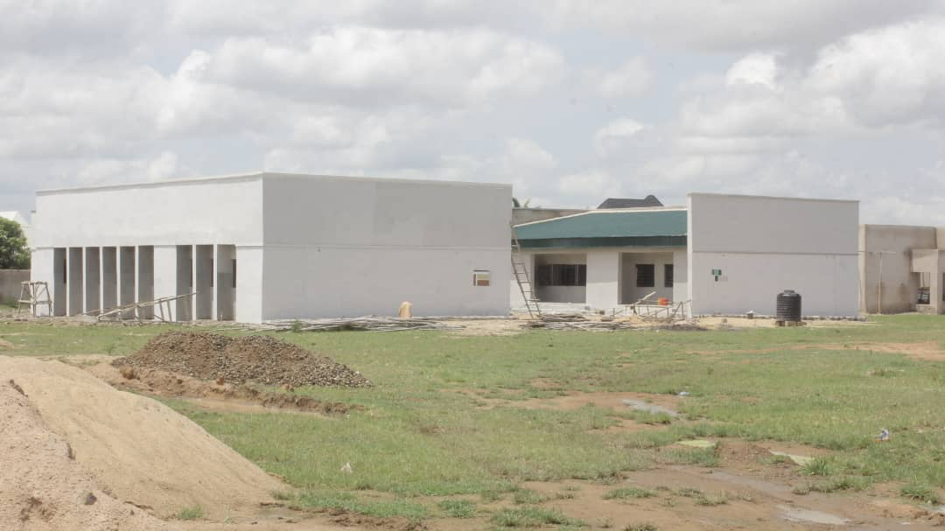
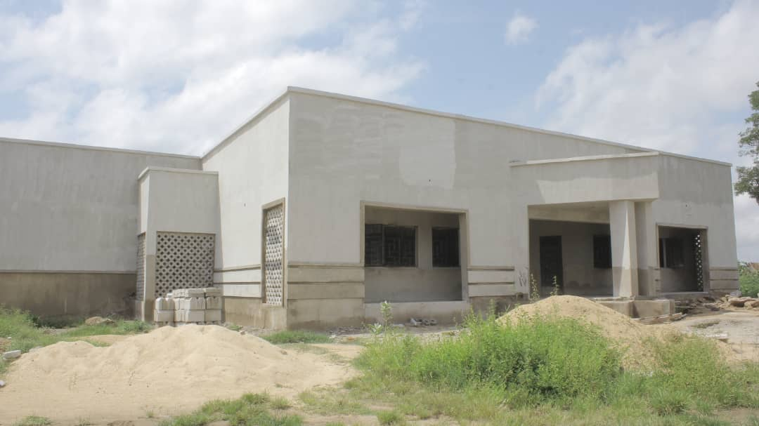
PHOTO GALLERY

