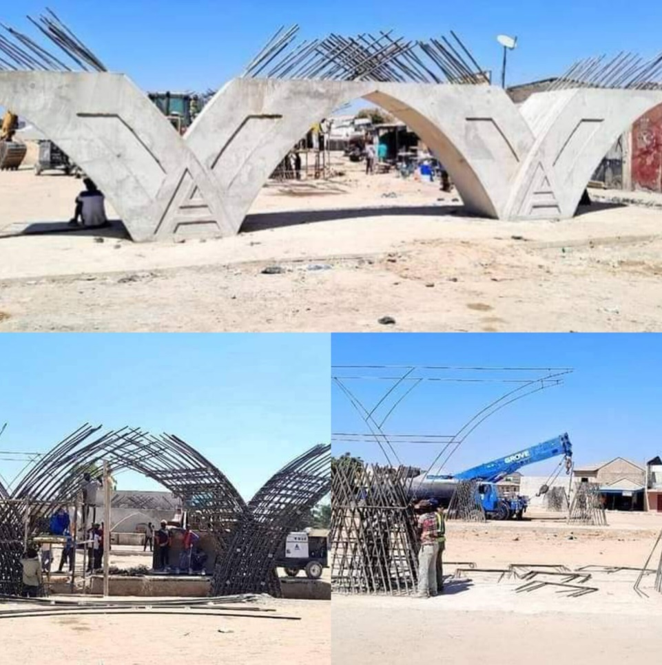
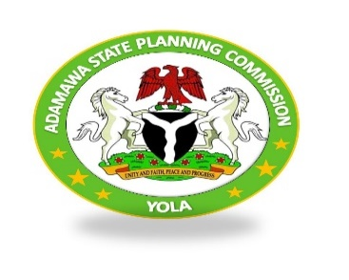
ADAMAWA STATE PLANNING COMMISSION

2023 PROJECT MONITORING REPORT

DECEMBER 2023

Index
PREAMBLE 2
TEAM COMPOSITION 4
MONITORING SITES VISITED 5
L.G.A PROJECT MONITORING 6
Summary of findings 11
DETAILED MONITORING ACTIVITIES 13
Photos 21
Local Government Areas Critical Needs 30

PREAMBLE

Your Excellency may wish to be informed that the edict establishing Adamawa State Planning Commission has amongst its mandates to monitor the implementation of Capital budgets and projects of the State to assess progress of project executions and provide policy advice on developmental plans to the Governor.
This, the ASPC does through organizing the inspection, identification of both abandon and on-going projects in the State and ascertain the cause of abandonment, prioritize and find out the stage of completion of each project and advise the Government accordingly through the reports rendered. The ASPC is also mandated to enhance the efficiency, accountability and transparency of public sector spending and general State economic and financial management.
The Adamawa state planning Commission together with the Special Advisers and Senior Special Assistant and the three (3) Zonal Special Assistants to His Excellency on Project Monitoring alongside some of the ASPC Board members on 3nd and 4th march toured the three senatorial districts. Selecting some Local Government Area in the state for physical monitoring of some Capital budget projects aimed at providing actionable data on project implementation and to track implementation progress to give feedback for policy decision purposes. The monitoring and evaluation team was divided in to three (3) thus, Team A, B and C. On day one, team A &B monitored and evaluated projects within Yola North and Yola South LGA, while team C went to Numan LGA to monitor the ongoing projects. On day two, all teams disseminated to the 3 different senatorial zones for the exercise. Projects monitored in the different zones and locations.
Your Excellency may wish to be informed that the edict establishing Adamawa state Planning Commission has among its mandates to prepare and monitor the implementation of capital budgets and projects of the state in order to assess progress of project executions and provide policy advice on developmental plans to the Governor
The Adamawa State Planning Commission acknowledges and appreciates the exemplary support provided by His Excellency, Rt. Hon. Ahmadu Umaru Fintri. His commitment to fulfilling the mandate of the ASPC has significantly contributed to the success of the commission in monitoring and evaluating state projects. This collaborative effort has set a positive precedent for sustainable development and effective governance in Adamawa State. As enshrined in the Law establishing Adamawa State Planning Commission Mandates Section 6(1) to monitor, and evaluate state projects. The commission serves as a critical entity in the overall development planning process, contributing to the realization of the state's socioeconomic objectives; the collaboration between the ASPC and other relevant stakeholders, creating a conducive environment for information sharing and joint efforts in achieving developmental milestones in the state.

TEAM COMPOSITION

Full Names | Designation
1). Mrs. Mary Paninga (Ph.D) | Executive Chairman ASPC
2). Mr. Enoch Amos Piribu | Permanent Secretary ASPC
3). Mr. Augustine James Pella | S.A to Governor on Project Monitoring
4). Mr. Abraham Murbuge | S.A to Governor on Planning & Statistics
5). Mr. Hassan Dedan | Director of Service Delivery Improvement
6). Mrs. Farida Bukar | Director of Donor Support Coordination
7). Mrs. Hassana Yakubu | Ag. Director of Planning & Research
8). Mal. Dahiru Wakili | Director Admin & Human Resources
9). Mrs. Drambi Cromwel | Director of Finance & Budget
10). Mr. Sidney Esthon Abubakar | Senior Planning Officer
11). Mr. Patrick Yunana | Senior Planning Officer
12). Gambo Japheth | Senior Planning Officer
13). Mal. Mohammed Bello Umar | Planning Officer II
14). Mrs. Hyelana’ati H. Bernard | Data Processing Officer
15). Patu Mohammed Tugga | Planning Officer II
16). Kpeshi Takoba | Senior Planning Officer
17). Koungu Thomson | Senior Planning Officer
18). Maurice Albert | Senior Accounting Officer

MONITORING SITES VISITED
- Construction of Mubi roundabout flyover
- Construction of Super High way
- Construction of Malkohi Housing Unit
- Construction of stormwater drainage behind shopping complex
- Construction of Bye-pass road
- Construction of New cemetery
- Renovation of Cottage Hospital Fufore
- Renovation of GSS Fufore
- Construction of Cattle market in Chigari Fufore L.G.A
- All LGA projects were visited by the LGA M&E officers

L.G.A PROJECT MONITORING

1. NUMAN
- Renovation of Numan General Hospital
- Construction of 3.5 KM Izala Gwada Mallam Road Completed
- Installation of transformer at Numan Water treatment plan Completed
- Police outpost in Bolki village Completed
2. DEMSA
- Ongoing construction of Cottage Hospital
- Construction of 5.9 Km Township road in Demsa
- Electrification of Dong and Kpasham Project
3. LAMURDE
- Ongoing construction of Lamurde cottage Hospital
- Road construction in Lamurde
- Ongoing construction of Exams hall at GSS Demsa
- Renovation of Lamurde Maternity completed
- Construction of Tingno Market completed
- Construction of college of Agric Satelite Campus Gyawana Completed
- Construction of block of classrooms at GDSS Lamurde Completed
4. SONG
- Construction of medical laboratory complex at Song
- Construction of Dumne cottage hospital
- Construction of Cattle Market at Song
- Construction of maternity complex completed
- Construction of male surgical ward completed
- Construction Song Cattle Market Completed
- Ongoing construction of Rural road from Maraaraban Dumne to Dirma
5. GUYUK
- Construction of three blocks of class room and a male hostel at GSS Banjiram
- Ongoing electrification of Banjiram in Chikila
- Construction of Guyuk township road Completed
- Ongoing upgrade of mechanized borehole to motorized
- Construction of 9 KM from Banjiram to Chikila ongoing
6. GOMBI
- Electrification project from kaulewa to Fwahar
- Construction of 40km Gombi- Ga’anda road
- Construction of 24km Gombi – Ga’anda – Fotta road
- Construction of Cottage Hospital in Ga’anda, Gombi.
- Reconstruction of Tashan Gwaigwai. Gombi North.
- Construction of Kwanan Yaji Mijiwana- Kangurungum- Amdur road Uncompleted
- Provision of solar street lights at Garkida Completed
- Electrification of Garkida Fwahar-Wuyaku, Ga,anda –Fotta Duwa Yang Abandoned
- Construction of Block of three classes with office and Rehabilitation of Block of two classes at Yang Primary School and Secondary Completed
- Rehabilitation of Lala development area ongoing
- Construction of Gombi township shops
- Maternity complex at PHC clinic Ga’anda Completed
7. YOLA NORTH
- Ongoing of Construction of Mubi Round About Flyover
- Ongoing construction of 1.9 KM Storm Water Drainage from Saminaka through FGGC to Gerio Lake – phase 1
- Ongoing Construction of 28KM Super Highway from Welcome to Yola to AA Lawan
- Ongoing Construction of 1000 Housing Unit Malkohi
- Construction of Jimeta Township Road Completed
8. YOLA SOUTH
- Ongoing Construction of New Cemetery
- Ongoing construction of Bole road
- Construction of Zumo road Completed
- Construction of Doctors Quarters Completed

9. FUFORE
- Ongoing construction of Fufore Cottage Hospital
- Ongoing Renovation of Government Secondary School Fufore
- Ongoing Construction of Chigari Cattle Market with Loading Bay, Solar Powered Bore Hole, Toilet and Security Post.
10. SHELLENG
- Ongoing Construction of kiri Shelleng Road
- Construction of Shelleng Cottage Hospital Completed
- Ongoing Construction LGA town hall
- Construction of Shelleng city gate abandoned
11. MICHIKA
- Ongoing Upgrade of 35 Rooms at Buba Marwa Lodge
- Ongoing construction Wurogyadi bridge at Madagali
- Construction of Buppa Phcc, Zah Ward. Ongoing
- Construction of primary Health Care Centre at Wambilmi.Completed
- Construction of Raod from main Road to Vi. Ongoig
- Construction of Road from Hausari to Dzuruk. Ongoing
- Construction primary Health Care Centre at Kali Zah Ward. Ongoing
- Rehabilitation of three classrooms at wadafa primary school Completed
- Construction of Solar powered borehole at Mampe Completed
- Construction of bore hole at Watu Completed
- Construction of Michika Township road Completed
- Construction of Jiddle Primary School Completed
- Construction of block of classroom Completed
- Construction of solar powered borehole at Lughu Completed
12. MAYO-BELWA
- Ongoing construction of cottage Hospital
- Perimeter fencing of GGSS Mayo-Belwa Completed
- Construction of Legislative Office. Ongoing
- Kasuwan Buhu.Completed
13. HONG
- Ongoing construction of 35 KM road from Mararaba Pella to Maiha
- Construction of European Quarters Road Completed
- Integrated power project 33/11 KVA injection transformer Completed
- Construction of Local Government Development Area secretariat, Uba Abandoned
- Ongoing construction of 3km road at Mampaya Uba
- Construction of 1000 bench for primary schools Completed
- Ongoing construction of 8 Km road at Kala’a Kwahkwah, Mula in Hosherisum
14. MAIHA
- Ongoing electrification of Maiha Gari
- Ongoing electrification of Maiha to Mbilla
- Ongoing renovation of cottage Hospital
15. GANYE
- Construction of Ganye cattle market with male and female toilets
- Security post at Ganye cattle market
- Stores at New Market Ganye
16. GIREI
- Construction of Girei Cottage Hospital Completed
- Construction of Njobore road at Vunoglank Completed
- Construction of ATV Junction to Damare road Completed
17. JADA
- Construction of Douwuro to cattle market road Completed
- Construction of Duta-Era road Completed
- Construction of District place to cattle market road
- Construction of Fresh Air clinic road Completed
- Construction of Fresh Air clinic
18.MADAGAL
- Renovation/upgrade of 55 Rooms Government Lodge Gulak.Completed
- Construction of Township Roads in Madagali Ward,LHMadagali LGA.Completed
- Construction of 6.3KM Road at Gulak Town Madagali LGA.Completed
- Construction of Doctors Quarters at Gulak General Hospital.Completed
- Construction of Nurses Quarters at Gulak General Hospital. Completed
- Ongoing Construction of Construction of WuronGayandi Bridge at Kirchinga Ward .Ongoing (50%)
- Construction of Storm Water Drainage at Shuwa and Gulak.Complete
- Provision of Solar Powered Boholes in Madagali LGA.Completed
19. MUBI-NORTH
- Ongoing Construction of school of post graduate at ADSU Mubi
- Renovation of GSS Mubi Completed
20. MUBI-SOUTH
- Construction of township road at Mubi Completed
- Construction/ Renovation of General Hopital Mubi Completed
21. TOUGO
- Construction of Toungo grain market with police out post Completed
- Construction of 11.4 KM road from Toungo to Kiri district Completed
- Construction of 1No. block of three class room and office at Ganzamanu Primary School Completed
- Drilling of 28 No. hand pump borehole across 10 ward Completed
- Ongoing construction of LGA town hall
- Construction of 10No. housing unit Abandoned
- Construction of ALGON clinic Abandoned
- Rehabilitation of GSSS Abandoned
- Electrification of Toungo town

Summary of findings
A team, led by the M&E team of Adamawa State Planning Commission and the Special Adviser to the Governor on Project Monitoring, conducted a supervision visit to the ongoing Mubi roundabout flyover project and the construction of a super highway in Adamawa state. The flyover project has reached a 30% completion level, while the super highway, spanning 20.8 km, is 20% complete with an 18-month completion period. Additionally, the team inspected a 17.5 km road network and storm water drainage projects, both showing significant progress. The road network is at 70% completion, and the drainage project is at 90% completion, focusing on addressing rainy season challenges. Renovation of projects at Cottage Hospital and GSS Fufore were also assessed. The GSS Fufore renovation covers classrooms, laboratories, library, and hostels across lots 1-12, estimated at 80-85% completion. The Cottage Hospital Fufore renovation includes separate male and female surgical wards and is aimed at enhancing healthcare delivery services. The construction of a cattle market in Fufore LGA is at an impressive 95% completion, with essential components such as loading bays, security posts, administrative block, police station, and sanitation facilities fully completed. Lastly, the team visited the ongoing construction of a graveyard in Yola South Local Government Area, addressing the need for a new burial ground. The project is 40% complete, focusing on excavation, leveling of burial plots, and the construction of a perimeter walls and fencing. The aim is to provide a well-organized and equipped resting place for the deceased in response to the growing population in the area.
Way forward
Flyover and Superhighway Projects:
Intensify efforts to accelerate the completion of the Mubi roundabout flyover and the 20.8 km superhighway. Regularly monitor progress, identify, and address challenges promptly to ensure adherence to the 18-month completion period.
Road Network and Storm water Drainage Projects:
Continue the momentum on the 17.5 km road network and 90% complete storm water drainage projects. Address any remaining challenges and ensure their completion to improve connectivity and address rainy season issues in the designated area.
Renovation Projects at Government Secondary School Fufore (GSSF) and Cottage Hospital Fufore:
Expedite the completion of renovation projects at Government Secondary School Fufore (GSS), focusing on achieving the estimated 80-85% completion. Similarly, prioritize the completion of the Cottage Hospital Fufore renovation to enhance healthcare services in the area.
Construction of Chigari Cattle Market:
Finalize the remaining aspects of the cattle market construction in chigari Fufore LGA, ensuring the loading bays, security posts, administrative block, police station, and sanitation facilities are fully operational. Meet the target completion date in February and ensure a smooth and efficient operation of the market.
Construction of Graveyard at Yola-South LGA:
Increase efforts in the construction of the graveyard in Yola South Local Government Area. Address challenges and expedite the excavation, leveling of burial plots, and the construction of boundary walls and fencing. Targeting the timely completion to meet the pressing need for the well-organized burial ground in response to the growing population.
Overall Monitoring and Coordination:
Strengthening monitoring and evaluation system to track the progress of all ongoing projects. Regular coordination meetings should be conducted to address challenges, allocate resources efficiently, and ensure that each project adheres to its timeline and quality standards.

DETAILED MONITORING ACTIVITIES
DAY ONE
RESPONSIBLE MDA: MINISTRY OF WORKS AND ENERGY DEVELOPMENT
LOCATION: YOLA-NORTH
PROJECT: Mubi round about flyover
NAME OF COMPANY: Triacta Nig. LTD
Introduction
This report provides an overview of the current status of the ongoing Mubi round about flyover supervised by M&E team comprising of Adamawa state planning Commission in collaboration with the special Adviser to Governor on project monitoring. The project supervision aims to ascertain the level of progress, challenges, and future expectations of the project. According to the site engineer, Engr. Mundi from Ministry of works and Energy says the project has achieved a 30% level of progress. Notably, there are 8 pillars situated between the abutments, each composed of 32-millimeter diameter radius rods emphasizing the structural integrity of the project. The construction comprises 102 Bim 61, which have already been completed. The project was initially scheduled for completion within 18 months, and as of now, it has covered a 3-month period.
Challenges and Mitigation:
One of the challenges faced during the project was the presence of miscreants and the pilfering of materials. However, the report indicates that appropriate measures have been taken to mitigate these issues successfully.
Compensation for Right of Way:
According to the site Engineer, Engr. Mundi said compensation arrangements have been made for all structures affected by the right of way. Individuals with proper documentation will be compensated, demonstrating a commitment to fair and just practices.
Comments from the M&E team:
Special Adviser to the Adamawa state governor on monitoring and evaluation Hon. Augustine James Pella expressed satisfaction with the project's progress, commending the contractor for a job well done.
The Executive Chairman of the Adamawa State Planning Commission Mrs. Marry Paninga (Ph.D) acknowledged the aesthetics of the project and emphasized the state's commitment to transparency and accountability. Furthermore, Adamawa State Planning Commission has taken steps to involve the local community in protecting infrastructure in all the Twenty-one Local Government Area in which Monitoring and Evaluation officers have been trained for this purpose.

RESPONSIBLE MDA: MINISTRY OF WORKS AND ENERGY DEVELOPMENT
LOCATION: YOLA-NORTH
PROJECT: Superhighway Construction from Welcome to Yola to A.A Lawan
NAME OF COMPANY: Triacta Nig. Ltd
Introduction
The ongoing construction of the superhighway is a significant infrastructure project. The project involves the construction of a 20.8 km dual carriageway, with 7.5 meters and 1.5 meters shoulders, connecting Welcome to Yola to the A.A Lawan filling station. The superhighway specification includes 20.8 km length, featuring a dual carriageway with 7.5 meters and 1.5 meters of shoulders on either side. The project has achieved a commendable 20% within the stipulated 30-month timeframe.
Comments from the M&E Team:
The Permanent Secretary of the Adamawa State Planning Commission (ASPC) Pharm. Amos Enoch Piribu expressed delight on the progress made and said he believes that the completion of the superhighway will significantly have an impact on the state's economic fortunes.

RESPONSIBLE MDA: MINISTRY OF WORKS AND ENERGY DEVELOPMENT
LOCATION: YOLA-NORTH
PROJECT: Construction of Road network at 1000 Housing unit
NAME OF COMPANY: Jediel Cons. Company

The team visited the ongoing construction of a 17.5 km road network with tributaries at 1000 housing unit Malkohi. According to the team, the project is a critical infrastructure need aimed at enhancing connectivity in the designated area. The project, with an 18-month completion period, has achieved significant progress, with 70% of the work already completed. It is expected that remaining 30% of the project is anticipated to be completed within the stipulated timeframe, ensuring that the road network becomes fully operational as scheduled. The project if completed will facilitate efficient transportation, connecting various points within the housing unit, and improving accessibility. The road network is designed to improve transportation within the 1000 housing units.
Challenges and Mitigation:
No challenges were specified, but it emphasizes the importance of addressing any issues promptly to ensure the project stays on schedule and meets its completion deadline.

RESPONSIBLE MDA: MINISTRY OF WORKS AND ENERGY DEVELOPMENT
LOCATION: YOLA-NORTH
PROJECT: Construction of Storm water Drainage from Saminaka through FGGC to Gerio Lake – Phase I (1.9 km)
NAME OF COMPANY: Triacta Nig. Ltd
Introduction
The team visited the ongoing construction of the Storm water Drainage from Saminaka through Federal Government Girls College (FGGC) to Gerio Lake attained 90% completion rate, with a particular focus on Phase I: The project aims to address the challenges faced by residents during the rainy season. The project involves the construction of a storm water drainage system, beginning from Saminaka, passing through FGGC, and extending to Gerio Lake. Phase I: The initial phase covers a distance of 1.9 km.
Residents Response
Interviews were conducted with local residents, these includes, Isa Suleiman, Abdullahi Bello, Aishatu Ibrahim, and Happy Resident of Saminaka. All interviewees expressed joy and gratitude for the ongoing project, they highlighted the experiences of difficulties faced during the rainy season, emphasizing the lack of adequate drainage leading to waterlogging and inconvenience. According to them, the project has alleviated the challenges faced by residents during the rainy season, improving overall accessibility to their homes. The residents expressed their appreciation for the government's intervention, thanking the project master for addressing a long-standing issue affecting their daily lives. Furthermore, the expressions of joy and gratitude from the residents underscore the positive impact of the project. It highlights the government's commitment to addressing essential infrastructural needs and improving the quality of life for citizens.

RESPONSIBLE MDA: MINISTRY OF EDUCATION AND HUMAN CAPITAL DEVELOPMENT
LOCATION: YOLA-NORTH
Project: Renovation of Government Secondary School Fufore
Names of Companies:
- Kachala Multi Links L.T.D
- Arafaman Investment L.T.D.
- Anajiezenco Global L.T.D
- Skydoor Nig. L.T.D.
- Hercules and Associates L.T.D
- Arching Cons. L.T.D
- Mapama Const. L.T.D

Introduction
The team proceeded to ongoing renovation of GSS Fufore, the principal of the school Mal. Yahya Waziri took the team around the different project sites, providing insights into the ongoing extensive renovation and overhaul activities currently taking place at the Government Secondary School (GSS) Fufore. The renovations cover various aspects of the school infrastructure, including classrooms, laboratories, library, and hostels. The renovation project encompasses a complete overhaul of classes, laboratories, and both boys' and girls' hostels, spanning across lots 1-12. As at the time of the visit the site engineer were not on site to ascertain the level performance, but it is assumed that the project has attained 80-85% level of completion.
Challenges:
Principal Waziri highlighted the lack of perimeter fencing as a significant challenge facing the school. The absence of proper fencing exposes the school to security threat and hampers its overall functionality. The principal further expressed gratitude to the government for making the extensive renovations possible; emphasizing the positive impact it would have on the learning environment. However, he urged the government to consider the fencing of the school as a paramount need, citing security concerns as stated above.
Student Interview:
Interviews were conducted with students, including Sandra Oyeboji and Halima Usman. The students expressed joy and appreciation for the ongoing renovations in their school. However, Sandra Oyeboji highlighted additional needs, including the renovation of the dining hall, fencing of the school, and the construction and renovation of toilets. Halima Usman further urged the government to prioritize the fencing of the school, a measure crucial for the safety and security of students.
Recommendations by the M&E Team:
The report recommends that the government consider the immediate fencing of GSS Fufore to address the security concerns raised by the principal and ensure the safety of students. Additionally, the plea of the students for the renovation of the dining hall and the construction and renovation of toilets should be given due consideration in the ongoing and future school development plans.

RESPONSIBLE MDA: MINISTRY OF HEALTH & HUMAN DEVELOPMENT
LOCATION: YOLA-NORTH
Project: Renovation of Fufore Cottage Hospital
NAME OF COMPANY: Yaks Solution
Introduction:
The team visited the ongoing renovation project at Cottage Hospital Fufore which involves a comprehensive overhaul of the existing facilities. The purpose of the visit was to assess the current status of the project and evaluate the progress made towards its completion. The Principal Medical Officer (PMO) who led the team on an inspection tour of the ongoing renovation at Cottage Hospital Fufore, says the renovation include separate male and female surgical wards, each with 16 beds. Additionally, there is a consultation room to facilitate patient-doctor interactions. The infrastructure development is aimed at enhancing the delivery of healthcare services.
According to Mr. Anyogwu Emmanuel, the site engineer responsible for the project says the renovation has reached an impressive 90% completion rate. The remaining tasks include the finalization of electrification, plumbing, fittings, and landscaping. He estimates that these tasks will be completed within the next 2-3 months, after which the project will be handed over to the state. However, during the inspection, the State M&E team made an important observation regarding the original project plan. They noted that instead of constructing VIP toilets as initially planned, it might be more beneficial to create a runway linking the two separate sites. In light of the State M&E team's observation, it is recommended that a thorough review be conducted to assess the feasibility and potential benefits of altering the original plan. The creation of a runway between the two sites could enhance operational efficiency and provide a more practical solution compared to the construction of VIP toilets.
Challenges
Despite the progress, the hospital faces notable challenges that need attention. The most pressing issue is related to the staff quarters, particularly during the rainy season. The staff quarters are reported to have dilapidated roofs, leading to leakages and posing a significant inconvenience to the hospital staff residing there.
Principal Medical Officer (PMO) Interview
The PMO says the expansion aims to accommodate more patients and enhance the overall quality of healthcare services provided. The Cottage Hospital is undergoing significant improvements, with particular emphasis on increasing the number of available beds and wards. The expansion has resulted in a substantial increase in capacity, allowing the hospital to accommodate up to 157 persons, up from the previous capacity of 58, with the primary objective of addressing the inadequacies in the hospital's capacity, particularly the shortage of wards and beds. He also, acknowledged His Excellency's Intervention and expressed his sincere gratitude to His Excellency Rt. Hon. Ahmadu Umaru Fintri for the timely intervention and support in expanding the capacity of Fufore Cottage Hospital. This intervention has played a crucial role in addressing the pressing issue of inadequate space, ensuring that more members of the community can access essential healthcare services.
Comments from the M&E Team:
Mal. Bala Yushau, Fufore LGA M&E officer, extends sincere gratitude to the government of the day for their timely intervention. The intervention has not only facilitated the progress of the project but has also underscored the government's commitment to the improvement of healthcare infrastructure in the region. In addition, Mr. Yushau appreciates the commendable effort put forth by the contractor in executing the project. The dedication and efficiency displayed by the contractor have significantly contributed to the advancement of the project completion. He also, takes the opportunity to make a plea to the government to consider extending the contract to include the construction of doctors' quarters within the Cottage Hospital premises. This extension is deemed necessary to provide adequate accommodation for medical professionals and enhance the overall functionality of the healthcare facility.
S.A to Governor on Project Monitoring:
The Special Adviser to the Governor on Project Monitoring Hon. Augustine James Pella applauded the effort of the government, by emphasizing on the positive impact it will have on the community's health sector. And further commends the contractor for the job well done, and urges him to adhere to the stipulated time frame for project completion, ensuring that the benefits of the expanded infrastructure are realized within the expected period.

Executive Chairman Adamawa State Planning Commission:
The Executive Chairman expresses gratitude to the executive governor for prioritizing infrastructure projects in the state and commends the contractor efforts. She also, acknowledges the significance of the M&E, emphasizing its role in protecting the state's plans and programs. She said infrastructural development aligns with the state's vision for improved healthcare services.

RESPONSIBLE MDA: MINISTRY OF LIVESTOCK AND ACQUACULTURAL DEVELOPMENT
LOCATION: YOLA-NORTH
Project: Construction of Chigari Cattle Market, Fufore LGA
NAME OF COMPANY: Dumel Infrastructure
Introduction:
The supervision of the ongoing construction of cattle market report outlines the progress made, the components of the project, and the challenges encountered. According to Mr. Emmanuel Isah, who is the site engineer overseeing the cattle market chigari in Fufore LGA, said the overall completion status stands at an impressive 95%. The project, which is expected to be fully completed by February, encompasses various essential components designed to enhance the functionality and efficiency of the market. The loading bay, which was a crucial component for the easy loading of cattle, is in the final stages of completion. Once finalized, it will significantly contribute to the smooth operation of the market. Two security posts have been fully completed to ensure the safety and security of both traders within the market premises. The administrative block, a central hub for market management, has been completed, providing necessary office space for administrative activities. A police station, dedicated to maintaining law and order, has been fully constructed within the market premises. Others include 5No. Male toilets and bathrooms, 2No. Female toilets and 1No. Female bathroom and Provision has been made for a solar-powered borehole to ensure a sustainable water supply within the cattle market all attained 100% completion rate.
Challenges:
The main challenge faced during the construction process is the shortage of materials, particularly plaster sand. The lack of adequate materials has resulted in delays and disruptions in the construction schedule.

RESPONSIBLE MDA: ADAMAWA STATE MINISTRY FOR LOCAL GOVERNMENT AFFAIRS
LOCATION: YOLA-SOUTH
PROJECT: Construction of fence, security post drainages, and Boreholes for the Adamawa State Cemetery at Sengere, off Numan Road
NAME OF COMPANY: D&B Contractors Company Limited

The team also visited the ongoing construction of a graveyard in Yola-South Local Government Area. The project has achieved significant progress, with approximately 40% of the construction completed. The key achievements were the excavation and leveling of the burial plots and the construction of boundary walls and fencing. Yola-South Local Government Area identified a pressing need for a new graveyard to accommodate the increasing population and ensure dignified and well-managed burials. The project was initiated to address this need and create a suitable resting place for the deceased within the community, with aim of addressing the growing need for a well-organized and adequately equipped burial ground in the area.

MDAs MONITORING AND EVALUATION TEMPLATE ON CAPITAL BUDGET IMPLEMENTATION, 2021
S/No. | Budgetary Code No | Implementing MDAs | Project Description | Project Location & LGA | Name of Contractor/ Vendor | Date of Award | Project Status/ Level of Completion | Findings/ Challenges
 |  | MINISTRY OF WORKS AND ENERGY DEVELOPMENT | Super Highway construction from Welcome to Yola - AA Lawan Junction | Yola - North | Triacta Nig. Ltd | 9th October 2023 | 20% | Ongoing project with high speed and quality work
 |  | MINISTRY OF WORKS AND ENERGY DEVELOPMENT | Mubi Roundabout Flyover | Yola - North | Triacta Nig. Ltd | 9th October 2023 | 30% | Ongoing project with high speed and quality work
3 |  | MINISTRY OF HOUSING & URBAN DEVELOPMENT | Construction of Road Network at the 1000 Housing Unit | Yola - North | Jediel Cons. Company | 2022 | 70% | Ongoing and Satisfactory
4 |  | MINISTRY OF WORKS AND ENERGY DEVELOPMENT | Construction of Storm water Drainage from Saminaka through FGGC to Gerio Lake – Phase I (1.9 km) | Yola - North | Triacta Nig. Ltd | 2023 | 90% | Ongoingand Very Satiisfactory
5 |  | MINISTRY OF EDUCATION AND HUMAN CAPITAL DEVELOPMENT | Renovation of Government Secondary School Fufore | Fufore | (1). Kachala Multi Links L.T.D (2). Arafaman Investment L.T.D. (3). Anajiezenco Global L.T.D (4). Skydoor Nig. L.T.D. (5). Hercules and Associates L.T.D (6). Arching Cons. L.T.D (7). Mapama Const. L.T.D | 2022 | 85% | Ongoing and Satsfactory
6 |  | MINISTRY OF HEALTH & HUMAN DEVELOPMENT | Renovation of Fufore Cottage Hospital | Fufore | Yaks Solution | March, 2021 | 90% | Ongoing and Satisfactory
7 |  | ADAS-P | Contruction of Chigari Cattle Market | Fufore | Dumel Infrastructure |  | 95% | Ongoing and Satisfactory
8 |  | ADAMAWA STATE MINISTRY FOR LOCAL GOVERNMENT AFFAIRS | Construction of fence, security post drainages, and Boreholes for the Adamawa State Cemetery at Sengere, off Numan Road | Yola - South | D&B Contractors Company Limited | 2022 | 40% | Ongoing
9 |  | MINISTRY OF HEALTH & HUMAN DEVELOPMENT | Construction of Demsa Cottage Hospital, Quarters and Mortuary | Demsa |  | 2022 | 90% | Ongoing
10 |  | MNISTRY OF WORKS AND ENERGY DEVELOPMENT | Rehabilitation of Izala Gweda Mallam Road | Numan | RECAD Const. LTD | 2022 |  | Rehabilitation
11 |  | MINISTRY HEALTH AND HUMAN DEVELOPMENT | Constructon of Numan Cottage Hospital, Mortuary, Pediatriac and Ward | Numan | Habitat building concept |  | 80 | Ongoing
12 |  | MINISTRY HEALTH AND HUMAN DEVELOPMENT | Construction of Lamurde Cottage Hospital, Quarters and Ward | Lamurde | AA Lawan Model investment Nig. LTD | 2022 | 70 | Ongoing
14 |  | MINISTTRY OF EDUCATTION AND HUMAN CAPITAL DEVELOPMENT | Construction of GSS Lamurde Examination Hall | Lamurde | Arching Cont. LTD | 2022 |  | Ongoing
15 |  | MINISTR OF WORS AND ENERGY DEVELOPMENT | Construction of 37 Km Kiri junction, Shelleng LGA | Shelleng | Triacta Nig. Ltd |  | 90 | Abandoned
16 |  | MINISTRY OF LOCAL GOVERNMENT AND CHIEFTANCY AFFIRS | Upgrading of 35 rooms at Buba Marwa's Lodge Gulak,adamawa state. | Madagali |  |  | 100 | Completd
17 |  | MINISTRY OF WORKS AND ENERGY DEVELOPMENT | Construction of Wurongayadi bridge Madagali | Madagali | Triacta Nig. Ltd | 2023 | 60 | ongoing
18 |  | MINISTRY OF HEALTH & HUMAN DEVELOPMENT | Ongoing construction of cottage hosital | Mayo-Belwa | Samparaco Nig. LTD |  | 65 | ongoing
19 |  | MINISTRY OF EDUCATION AND HUMAN CAPITAL DEVELOPMENT | Construction of GGSS Mayo-Belwa | Mayo-Belwa | Belridge Nig. LTD | 2022 | 100 | Completed
20 |  | MINISTRY OF WORKS AND ENERGY DEVELOPMENT | 5.9km road completed from main road to old Demsa | Demsa | Triacta Nig. Ltd | 2020 | 100 | Comleted
21 |  | MINISTRY OF WORKS AND ENERGY DEVELOPMENT | brige that link Hong to mararaban pella 35km road | Hong- Maiha | RECAD Const. LTD | 2023 | 95 | Ongoing
22 |  | MINISTRY FOR RURAL AND INFRASTRUCTURE AND COMMUNITY DEVELOPMENT | electrification project on progress to maihagari in Maiha | Maiha, Maihagari | CHALENig. LTD | 2023 | 80 | Ongoing
23 |  | MINISTRY FOR RURAL AND INFRASTRUCTURE AND COMMUNITY DEVELOPMENT | Rural electrification on progress to mbilla in Maiha | Maiha, Mbilla | CHALENig. LTD | 2023 | 75 | Ongoing
24 |  | MINISTRY OF HEALTH & HUMAN DEVELOPMENT | Renovation of Maiha Cottage hospital | Maiha | MCRP | 2023 | 100 | Completed
25 |  | MINISTRY FOR RURAL AND INFRASTRUCTURE AND COMMUNITY DEVELOPMENT | Rural Road from Mararraba Dumne to Dirma Project Status: Ongoing | Song, Dumne | Hydro-Source & Resouce Nig. LTD | 2023 | 85 | Ongoing
26 |  | MINISTRY OF LIVESTOCK AND ACQUACULTURAL DEVELOPMENT | Song Cattle Market Project Status: Completed | Song | ADAS-P |  | 100 | Completed
27 |  | MINISTRY OF HEALTH & HUMAN DEVELOPMENT | Male surgical Ward at Cottage Hospital Song Project | Song | RSR Multi-link LTD | 2022 | 100 | completed
28 |  | MINISTRY OF HEALTH & HUMAN DEVELOPMENT | Maternity Complex at Cottage Hospital Song | Song | Unicode Nig. LTD | 2022 | 100 | Completed
29 |  | MINISTRY OF HEALTH & HUMAN DEVELOPMENT | Dumne Cottage Hospital Song | Song | Northern Pyramids LTD | 2022 | 100 | Completed
30 |  | MINISTRY OF HEALTH & HUMAN DEVELOPMENT | Medical Laboratory at Cottage Hospital Song | Song | Unicode Nig. LTD | 2022 | 100 | Completed
31 |  | MCRP | Construction of a block of classrooms and male hostels at GSS Banjiram | Guyuk | Ledons global ventures LTD | 2023 | 100 | Completed
32 |  | MINISTRY OF INFRASTRUCTURE AND COMMUNITY DEVELOPMENT | Ongoing electrification of Banjiram Chikila rural electrification project | Guyuk |  |  | 65 | Ongoing
33 |  | MINISTRY OF RURAL AND INFRASTRUCTURE AND COMMUNITY DEVELOPMENT | Electrification project from kaulewa to fwahar. | Gombi |  |  | 69 | Ongoing
34 |  | MINISTRY OF RURAL AND INFRASTRUCTURE AND COMMUNITY DEVELOPMENT | Electrification project from Garkida to Mbewa completion | Gombi |  |  | 57 | abandoned
35 |  | MINISTRY OF WORKS AND ENERGY DEVELOPMENT | Ongoing construction of 40km road from Gombi to Ga'anda | Gombi | AG Vision | 2007 | 56 | Ongoing
36 |  | MINISTRY OF WORKS AND ENERGY DEVELOPMENT | Ongoing construction 24km road from Gombi to Ga'anda to Fotta | Gombi | AG Vision |  | 60 | Ongoing
37 |  | MINISTRY OF WORKS AND ENERGY DEVELOPMENT | Ongoing construction of Ga'anda cottage hospital | Gombi | Alh. Dauda Salu Malgwi | 1982/83 | 50 | Abandoned

Photos

PICTURES OF THE MONITORING AND EVALUATION EXERCISE CONDUCTED BY THE ADAMAWA STATE PLANNING COMMISSION ON MAJOR ONGOING STATE PROJECTS
14-15 DECEMBER, 2023

DAY ONE

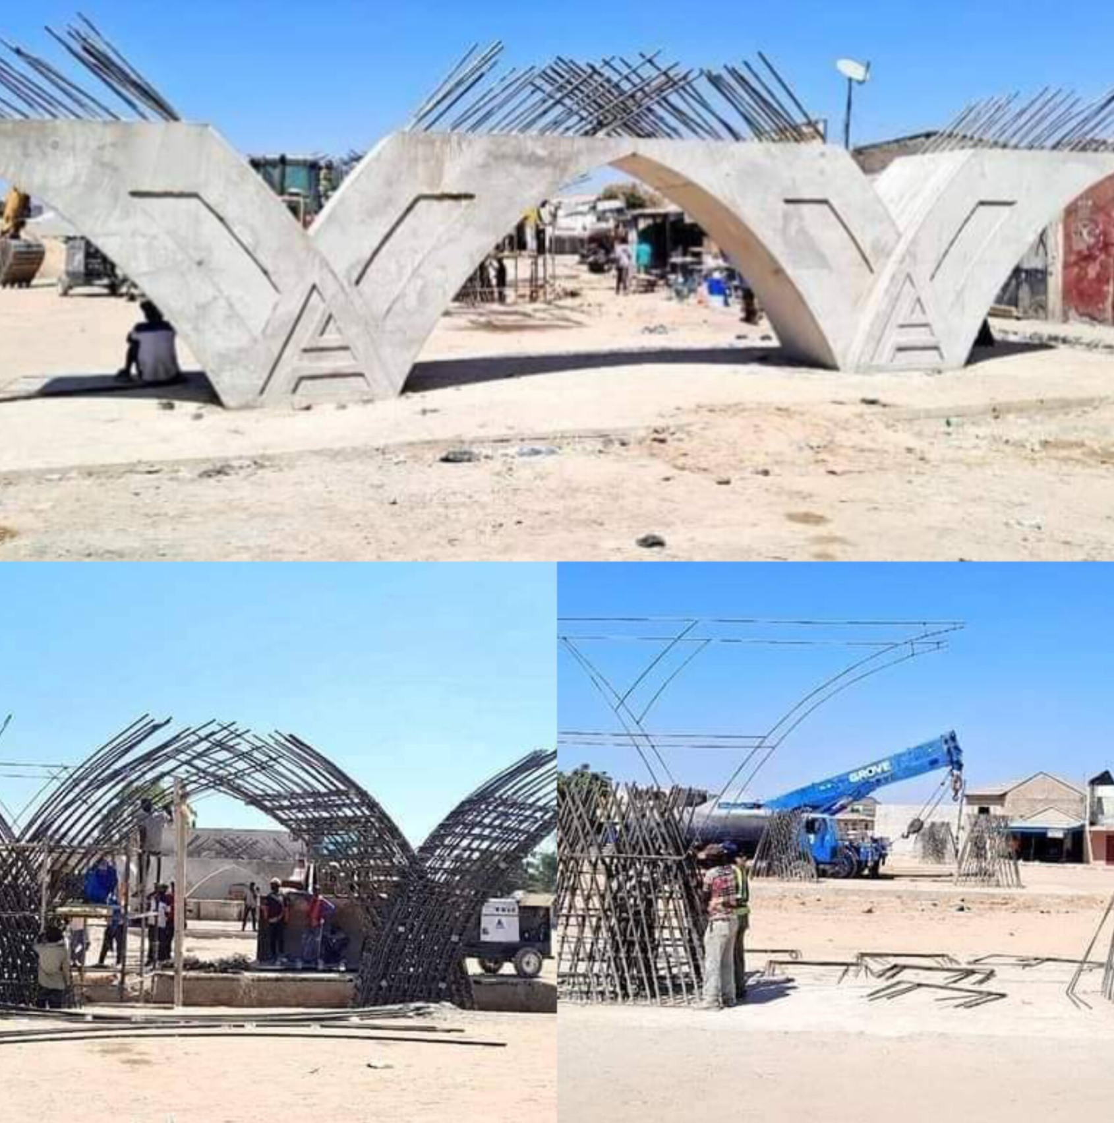
PROJECT: CONSTRUCTION OF MUBI ROUND ABOUT FLYOVER
STATUS: ONGOING
EXPECTED DATE OF COMPLETION: JUNE 2025

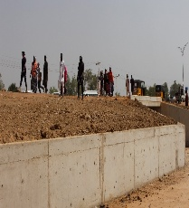
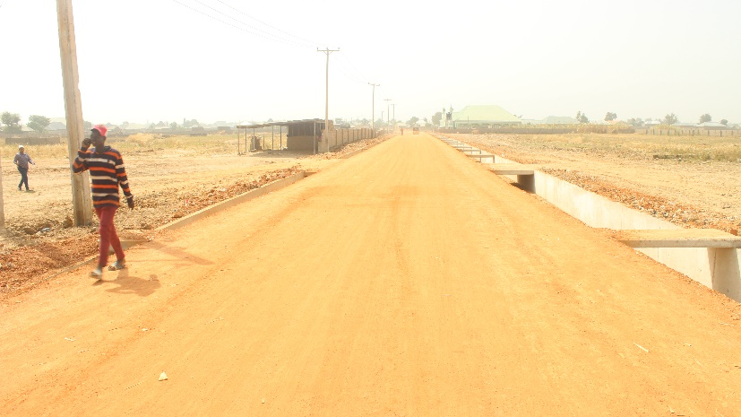
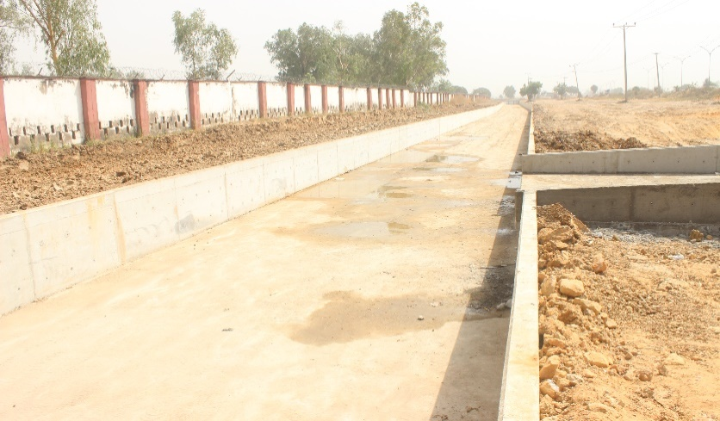
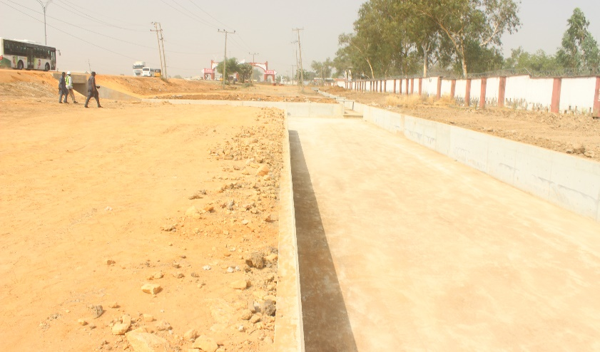

PROJECT: CONSTRUCTON OF STORM WATER DRAINAGE FROM SAMINAKA THROUGH FGGC TO GERIO LAKE – PHASE 1 (1.9KM)
STATUS: ONGOING
EXPECTED DATE OF COMPLETON:

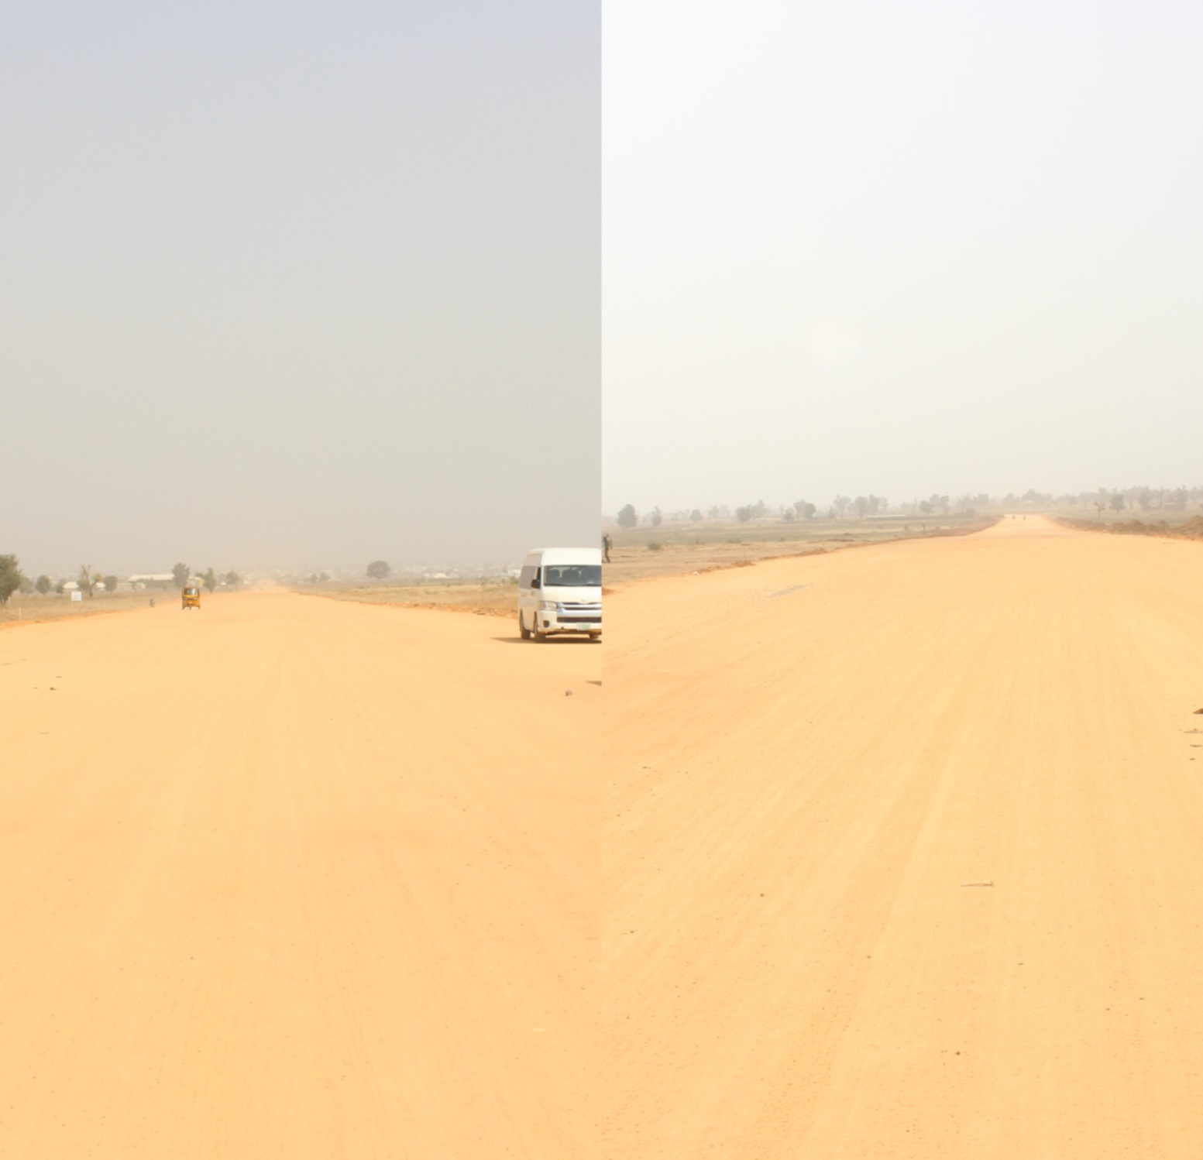
PROJECT: CONSTRUCTION OF 28KM SUPER HIGHWAY FROM WELCOME TO YOLA TO AA LAWAN
STATUS: ONGOING
EXPECTED DATE OF COMPLETION:

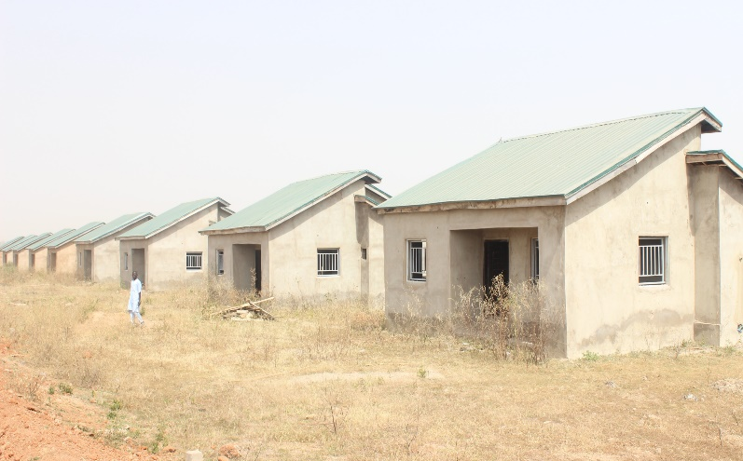
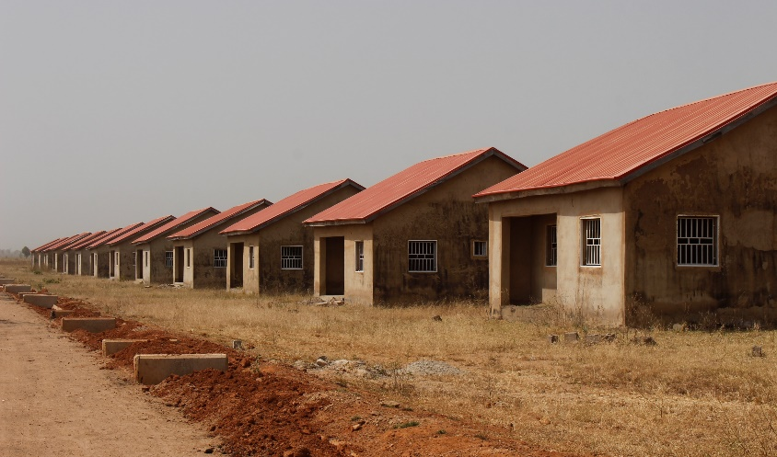
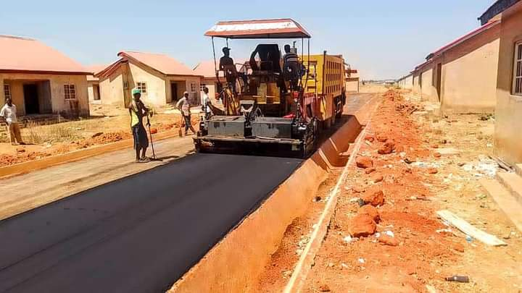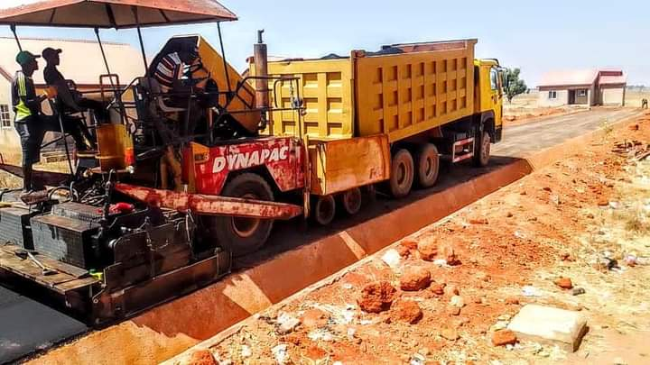
PROJECT: CONSTRUCTON OF 1000 HIOUSING UNIT
STATUS: ONGOING
EXPECTED DATE OF COMPLETIOON:

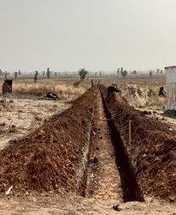
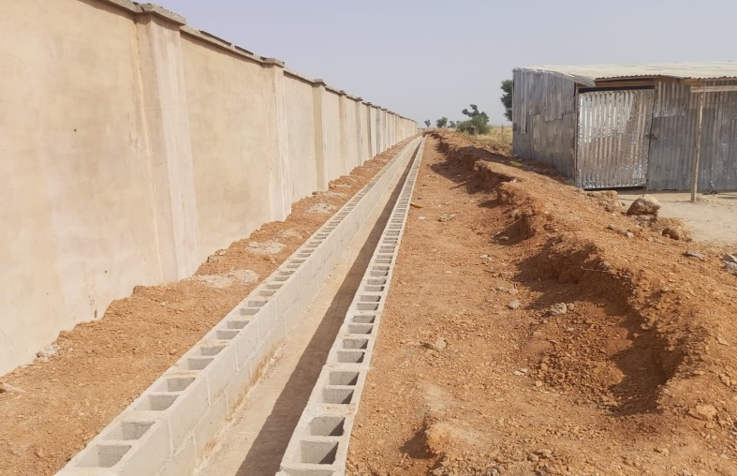
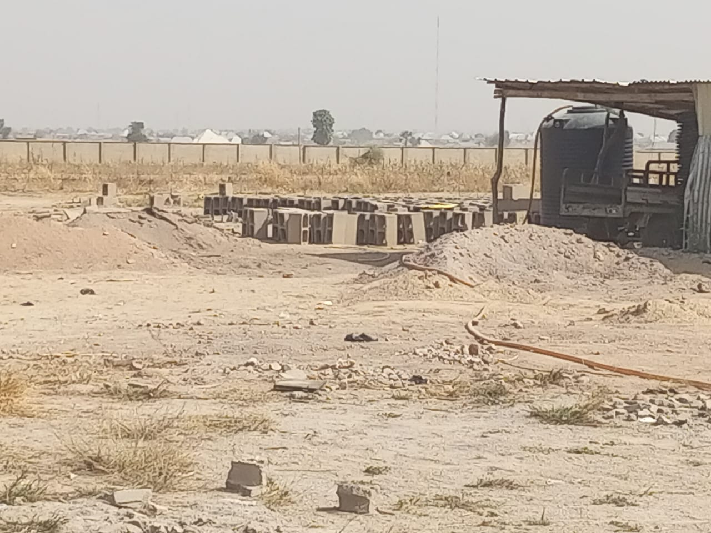
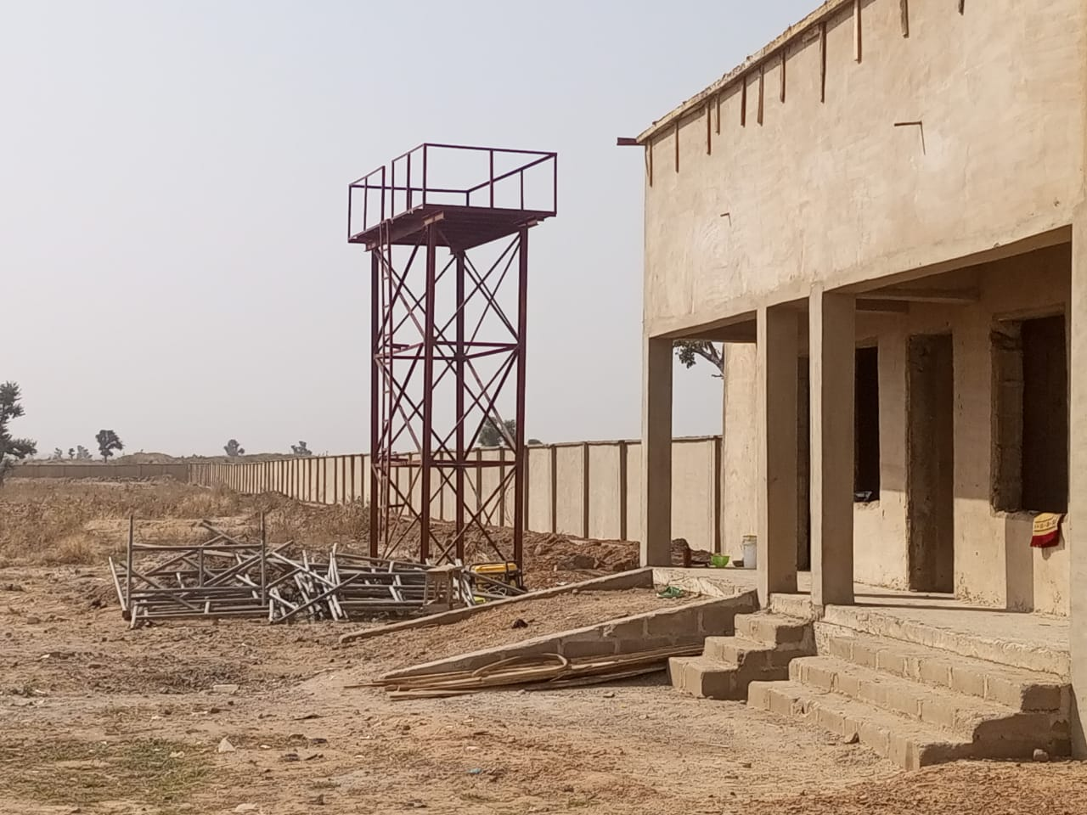
PROJECT: CONSTRUCTION OF NEW CEMETARY
STATUS: ONGOING
EXPECTED DATE OF COMPLETION:

PROJECT: CONSTRUCTON OF STORM WATER DRAINAGE FROM SAMINAKA THROUGH FGGC TO GERIO LAKE – PHASE 1 (1.9KM)
STATUS: ONGOING
EXPECTED DATE OF COMPLETON:

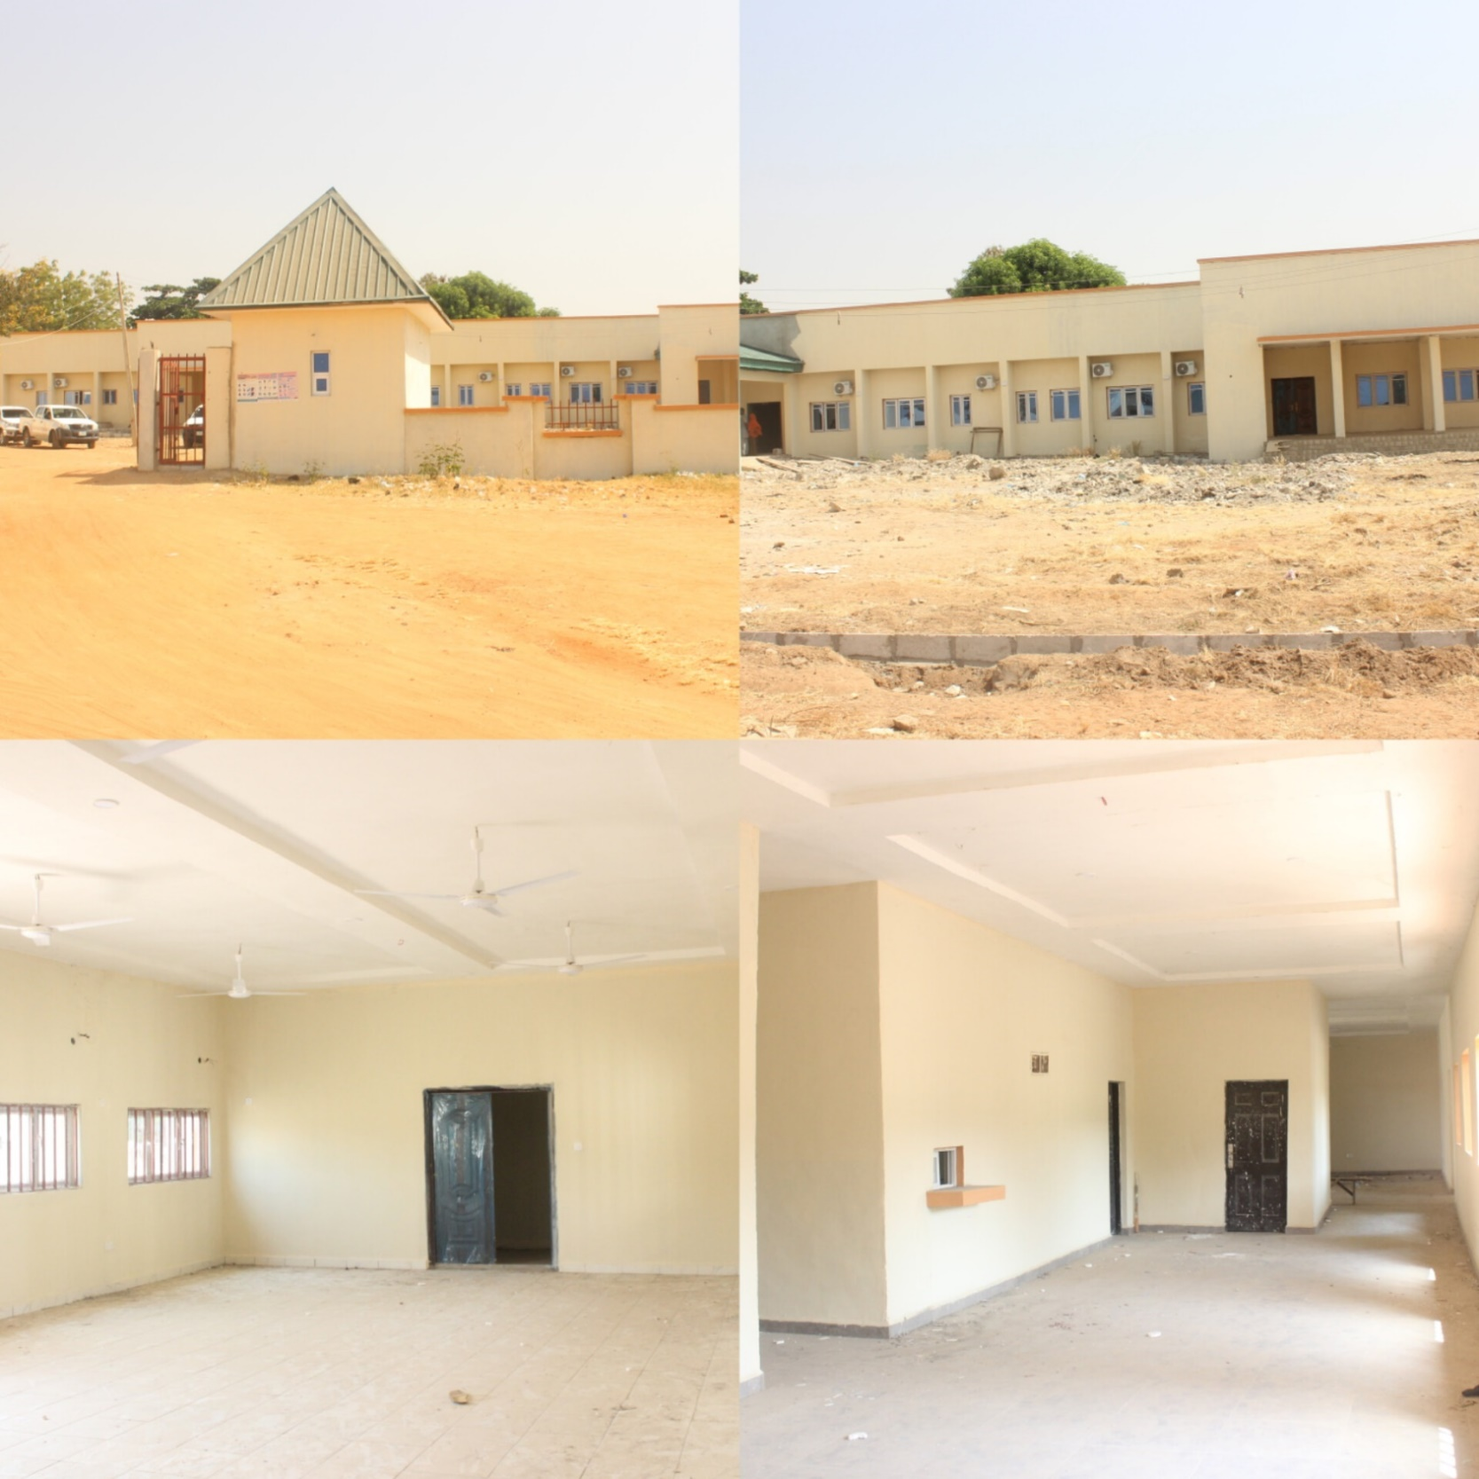
PROJECT: ONGOING CONSTRUCTION OF FUFORE COTTAGE HOSPITAL FUFORE
STATUS: ONGOING
EXPECTED DATE OF COMPLETION:

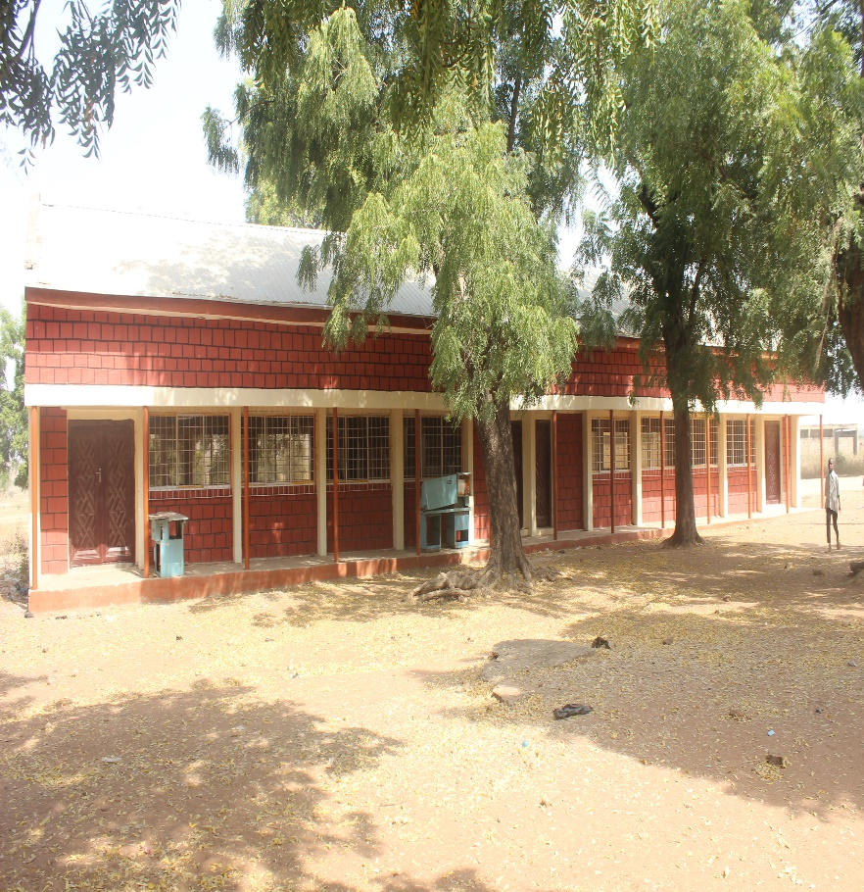

PROJECT: ONGOING CONSTRUCTION OF GOVERMENT SECONDARY SCHOOL FUFORE
STATUS: ONGOING
EXPECTED DATE OF COMPLETION:
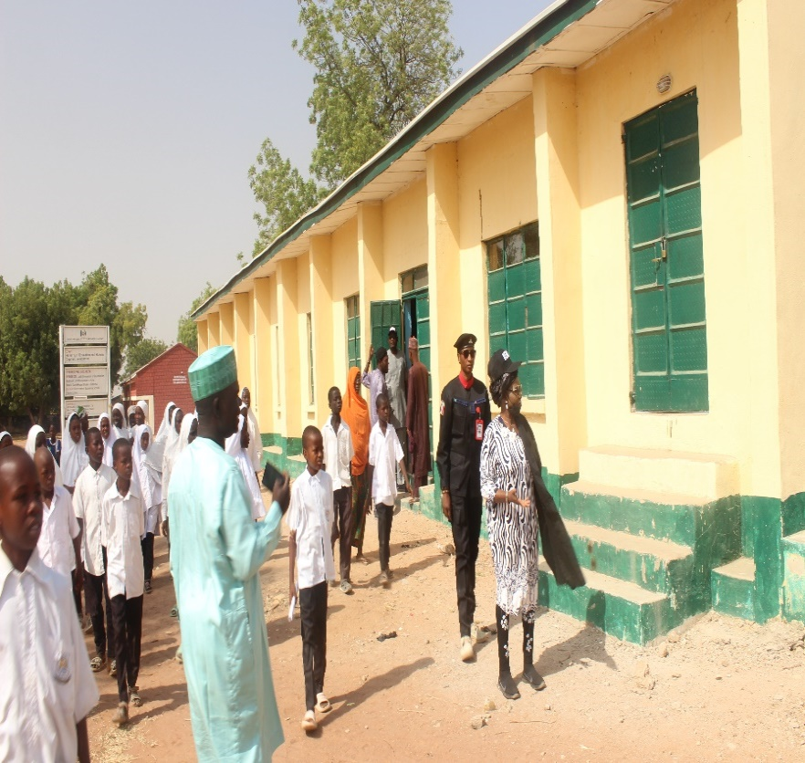
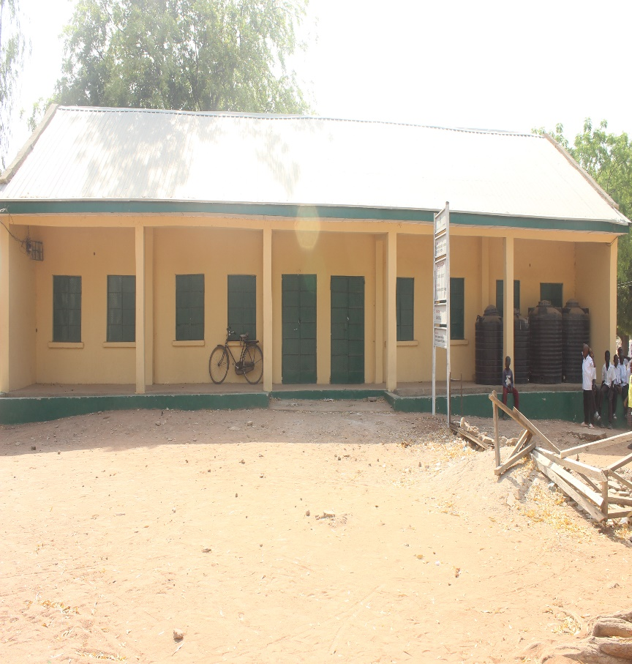

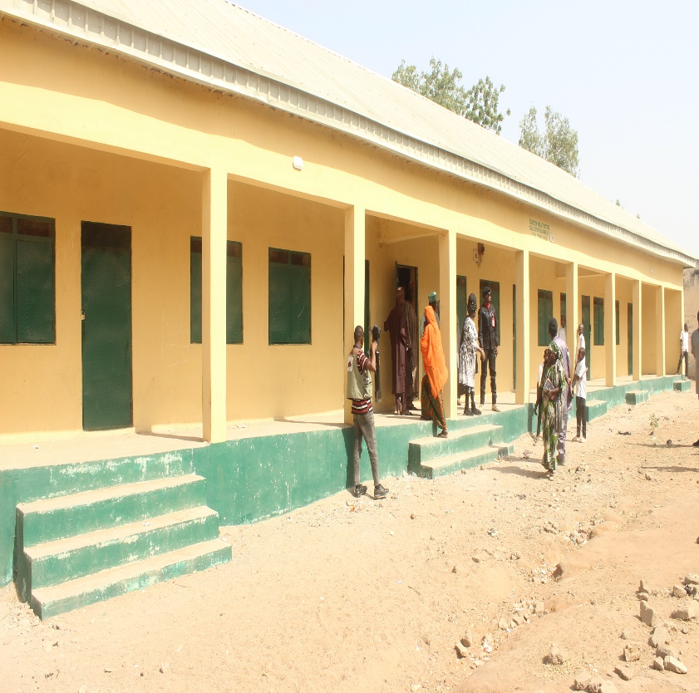

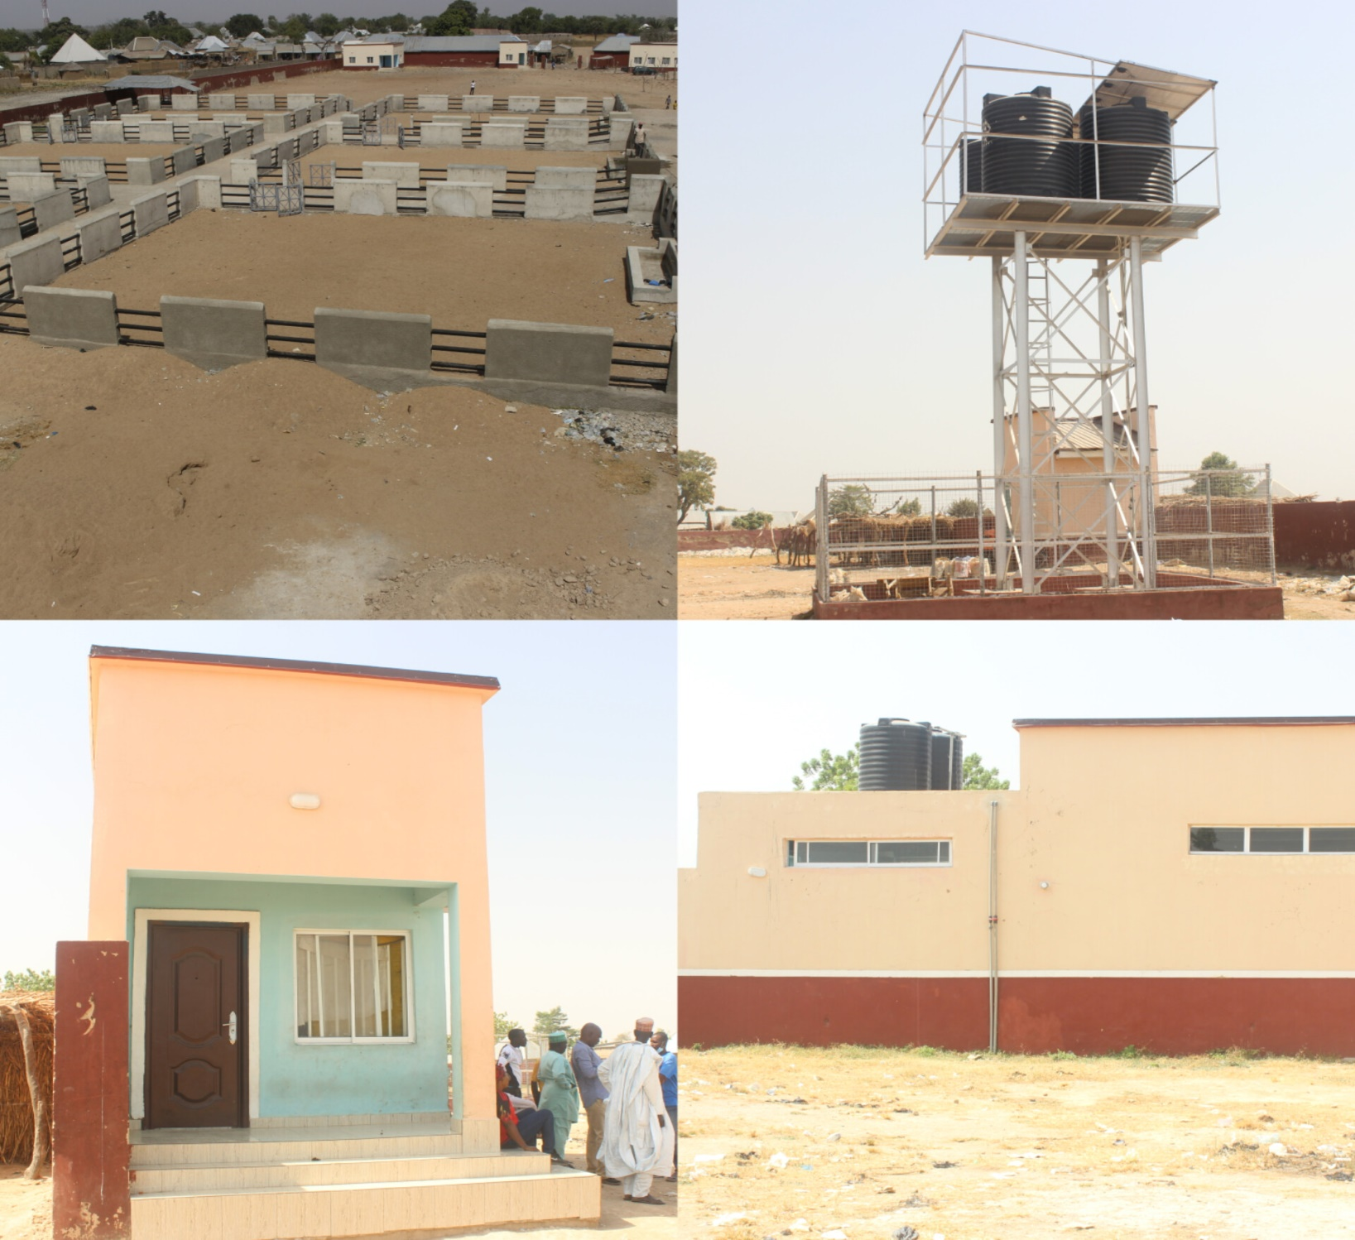
PROJECT: ONGOING CONSTRUCTION OF CHIGARI CATTLE MARKET LOADING BAY, SOLAR POWER BORE HOLE, TOILET & SECURITY POST
STATUS: ONGOING
EXPECTED DATE OF COMPLETION:

Summary of the LGA critical needs

Local Government Areas Critical Needs
S/N | LGA | CRITICAL NEEDS  PROJECT DESCRIPTION | LOCATION  LGA/WARD | REMARK
1 | DEMSA | - FEEDER ROAD FROM OLD DEMSA TO SABON LAYI (20KM)  - FEEDER ROAD FROM BIDOMA TO BILLE IS (11KM)  - FEEDER ROAD FROM THE MAIN ROAD TO DONG (6KM)  - FEEDER ROAD, FROM MAIN ROAD TO DWAM-PARE, DWAM-SAKATO  - BOREHOLE IN TASSALA VILLAGE  - ELECTRIFICATION FROM BORRONG TO GWAMBA (14KM)  - POLICE OUTPOST | - DEMSA  - BILLE  - DONG  - DWAM  - MBULA  - GWAMBA  - KODOMUN
2 | FUFORE | - RENOVATION OF DOCTORS QUARTER AND STAFF QUARTERS IN COTTAGE HOSPITAL  - RENOVATION OF FEMALE HOSTEL  - FENCING OF GOVERNMENT SECONDARY SCHOOL.  - PROVISION OF TRANSFORMER TO CONNECT WITH THE TOWN BOREHOLE.  - RENOVATION OF PRESIDIENTIAL LODGE  - ROADS, SCHOOLS, CLINICS, POLICE OUTPOST AND BOREHOLES | - FUFORE  - FUFORE  - FUFORE  - FUFORE  - FUFORE  - GARIN BANGE, GARIN ALAJI, SAWUN AND BILACI
3 | GANYE | - RECONSTRUCTION OF 3KM NEW MARKET ROAD FROM LCCN JUNCTION TO WELCOME TO GANYE LOCAL GOVERNMENT WITH JADA LOCAL GOVERNMENT  - RECONSTRUCTION OF 1KM NITEL ROAD FROM LCCN JUNCTION TO FEDERAL GOVERNMENT COLLEGE GANYE  - RECONSTRUCTION OF PIPE BORNE WATER WITHIN GANYE METROPOLITAN BEHIND GANYE 1 PRIMARY AND SECONDARY SCHOOL. | - GANYE LOCAL GOVERNMENT  - GANYE TOWN  - GANYE TOWN
4 | GOMBI | - CONSTRUCTION OF BRIDGE/CULVERT TO GDSS TELA BALA  - REHABILITATION OF 2 NO. BLOCKS OF CLASSROOM WITH CHAIRS/FURNITURE FOR STUDENTS.  - REHABILITATION OF 2 NO. BLOCKS OF DILAPIDATED CLASSROOMS  - COMPLETION OF EXAM HALL TO BE ROOFED AND FURNISHED @ GDSS GANGRANG  - CONSTRUCTION OF 3 CULVERTS WHICH CONNECTS FOTTA TO RIJI  - GULLY EROSION AT MAKERA, DOWN TO GOMBI 2 PRIMARY SCHOOL NEEDS DRAINAGES, CULVERTS AND SAND FILLING  - DRAINAGES, BIG CULVERTS, SAND FILLINGS AND TARRING OF THE ERODED HIGHWAY.  - ONGOING RECONSTRUCTION OF ROAD AT GOMBI NORTH TASHAN GWAIGWAI  - 12.5 KM ROAD FROM BALHONA-KWALAMBA | - GUYAKU  - GARKIDA  - GA'ANDA  - DUWA  - GOMBI TOWN  - TASHAN ALLEWA MAKERA  - TASHAN KWAIKWAI  - GUYAKU/GARKIDA
5 | HONG | - RENOVATION OF STAFF QUARTERS AS IT WAS BURNT DONW DURING THE INSURGENCY  - CONSTRUCTION OF 2KM IN TOWNSHIP ROAD DRAINAGES  - RENOVATION OF GSS HONG | - HONG TOWN  - BEHIND KT HONG LGA  - HONG TOWN
6 | JADA | - CONSTRUCTION OF ROADS IN MBULO, POLA, JADA TO GANGNANI, AND BAGOBIRE  - ELECTRIFICATION OF DASHEN IN JADA LOCAL GOVERNMENT AREA  - REHABILITATION OF POLA MARKET | - JADA  - JADA  - JADA
7 | LAMURDE | - GYAWANA ALONG NGBAKOWO ROAD  - ELECTRIFICATION FROM RIGANGE TO BAJEN DUBWAGUN TO MBEMUN IN LAMURDE LGA  - CONSTRUCTION OF ROAD FROM LAFIYA TO TINGNO  - SAND FILLING OF BY-PASS ROAD LAMURDE TO GYAWANA | - GYAWANA, NGBAKOWO  - LAMURDE  - LAMURDE  - LAMURDE
8 | MADAGALI | - CONSTRUCTION OF ROADS FROM GWABA TO DZUEL AND FROM APIAKUJA TO WANNU.  - RENOVALATION AND CONSTRUCTION OF ONE BLOCK OF THREE CLASSROOMS  - DRILLNG OF MORE BOREHOLE AS THE COMMUNITY HAS ONLY ONE SOURCE OF WATER  - CONSTRUCTION OF 8KM ROAD FROM WURO GAYANDI TO KOPA  - CONSTRUCTION OF 3KM ROAD FROM APIAKUJA TO WANNU IN GULAK WARD  - CONSTRUCTION OF 8 KM ROAD FROM LUMADU TO PALLAM  - RENOVATION OF CLASSROOMS AND THERE'S NEED FOR SEATS  - CONSTRUCTION OF 8KM ROAD STARTING FROM SHUWA MAIN ROAD TO KIRCHINGA | - GWABA – DZUEL & APIAKUJA – WANNU  - PALLAM-KOJITI  - PALLAM-DUEL  - K/WURONGAYANDI-KOPA  - GULAK  - PALLAM  - KOPA CENTRAL PRIMARY SCHOOL  - KIRCHINGA
9 | MAIHA | - UPLIFT THE ABANDONED ADAMAWA STATE UNIVERSISTY MUBI SCHOOL OF REMIDIAL AND BASIC STUDIES  - RESTRORATION OF THE 2.MVA, 33/11KV POWER TRANSFORMER  - COMPLETION OF THE ABANDONED BRIDGE ACROSS RIVER JABA | - MAIHA  - MAIHA TOWN  - MAIHA GARI
10 | MAYO-BELWA | 1. REHABILITATION OF TOWNSHIP ROADS AND RURAL ROADS.  2. CONSTRUCTION OF ROADS/BRIDGES FROM MAYO BELWA THROUGH YOFFO TO NGENLE.  3. REHABILITATION OF DILAPIDATED GOVERNMENT SECONDARY SCHOOL MAYO BELWA.  4. SPORTS FACILITIES ARE LACKING IN MAYO BELWA HENCE THE NEED FOR GOVERNMENT TO INVEST BY PUTTING IN PLACE A MINI STADIUM. | - MAYO BELWA  - YOFFO NGENLE.  - MAYO BELWA  - MAYO BELWA
11 | MICHIKA | - RENOVATION OF MICHIKA LOCAL GOVERNMENT STAFF QUARTERS  - CONSTRUCTION OF DLAKA- FUTU ROAD  - RENOVATION OF MICHIKA YOUTH PLAZA  - RENOVATION OF GEN. BUBA MARWA’S LIBRARY  - RENOVATION FINANCE DEPARTMENT, MICHIKA LGA  - CONSTRUCTION OF 1 BLOCK OF 3 CLASSES IN FWA PRIMARY SCHOOL BAZZA MARGHI WARD  - CONSTRUCTION OF A 5KM ROAD FROM THE MAIN ROAD THROUGH GADA UKU TO KANKILIA IN BAZZA MARGHI WARD  - RENOVATION OF MICHIKA MOTEL | - MICHIKA  - DLAKA-FUTU  - MICHIKA  - MICHIKA  - MICHIKA SECRETARIATE  - BAZZA-MARGHI  - BAZZA  - MICHIKA
12 | NUMAN | - RENOVATION OF ADAMAWA STATE POLYTECHNIC NUMAN CAMPUS  - RECONSTRUCTION OF THE JUST COMPLETED AND COMMISSIONED 3.5KM KASUWAN IZALA-GWEDA MALAM-WAYAM ROAD.  - VULPI DEVELOPMENT AREA DILAPIDATED FEEDER ROAD.  - YANGA FEEDER ROAD | - NUMAN  - NUMAN  - VULPI  - BOLKI
13 | SONG | - RENOVATION OF WALTANDI BRIDGE FROM DUMNE TO SHELLENG LOCAL GOVERNMENT.  - RENOVATION OF 9 (NINE) BLOCKS OF 4 (FOUR) CLASSROOMS,1 (ONE) BLOCK OF 6 (SIX) CLASSROOMS,1 (ONE) BLOCK OF 2 (TWO) CLASSROOMS, 1 (ONE) BLOCK OF 4 (FOUR) LABORATORIES, 2 (TWO) EXAMINATION HALLS, 7 (SEVEN) HOSTEL ACCOMMODATION, 2 (TWO) ADMINISTRATIVE BLOCKS, 1 (ONE)NO. FLAT OF A CLINIC, WATER AND ELECTRICITY SUPPLIES, 46 (FORTY-SIX) FLATS OF TEACHER’S ACCOMMODATION (1) 4 (FOUR) BEDROOMS. (2) 3 (THREE) BEDROOMS (3) 2 (TWO) BEDROOMS AND THEIR BOY’S QUARTERS RESPECTIVELY. | - DUMNE  - GOVERNMENT SECONDARY SCHOOL, SONG.
14 | TOUNGO | - RENOVATION OF GSS TOUNGO  - GSS TOUNGO EXAMS HALL  - CLASSROOMS  - MALE HOSTEL | - TOUNGO  - TOUNGO  - TOUNGO  - TOUNGO
15 | SHELLENG | - KIRI DAM  - COMPLETION OF SHELLENG ROAD  - RENOVATION OF PHCCS ACROSS THE LGA  - IMPROVING ANIMAL FARMING IN THE LGA  - IMPROVING FARMING ACTIVITIES | - SHELLENG  - SHELLENG  - SHELLENG  - SHELLENG  - SHELLENG

Dr. Mary B. Paninga Hon. Augustine Pharm. Amos Piribu
Executive Chairman, ASPC S.A. M&E P.S. ASPC

