CRS INFRASTRUCTURE INTERVENTIONS PHASE I

- School infrastructure Construction: A total of 15 blocks of classroom and 12 sanitation facilities were constructed/ rehabilitated across Gwolontabal, Loko, Dadinkowa Hausawa, Murke, Mbamba, Yolde Pate, Namtari, Gundu-Kem, Kiri, Libbo and Shelleng Gari wards. All the school infrastructures were equipped with furniture.
- Health Centre Rehabilitation: Construction/ Rehabilitation of health centre and incinerator in Yolde Kohi, Gundo-Kem and Wuro Dole wards. The health centres were provided with adequate furniture.
- Hand Pump construction: A total of 11 boreholes equipped with handpump facilities were constructed across Gwolontabal, Loko, Dadinkowa Hausawa, Mbamba, Bole-Yolde Pate, Namtari, Gundu-Kem and Libbo.
- Borehole Rehabilitation and upgrade: 9 Rural water supply facilities and 2 small town water supply facilities were rehabilitated and upgraded to solar powered system across Gwolontabal, Song Gari, Jera Bonyo, Jera Bakari, Wuro Dole, Girei 1, Girei 2, Toungo, Kiri, Shelleng Gari and Bodwai wards.
- New Borehole construction: 3 solar powered Rural water supply facilities were newly constructed across Yolde Kohi, Wuro Dole and Kiri wards.
- Culvert Construction: Construction of a single cell culvert in Yolde Kohi including earth filling.
CfW construction:
- Road upgrade: Upgrade and rehabilitation of 16 earthen roads including installation of culverts through CfW in Gwolontabal, Loko, Dadinkowa Hausawa, Murke, Mbamba, Yolde Pate, Wuro Dole, Gundu-Kem, Kiri, Libbo, Jera Bonyo, Jera Bakari, Girei 1, Girei 2 and Yolde Kohi wards.
- Drainage Construction: Construction of 5 drainage and evacuation of 1 drainage through CfW in Toungo, Girei 2, Loko, Shelleng Gari and Bodwai wards.
- Water Control: Construction of low water crossing infrastructure in Namtari ward and concrete Stabilization of river embarkment in shelling Gari ward, through CfW.

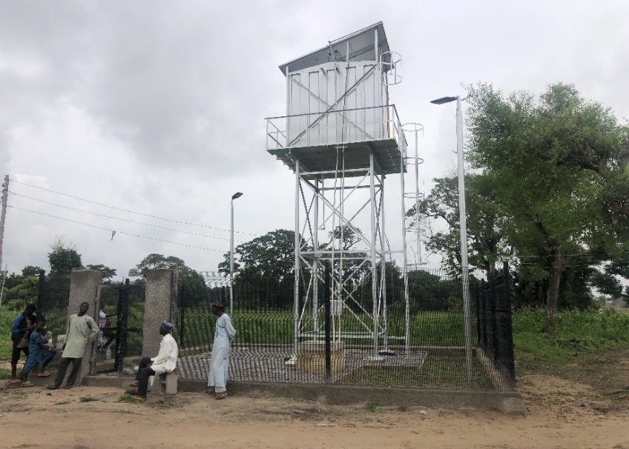
- BOREHOLES REHABILITATION
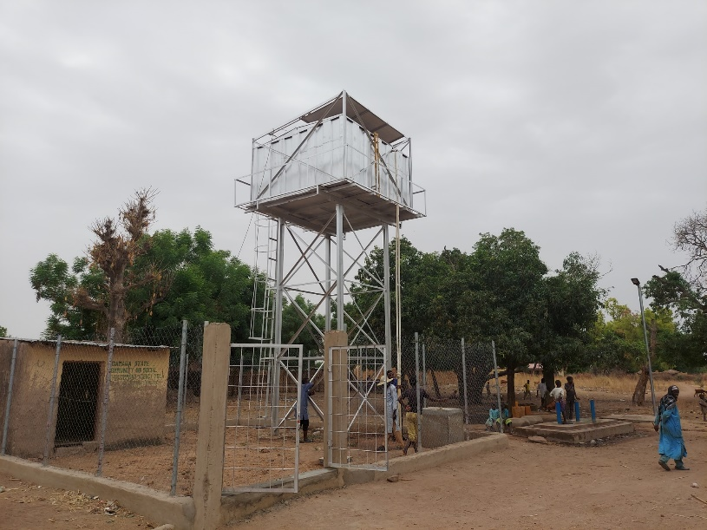

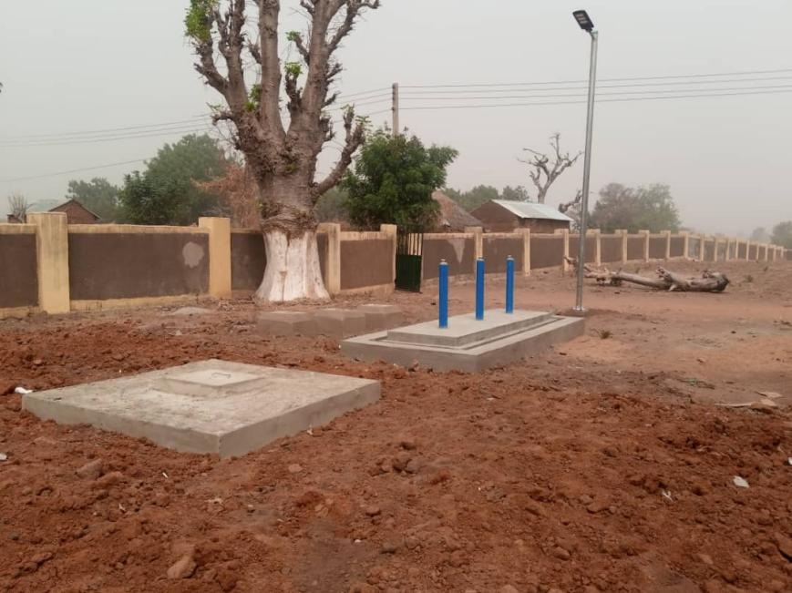
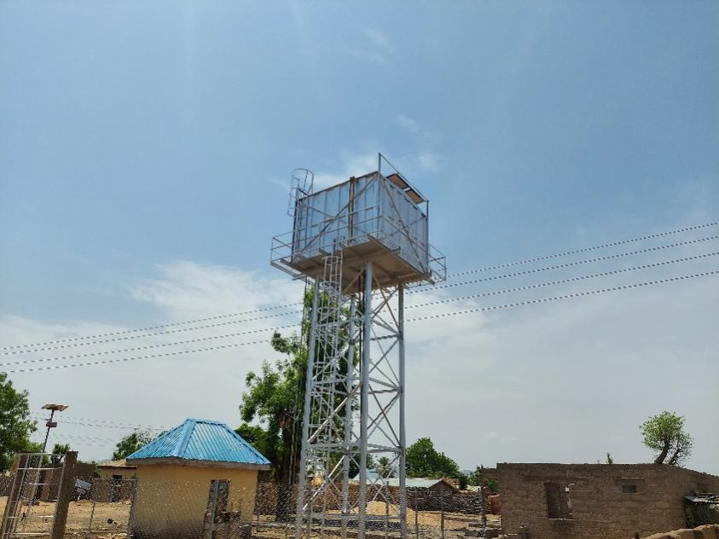

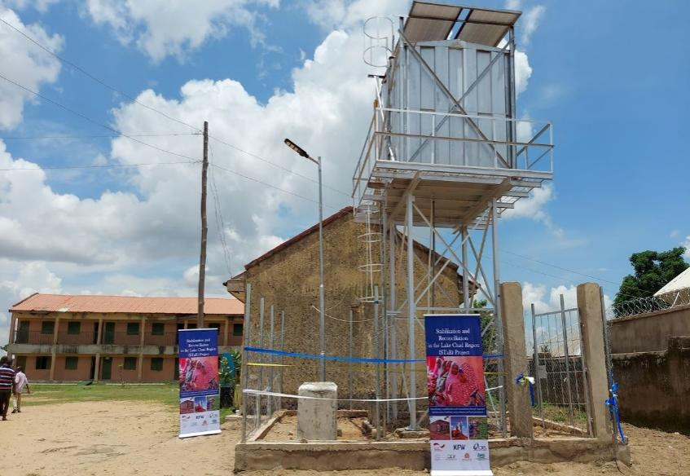
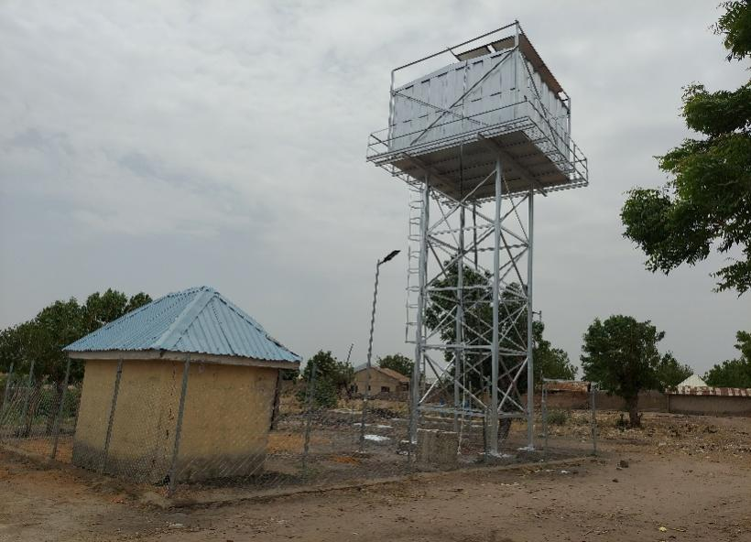

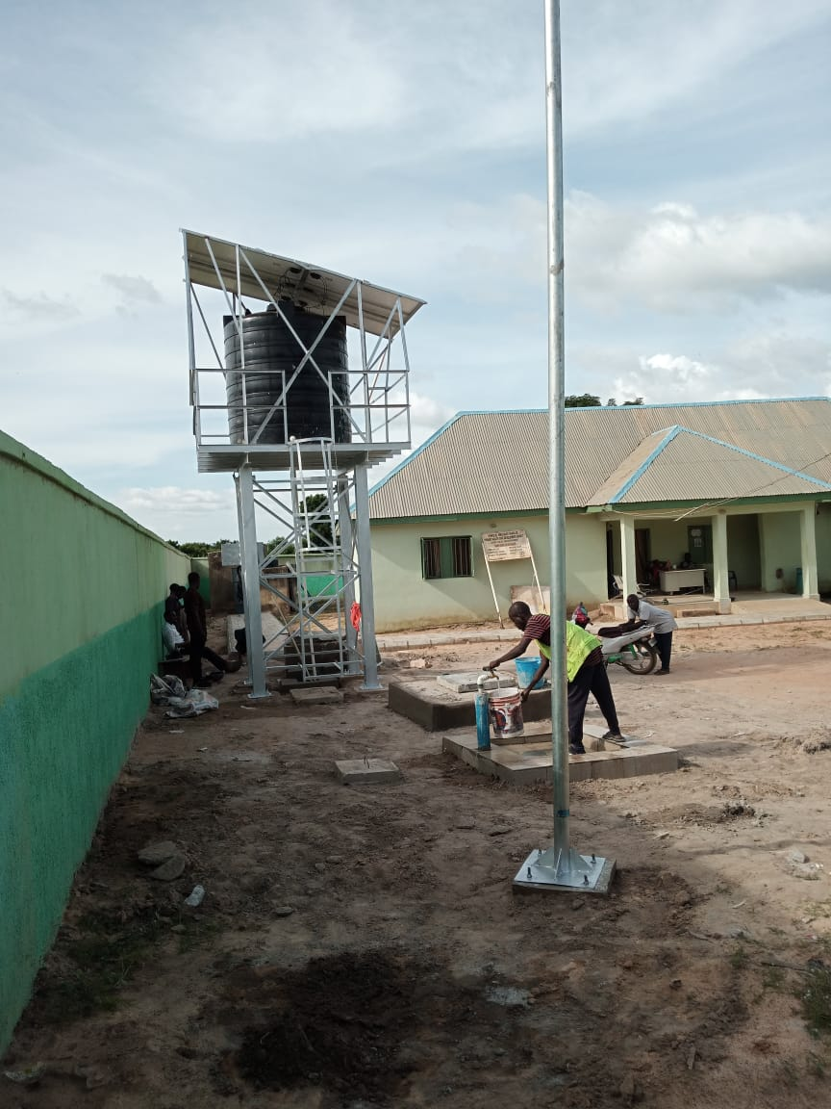

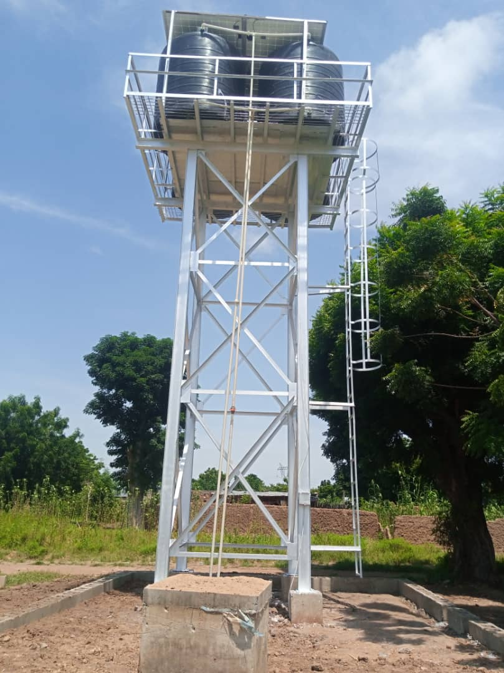

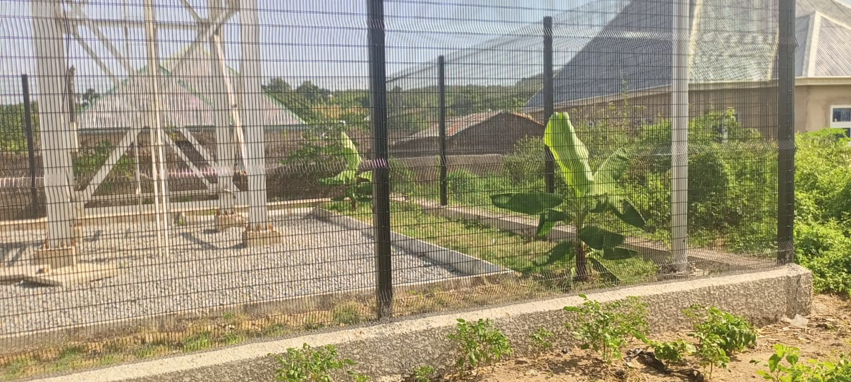

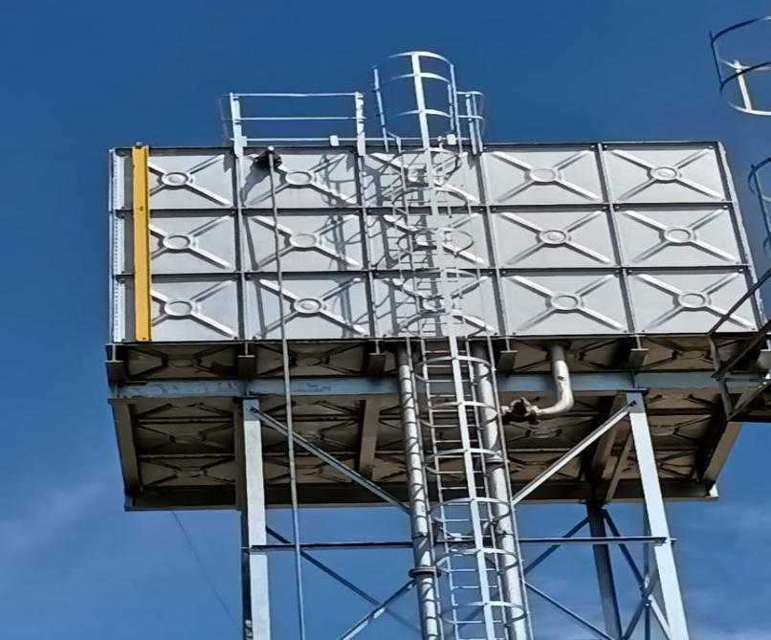
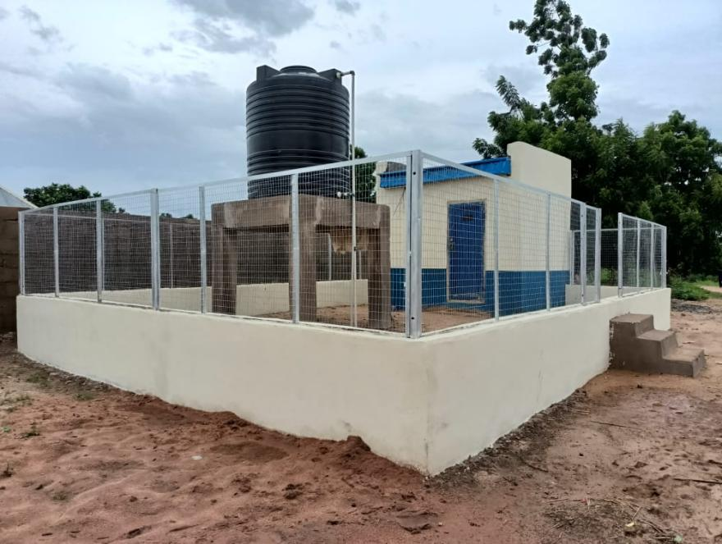

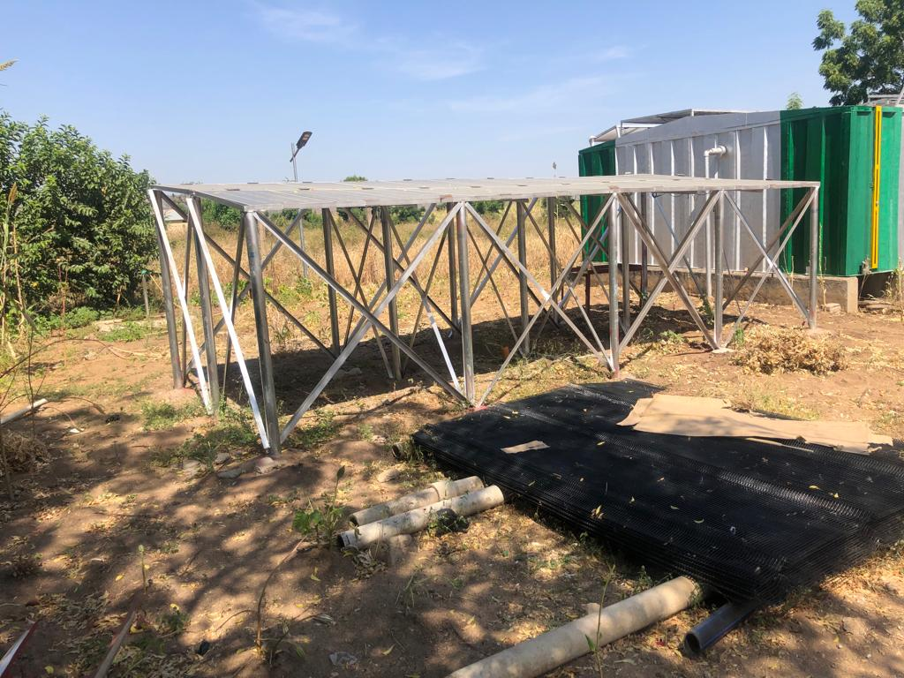

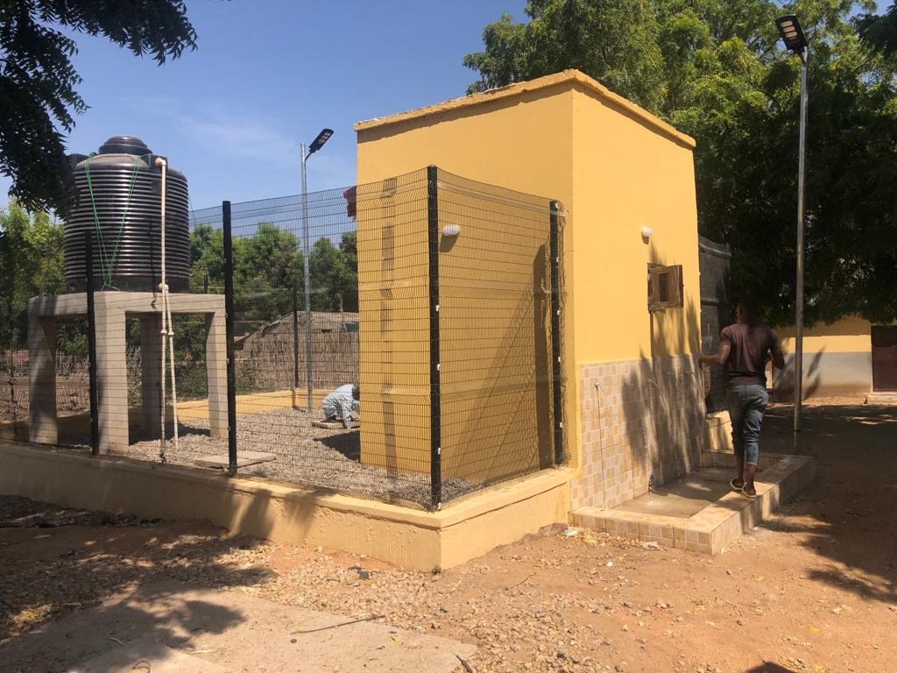

- HANDPUMP BOREHOLES
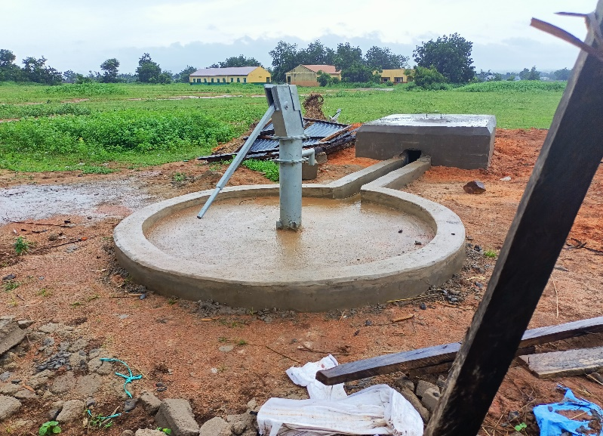
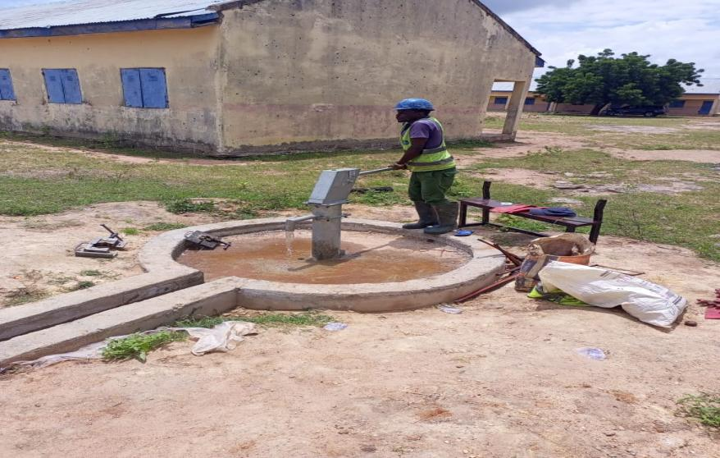

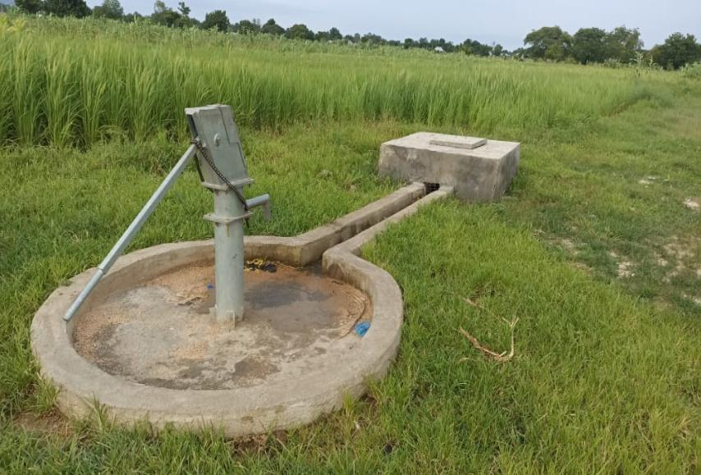
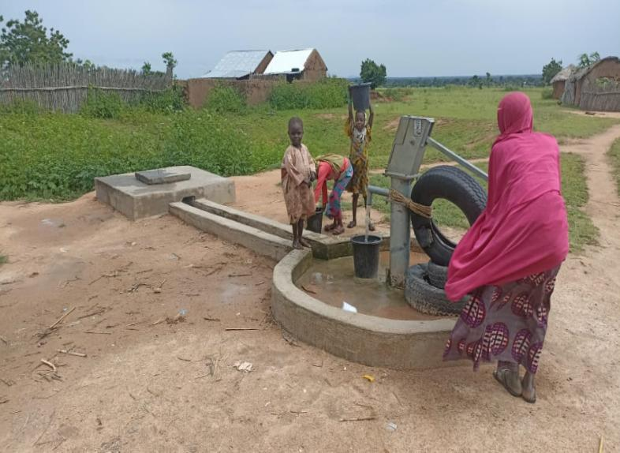

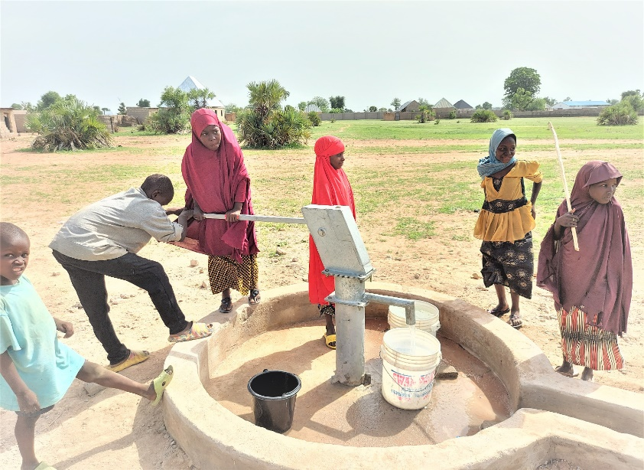
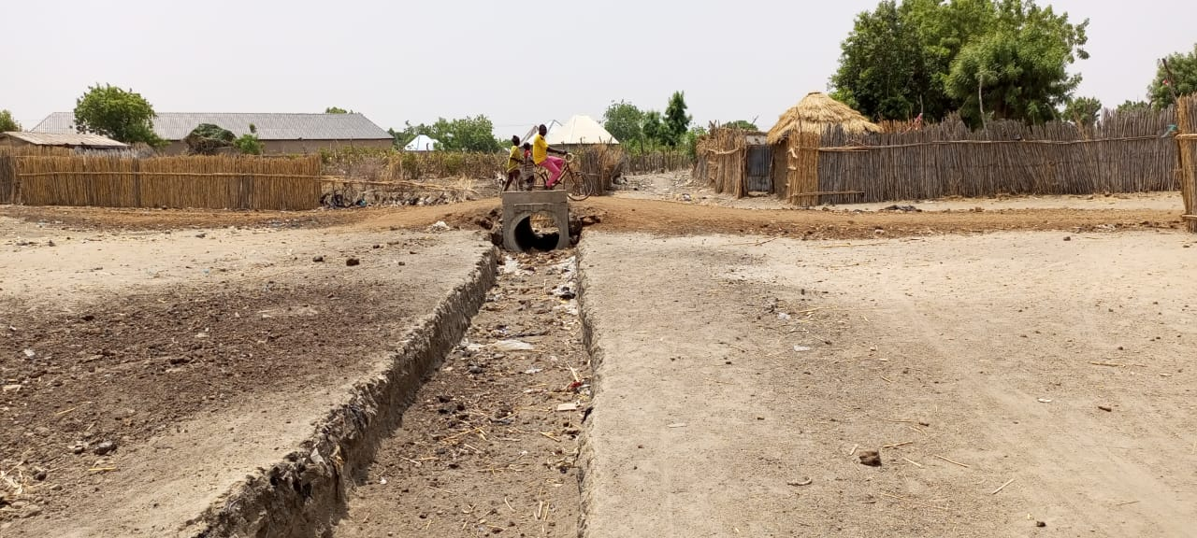

- CLASSROOM REHABILITATION
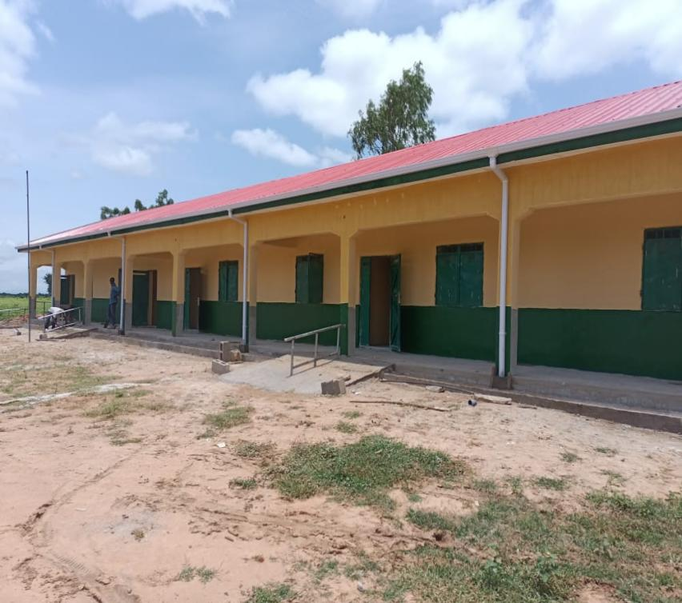
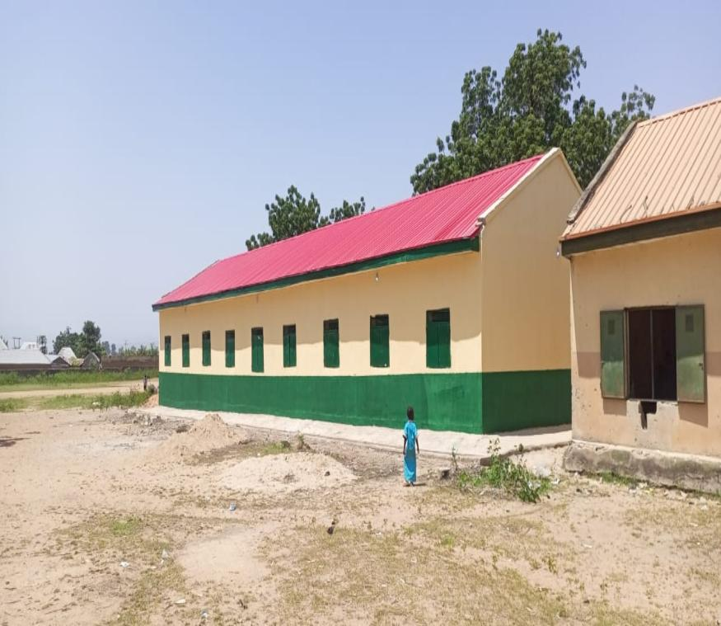

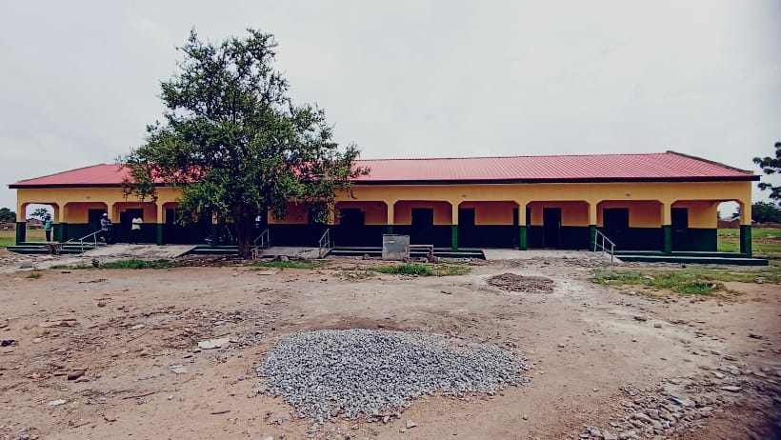
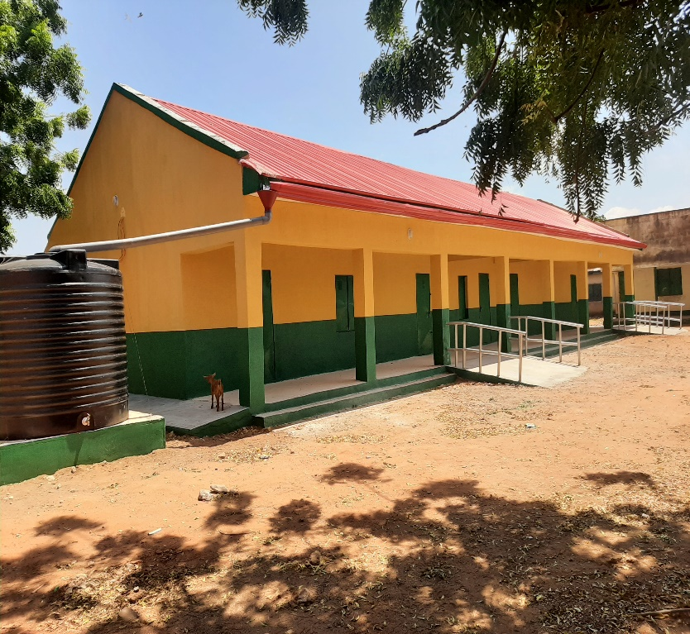

- CULVERTS AND DRAINAGES CONSTRUCTIONS
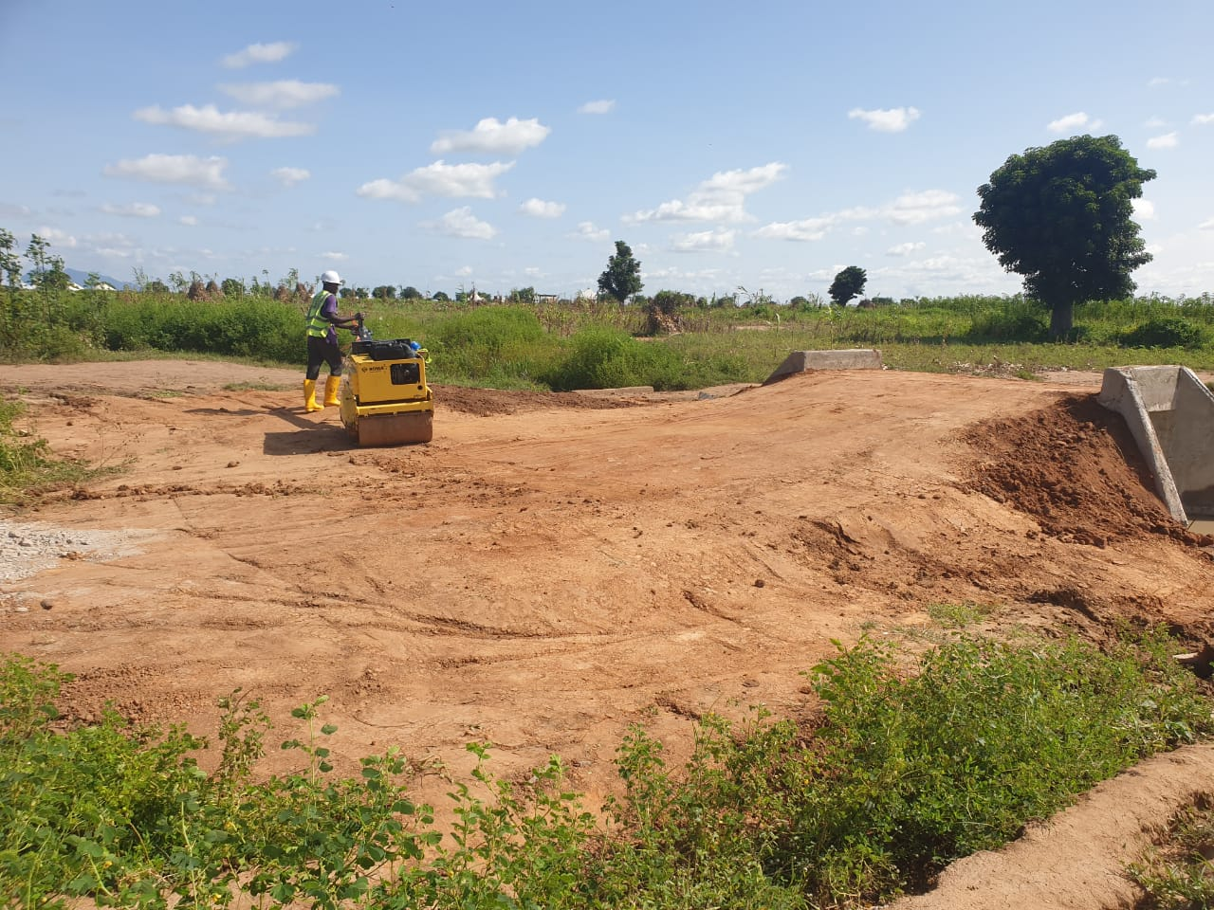

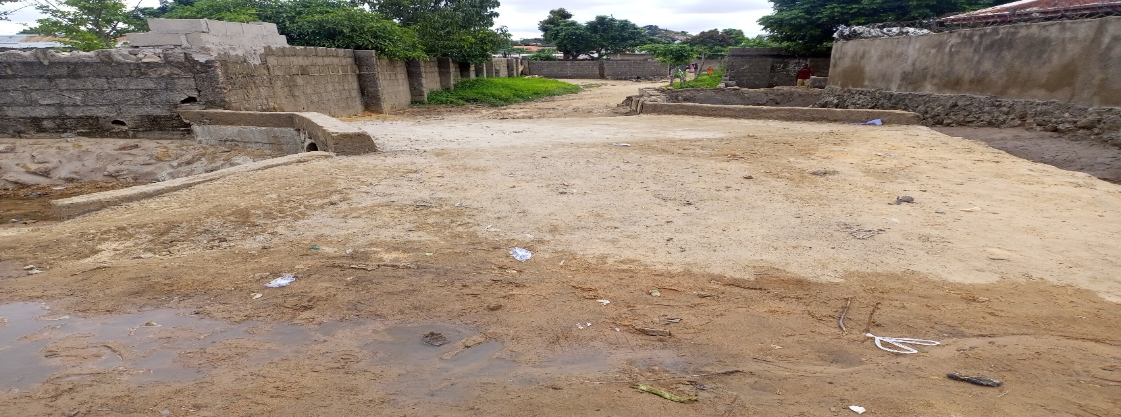

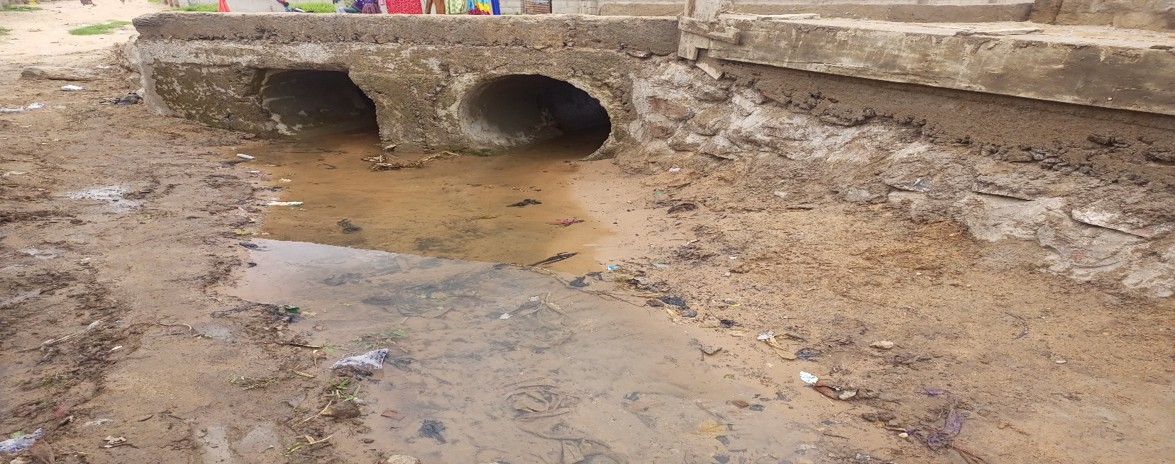

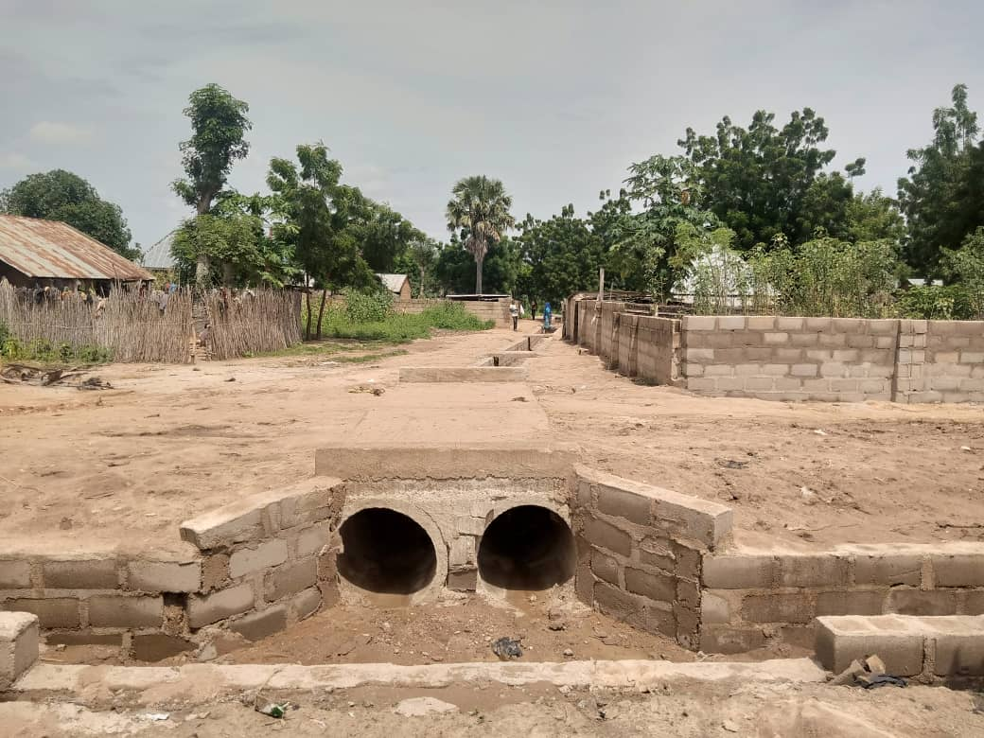

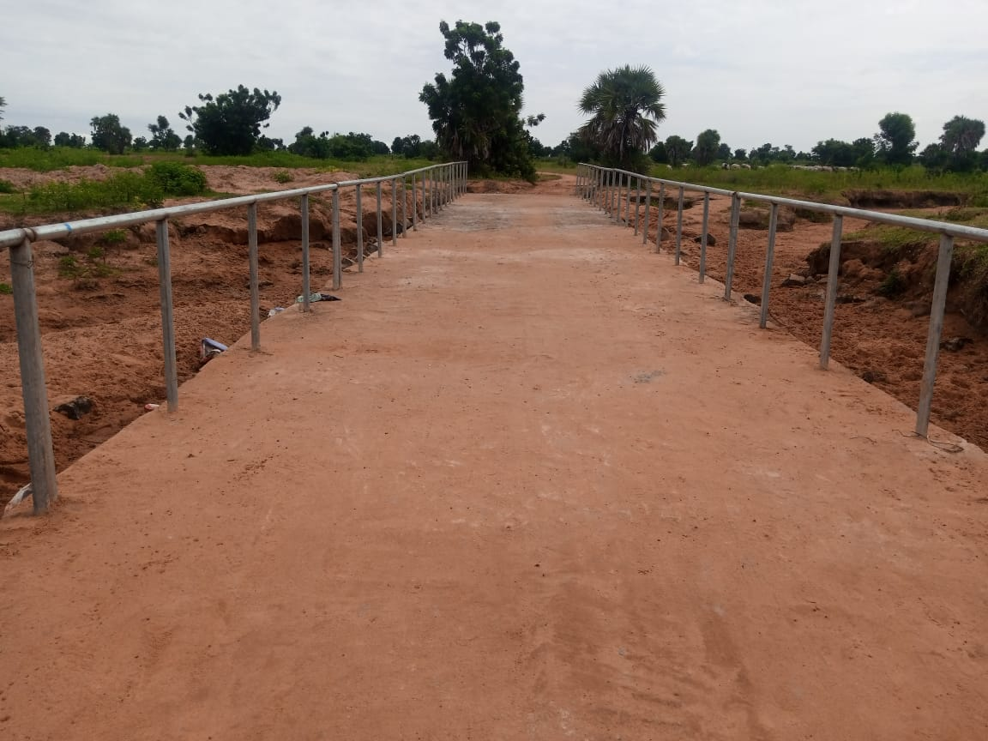

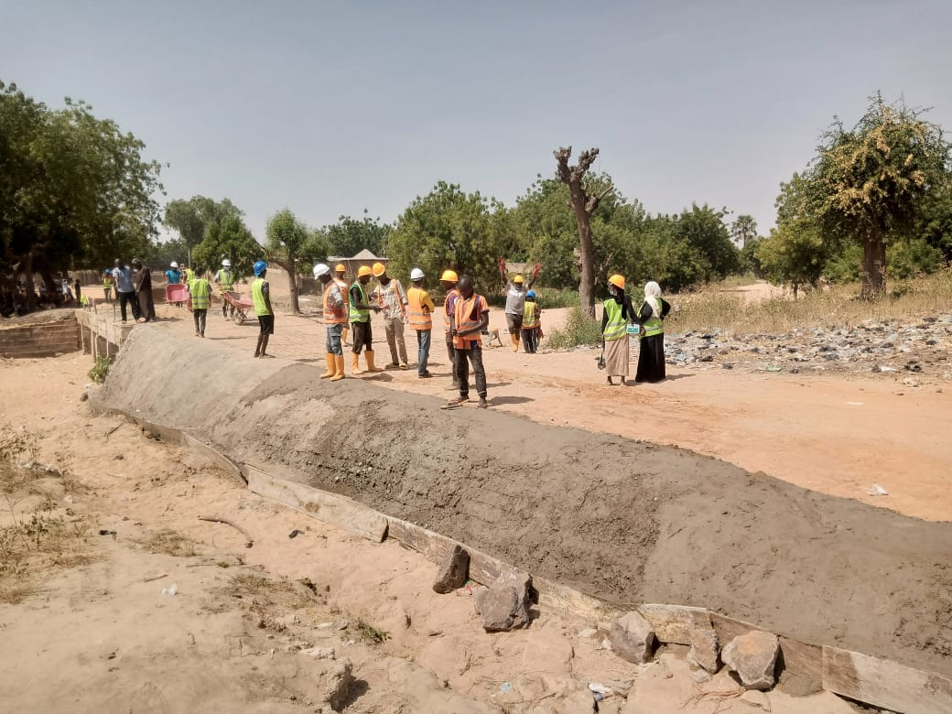

HEALTH CENTRE REHABILITATION
