“FINTIRI SUCCESS STORY IN RURAL DEVELOPMENT”
PRESS BRIEFING BY THE HONOURABLE COMMISSIONER FOR RURAL INFRASTRUCTURE AND COMMUNITY DEVELOPMENT, HON. TITUS SOLOMON, FCNA, ON THE ACHIEVEMENTS RECORDED IN RURAL ELECTRIFICATION AND RURAL ROADS CONSTRUCTION UNDER THE LEADERSHIP OF RT. HON. AHMADU UMARU FINTIRI; CON, GOVERNOR OF ADAMAWA STATE
The Honourable Commissioner Ministry of Information and Strategy,
Permanent Secretaries here present,
Directors and other officials of line Ministries,
Gentlemen of the Press.

On behalf of the Adamawa State Ministry for Rural Infrastructure and Community Development, I welcome you all to this briefing, which is inline with the policy thrust of Governor Ahmadu Fintiri led Administration in operating an open and transparent Government in the State.
Distinguished Gentlemen of the press, let me begin by expressing the Ministry’s appreciation to His Excellency for all the necessary moral and financial supports to carryout laudable projects of rural developments across the state which includes rural electrification and rural roads constructions. This has significantly opened up accessibility and further uplifted the socio economic well being of the rural populace. May I also use this forum to thank the Adamawa State House of Assembly for ensuring that all projects proposed during the period under review are appropriated and approved in the budget. We hope this tempo will be maintained.
Ladies and Gentlemen, the Ministry for Rural Infrastructure and Community Development has as its mandate to ensure that the rural populace are linked to the National Grid and also open up access through the construction of rural roads to facilitate easy movement of goods and services. Let me boldly inform you that this has been significantly and greatly achieved during the period under review. There is a physical presence of either an electrification project or a rural road construction in each of the 21 Local Government Area.
A total of 33 projects comprising rural electrification, supply of transformers and rural road constructions were carried out across the state. Out of this number, 27 are successfully completed with 100% payment made to the contractors. Most of the affected communities are already making good use of the projects.
Gentlemen of the press, may I now have the honor to present to you the details of the projects as carried out across each Local Government Area and according to the senatorial zone.
CENTRAL SENATORIAL ZONE
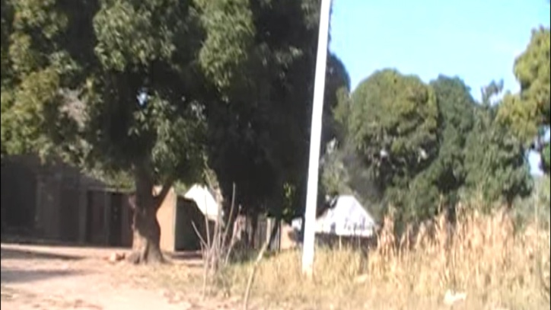
- Hong Local Government: A total of four projects were initiated and carried out in Hong Local Government. They include:
- The Fadama Rake/Kwanan Kuka Electrification in 2021-2022.This project was carried out by two firms; They include Audu Gombi
Investments Nigeria Limited with a contract sum of (N48,247,394.75) and Ibu Layaru Global Ltd. With a total contract sum of (N8,801,000.00) the firms were paid fully and the projects are 100% completed.

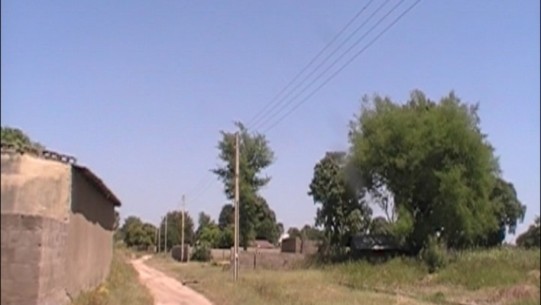
- Electricity Supply to Uba Mishara in 2020.This project was awarded to Electromax Engineering Services at a contract sum of (N91,115,939.36) the project is completed and put into use with 100% payment made.
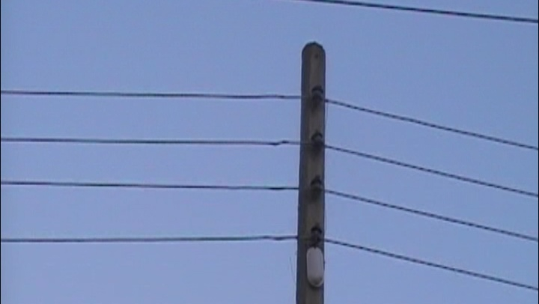

- Hildi-Jalingo Electricity Supply in 2022.This project was awarded to Ms. Gadawai Energy at a cost of (N49,494,821.25).It was successfully completed with 100% payment made to the firm.
- Electricity Supply to Kurmi in 2022.This is another project that is 100% completed and full payment made to the contractor and already put into use. It was awarded to Ms. Kenedy Ventures Ltd.
- Gombi Local Government: A total of two projects were carried out in Gombi LGA within 2022 – 2023 extending to the present 2024 they are:
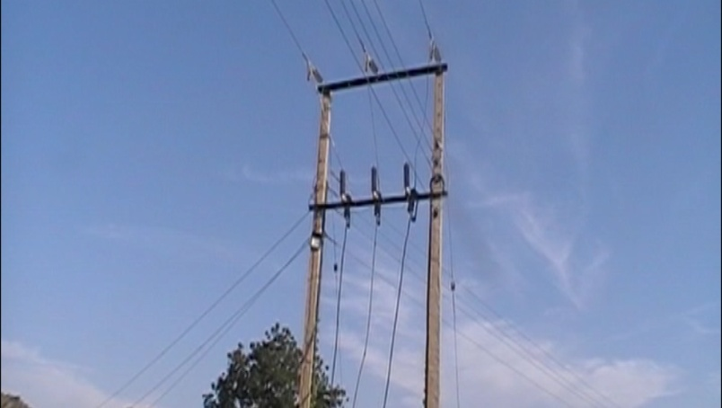
- The supply of Electricity to the Cottage Hospital, Gombi with a contract sum of (N24,476,113.37).It was awarded to Ms. SWS Logistics and already
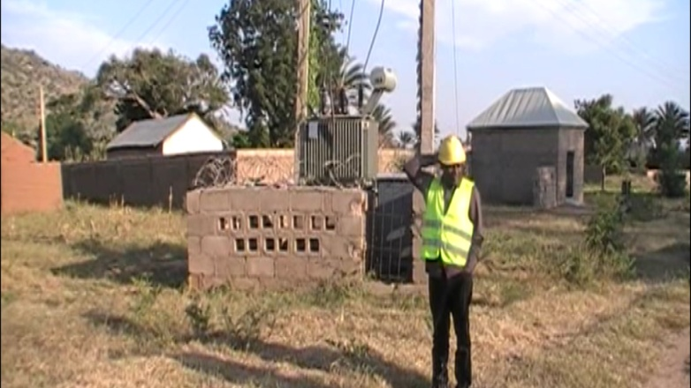
completed and put into use for the health benefits of the people.
- Wuyaku, Fahar, Mbewa and Kaulewa Electrification project: This is a project that cut across the four communities mentioned. It was
awarded in 2023 to Galaxy Rays Limited, full payment was made after it was successfully completed. The facility is now fully in use.
- Girei Local Government: Girei Local Government benefitted from both Electrification and road construction project. It has a total of three projects carried out as follows:
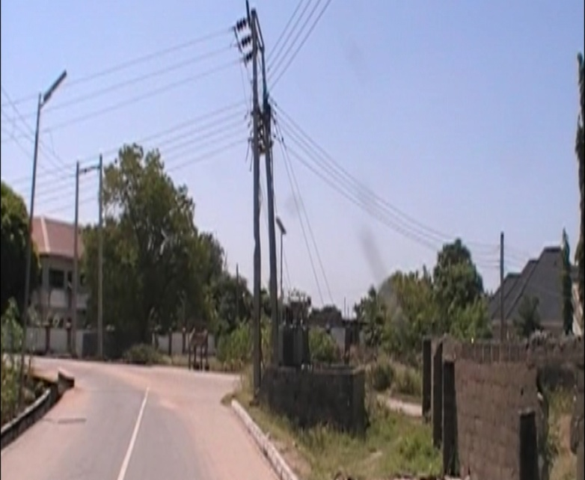
- Electrically Supply to Cottage Hospital Girei: It was awarded in 2022, to PRC Resources Ltd. at a cost of (N27,673,535.40).It is already completed and put into use with 100% payment made to the contractors.
- Electricity supply to Margi IDP Camp. This is a “Force Majeure” (Direct Labour) project that was done in 2022 at a cost of N47,900,700.00
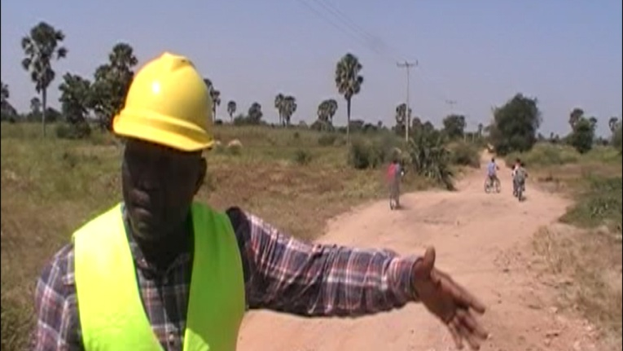
- The third project is the construction of 42 km Road that traverses two local governments, from the NYSC Orientation Camp in Girei LGA to Labondo and
terminating in Borrong Town of Demsa LGA. It was awarded to Hydro-Source and resources Ltd in this year 2024 at a contract sum of N839,912,430.00 the project is still ongoing.
- Fufore Local government: Fufore benefitted from 2 Electrification project they are:
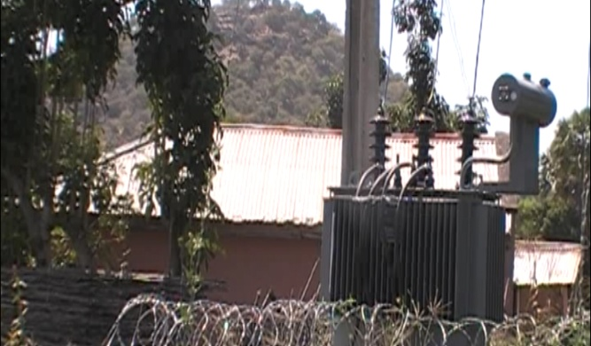
- Electricity supply to Malabu and Farang Communities was another project executed by direct labour and is 100% completed and put into use. It was at a cost of 66,864,000.00
- Yola South Local Government: Yola South Local Government is a beneficiary of three electrification projects all awarded in 2022.They include:
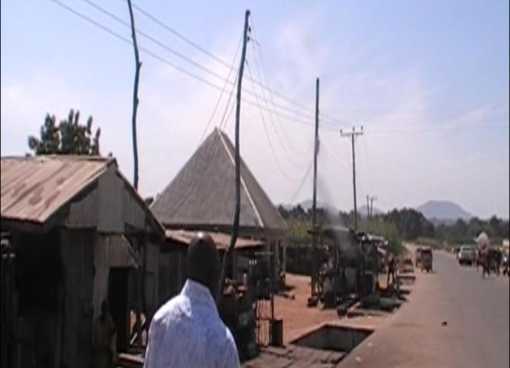
- Electricity supply to Wauru Jabbe. This was awarded to Ms. Chale Nigeria Limited at a cost of (49,538,299.25) 100% payment was made and the project is 100% completed and put into use.
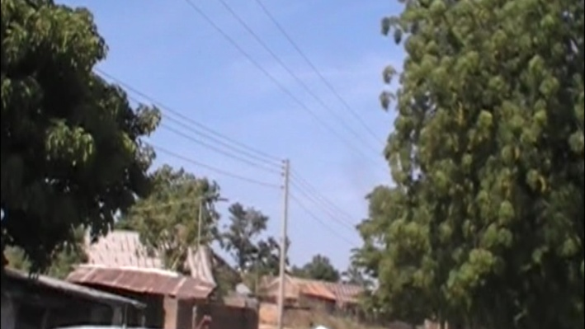
- Electrification of Rugange Community: This project was carried out by Yawurebe Investment Limited in 2022 at a contract sum of (N44,243,075.50). The project
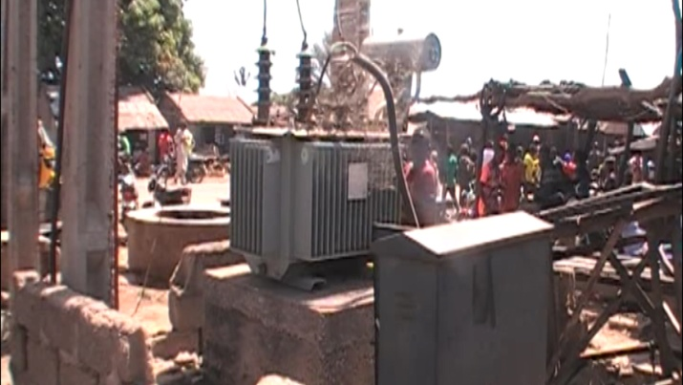
is completed and is being utilized by the community and full payment made to the contractor.
- Supply and Installation of 500 KVA Transformer with all the accessories at Kofare “B”. This is another project that was achieved through direct labour and is presently being enjoyed by the Kofare‘B’
Community. This cost the Government a sum of 49,538,299.25.
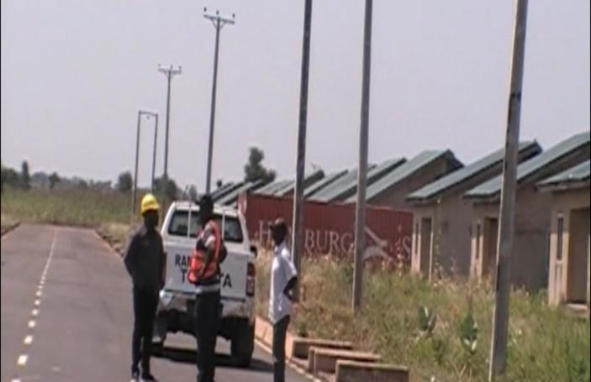
- Electrification of 1,000 Housing Unit. This project is awarded to Electromax Engineering Services at a cost of 832,205,405.20. the sum of 332,882,162.08 was given to contractor as mobilization fee
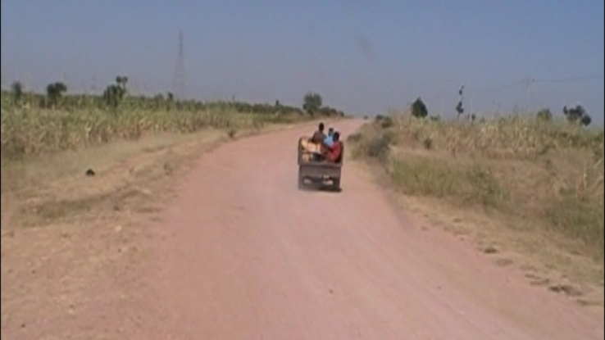
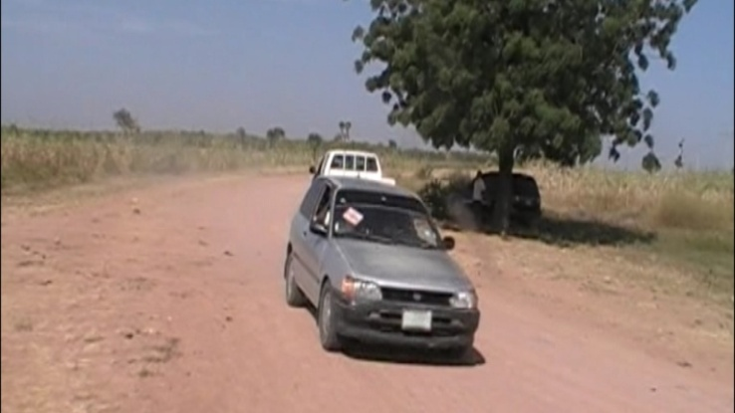
- Song local Government: Song Local Government is benefitting from a 24 kilometers road project. This is the Marraraba-Hombo-Dumne rural road project awarded to Hydro-Source and resources Ltd in 2022 and in which construction work is still ongoing. It was at a contract sum of 1,233,536,703.63 and payments of up to
N1,169,672,757.32 was made to the firm with a significant progress recorded with an outstanding balance of 63,863,946.28 which will be made after the completion of the project.
SOUTHERN SENATORIAL ZONE
The Southern Zone has its own fair share of rural development projects carried out by the Gov. Fintiri led Administration we begin with Demsa Local Government.
- Demsa is a beneficiary of electrification and rural road projects which include:
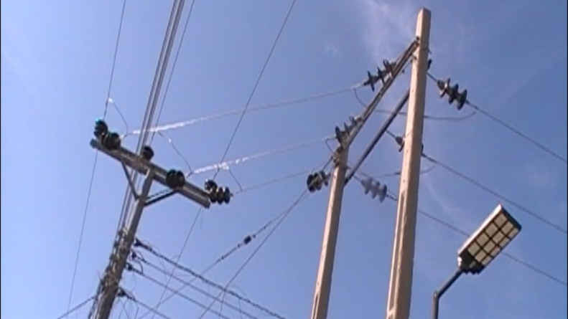
- Electrification of Bille, Kpasham and Dong Communities. This is another landmark project initiated by the present Administration of Gov. Ahmadu Fintiri.
It was awarded in 2022 to Electromax Engineering Services at a sum of ₦654,630,306.75. The work has reached 100% completion and will soon be connected to the National Grid System for the benefit of the communities.
- Construction of Tower River Crossing at Borrong. The tower was affected by erosion and hence electricity was cut off from Borrong and environs. The magnanimity of the Governor made it possible by releasing a total cost of 5,862,102.75 released to the Ministry and the work was done by direct labour. Borrong and environs became connected to the National Grid after years of black out.

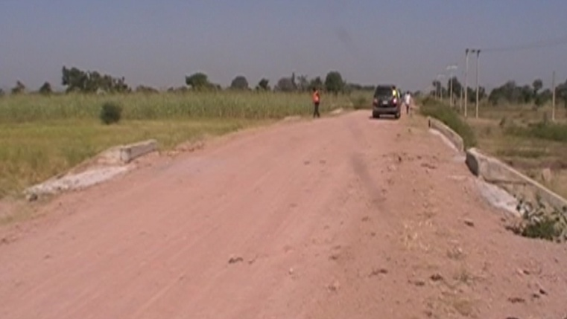
- NYSC Gate-Labondo-Borrong (42km) Road: Another project for the benefit of this Local Government is the construction of 42 km Road
from the NYSC Camp in Girei to Labondo to Borrong in Demsa LGA. This project, which is still ongoing, was awarded to Hydro -Source and resources Ltd. in this year 2024 at a contract sum of₦836,822,330.00. So far, the contractor has been paid the sum of ₦531,658,351.54
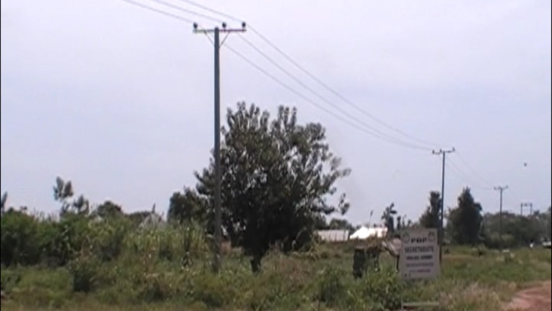
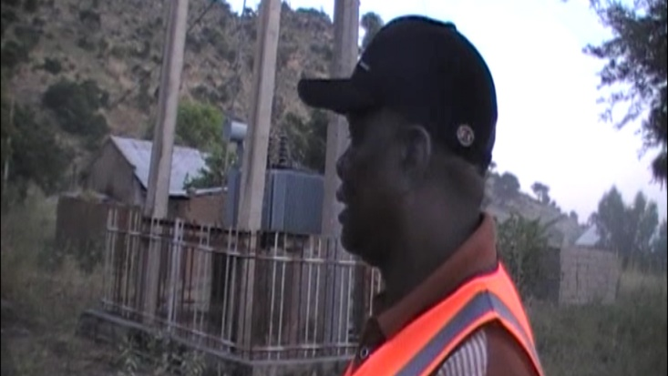
- Lamurde: Residents of Lamurde Local Government Area also benefited from the magnanimity of the Peoples’ Governor, Rt. Hon. Ahmadu Fintiri. Four towns of Opalo, Shemun, Hoki and Zekun, who have been without electricity for more than a decade when floods destroyed electrical installations. Communities in that axis are about to smile as contract for the electrification of the four towns is 99% completed.
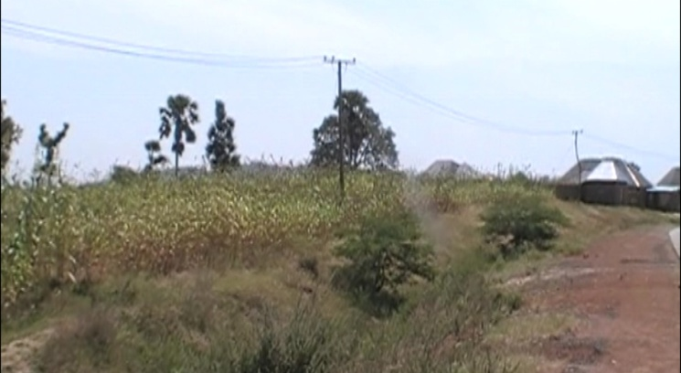
This project will soon be connected to the National Grid system. The contract for the electrification project was awarded to Bengins & Associate at a contract sum of
₦243,781,700.09. Payment of ₦219.403,530.81 was made with an outstanding balance of ₦24,378,170.09.
- Mayo-Belwa LGA:
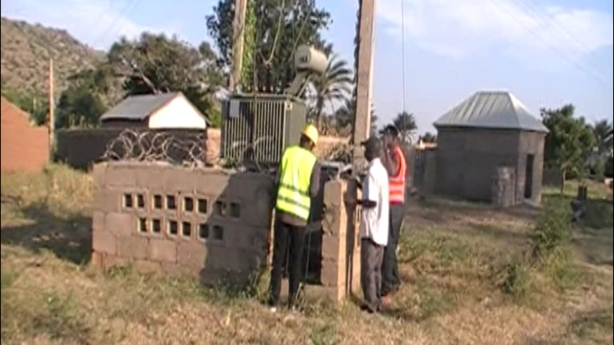
- Wuro-Liman and Nyombe benefitted from the rural development of Gov Fintiri as works to connect the two communities to the National
Grid was done by Direct Labour and the two town s are enjoying electricity since 2022. It was at a cost of 17,862,700.00.
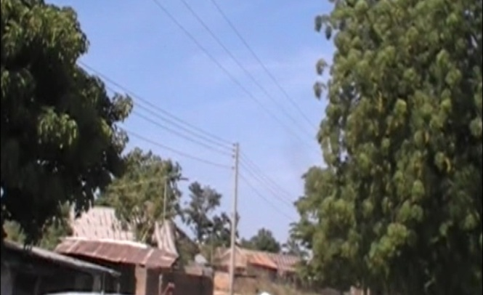
- We also have the Electrification of Gorobi and Dapanti Communities awarded to Mudaba Nigeria Limited at a total contract sum of ₦155,914,940.71.
The projects are completed and Gorobi and Dapanti hooked to the National Grid.

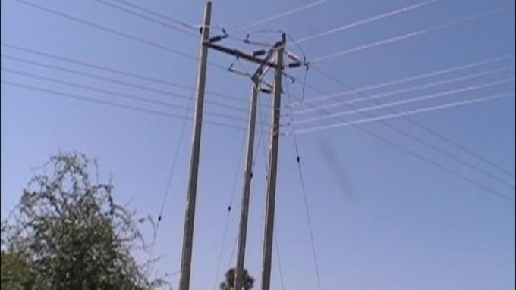
- Jada LGA: Two Electrification Projects was carried out in Jada Local Government this included:
- Electricity Supply to So’o and Mapeo Communities awarded in 2022 to Electromax Engineering Services at a cost of
N270,185,099.95 which is still ongoing due to the difficult terrains. Payment was made up to ₦108,074,039.70 with an outstanding balance of₦162,111,059.55.

NORTHERN SENATORIAL ZONE
Distinguished Gentlemen of the Press, we now move to the Northern Senatorial Zone:
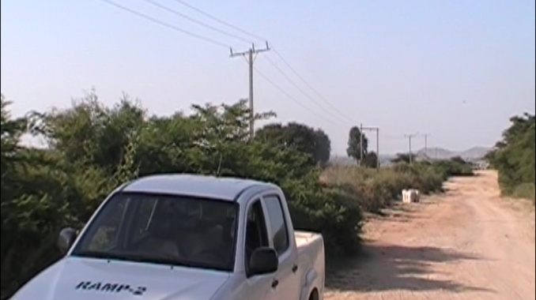
- In Mubi North LGA: a contract was awarded to S & S Business for the Electricity Supply to Bahuli at a contract sum of N33,995,312.00. The job has since been completed 100% and put into use.
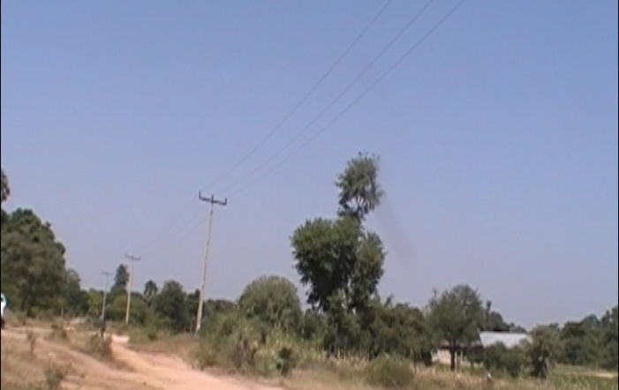
- Mubi South LGA: The towns of Nassarawo Mugulbu and Bajaule were not left out in the developmental strides of the Fintiri led administration. Audu Gombi Investments Ltd won
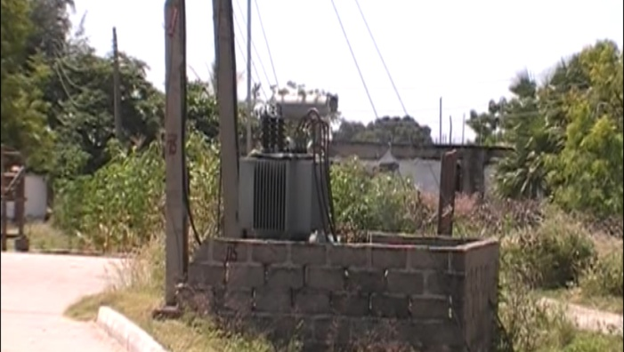
the contract for the rehabilitation of electricity supply to the three communities of a contract sum of 63,676,566.14. Nassarawo Mugulbu and Bajaule are already connected to the National Grid.
- Michika/Madagali LGA: We also have a rehabilitation of Electricity Supply awarded to Electromax Engineering Services at a cost of
(N283,850,277.75) in the year 2020. This project covers some communities in both Michika and Madagali Local Government Areas. It was paid 100% and the project completed and put into use.
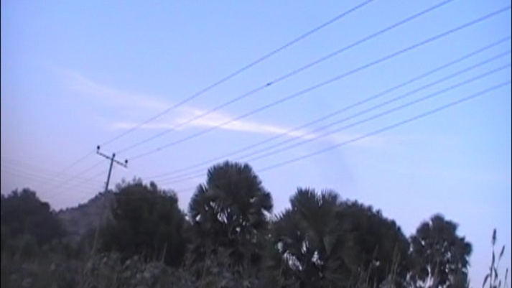
- Maiha LGA: The towns of Maiha-Gari and Humbutudi in Maiha LGA also benefitted from the rural development programme of the Fintiri administration. A contract
was awarded to Ms Chale Nig Ltd for the electrification of Maiha-Gari in 2023 at a contract sum of N205,205,153.67 which was completed 100% and the people enjoying the facility. Another contract was awarded to Audu Gombi Investments Ltd for the electrification of Humbutudi and this also has been completed 100% and will soon be hooked to the National Grid. It was at a contract sum of N89,398,119.04

DISTRIBUTION OF TRANSFORMERS
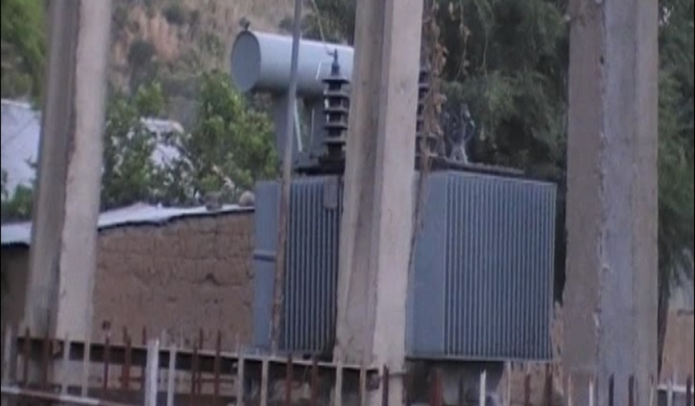
Ladies and Gentlemen, the last batch of project on our list is the distribution of transformers that cut across some of the Local Government Areas of the State. This is the
procurement and distribution of 10 Transformers to various communities in Adamawa State. Communities that benefitted from the transformer distribution includes Hombo and Balma in Song LGA, Jada Town in Jada LGA, Bange and Demsa in Demsa LGA and Rigange in Lamurde LGA. Others are Fufore Water Scheme in Fufore LGA, Zangun in Numan LGA, Mayo-Nguli Ward, in Maiha LGA and LCCN HQ, Yola Diocese in Yola North LGA.

CONCLUSION
Distinguish Invited Guests, Gentlemen of the Press, this is so far the score card under the Ministry For Rural Infrastructure and Community Development, under the reign of Gov. Ahmadu Umaru Fintiri.
We thank the organizers of this forum, the Ministry of Information and Strategy, and we appreciate you all. Thank you for listening.

